STATE OF CONNECTICUT
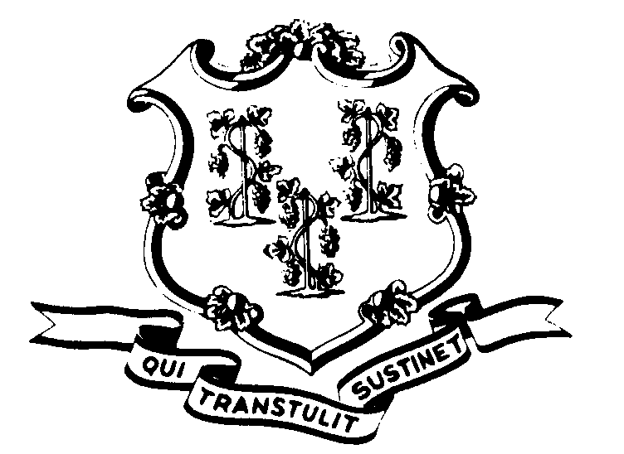

OFFICE OF POLICY AND MANAGEMENT

Office of Labor Relations

November 29, 2004

General Notice 2004-24

TO: Labor Relations Designees

SUBJECT: Notice to Departments Employing P-4 Bargaining Unit Members
As you probably know, we recently commenced negotiations with CSEA (P-4) for a successor collective bargaining agreement. The Union has made a substantial information request. While we have been able to gather some of the information requested with the assistance of DAS and OPM Personnel, we need your assistance to compile some of the information available only from the State Agencies. This includes the request for the following:
List of employees receiving vehicle use fee in DOT and DPW.
List of employees receiving the EMT stipend.
List of employees receiving the safety shoe allowance.
List of employees that are on-call.
List of employees by agency ordered to active military duty.
Copy of the service rating form used by your agency for P-4 bargaining unit members.
List of State contracts with vendors.
Cost of contracts with vendors.
New employees hired after January 3, 2003, their name, classification, rate of hire and agency.

Please gather this information as soon as possible and forward it to Robert Curtis via email at Robert.Curtis@po.state.ct.us or via fax at 418-6491.

If you should have any questions, please do not hesitate to contact Robert Curtis at 418-6241. Employees with questions should contact their Agency Personnel Office.

Linda J. Yelmini

Linda J. Yelmini
Director of Labor Relations

