STATE OF CONNECTICUT
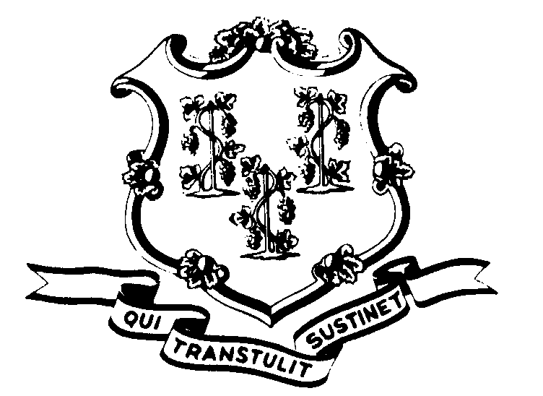

OFFICE OF POLICY AND MANAGEMENT

Office of Labor Relations

October 11, 2000

General Notice No. 2000-19

TO: Labor Relations Designees

SUBJECT: A&R Interest Arbitration Award Implementation

On October 3, 2000, Superior Court Judge Norris L. O’Neill issued his decision on the State’s application to vacate the A&R Interest Arbitration Award. That decision denied the State’s application to vacate and granted the Union’s application to confirm the award.

The Secretary of OPM and the Attorney General have consulted on this decision. It appears that an appeal of the decision would not be in the best interest of the State. Therefore, agencies should proceed with implementation of the Arbitration Award.

The OLR General Notice summarizing the Interest Arbitration Award and the Comptrollers Memorandum regarding implementation of the award will be forthcoming. Labor Relations Designees with questions concerning this general notice should contact Fae Brown-Brewton at 418-6217. All others should contact their Central Personnel Office.

Linda J. Yelmini
Linda J. Yelmini
Director of Labor Relations

