POS/PSA Contractor Performance Evaluation Job Aid
OPM’s Procurement Standards require that executive branch agencies complete a performance evaluation within 60 days of the end date of any POS or PSA contract. This requirement is an implementation of C.G.A. Sec. 4-217, which requires OPM to ensure the evaluation of contractor performance. As of February 2022, these evaluations can now be completed directly in CTsource, the State Contracting Portal. This job aid provides a step-by-step guide to submitting a performance evaluation.
Who should complete a contractor performance evaluation?
Evaluations should be completed by agency staff with management and oversight knowledge of the contract and services provided. The most appropriate staff member to complete the evaluation may not have the requisite permissions to create an evaluation in CTsource. If this is the case, the agency should either secure permissions for that staff member, or designate a CTsource point of contact who can provide support in submitting the evaluation.
How do I register with CTsource to complete performance evaluations?
For assistance with registering with CTsource, and receiving login credentials, please reach out to your agency’s system administrator to be added as a user. There is no limit to the number of staff that can be registered in CTsource. You can find a list of system administrators by agency, current as of January 2022, in the appendix of this job aid.
What if the contractor whose performance I am trying to evaluate is not registered in CTsource?
In order to complete a performance evaluation for a contractor, vendor, or provider, the contractor must first be registered in CTsource. Registration is a quick and simple process that allows vendors and providers to access a variety of benefits, including notifications for new procurement opportunities. You can share the following link with your vendors and providers, which will guide them through the registration process: https://portal.ct.gov/DAS/CTSource/Registration.
Am I required to complete a contractor performance evaluation when utilizing DAS master contracts?
DAS is in the process of establishing a vendor performance evaluation process for master contracts that will be consistent with the OPM process for POS/PSA contracts described in this job aid. OPM and DAS will provide additional guidance on master contracts in the coming months.
How do I complete a contractor performance evaluation?
Contractor performance evaluations should be submitted via CTsource within 60 days of the end date of the contract in question. Staff can follow the steps on the following pages to complete an evaluation.

- Log into CTsource – enter your username and password on the CTsource login screen found at https://webprocure.perfect.com/login.do
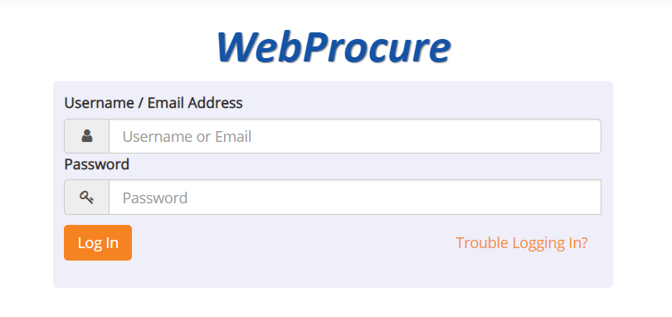

- Navigate to the Vendors tab and select “View Vendors.”
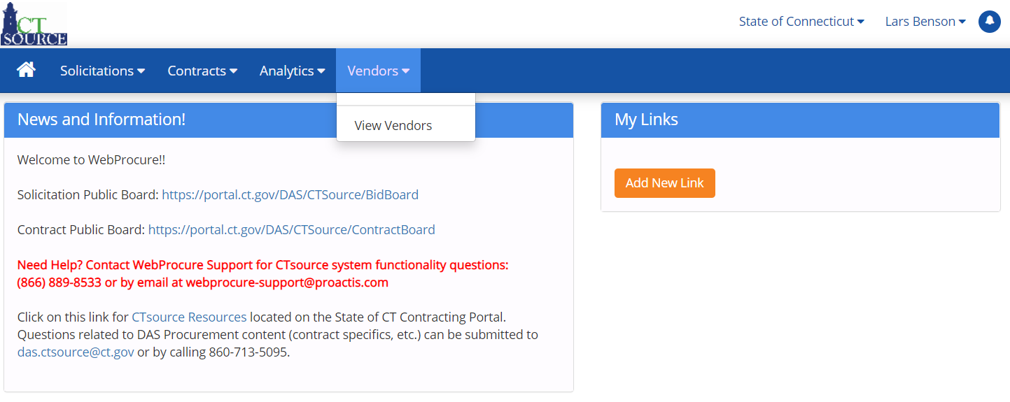

- Enter the name of the supplier to be evaluated (your provider or vendor) and hit the “enter” key or the “Search” button at the bottom of the page.
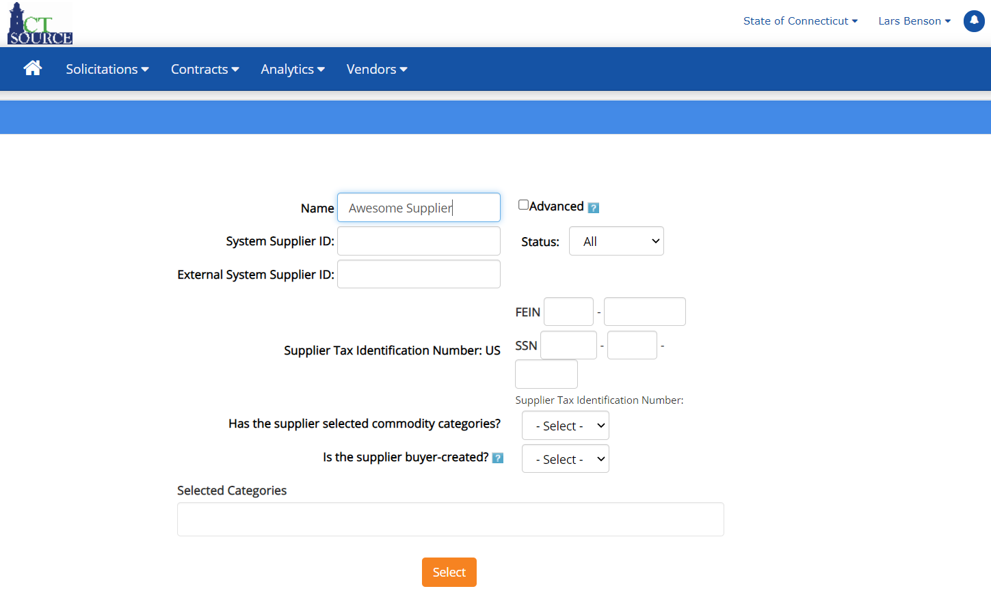

- Select the correct supplier from the search page by clicking their name

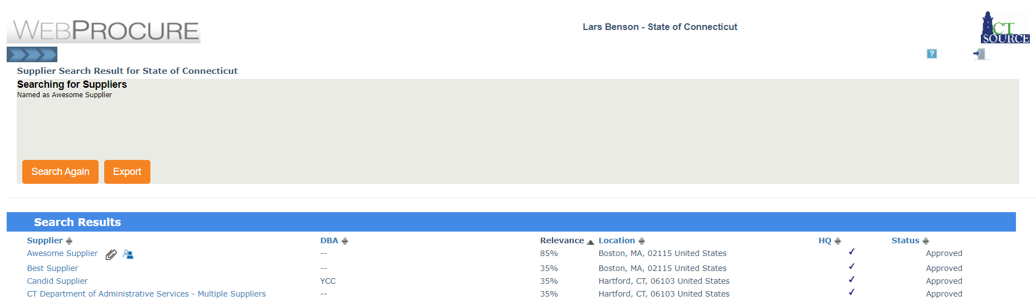

- You will now be viewing the supplier’s profile. Navigate to the “Supplier Evaluation” tab.
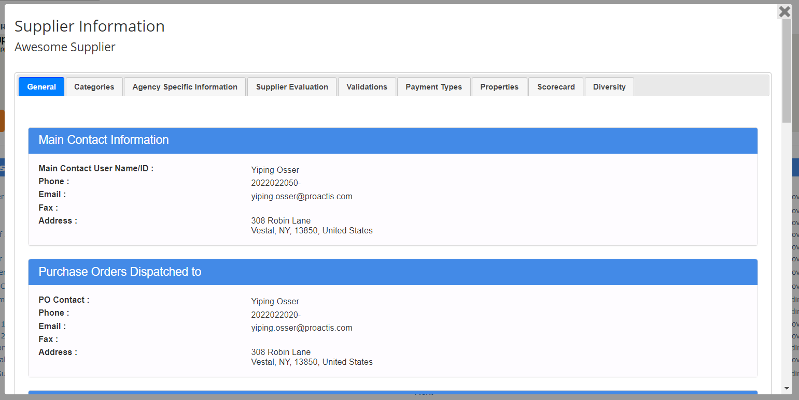

- Follow the instructions on the evaluation form. Begin by providing the contract number, agency name, and a brief description of the services. If this evaluation is intended to amend a previously submitted evaluation, because new information has surfaced or an error was made, please make note of this in your contract description answer. You may also upload any supporting documentation.
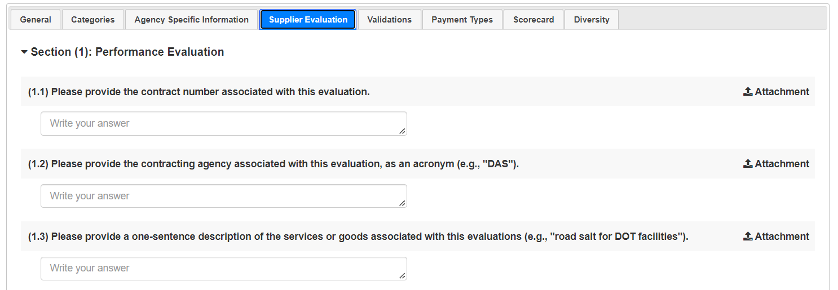

- Complete the evaluation by assigning a 1-5 score for Quality, Timeliness, Compliance, and Responsiveness. Use the “Comment” button to explain your reasoning for each score. Finally, state whether a corrective action plan was required during the contract, and press “Submit Score.” You may also upload any supporting documentation.
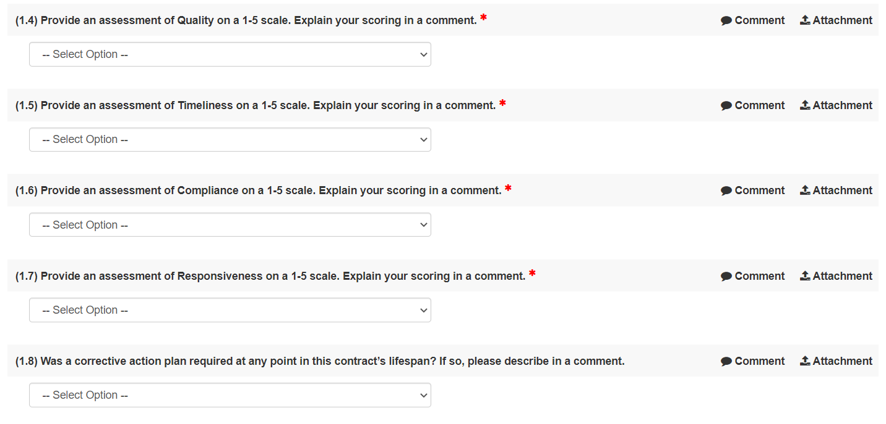
- You’re all done!

How do I review completed evaluations?
When making important procurement decisions, such as the decision to award a contract to a particular vendor or provider, agencies may wish to consult any previously completed evaluations that have been logged for that vendor or provider, to better understand their record of performance. Previously completed evaluations can be found via the following steps:
- Within the supplier profile, navigate to the “Scorecard” tab.

- Click “General Performance Score.” You will see a breakdown of all completed performance evaluations. You may click “View Evaluation” on any evaluation you would like to view in detail, to review further. You may also review your own evaluations on this page.
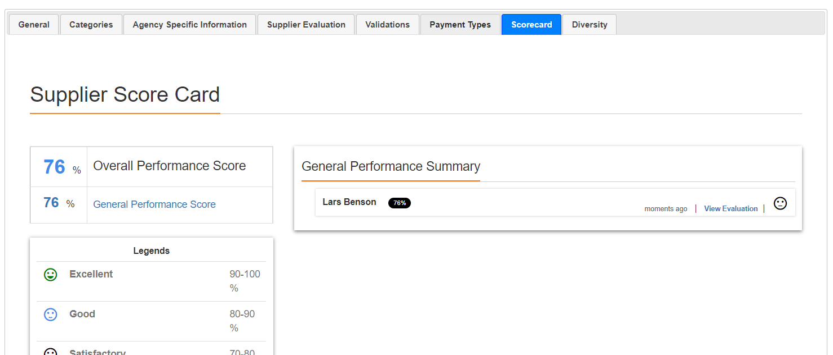

APPENDIX: Agency System Administrators
This list of system administrators is current as of January 2022. If contacts are outdated, to receive an updated list, please reach out to John Winschel at DAS Procurement (John.Winschel@ct.gov).
Org Name | User Name | Email Address
Aging & Disability Services | Michelle Provost | Michelle.Provost@ct.gov
Aging & Disability Services | Mary Van Ness | Mary.VanNess@ct.gov
Agriculture, Dept. of | Suzanne Giansanti | Suzanne.Giansanti@ct.gov
Charter Oak State College | Douglas Ginsberg | dginsberg@commnet.edu
Charter Oak State College | Rafaella Almeida | ralmeida@charteroak.edu
Charter Oak State College | Silas Shannon | sshannon@charteroak.edu
Charter Oak State College | Steven Hurlburt | shurlburt@charteroak.edu
Charter Oak State College | Michael Moriarty | mjmoriarty@charteroak.edu
Children and Families, Dept. of | Melanie Sparks | MELANIE.SPARKS@ct.gov
Children and Families, Dept. of | John McCarthy | JOHN.MCCARTHY@ct.gov
Children and Families, Dept. of | Jason Szczesniak | JASON.SZCZESNIAK@ct.gov
Children and Families, Dept. of | Dawn Alexander | DAWN.ALEXANDER@ct.gov
Children and Families, Dept. of | Cathy Shepherd | CATHERINE.SHEPHERD@ct.gov
Children and Families, Dept. of | Connie Caruso | CONNIE.CARUSO@ct.gov
Comptroller, Office of State | Donalynn Black | donalynn.black@ct.gov
Connecticut State Library | Suzanne Giansanti | Suzanne.Giansanti@ct.gov
Consumer Protection, Dept. of | Suzanne Giansanti | Suzanne.Giansanti@ct.gov
Correction, Dept. of | Cheryl Santos | Cheryl.Santos@ct.gov
Correction, Dept. of | Michael Lettieri | Michael.Lettieri@ct.gov
Correction, Dept. of | Barbara Farrell | Barbara.Farrell@ct.gov
CT Teachers' Retirement Board | Charlene Hill | charlene.hill@ct.gov
CT Teachers' Retirement Board | Helen Sullivan | helen.sullivan@ct.gov
CT Teachers' Retirement Board | Javiel Resto | javiel.resto@ct.gov
CT Teachers' Retirement Board | Keith Petit | keith.petit@ct.gov
Developmental Services Central | Kevin Lawton | Kev.Lawton@ct.gov
Developmental Services Central | Peter Mason | Peter.Mason@ct.gov
Developmental Services Central | David David | David.David@ct.gov
Developmental Services North | Peter Mason | Peter.Mason@ct.gov
Developmental Services North | David David | David.David@ct.gov
Developmental Services South | Brenda Maccione | brenda.maccione@ct.gov
Developmental Services South | Peter Mason | Peter.Mason@ct.gov
Developmental Services South | David David | David.David@ct.gov
Developmental Services West | Brenda Maccione | brenda.maccione@ct.gov
Developmental Services West | Peter Mason | Peter.Mason@ct.gov
Developmental Services West | David David | David.David@ct.gov
Developmental Services West | Julie Bouchard | julie.bouchard@ct.gov
DPH - Communications | Heather Trabal | Heather.trabal@ct.gov
Early Childhood, Office of | Africka Hinds | Africka.Hinds@ct.gov
Economic and Community Development | Michele Richmond | michele.richmond@ct.gov
Education, Dept. of | Pam Casiano | pam.casiano@ct.gov
Emergency Serv. & Public Protection | Joshua Joseph | Joshua.Joseph@ct.gov
Emergency Serv. & Public Protection | Beata Szwajger | Beata.Szwajger@ct.gov
Energy & Environmental Protection | Chanel Macklin | chanel.macklin@ct.gov
Energy & Environmental Protection | Garrett McCurdy | garrett.mccurdy@ct.gov
Energy & Environmental Protection | Joseph Wagner | joseph.wagner@ct.gov
Energy & Environmental Protection | Raul Granillo | raul.granillo@ct.gov
Housing, Dept. of | William Lungren | william.lungren@ct.gov
Housing, Dept. of | Beth Generali | beth.generali@ct.gov
Housing, Dept. of | Kathleen Durand | kathleen.durand@ct.gov
Housing, Dept. of | Michele Richmond | michele.richmond@ct.gov
Housing, Dept. of | Cheryl Bocwinski | Cheryl.Bocwinski@ct.gov
Housing, Dept. of | Michelle Peters | michelle.peters@ct.gov
Labor, Dept. of | Robert Hunt | robert.hunt@ct.gov
Medical Examiner, Office of Chief | Aida Kristo | kristo@ocme.org
Mental Health & Addiction Services | Megan Sopelak | Megan.sopelak@ct.gov
Mental Health & Addiction Services | Lillian Ruiz | Lillian.ruiz@ct.gov
Mental Health & Addiction Services | Betty McCants | Betty.McCants@ct.gov
Motor Vehicles, Dept. of | Abigail Lawson | abigail.lawson@ct.gov
Motor Vehicles, Dept. of | Michelle Schott | michelle.schott@ct.gov
Motor Vehicles, Dept. of | Darrell Grant | darrell.grant@ct.gov
Office of Health Strategy | Shiu-yu Schiller | Shiu-yu.schiller@ct.gov
Policy & Management, Office of | Kathleen Taylor | Kathleen.Taylor@ct.gov
Policy & Management, Office of | Susan Sousa | Susan.Sousa@ct.gov
Policy & Management, Office of | Vernieke Calloway | Vernieke.Calloway@ct.gov
Policy & Management, Office of | Jordan Hill | Jordan.Hill@ct.gov
Secretary of the State | Sonya Mathis | Sonya.mathis@ct.gov
Secretary of the State | Blanche Tucker | blanche.tucker@ct.gov
Social Services, Dept. of | Diana Speranza | diana.speranza@ct.gov
Transportation, Dept. of | Carrie Cyr | carrie.cyr@ct.gov
Transportation, Dept. of | Pall Oushana | pall.oushana@ct.gov
Transportation, Dept. of | Gregory Straka | gregory.straka@ct.gov
Transportation, Dept. of | DOT Contracts | DOTContracts@ct.gov
Transportation, Dept. of | Melanie Goodin | Melanie.Goodin@ct.gov
Transportation, Dept. of | Sandra Ferrara | sandra.ferrara@ct.gov
Transportation, Dept. of | Mary Matuszak | mary.matuszak@ct.gov
Transportation, Dept. of | James Stutz | james.stutz@ct.gov
Treasurer, Office of State | Marva Balfour | marva.balfour@ct.gov
State of Connecticut | Gene Burk | gene.burk@ct.gov

