CON Portal Instructions
Welcome to the CON Portal Instructions Document. Please note that only one user per entity should register with OHCA’s CON Portal. Only the user who submits the original material, can communicate with OHCA throughout the CON process. Therefore, it is very important that the appropriate contact person is assigned to the CON. Also, as a reminder, do NOT enter or upload any confidential information into the CON Portal. This includes direct patient information, social security numbers, bank account information, etc. Please note that you Do Not need to register to view CON materials. Interested parties wishing to see the status of all CONs can do so without registering by going to this link: https://dphconwebportal.ct.gov/Report
Registration:
- Navigate to the OHCA website at http://www.ct.gov/dph/cwp/view.asp?a=3902&Q=277344&dphNav=|

- Click the link http://dphconwebportal.ct.gov/ to navigate to the CON web portal.

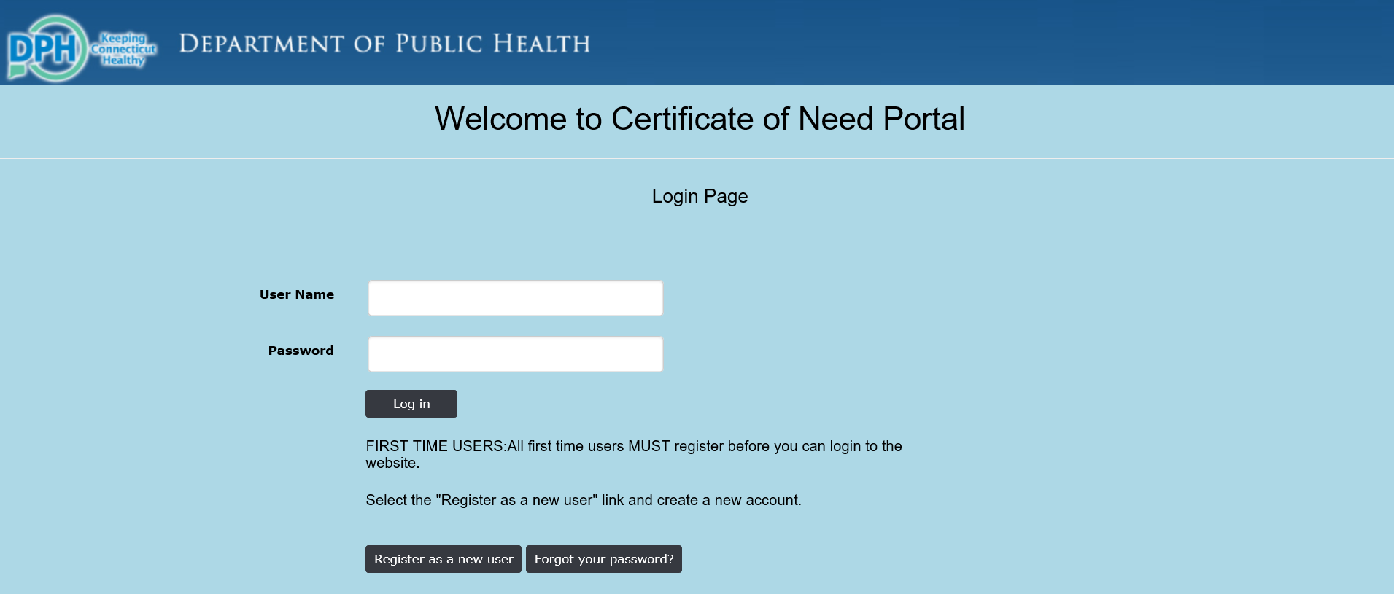

- Choose the button to Register as a New User. Please note that you only need to register once. For further submissions and viewing of CONs after your initial registration, please proceed to the Login Instructions.

- Complete the Registration Information below. Ensure your password contains at least 6 characters, including one number, one letter, one uppercase letter and 1 non-alpha numeric symbol (i.e. @&!, etc.). Once complete select the Register Button.

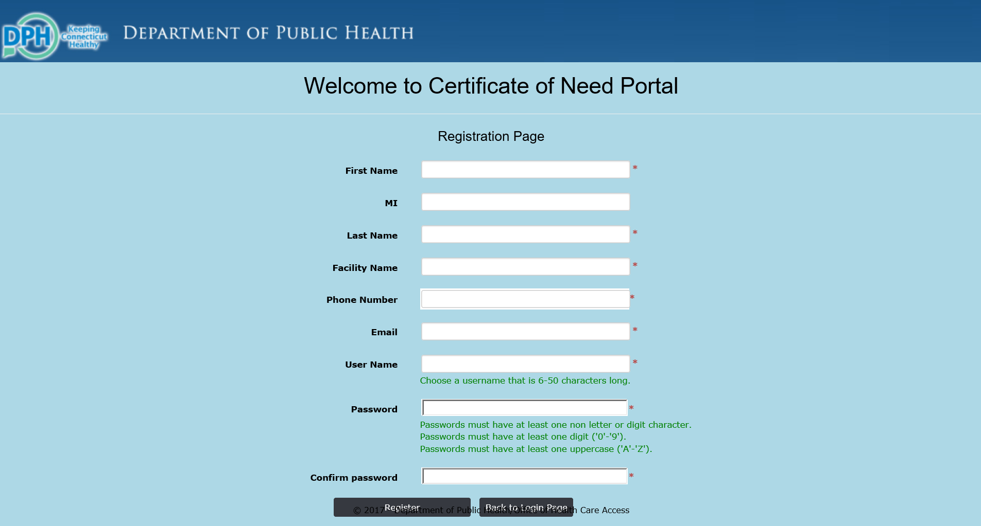

- You will then reach a screen telling you that your registration is pending and that you will receive an email from OHCA once your registration is processed.

- Once OHCA has processed your registration you will receive an email resembling the following:

From: OHCA@ct.gov [mailto:OHCA@ct.gov]
Sent: Thursday, August 31, 2017 2:48 PM
To:
Subject: OHCA CON Web Intake and Payment Process new user registration approved

Dear User,
OHCA CON Web Intake and Payment Process account has been approved.
Your Username is : your username will appear here
Use http://dphconwebportal.ct.gov/ for accessing OHCA CON Web Intake and Payment Process.
Should you have questions, please contact DPH DPH Helpdesk or 860 509 7777. Please do not reply to this e-mail as it is an automated notification.

Log In Instructions:
- Navigate to the OHCA CON Portal at http://dphconwebportal.ct.gov/ and enter your Username and Password. Click Log in.

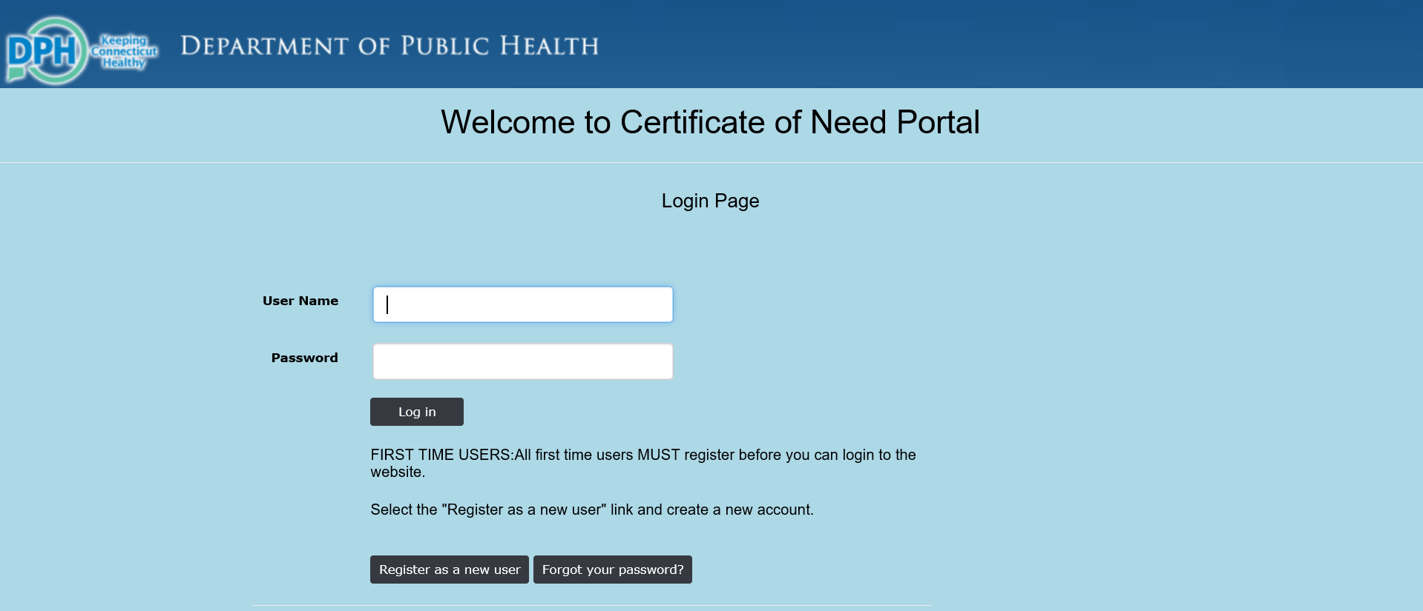

Welcome to the CON Portal:

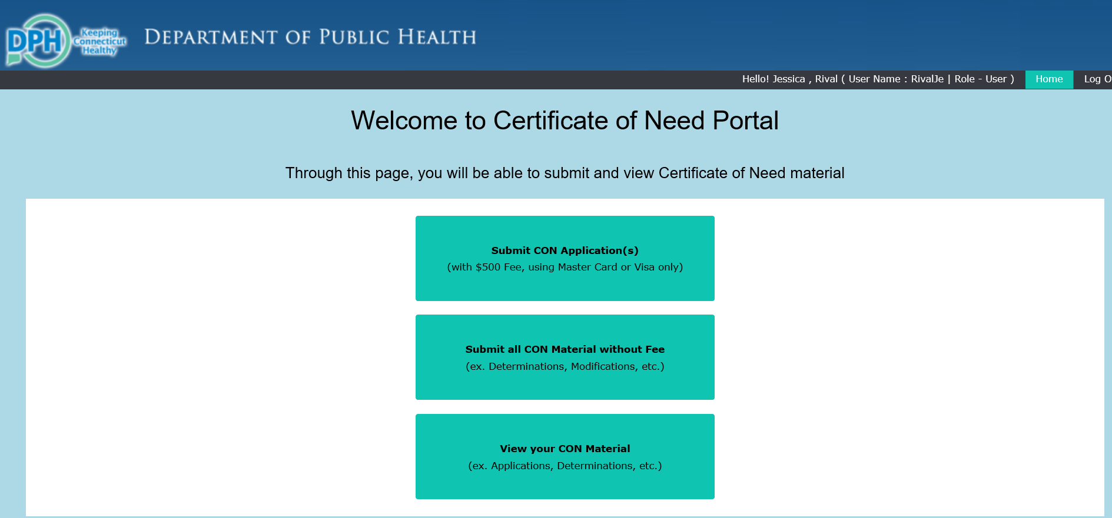

- Submitting CON Application(s) (with $500 Fee, using Master Card or Visa only).

- Select the Button to Submit Con Application(s) (with $500 Fee, using Master Card or Visa only)

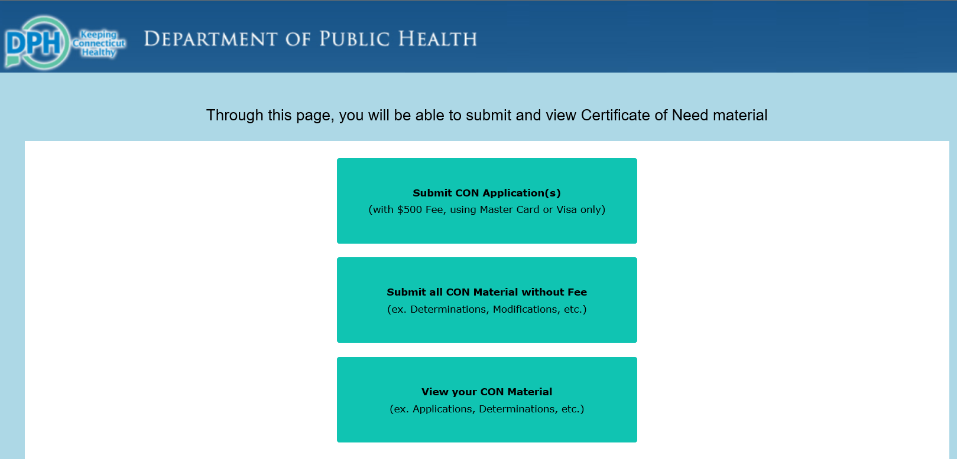

- A pop up box will open asking if you are sure you want to submit CON with payment. If so, click OK.

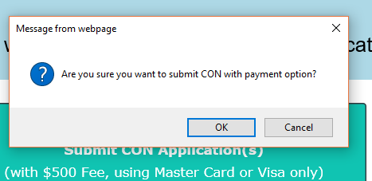
- A pop up box will open confirming you have created a CON with payment application successfully. Click OK to continue.

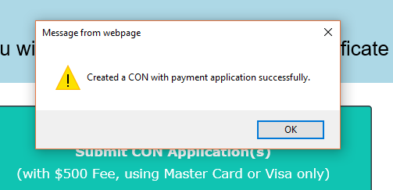

- Your CON application with Fee will be listed. Click on documents to upload your files.

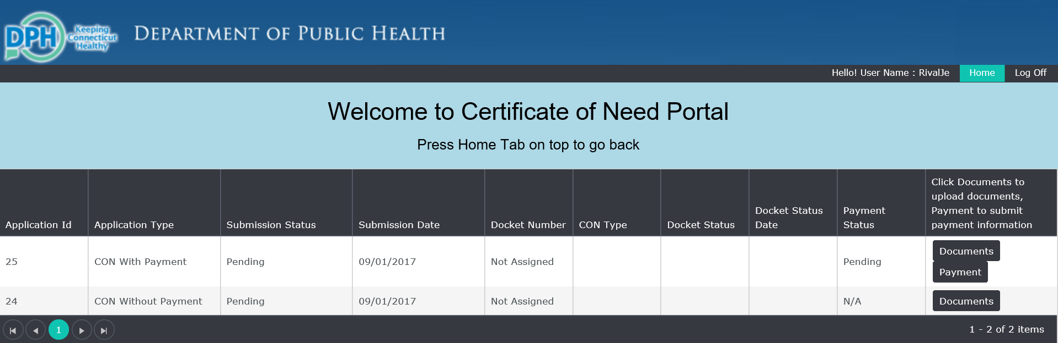

- A pop up window will ask you to Please Attach CON Documents. Please upload your electronic copies by clicking Browse Documents and selecting the appropriate files from your computer. Please note that CON submissions unaccompanied by at least one document will be deleted in 24 hours.

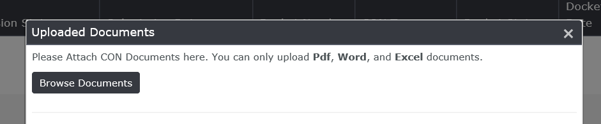

- Once selected, the documents are uploaded to the CON Portal. Please note that once a file has been uploaded it CANNOT be deleted. If a file is uploaded in error please upload the correct file and contact OHCA directly.

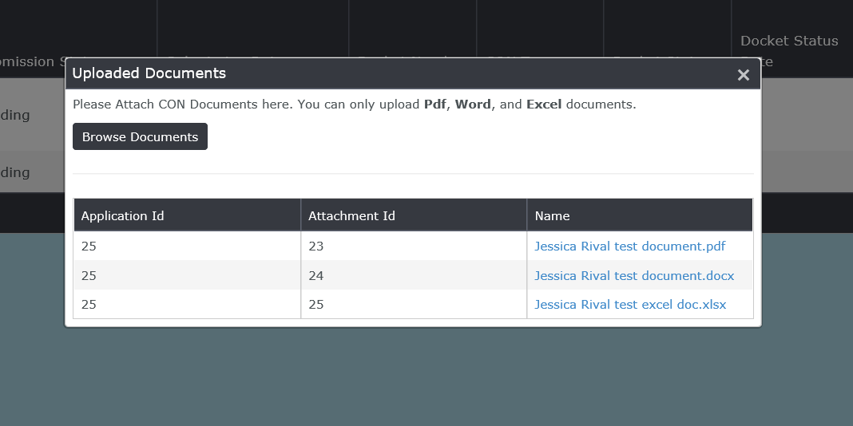

- Close this window to return to the previous screen and click on the Payment button.

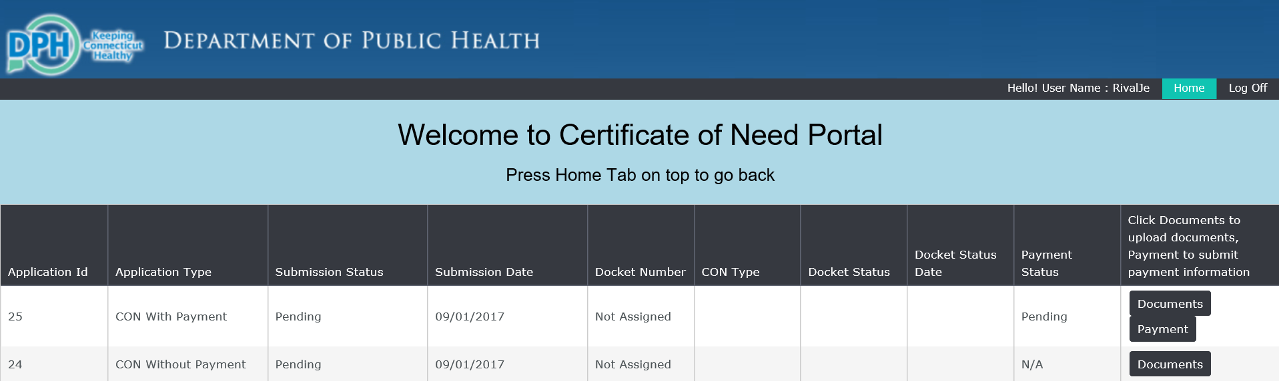

- A pop up box will appear to collect your payment information. Please complete all fields, check all appropriate boxes, sign and click on submit.

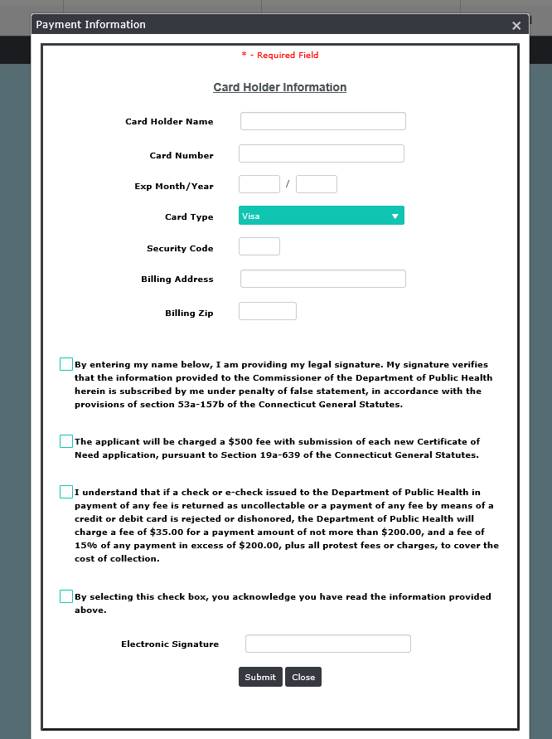

- A pop up box will confirm your payment has been accepted. Click OK.

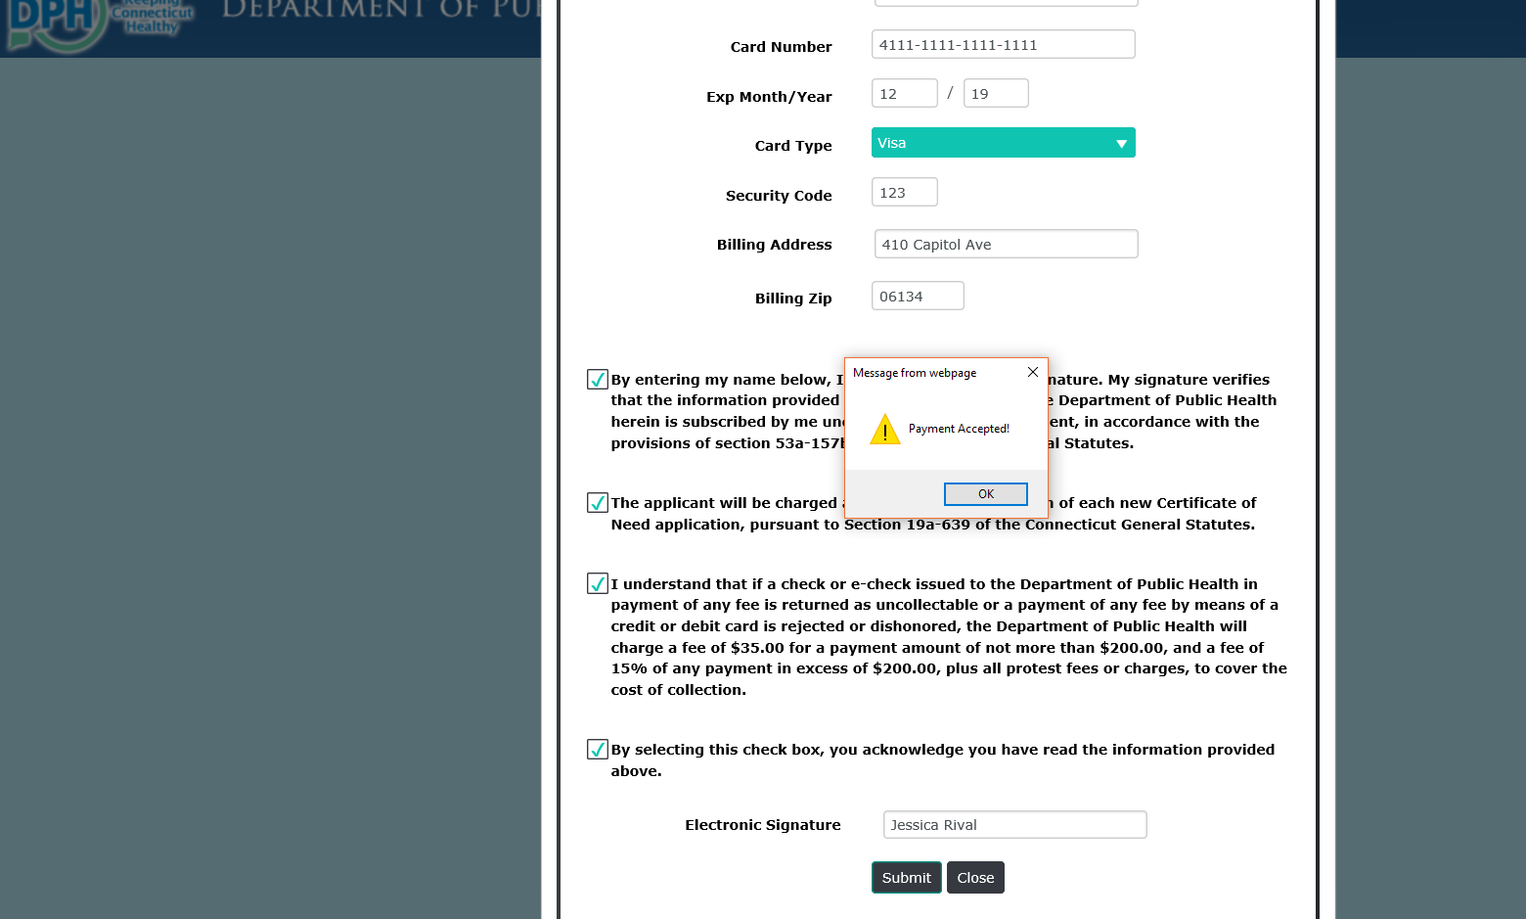

- The CON payment status will change to accepted, and the payment button will disappear as a selection.

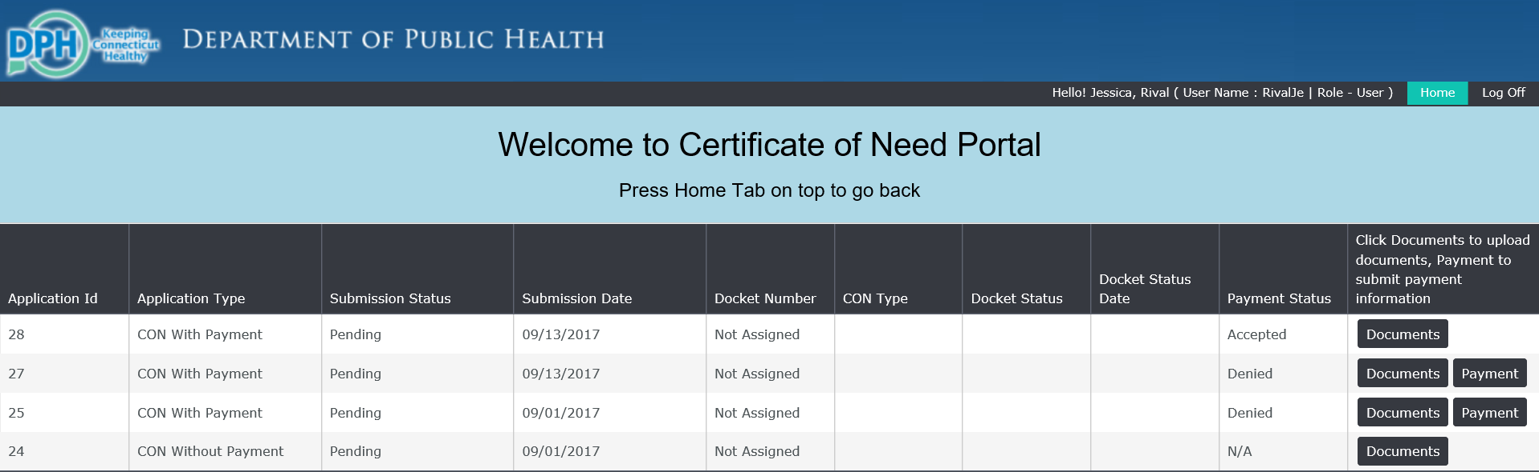

- Your submission is complete. You may return to the home screen or log out.

- When finished please remember to log off of the system.

- To view status changes to the CONs you have submitted, or if you want to view the status of all CONs, you can do so through this link: https://dphconwebportal.ct.gov/Report

- If you need to add additional documents to a previously submitted CON, you can log back into the system at a later date to do so. Please note that CON submissions unaccompanied by at least one document will be deleted in 24 hours.

- As OHCA updates the status of your CON you will get an automatic notification asking you to log on and view the status change. This is also how you will be notified that there is a document waiting for your review (completeness letters, determinations, etc.)

- Submit all CON Materials without Fee (ex. Determination, Modifications, etc.)

- Select the button to Submit all CON Materials without Fee.

- A pop up window will ask you if you are sure. If so, select OK.

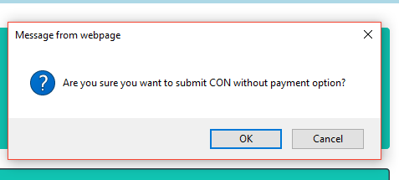

- A second pop up window will state that you have created a CON without payment successfully. Select OK.
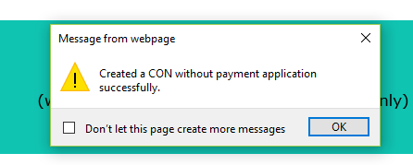

- Your CON application without Fee will be listed. Click on Documents to upload your files.

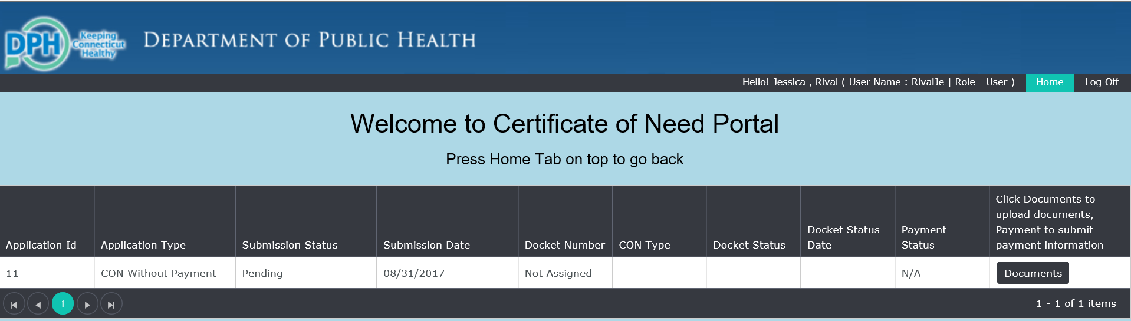

- A pop up window will ask you to Please Attach CON Documents. Please upload your electronic copies by clicking Browse Documents and selecting the appropriate files from your computer. Please note that CON submissions unaccompanied by at least one document will be deleted in 24 hours.

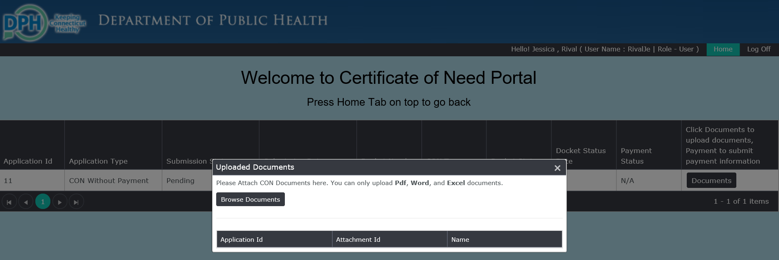

- Once selected they are uploaded automatically to the CON Portal. Your submission is complete. You may return to the home screen or log out.

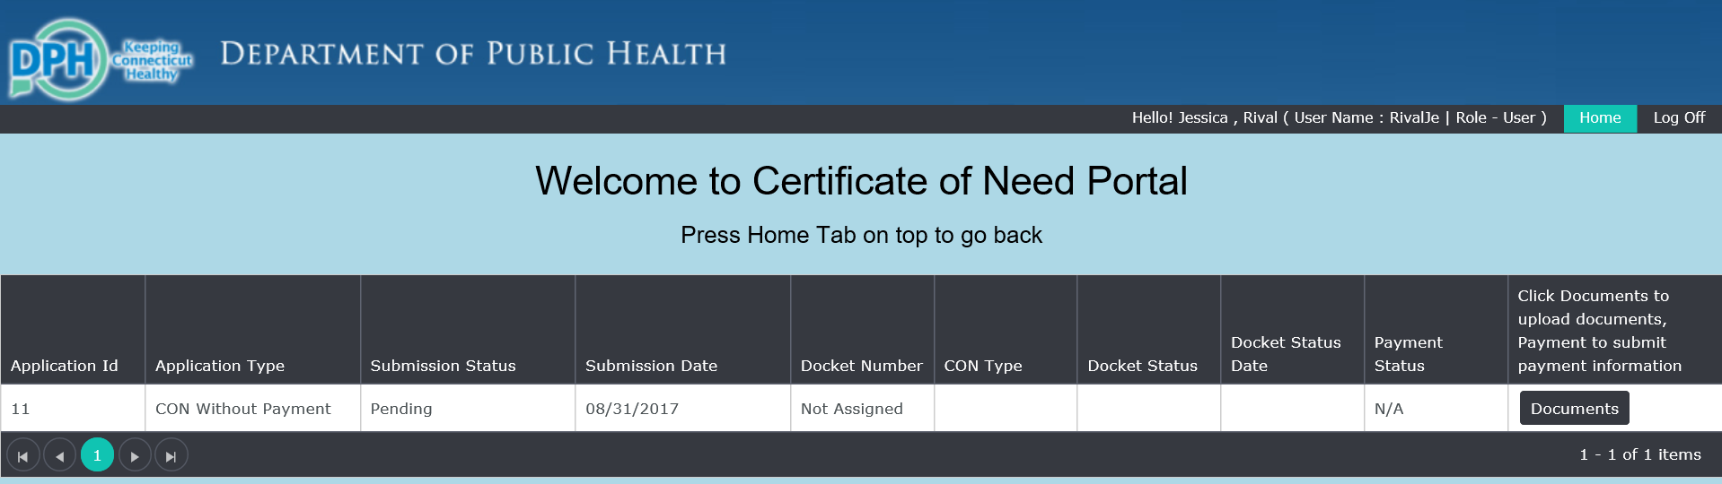

- When finished please remember to log off of the system.

- To view status changes to the CONs you have submitted, or if you want to view the status of all CONs, you can do so through this link: https://dphconwebportal.ct.gov/Report

- If you need to add additional documents to a previously submitted CON, you can log back into the system at a later date to do so. Please note that CON submissions unaccompanied by at least one document will be deleted in 24 hours.
- As OHCA updates the status of your CON you will get an automatic notification asking you to log on and view the status change. This is also how you will be notified that there is document waiting for your review (completeness letters, determinations, etc.)

- Viewing Your CON Material (ex. Applications, Determinations, etc.) Please note that you Do Not need to register to view CON materials. Interested parties wishing to see the status of all CONs can do so without registering by going to this link: https://dphconwebportal.ct.gov/Report

- Select View your CON Material

- The next screen will contain the information available about your submission. This information includes your application ID, the type of application, the status of your submission, etc. To view or verify the correct documents have been attached select the documents button.

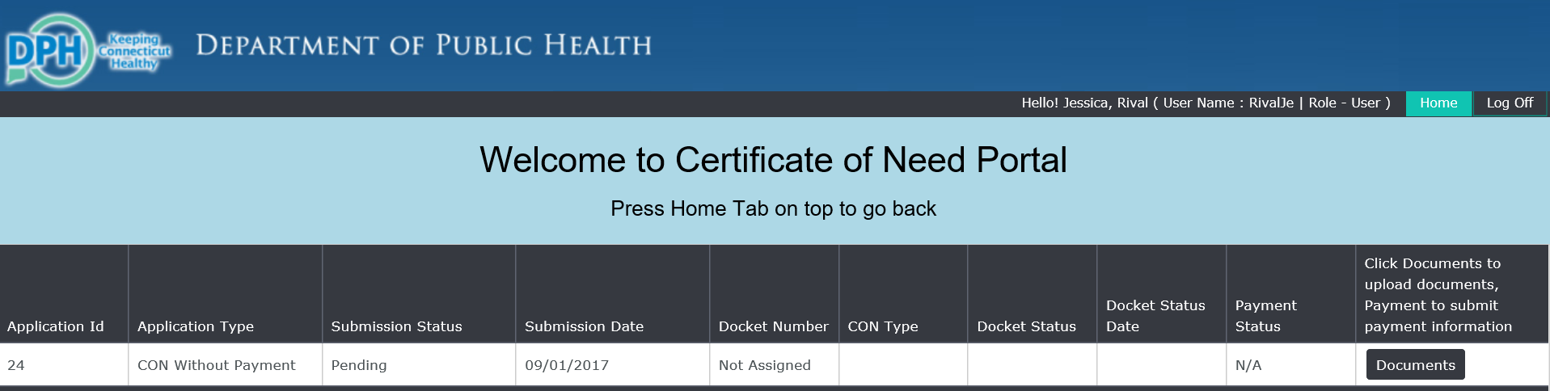

- When finished please remember to log off of the system.

- To view status changes to the CONs you have submitted, or if you want to view the status of all CONs, you can do so through this link: https://dphconwebportal.ct.gov/Report

- If you need to add additional documents to a previously submitted CON, you can log back into the system at a later date to do so. Please note that CON submissions unaccompanied by at least one document will be deleted in 24 hours.

- As OHCA updates the status of your CON you will get an automatic notification asking you to log on and view the status change. This is also how you will be notified that there is document waiting for your review (completeness letters, determinations, etc.)

