***~~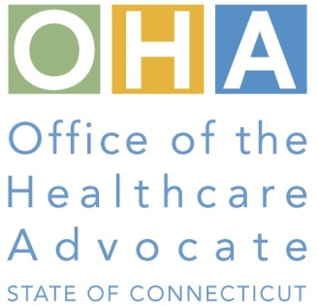~~***

OHA Outreach Materials Request Form

Attention: _____________________________________

***OHA's mission is "...to assist consumers with health care issues through the establishment of effective outreach programs and the development of communications related to consumer rights and responsibilities as members of healthcare plans."***  If you would like OHA materials for your community or Outreach Event, please indicate which language and the brochure quantities. You may also request from a limited supply of English/Spanish posters.

**Brochure Languages:**

Albanian Greek Korean Urdu

Arabic Gujarati Lao Vietnamese

Bengali Haitian (Creole) Polish

Braille Hindi Portuguese

Cambodian Italian Russian **Posters:**

Chinese Japanese Serbian Sick. with worry

French Pulling all-nighters

Need help with bills

|  |  |  |  |
| --- | --- | --- | --- |
| ORGANIZATION | ADDRESS/PHONE/E-MAIL | LANGUAGE (S) | QUANTITY |
| 1.  Contact:____________________ | A:_____________________________  _____________________________  P: ______________________________  E: ______________________________ | * ___________ * ____________ * ____________ * ____________ | * ___________ * ___________ * ___________ * ___________ |
| 2.  Contact:____________________ | A: _____________________________  _____________________________  P: ______________________________  E: ______________________________ | * ___________ * ____________ * ____________ * ____________ | * ___________ * ___________ * ___________ * ___________ |
| **POSTERS:**   1. Sick. with worry 2. Pulling all-nighters 3. Need help with bills | Please indicate the quantity you would like for the English and/or Spanish posters you are requesting. | English  1. ______________  2. ______________  3. ______________ | Spanish  1. ___________  2. ___________  3. ___________ |

**Please Fax your request to:**

**(860) 331-2499 or (860) 331-2498**



OHA Outreach Event Request Form

Attention: ___________________________________

OHA's mission is *"...****to assist consumers with health care issues through the establishment of effective outreach programs and the development of communications related to consumer rights and responsibilities as members of healthcare plans.****"* Our services include, but are not limited to, explaining health plans, advocating for consumers with health plans through the appeal process, informational presentations about the Affordable Care Act, case management, outreach events, etc. If you would like for OHA to participate in **your** Outreach Event, please provide the information below and we will be happy to contact you!

|  |  |  |
| --- | --- | --- |
| NAME/ORGANIZATION | ADDRESS/PHONE/E-MAIL | EVENT DATE |
| 1.  Contact:_______________________ | A: _______________________________________  ________________________________________  P: ________________________________________  E: ________________________________________ | _________________ |
| 2.  Contact:_______________________ | A: _______________________________________  ________________________________________  P: ________________________________________  E: ________________________________________ | _________________ |
| 3.  Contact:_______________________ | A: _______________________________________  ________________________________________  P: ________________________________________  E: ________________________________________ | _________________ |
| 4.  Contact:_______________________ | A: _______________________________________  ________________________________________  P: ________________________________________  E: ________________________________________ | _________________ |

**Please Email your request to:** [OHA.Outreach@CT.Gov](mailto:OHA.Outreach@CT.Gov)

**or Fax to:**

**(860) 331-2499 or (860) 331-2498**