X. APPENDIX B – Profile of the City of Middletown
LOCATION
The City of Middletown is almost at the geographic center of Connecticut. It is approximately 20 miles from both Hartford and New Haven. The City’s central location puts it in the heart of the Boston to New York City corridor. Middletown is part of the eastern megalopolis reaching from Norfolk, Virginia at the southern end to Boston, Massachusetts at the northern end. Locally, Middletown is the employment, retail and cultural center for the rural communities to the south and east.

Middletown’s population is just over 47,000 and is expected to grow 1% per year through 2020(see CERC profile). Just over 67% of the population is in the 18 – 64 age bracket. They live in 19,800 households and have a median income of $60,500, equal to that of the State as a whole.

The City of Middletown has an educated workforce. More than half of those 25 and older have at least a high school diploma and 41% have a 2-year, 4-year college degree or advanced college degree. There are 27,000 jobs in Middletown spread across healthcare (22%), manufacturing (16%), government (21%), and retail trade (7%). Its closest economic ties, based on commuting patterns, are to Hartford to the north and Meriden and New Haven to the west and south respectively.

Middletown’s economy is tied to that of central Connecticut. Its strengths are in aerospace manufacturing, education and healthcare. These industries support a vibrant downtown and a diverse arts and culture environment.

Middletown also has a growing energy sector. There are two major power plants owned by Middletown Power, LLC, a subsidiary of NRG Energy, Inc. and Kleen Energy Systems, LLC a privately held electricity producer. Three solar energy installers, Greenskies, NRG Solar and Astrum Solar have come to Middletown recently.

The City’s growing healthcare industry is anchored by Middlesex Hospital and two State hospitals, Connecticut Valley Hospital and Whiting Forensic Institute which, combined, employ the most workers. This industry is tied in many ways to education and Middletown is home to renowned Wesleyan University that has approximately 4000 faculty and students

Wesleyan University is known for the excellence of its academic and co-curricular programs. About 2,900 undergraduates—and some 200 graduate students—from around the world pursue their classroom studies, research projects, and co-curricular interests in ways that are demanding and intensely rewarding.

Wesleyan has a dual-homed connection to the Internet and Internet2 using Comcast for its commercial provider and Connecticut Education Network as its Internet2, educational network, and failover provider. Wesleyan uses 1GB of a 10Gb capable circuit from Comcast and 250MB of connectivity with CEN. Wesleyan uses BGP to route traffic with Comcast being the primary provider for most throughput and CEN for all Internet2 and traffic bound for other Higher Ed institutions in CT. Wesleyan is a residential-only program that provides near ubiquitous wireless and wired connectivity.

Additionally Wesleyan owns approximately 190 homes in the area immediately surrounding the main campus. Most of these dwellings serve as residential housing for upper classmen and are not physically connected to Wesleyan’s fiber optic network. As a result, for these locations, the University outsources internet access to Comcast. Comcast provides a point of connectivity in every location while Wesleyan augments that connection with additional wireless access points.

Many faculty and staff live in the area surrounding the University in buildings not physically connected to the network. Those residents obtain their own internet access. Wesleyan operates the Green Street Arts Center located in Middletown’s north end where it provides valuable programming to socio-economically disadvantaged residents. As part of its mission, Wesleyan students enjoy frequent opportunities to interact with students in Middletown Public Schools.

Middlesex Community College (MxCC) is based here as well. MxCC offers associate degrees in art and in science in more than 25 disciplines. Broad areas of study include accounting, broadcast cinema, business, business administration, computer information systems, computer science and technology, criminal justice, early childhood education, fine arts, general studies, health careers, human services, humanities, and the liberal arts and sciences. MxCC has 43 full-time and 154 part-time faculty members.

The Middlesex County Chamber of Commerce, based in Middletown, is the State’s largest and supports this effort. It is a dynamic business organization with over 2,350 members that employ over 50,000 people. The Chamber has nine geographically based divisions which meet on a monthly basis throughout Middlesex County, including three in the City of Middletown. These divisions focus on local economic development issues and always feature reports from local and state officials. It also has a number of industry based committees and councils, and programs, concentrating on workforce readiness, education and training.
In the City of Middletown, the Chamber has approximately 950-1000 member businesses, and approximately 95-100 of those members deal specifically in technology or technology related fields, engineering or manufacturing. Middletown is home to a number of high performing employers, which are large data users. They inclde: Middlesex Hospital, Pratt & Whitney Middletown Engine Center, Liberty Bank, Wesleyan University, Jarvis Products, Pegasus Manufacturing, Norpaco, WinWholesale, Xpedx, and the City itself.
Middletown is served by an excellent transportation system. Interstate 91 which runs north and south through the west side of the City and Connecticut Route 9 through the east side of Middletown. Route 66 runs east and west through the heart of the City and connects directly to I-691 just to our west. Bus service is provided by the Middletown Area Transit system.

EXISTING INFRASTRUCTURE AND NETWORKS
The City of Middletown owns 5,200 street lights on 1,200 poles. There are 195 miles of streets.

Fibertech has an extensive network in Middletown.

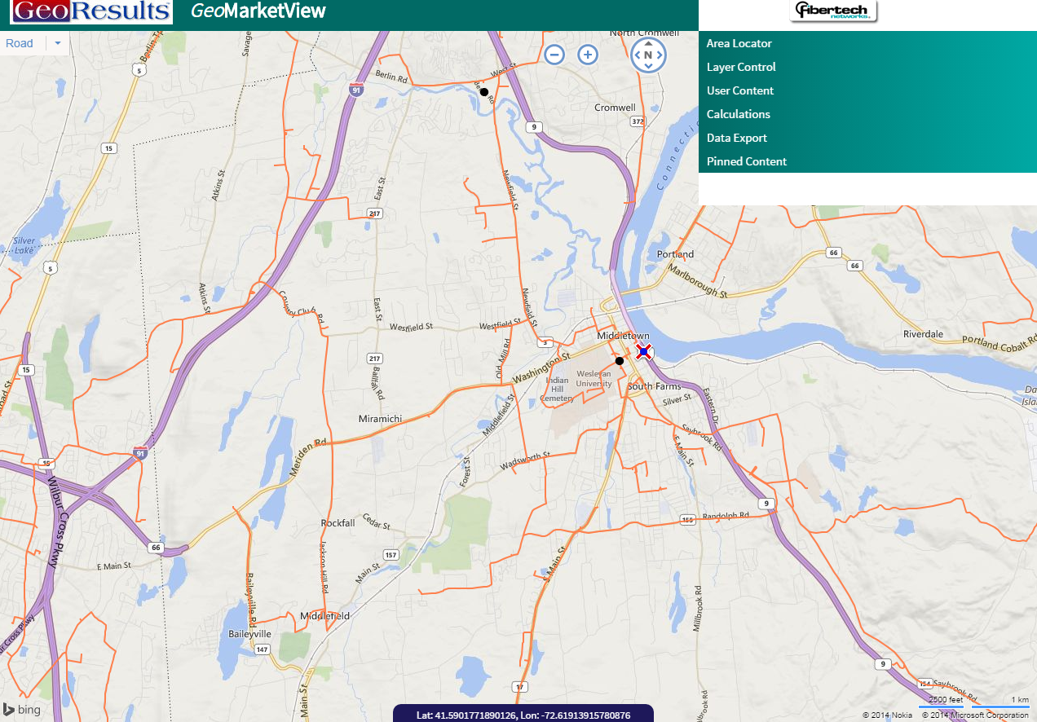

Current Internet Service Providers in Middletown, CT
The Key Areas referenced include industrial, educational, commercial and medical.
Company | Advertised Speed Range | Service to Key Areas
COMCAST Infinity | 6Mbps – 150Mbps | Yes
Mega Path
Ethernet | 1.1Mbps – 1.5Mbps | Yes
T1 | 768Kbps – 6.1Mbps | Yes
ADSL | 1.5Mx128k-6.0Mx768k | Not All
SDSL | 192Kbps – 1.5Mbps | Not All
AT&T
Business | 768Kbps – 45Mbps | Not All
Internet Direct | 768Kbps – 6.0Mbps | Not All

Current Wireless Internet Service Providers in Middletown, CT
Company | Advertised Speed Range | Percent Coverage
Verizon 4G LTE | 2Mbps – 12Mbps | 99.3%
AT&T 4G LTE | 1.5Mbps – 7.oMbps | 98.4%
Sprint | 1.7Mbps – 5.0Mbps | 91.5%

Other potential users of high speed internet services include:

High Schools:
Middletown, Xavier, Mercy and Vinal Technical
Connecticut Valley Hospital
Engineering and architecture firms including (about 20):
Tighe & Bond
AI Engineers
Haks Engineers, PC
GHD, Inc.
Consulting Engineering Services
Phasor Engineering

The City of Middletown recognizes the importance of this project. We will work with the provider from the onset to insure the internet infrastructure can be approved and built out as quickly as possible.

