S:\SHAREDAT\Broadband\StateGig Project Key Docs\RFQ Docs 091514\RFQ Addendum instructions for munis 120114.docx

Guidance is provided below as to what information each municipality should consider providing to the potential Respondents to the RFQ.
The due dates for municipalities to file an addendum with the New Haven Purchasing Department is December 12, 2014.
The deadline for responses to be filed by Respondents to the RFQ is January 1, 2015.
For municipalities to merely view the materials gathered on the New Haven Purchasing Department, simply go to:
http://cityofnewhaven.com/PurchasingBureauOnline/PreYourAccount.asp
and enter your office telephone number. Enter contact information on the next page and you will have access to the procurement website.
Contacts :  Bill Vallee  Broadband Policy Coordinator  william.vallee@ct.gov  www.ct.gov/OCC  www.ct.gov/broadband  860-827-2905 | Shawn J. Garris  Procurement Specialist  Bureau of Purchases  City of New Haven  New Haven, CT 06510  (P)203-946-8202 (F)203-946-8206  www.cityofnewhaven.com/purchasingbureau

Connecticut Municipalities Broadband Infrastructure Upgrade and Expansion Project
On September 15, 2014, a generic REQUEST FOR QUALIFICATIONS (RFQ) was jointly issued by the various Connecticut Municipalities, listed and detailed in addenda to the RFQ (collectively, the “Requesting Entities” or “RE”).
The RE municipalities are required to file an addendum with the New Haven Purchasing Department in order to register their interest in potentially joining the project and to provide information to potential Respondents to the RFQ that might be useful to potential Internet service providers considering building fiber network infrastructure in Connecticut. Inclusiveness being the theme of this Project, other municipalities may choose to join this RFQ during its pendency or thereafter, as practicable.

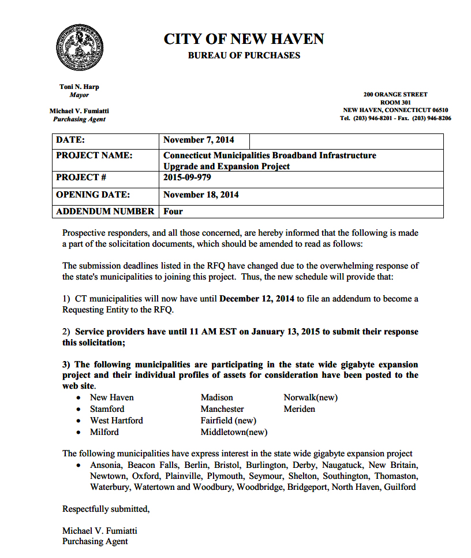
Addendum instructions:
The immediate goal of the RFQ and the municipalities choosing to join the group of requesting municipalities is to entice the right audience: the potential Respondents to the RFQ, Internet service providers (ISPs). These will be fiber network finance and construction companies, providers of retail services to residences, businesses, and community anchor institutions (government, hospitals, libraries, schools), as well as various consulting groups that support municipal fiber networks.
The ISPs need to quickly and easily determine if there is sufficient value to be received by building and operating a profitable network in a particular municipality. Thus the focus of the addendum must be on briefly deliver the type of information that the ISPs can use to develop a business plan for each municipality seeking to have a fiber network.
A common mistake by municipalities filing addendums to the RFQ is to focus on this project as an “economic development” exercise in which social assets of the town are the key factor. It is not enough to file an economic development pitch that might be effective in getting a company to move from somewhere else. Economic development is certainly a major reason for constructing a fiber network, but it is only one result of this project.
In terms of economic development or other social profiles, supplying the CERC Profile is sufficient for the Addendum:
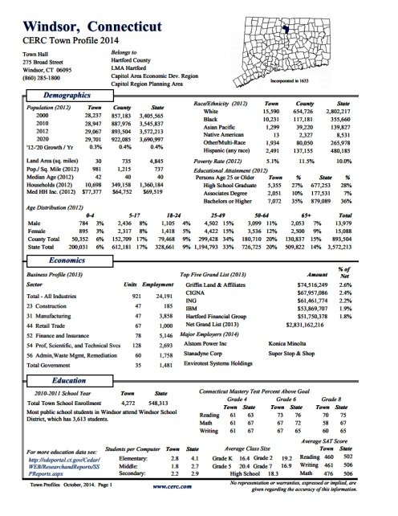 | http://www.cerc.com/TownProfiles/

Topics to Address
Respondents need revenue certainty.
- ISPs will not merely “build a network and hope that customers will come.”
- ISPs will only build to demand and where a return is guaranteed.
- Municipal commitments must be expressly stated.
Thus, “addendums” must be directed to the target audience: Only useful facts will drive ISPs to risk massive capital on a fiber network construction project. Each municipality must convince the ISPs rs of the project’s viability.
Some useful facts to present:
- Calculate costs the ISPs can avoid through muni help. Calculate the value of fiber use of Internet services that the muni and related organizations can transfer to the ISPs.
- Fiber owned by the muni is a key selling asset.
- ISPs expect construction and logistical help from the towns. Provide details.
Public Rights Of Way (PROW) access is critical to mitigate ISP building costs.
The ISPs need to know they can build out in the PROW without regulatory delays & at reasonable prices. A quick glance at the Google Fiber City Checklist, linked below, reveals that access to the PROW is the single most important asset a fiber network provider will consider when examining the profit potential of a municipality. Whether the municipality has an information officer or an established IT department will be important.
All details about the existence, condition, and rights to use a municipal fiber network asset that will be offered by the municipality must be front and center in the Addendum. All addendums should also note whether the municipality has a fiber network, whether it is attached to the statutory municipal gain, and thus that it enjoys rent-free pole and conduit access. Equally essential are creative approaches to providing Respondents with irresistible reasons for choosing the particular municipality for building a fiber network, as further detailed below.
- Note that Connecticut municipalities have very few regulatory powers over the PROW since PURA is the statewide regulator, a legal factor considered to be a major asset by potential fiber network and Internet service providers.
- Connecticut enjoys state-level regulatory authority over all utility operations in the public rights of way, including rapid make-ready procedures and schedules, and uniform interconnection agreements and pricing.
The state has taken great steps to ease access to the poles and conduit for attachers considering municipal buildouts of fiber networks:
The Addendum must detail the muni’s use of assets such as these:
- Streamlined permitting (by municipality);
- Make Ready processes and charges (existing state rules);
- Single Pole Administrator (existing state rules);
- Municipal Gain (existing state rules).
- Connecticut has the unique asset of a statutory “municipal gain” which is possessed by all 169 municipalities and could be an invaluable asset to each town.
… a section of utility poles on all the state’s
utility poles and in conduit reserved for use by the state’s 169 municipalities to attach telecommunications equipment
“for any purpose.”
[C.G.S. § 16-233]
- Note also that on October 8, 2014, Connecticut’s statewide regulatory, PURA, instituted a “Single Pole Administrator” process with a central database, transparent to all attachers, which further streamlines the attachment process, with rates subject to rate-of-return regulatory examinations by the state regulatory agency. PURA stated the following in its Single Pole Administrator Order:
  - “The Authority reiterates its position that one of the avenues of effective competition is an equitable access to the PROW.”
  - “In this case, it is the utility pole structure and pole attachment processes and coordination of pole work that can enhance competition among the carriers.”
  - “The Authority expects the SPA, as point of contact, to provide efficient communication, work coordination and cooperation among the attachers to effectively manage pole attachments.”
- Make-ready procedures and charges (charges incurred by municipalities and other “attachers” when there is insufficient room on a pole or if the pole must be replaced) are highly regulated as to response time for refitting poles and conduit by PURA. Make ready processes have long been subject to abuse by pole owners so PURA’s orders have streamlined and made less expensive this central activity in the PROW.
  - While municipalities must pay make ready charges incurred involving their use of the Municipal Gain, their the unfettered access to the poles and conduit, rent-free, is a very valuable asset to fiber network providers who can “lease” that space on the poles from the municipality, hopefully at no charge as an in-kind asset.

Going Forward Toward Developing a Fiber Network
The municipalities should recognize, and discuss in their addendums, the need to form a working group of municipal representatives from the Requesting Entities to manage day-to-day decisions and information flow to the Responding fiber network construction, Internet service providers, and financing groups.

The municipalities should recognize, and discuss in their addendums, the need to jointly develop a business plan and a feasibility study to guide the negotiations leading to a Request for Proposal (RFP) and eventual network build out and implementation plan. Issues of importance include:
- what resources are needed;
- where to find them;
- how to best to manage the right ones for the project;
- narrowing the scope of issues; and
- designing discrete milestones with staged processes.
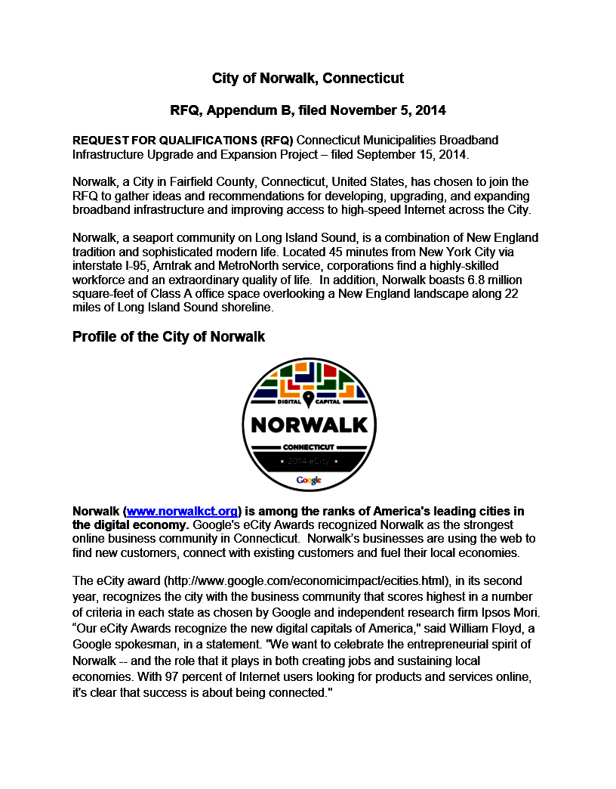
Additional Resources:
- See, reprinted below : the RFQ, at APPENDIX B – Profile of RE Municipality, for detailed suggestions.
- The Google Fiber City Checklist is a collection of best practices for municipalities based on guidelines from Gig.U, Fiber to the Home Council, and the U.S. Conference of Mayors. The document can be downloaded from this website:
https://fiber.storage.googleapis.com/legal/googlefibercitychecklist2-24-14.pdf
@@
Manchester Chief Information Officer and president of the municipal CIO Association (GMIS) Jack McCoy has suggested questions that each municipality filing and addendum should answer:
1. Identify Customers for Gig Internet/Ethernet use.
2. Locate potential business or community anchor customers that would help offset construction and implementation costs for a Respondent building a fiber network across your town.
3. Detail how your municipality can minimize the construction costs and schedule or otherwise expediting the fiber build application process.
4. Identify Municipality / Respondents partnerships that could reduce Capital Expenditures (CapEx) for a Respondents to the RFQ.
5. Identify provider revenue that the municipality’s own business and that of its community anchor institution partners would be able to channel toward a Respondent after a fiber network is installed in the town.
@@
Questions were filed by two potential Respondents; those questions and responses are available on the New Haven site:
o Do the REs intend to aggregate their current spend to increase purchasing power?
o Please provide details on the existing RE programs facilitating broadband access for low income users?
@@
The following is a reprint of the Appendix B of the RFQ which suggested issues to be addressed by municipalities wishing to join the project:

X. APPENDIX B – Profile of RE Municipality

- Demographics, Marketing and High Tech Profile of the Municipality

  - Demographics
  - The area still to be built includes XX,xxx population, X,XXX households (XX % of which are in MDUs), X,XXX businesses, and XXX community anchor institutions.
  - Municipal buildings and services, such as building inspection, meter reading, and new generation e-government services such as streaming public meetings, improving PEG TV services.
  - Schools?
    - Higher education campuses: campus network description computer science, electrical, and computer engineering departments?
  - Libraries?
  - Healthcare facilities?
  - Public safety agencies (police, fire and emergency services).
  - Other community anchor institutions?
  - Home to local high-technology businesses? Such as?
  - Start-up innovation and commercialization facilities?
  - Incubator programs active in the municipality?
  - Describe any local angel investing and venture capital organizations?

- What high technology assets does your municipality possess?
  - What word would be best be used about your municipality to complete this phrase:
    - [Municipality] is the “Silicon ______.” (valley, corridor, prairie, alley, island)
  - What Big Data does your municipality possess; how is access to that data being developed?
  - What Big Computing exists in your municipality?
  - How could your selected private partner add Big Bandwidth to the local equation and enable unmatched connectivity to a major supercomputer from any home or business in the community?
  - What communications infrastructure steps has the municipality taken to make companies want to relocate to this area over others in this state?

- Specify how the community has enlisted the support for this RFQ
  - Resolutions of the City Councils in support for an RFI/FRP process
  - Adoption of a list of community values, such as open access, to facilitate the formation of any future partnership.
  - List community anchor institutions that are committed to this effort.
  - What links to state government assets does your municipality have or believe could be helpful to making this Project successful?

- Staff and municipal organizations available to work on Project
  - Chief Information Officer?
  - Public rights of way: how are attachments and other work managed?
  - How is broadband managed organizationally by the municipality?
  - To what use can the chosen provider use municipal employees to install or maintain equipment?

- Has a pre-commitment plan for residents and businesses been created, along the lines of the Google Fiber “fiberhood” model?
  - What number of commitments have been achieved which these residents and businesses have contributed funds toward any potential future buildout in return for service discounts over time
  - Will these funds will be refunded if no private partner is identified.

- What help will the municipality provide the chosen partner to maintain a local customer service presence?

- What help will the municipality provide the chosen partner regarding local job creation and supporting local contractors?

- Can the selected private partner can start generating service revenue immediately?
  - What is the number of existing customers that a new partner can start delivering services to as soon as an agreement is completed?
  - What is the number and revenues related to municipal government customers that could be immediately transferred to the ISP’s services?
    - What use of municipal buildings will be available for this Project?

- Technical Description of the Existing Fiber Network Infrastructure
  - Who owns the fiber?
  - Data center facility available?
    - What arrangements will the municipality make available to the chosen partner via rental agreements for appropriate rack space and access to the telecommunications nodes that house existing core electronics?
  - What percentage of the municipality’s population currently has DSL and T-l line service, or cable broadband service?
  - Unserved areas: XXX fiber service areas of roughly XXX homes each.
    - Maps of existing service areas, also showing unserved areas
    - maps of the proposed service areas.
    - Define these by man-made and natural boundaries and by homeowners’ association and condominium association
    - In new construction
  - What backbone fiber is built?
    - Are there redundant core nodes built?
    - Do these have access to major carriers in diverse locations?
    - Is there is space in those nodes for additional core equipment?
    - What neighborhood cabinets exist, do they have redundant links to a backbone ring and FTTP fiber infrastructure in the neighborhood.
  - Technical documentation of electronics, fiber, attachments, public works support available.

- Regulatory profile of municipal rules and regulations concerning public rights of way, provision of telecommunication services
- Municipal financial, legal, permitting opportunities available to promote Project?

