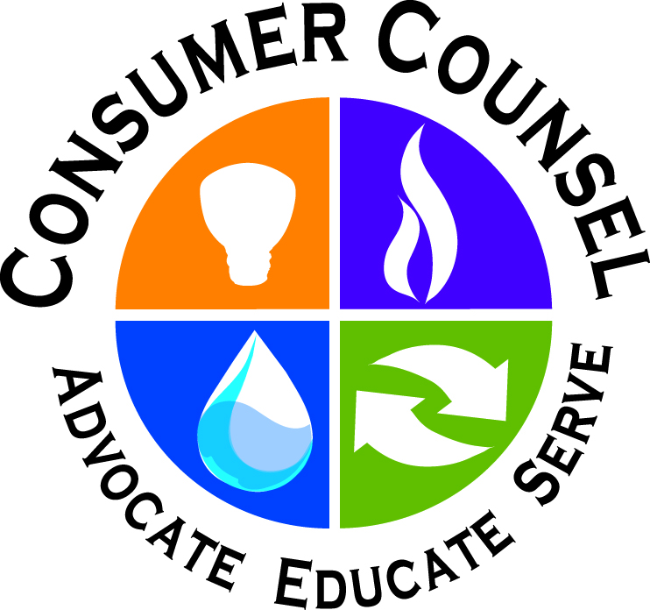

Be prepared: A Good Motto for all of us

Most of us may not be prepared for an emergency….. if the power goes out, there’s no running water, or the grocery store is closed for a few days. Some of the reasons may be the lack of time, the belief that it won’t happen to us, that it’s too expensive, or that first responders can handle all the problems. About two-thirds of U.S. residents live in areas where the natural disaster risk level is rated moderate to very high. We often hear about weather related events on the news, and in May 2019 there was an unprecedented 13 straight days of tornadoes, shattering a prior U.S. record. Many in the path of destruction were left without basic services. There’s been injuries to people, power outages, and extensive damage to homes and businesses. It is a good idea to check your insurance policies to determine coverage for likely events as a separate policy may be needed to cover some types of disasters.
The American Red Cross has suggested recommendations to help us all prepare for emergencies as responding to disasters is a big part of what they do every day. We should all have an understanding of how imminent a threat may be, from less severe to more severe:
- Advisory: While there could be considerable inconvenience, conditions should not be life-threatening;
- Watch: There is a possibility of electrical power loss and danger to life; and,
- Warning: A hazardous event is underway or about to begin. Take cover and stay alert.
By knowing what these different terms means, you will be in a better position to take appropriate action.
We should all educate ourselves on what to do in the event of an emergency and how to care for our basic medical needs. If a disaster occurs in your community, local government and disaster-relief organizations will try to help you, but you need to be ready as well.

Local responders may not be able to reach you immediately, or they may need to focus their efforts elsewhere. You should be ready to be self-sufficient for at least three days. This may mean providing for your own shelter, first aid, food, water, and sanitation. Three minimal essentials needed for a basic home preparedness kit: (1) Water - one gallon per person for approximately three days; (2) Food - that doesn’t require refrigeration or cooking (enough to feed everyone for three days); and, (3) First Aid Kit - and an adequate supply of prescription drugs. Subscribing to emergency broadcast systems will provide news about conditions near you. Some sites to consider are the National Weather Service, FEMA’s Emergency Alert System, weather.gov and ready.gov. In addition, for those traveling or for loved ones living in other states registering on the “Safe and Well” website allows individuals to confirm their situation.
When a disaster strikes, it can often be difficult to communicate with loved ones. Emergencies may cause power outages or overwhelm cellular services which can make normal lines of communication nearly impossible. Remember that landline telephones may still be in service if cellular service is unavailable but you need to check to make sure your phone is one that does not require electricity to operate. By planning ahead, you can ensure you and your family stay informed throughout an emergency. Being prepared can reduce fear, anxiety, and losses that accompany disasters.

Please visit OCC’s website.

https://www.consumer-action.org
https://www.fema.gov/disaster-recovery-centers
https://www.redcross.org

