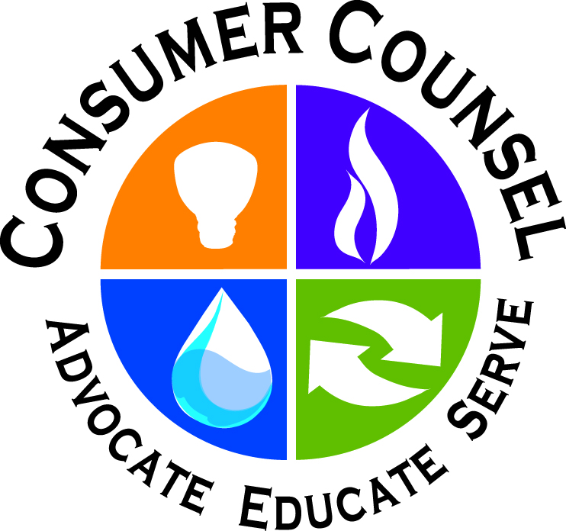
Consumer Counsel Katz to be Judge on “Shark Tank”
Panel Coming to NECPUC

April 29, 2019

The New England Conference of Public Utilities Commissioners (NECPUC) will host its 72nd annual Symposium in Hartford, Connecticut, on June 2-5. A new and fun feature of the Symposium will be the “Shark Tank! Innovation Extravaganza,” showcasing entrepreneurs and innovators presenting the latest and greatest in technological and programmatic advancements. The presenters will then hear real-time feedback from a panel of “sharks” with exceptional regulatory expertise, including Connecticut Consumer Counsel Elin Swanson Katz as one of the sharks. At the end of the session, the audience will have the opportunity to vote on its favorite presentations.

“We hear about lots of new and innovative ideas in our industry,” Consumer Counsel Katz said, “but we don’t often get the chance to engage in a good-natured give-and-take with the innovators on the benefits versus the costs and unintended consequences of a particular new technology or program. I expect a spirited debate.”

Registration information and full agenda for the NECPUC Symposium can be found here.

Please visit 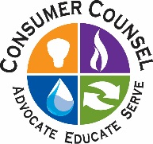OCC’s website.

