Updated on
March 2, 2016

OCC FACT SHEET: ELECTRIC SUPPLIER MARKET, JANUARY THROUGH DECEMBER, 2015

The following is an update to the Office of Consumer Counsel’s (OCC’s) Electric Supplier Market Fact Sheet, originally created in 2014. The numbers provided herein are based on data submitted as compliance filings in the Public Utilities Regulatory Authority’s Docket Number 06-10-22.

- Retail suppliers serve 31% of Eversource Energy (Eversource) residential customers and 36.1% of United Illuminating (UI) residential customers, as of November 2015.

- In the month of December 2015, over eight out of ten residential supplier customers paid more than the Standard Offer in Eversource territory, and over seven out of ten residential supplier customers paid more than the Standard Offer in UI territory.

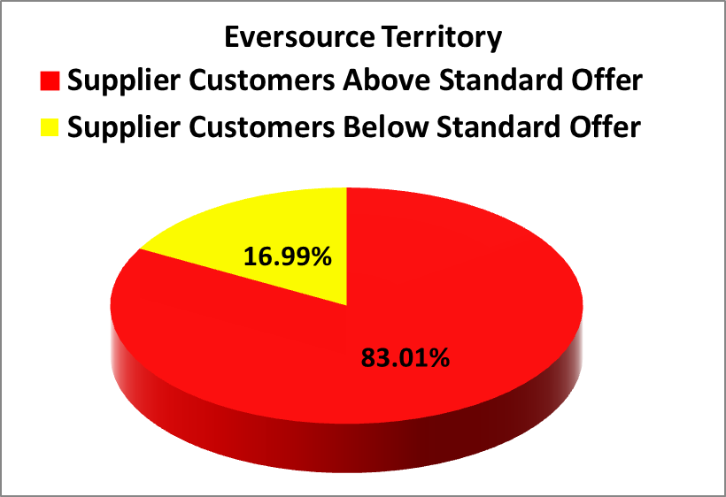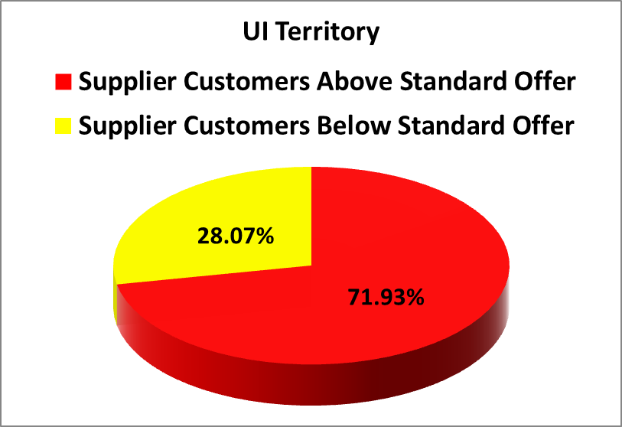
- In the month December 2015, residential Eversource customers who chose suppliers paid in aggregate $6,520,931.14 more than the Standard Offer for their electric generation, and residential UI customers who chose suppliers paid in aggregate $1,627,913.79 more than the Standard Offer.
- For the time period of January 2015 through December 2015, which includes a six month period during which the Eversource and UI Standard Offer prices were unusually high, residential consumers who chose a retail supplier paid, in aggregate, $57,990,296.22 more than the Standard Offer.
- Standard service for Eversource customers was 12.6 cents/kWh from January 1, 2015 through June 30, 2015 and 8.2 cents/kWh from July 1, 2015 through December 31, 2015.
- Standard service for UI customers was 13.35 cents/kWh from January 1, 2015 through June 30, 2015 and 9.12 cents/kWh from July 1, 2015 through December 31, 2015.
- The following table lists all electric suppliers who charged at least 20% of their residential customers 13.9 cents/kWh (50% higher than Eversource standard service) or more in the month of December. The phone numbers for each supplier are taken from those listed at energizect.com or the website for that supplier.

Suppliers Charging at Least 20% of their Customers 13.9¢/kWh or more in October
Electric Suppliers | % of Eversource Customers paying over 13.9 cents | % of UI Customers paying over 13.9 cents | Supplier Phone Number
Choice Energy | 47.41% | 56.29% | (888) 565-4490
Clearview Electric | 35.41% | 31.04% | (888) 257-8439
Direct Energy Services, LLC | 32.40% | 32.65% | (888) 998-6415
Energy Plus Holdings, LLC | 70.77% | 64.76% | (888) 766-3509
NRG Retail Solutions | 81.84% | N/A | (855) 500-8703
North American Power & Gas LLC | N/A | 38.86% | (888) 313-9086
Palmco Power CT, LLC | 94.38% | 95.25% | (877) 726-5862
Public Power, LLC | N/A | 29.30% | (844) 585-8900
Spark Energy LP | 44.90% | 44.10% | (877) 374-8013
Starion Energy, Inc. | 32.86% | 28.21% | (800) 600-3040
Verde Energy USA, Inc | 28.35% | 26.64% | (800) 388-3862
Reliant Energy | N/A | 87.91% | (713) 497-3000

Please feel free to contact the Office of Consumer Counsel at 860-827-2900 or occ.info@ct.gov if you have any questions about this information.

These calculations are based on an assumption of 750/month kWh usage, and likely underestimate the consumer harm, because they assume all non-electric heat customers. Were the additional usage by heating customers factored into this calculation, the estimated consumer harm would likely be even greater.
From January 1 through June 30, 2016, standard service for Eversource is 9.55 cents/kWh, and standard service for UI is 10.74 cents/kWh.

