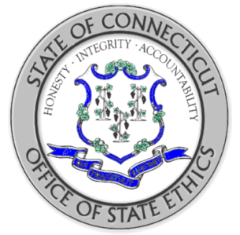
STATE OF CONNECTICUT
OFFICE OF STATE ETHICS

PUBLIC OFFICIAL AND STATE EMPLOYEE TRAINING
CERTIFICATION OF COMPLETION

Employee Name:
Employee Agency:

I hereby certify that I am in compliance with the Code of Ethics and have completed the self-study and viewing of the web-streaming video:
Top Ten Rules for State Employees and Public Officials

Date of Training Completion:
Employee Signature:
Supervisor Signature:

