Buying Food Online with SNAP
FAQs

General

- What is SNAP? How can I apply?
SNAP (formerly called food stamps) provides a monthly benefit to buy healthy
food. Check your eligibility and apply at www.connect.ct.gov.

- What stores are currently participating in the Connecticut’s SNAP Online Purchasing Pilot?
Participating retailers are ALDI & Price Chopper Stores in partnership with Instacart Amazon, including Amazon Pantry and Amazon Fresh; Walmart stores (please click here for list); and Wakefern Food Corp., which has 22 participating ShopRite stores in state (please click here for list).

- What can I buy online at Instacart, Amazon, ShopRite, and Walmart?
You can buy SNAP-eligible foods including fresh produce, frozen foods, dairy and eggs.

- Can I use my SNAP benefits to pay for the delivery or service fee?
No. You can only use your SNAP benefits to buy SNAP eligible food items. You
must pay for fees with another form of payment, like a credit card or gift card.

- I receive TANF, State Supplement Cash or SAGA Cash benefits. Can I use my cash benefits to buy items online?
No. You currently cannot use your cash benefits on your EBT card to buy food and
non-food items online. To learn about and apply for TANF, State Supplement Cash or SAGA Cash economic assistance (cash benefit) programs, click here.

- Who do I contact for customer support?
For customer support, please contact Instacart, Amazon, ShopRite or Walmart.

- I am a retailer and I want to join Connecticut’s SNAP Online Purchasing
Program. What do I need to do?
The United States Department of Agriculture (USDA) approves retailers for the
online purchasing program. To learn more, click here.
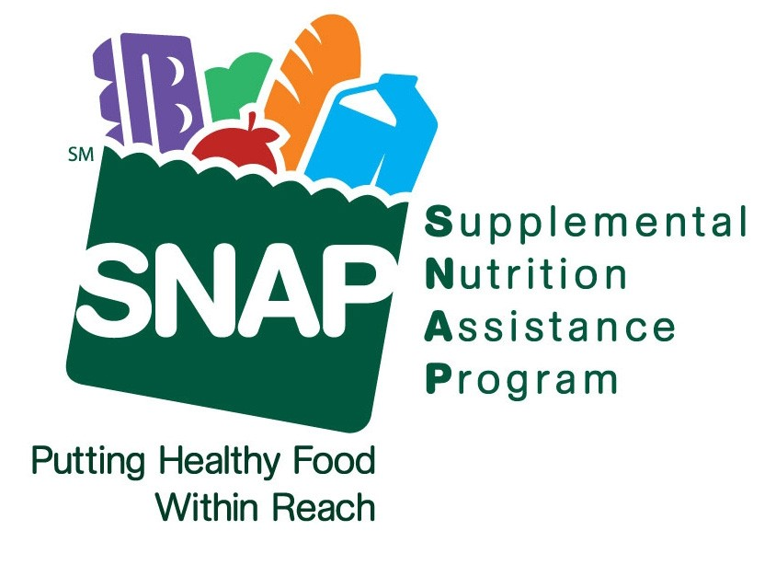

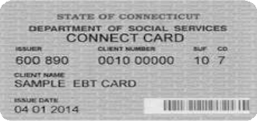
Learn more or apply for SNAP
online at:

www.ct.gov/snap
This is an Equal Opportunity Institution

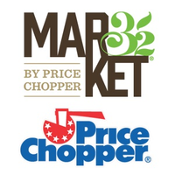
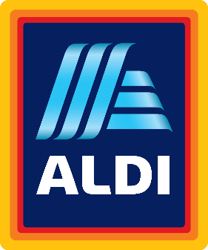

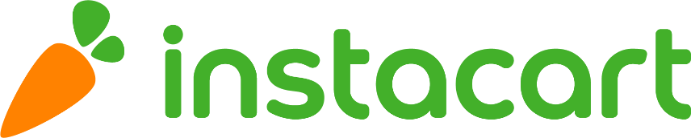

- How will I know which items are eligible to buy with SNAP?
There are a few ways for you to see which items are SNAP-eligible.

- You can allow SNAP-eligible items to display when you shop. To enable this setting:
- Click or tap Account
- Select Your account settings
- Select SNAP EBT info
- Tap the slider to turn on Show EBT eligibility by item

- When searching for items you can add a filter by tapping Explore > EBT Eligibility and selecting Only EBT-eligible items

- If you are browsing items from the Store Homepage, tap or click on a specific item to see if it is EBT SNAP eligible. If it is eligible, it will say EBT above the price of the item.

- You can confirm which items are EBT SNAP-eligible in your cart before checking out. It will say EBT under the name of each item that qualifies.

- How do I add my EBT card to my account?
To add an EBT card to your account on Instacart.com or on the app:
- Click or tap Account
- Select Your account settings
- Select Payment Methods
- Choose Add EBT Card
- Enter the first name, last name, and card number on the EBT card.
- Click or tap Save

*NOTE* To successfully use your EBT card, a credit or debit card must also be linked to your Instacart account to cover fees, bottle deposits in some states, taxes, delivery tips, and any other non-EBT SNAP-eligible items you may want to purchase.

- How do I check out with my EBT card?
To checkout, visit your cart and tap or click the green Checkout button. You’ll be asked to add a delivery address and your payment information

- Enter your credit or debit card information and address
- Add your EBT card information
- Click or tap Edit to change the amount that will apply to your EBT card
- Click or tap Confirm payment method
- On the Place Order page, confirm all information is correct
- Click or tap Place Order
- After placing your order, you will be prompted to enter your EBT card pin to verify your purchase

*NOTE* You’ll notice there is a payment breakdown on the Place Order page. You’ll see what will be charged to your EBT card and what will be charged to your credit or debit card.

All delivery and service fees, bottle deposit fees in some states, taxes, tips, and any items that are not EBT SNAP-eligible will be charged to your credit or debit card.

- Is there a delivery fee?
Through June 16, 2021, Instacart will waive delivery fees on the first three EBT SNAP orders for each customer.

Instacart delivery starts at $3.99 for same-day orders over $35. Fees vary for one-hour deliveries, club store deliveries, and deliveries under $35.

ALDI pickup via Instacart costs $1.99 for orders over $35.

- Where can I learn more?
Visit https://www.instacart.com/help/ or https://www.pricechopper.com/snap-ebt/

- How do I sign up to use my SNAP EBT benefits on Amazon?
To use your SNAP EBT card, visit www.amazon.com/snap and follow the instructions on the screen.

If you are not already an Amazon customer, you will need to create an account. There are also opportunities to add an EBT card during checkout or in your wallet.

- How will I know which items are eligible to buy with SNAP?
Look for the ‘SNAP EBT Eligible’ label by the product’s name.

- Is there a delivery fee?
When you spend $35 or more, delivery is free.

- Where can I learn more?
Visit amazon.com/snap.
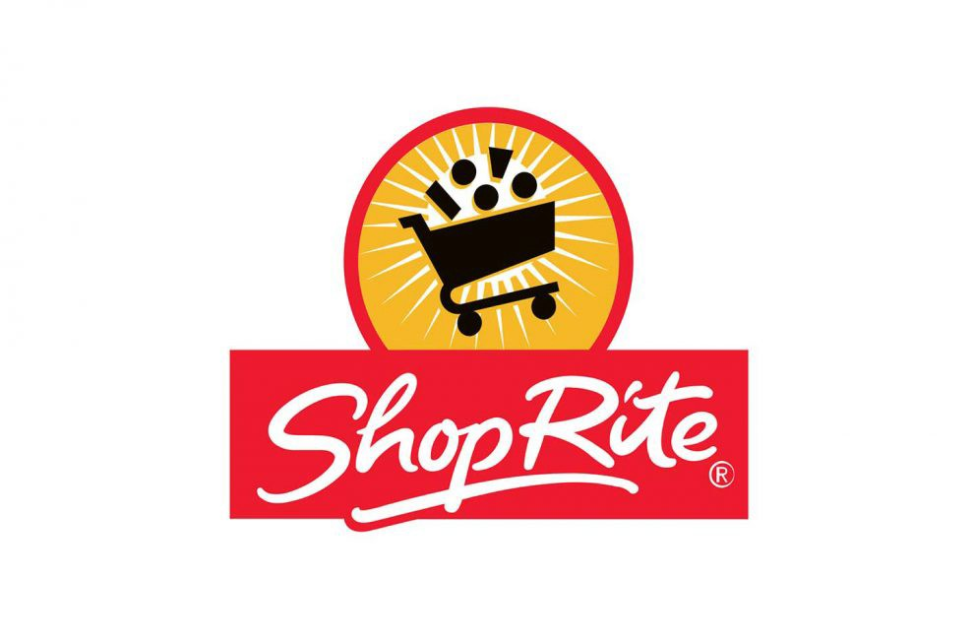

- How will I know which items are eligible to buy with SNAP?
When you go to checkout, the payment screen will show what items are SNAP
eligible and how much money is left to pay with other forms of payment.

- Is there a delivery fee?
Delivery fees vary by area, but in some cases, delivery incurs no additional charges
on top of the standard $10 service fee

- Where can I learn more?
Visit https://shop.shoprite.com/contact-us

- How will I know which items are eligible to buy with SNAP?
When you go to checkout, the payment screen will show what items are SNAP eligible and how much money is left to pay with other forms of payment.

- Is there a delivery fee?
Yes, fees vary $7.95 - $9.95. You also have the option to pay a flat fee of $98 per year for no delivery fees.

- Can the groceries be delivered?
Delivery options vary by location. Go to Walmart.com/groceries and type in your zip code to see what options are near you.

- Where can I learn more?
Visit Walmart’s FAQ by clicking here.

