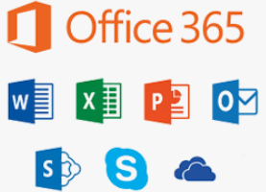
Welcome to Office 365 at the State of Connecticut
End User Overview
DSS Revised: Mkryzanski 03/20/2023
Congratulations! You have been assigned a license in the new Microsoft Office 365 State of Connecticut IT System. For enhanced security, the system has been setup to use something called Multi-Factor Authentication (MFA) which means that two means of authentication will be required when you try to login to the system from outside of the state of CT network. This means that for logging into Office 365 remotely (when not connected to the state of CT network directly or by VPN) to use Microsoft Office (Word, Outlook, Excel, etc) you will need to use not only your normal network password but also a second authentication method as well. There are several options you can pick from to select the second form of authentication you will use like having a text message with a code sent to your cell phone or using an app you would download to your cell phone to get a code. Please note that you will need to configure MFA even if you never plan to connect to Office 365 outside of the State of CT Network. If you do not configure MFA, you will never be able to login to Office 365 which is the version of Microsoft Office that the whole state of CT is moving to. The instructions below can be performed on any computer (work, personal, etc.) from any location as long as the computer has an internet connection.
IMPORTANT: The website address you will use to access Office 365 is: http://www.office.com
You may want to set this address as a favorite/bookmark in your web browsing program. In the document below you will be accessing a different website address only for the purpose of setting up MFA.
IMPORTANT: Office 365 is still being developed/configured/planned so currently you may or may not have access in Office 365 to all of the applications that it is capable of providing (Outlook, Word, Excel, Power Point, Teams, One Note, SharePoint, etc). Please be patient as these details are worked out. DO NOT use the OneDrive online cloud storage option in O365 as there are some legal issues being worked out related to the storage of data in the Cloud.

**Please read the document in its entirety before proceeding**.

Multi-Factor Set-up on Your Account:
- Go to any Windows computer that you have access to that has a working internet connection (it can be a work or personal computer and it can be located in your office or anywhere else). Go to website http://aka.ms/mfasetup and click “Sign in”. Enter your state email address | If prompted, select Work or School Account. This is the website you will use to setup Multi-Factor Authentication.
- Password: Enter your usual network password (same one that you use to login to get to the desktop of your computer) and Click Next
- You will now be prompted to set up Multi-Factor Authentication on your O365 account. You will be required now to Set up MFA. In O365, there are three methods/factors that you can choose from to set up authentication: Text Message, Phone Call, and the Microsoft Authenticator App. Click Next.

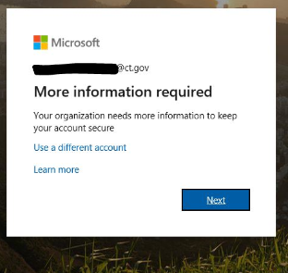
- You will be prompted to set up your factors for MFA on your account. You can choose Authentication Phone (DO NOT SELECT OR PROVIDE YOUR OFFICE DESK PHONE as you are not able to use your office desk phone when you are out of the office)– select either Call Me or Send a Code via Text; Click Next. IMPORTANT NOTE: For users who will be accessing Federal Tax Information (FTI), you should NOT authenticate via a phone call as this is not an approved IRS authentication method. You should use a different method.
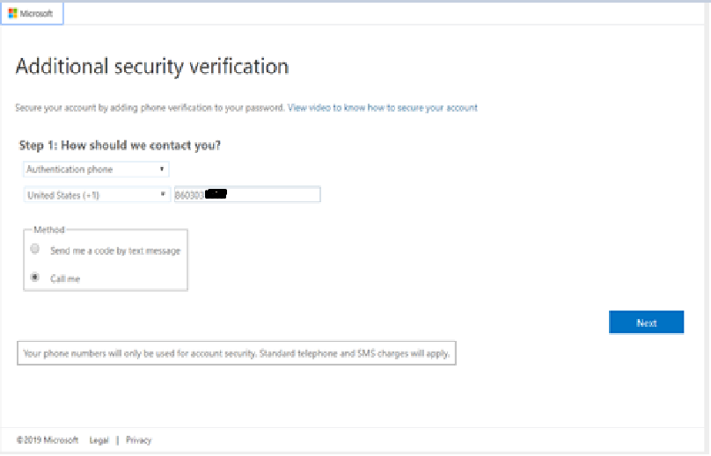
- Depending on the method you chose; You will receive either a phone call that will require you to press pound, or a text message to your mobile device that will require you to enter the code in; Click Verify or Next.
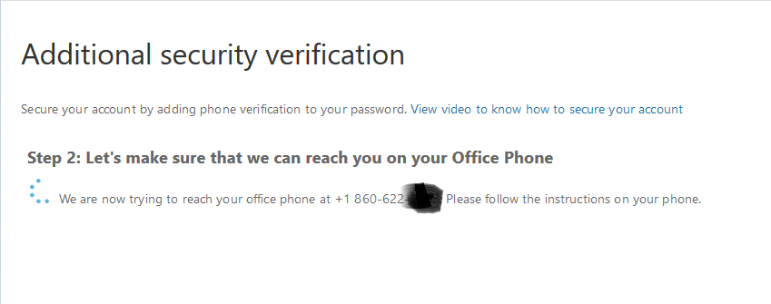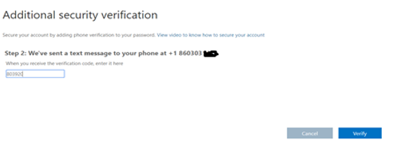
- The last step for MFA, is a default screen for application security; Click Done.
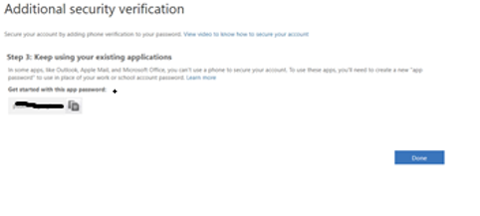
Office Portal:
In the portal, you will now have access to all of the applications provided to the State in the Government Community Cloud.
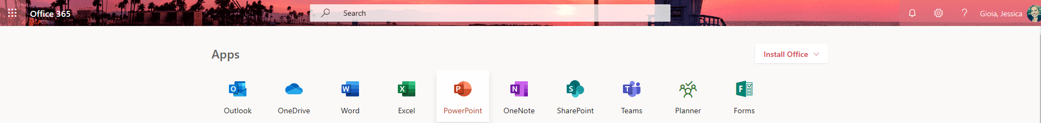
- Please Do Not Click Install Office at this time, in the top right corner. This will potentially cause corruption in your existing Microsoft products. Contact your IT support for further information regarding the process for installing the full O365 Client.

Verifying and Editing Your Multi-Factor Verifications:
Please be sure to go through these steps below even though you have done the initial O365 MFA setup so as to verify the settings and add additional authentication methods if desired.

- In the portal, select your name in the upper right-hand corner of screen as shown highlighted below.

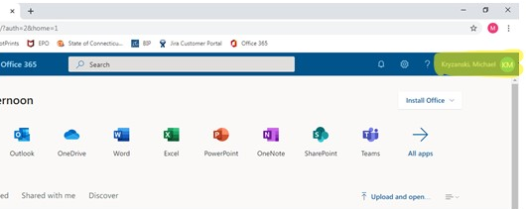

- Click “My account”

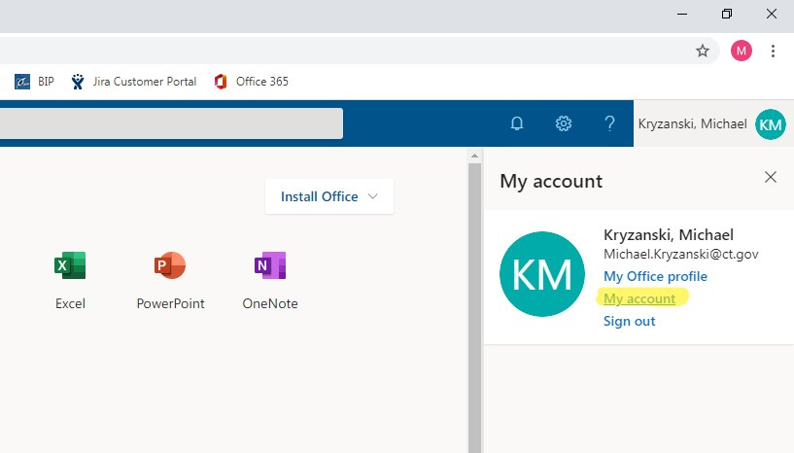

- Click “Manage security & privacy”
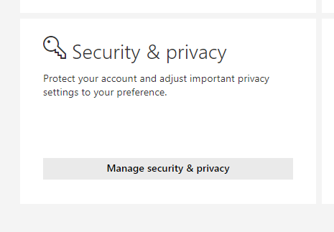
- Click “Additional security verification”
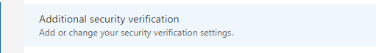

- Click “Update your phone numbers used for account security”. IMPORTANT NOTE: If you do not have the “Additional security verification” option shown below, you will need to go to the following website address: http://aka.ms/mfasetup . You can do that by opening up a new browser window or a new tab in your browser. Then follow the steps below to change your MFA.
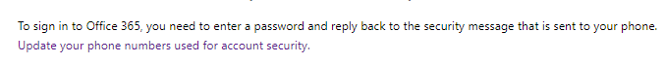

- You now can select the second form of authentication by checking off the check box of the secondary authentication method you want to use and entering in the appropriate information. All methods are described below.
  - Authentication Phone: can be your office phone, cell phone or home phone number
  - Office Phone: DO NOT USE FOR NOW as there is a technical issue being worked on. If you want to use your office phone number, you should enter it in the “Authentication phone” field.
  - Alternate authentication phone: can be a cell phone number, home phone number or other phone number (you will have the option to use this each time you login to O365 if your primary authentication device is not available).
  - Authenticator app or Token: Use the Microsoft Authenticator app on your cell phone to receive a verification code – The App setup instructions are in section below

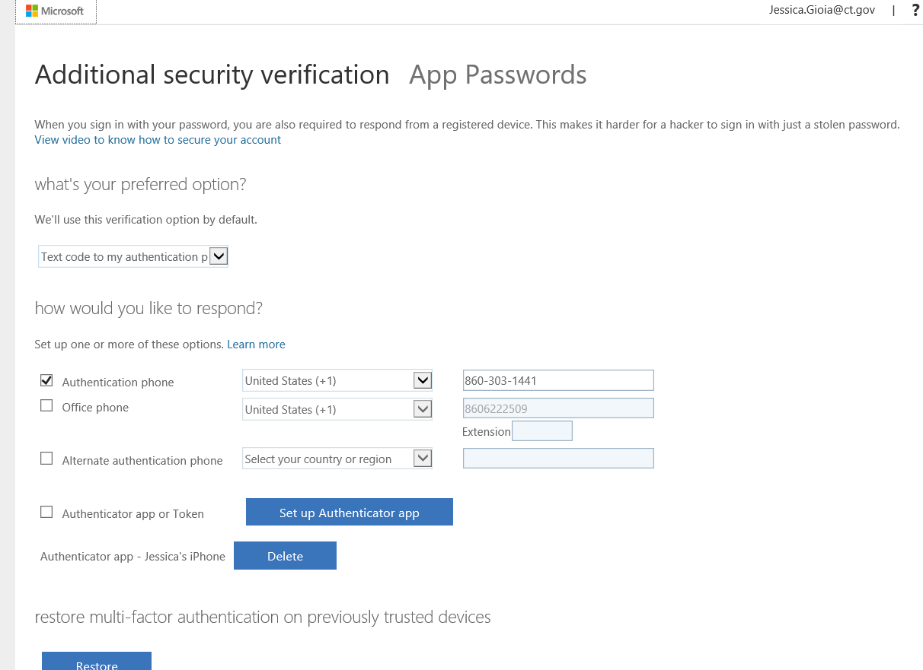

- Now select from the “We’ll use this verification option by default” drop down box which verification method you want to be your default. They are described below:
  - Text code to my authentication phone: This will send a text message with a code to the cell phone that you entered to be your “Authentication Phone”.
  - Call my authentication phone: You will receive a phone call on the phone you specified as your authentication phone. The automated caller will ask you to hit the pound (#) sign on your phone. Once you do that you are authenticated. IMPORTANT NOTE: For users who will be accessing Federal Tax Information (FTI), you should NOT authenticate via a phone call as this is not an approved IRS authentication method. You should user another method.
  - Call my office phone: DO NOT USE FOR NOW as there is a technical issue with this. (You will receive a phone call on your office phone. The automated caller will ask you to hit the pound (#) sign on your phone. Once you do that you are authenticated.)
  - Notify me through app: The Microsoft Authenticator app will display a message on your phone asking you to approve or deny the sign-in. You will need to select “Approve” and you will be logged in. You can disregard the six digit code in the app.
  - Use verification code from app or token: The Microsoft Authentication app will display a six digit authentication code. You will need to type that up in the pop up authentication window on the computer you are using to login to Office 365.
- Hit the “Save” button. From now on when you login to Office 365 with your windows/network password you will be prompted immediately after by the secondary authentication method you selected (ex: text message to your cell phone with a code, a phone call to your phone with a code, a code displayed in the Authenticator app on your cell phone, etc.). Once you have successfully completed both authentication screens you will be logged into O365.

Verification code from Microsoft Authenticator App
- Search for and download the “Microsoft Authenticator App” on your mobile device. You will need to go to the ITunes store (for iPhones) or the Google Play Store (for Android devices) to download and install the app.

- Once you have downloaded and installed the app, find it and tap it on your cell phone screen. You will be asked to add an account on your device, make sure to select Work or School Account.
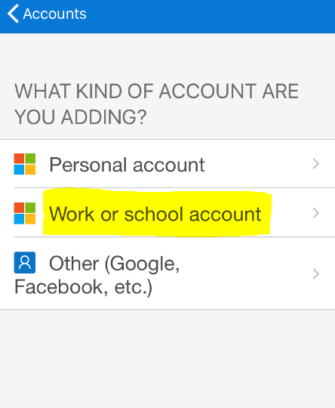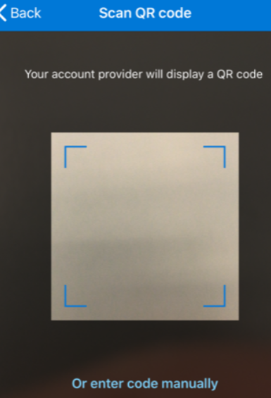
- Move your cell phone screen so that its camera displays the QR code on the computer screen (see QR code image on the computer screen below).
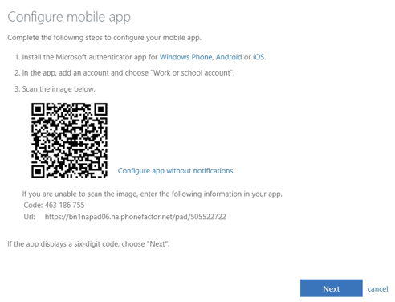

- The cell phone will take a picture of the QR code and begin the configuration of your Microsoft Authenticator app
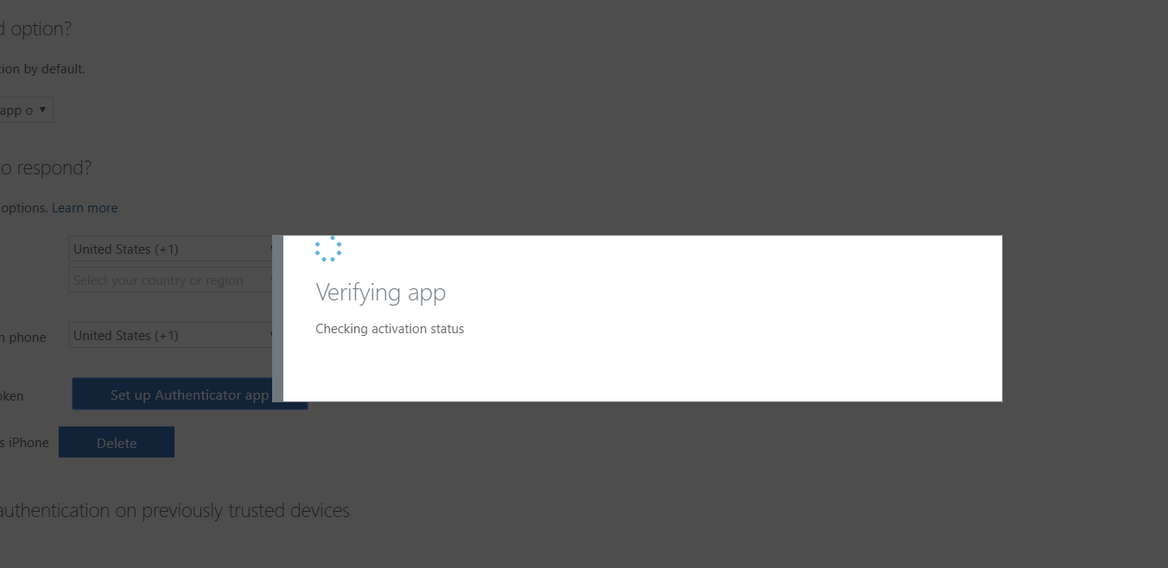
- The cell phone will now prompt to Approve the account on the device and authenticator app. Select “Approve”.

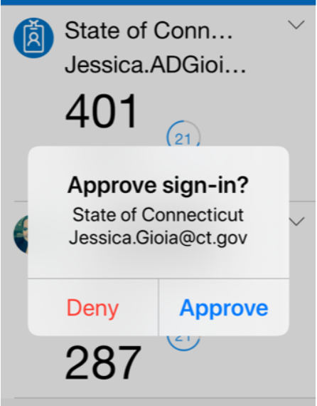
- You will then be successfully authenticated with the app, select “Verify preferred option” and then click “close”. The Microsoft Authenticator app will now be used as your secondary authentication method each time you login to O365..

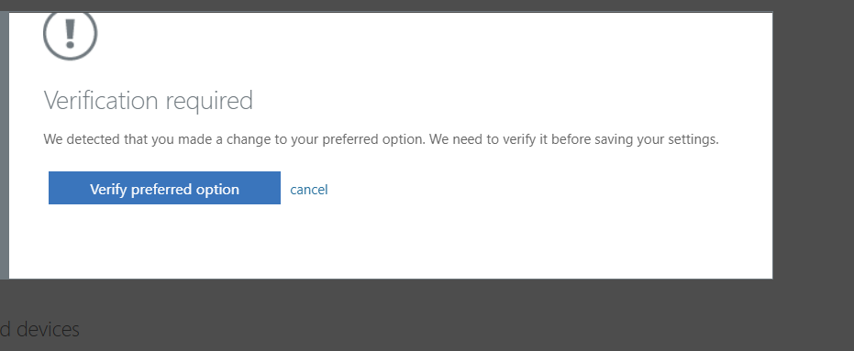
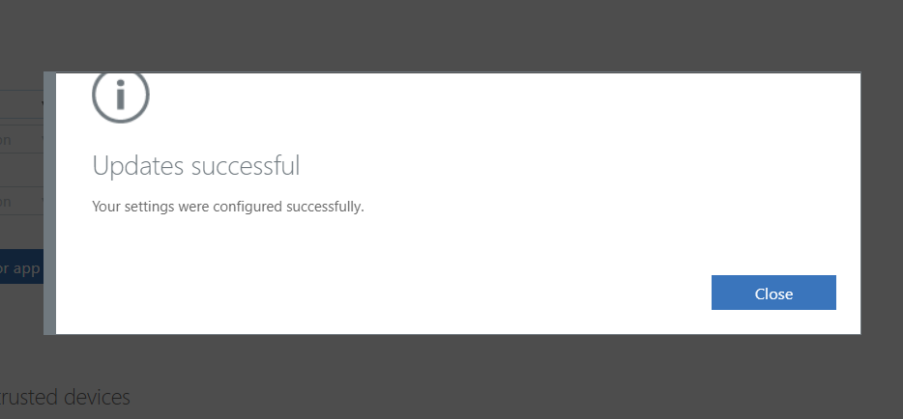

O365 Microsoft Training Portal
We are in the process of creating a more formalized training approach to O365. However, in the meantime, this portal through Microsoft, offers a vast amount of online free training. The main training hub link can be found here:
https://support.office.com/en-us/office-training-center
In particular, we recommend users review TEAMS training, as this is a new feature for the State of Connecticut:
https://support.office.com/en-us/article/microsoft-teams-video-training-4f108e54-240b-4351-8084-b1089f0d21d7?wt.mc_id=otc_home&ui=en-US&rs=en-US&ad=US

