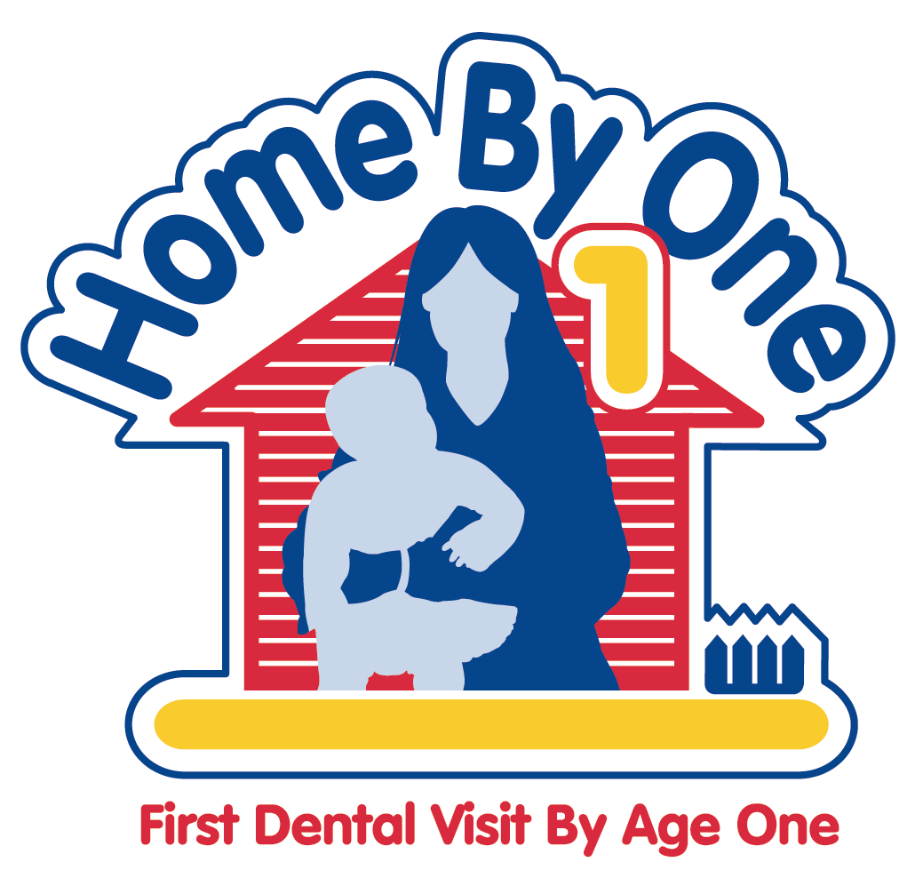
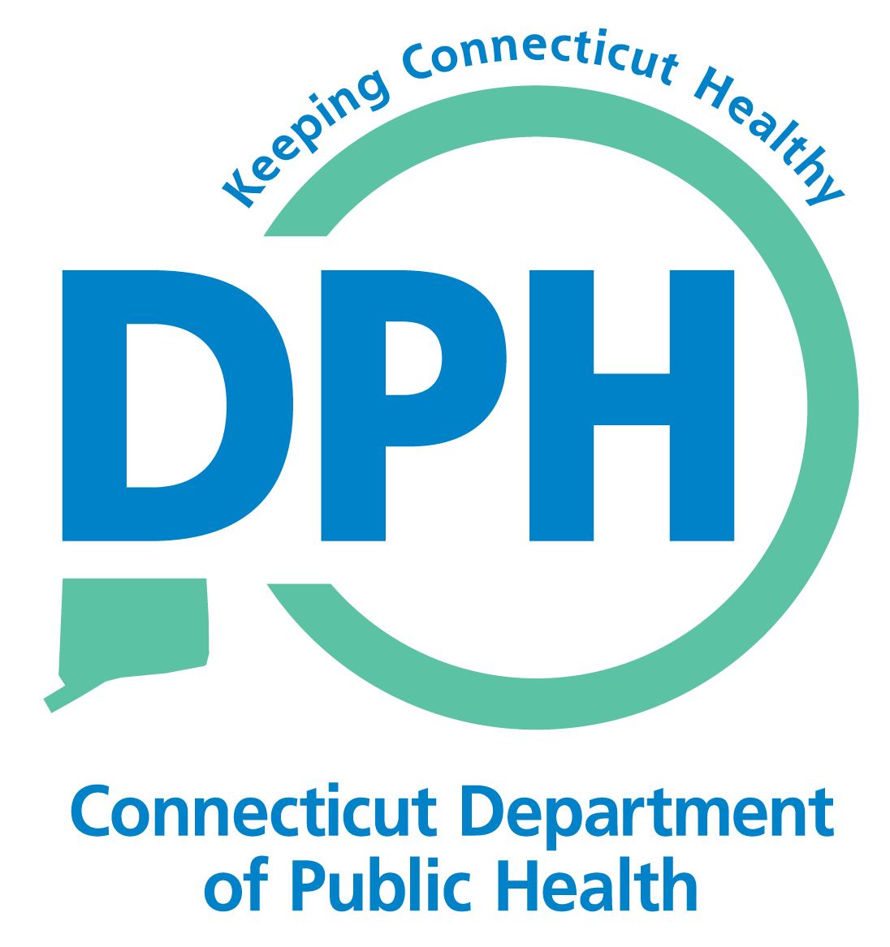
Home by One Program

Home by One

What You Should Know and How You Can Help

What is “Home By One”?
The State Department of Public Health, Office of Oral Health has developed a program, called “Home by One”, to build partnerships with dental and medical practitioners, social service providers, parents and caregivers that focus on oral health as essential to the overall health and well being of the children through the achievement of the following goals:
- Expand the number of dental practices providing dental homes for children beginning at age one.
- Coordinate and exchange oral health information as it relates to overall health among state agencies and community organizations.
- Train parents as advocates for oral health for their children and families.
- Expand the non-dental workforce competent in preventive dental strategies (i.e. oral disease preventive education).

Why “Home by One”?
The American Academy of Pediatric Dentistry, American Academy of Pediatrics, American Dental Association, American Dental Education Association all recommend preventive dental care by age one which includes risk assessment, preventive dental care and the establishment of a dental home.
- Parents and caregivers need the knowledge of preventive dental practices to reduce the risk of dental decay in early childhood.
- Oral disease can begin as soon as teeth erupt
- Oral health is important for overall health
- Oral disease can be PREVENTED.

What is a Dental Home?
A Dental Home is:
- An ongoing relationship between the patient and the dentist
- Providing comprehensive, coordinated, oral health care that is continuously accessible and family-centered.
- An approach to assuring that all children have access to oral health care both preventive and restorative.
- Best established in infancy for continuous dental care through all stages of life.
- Essential to prevent oral disease in early childhood.
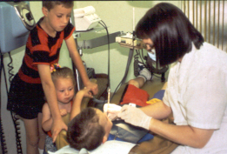

How Will becoming a Dental Home Affect Your Practice?
- Infant dental visits are cost effective for the dental office. (Medicaid/HUSKY fees =Initial exam-$65, cleaning-$46, and fluoride- $29).
- A typical visit will take approximately 20 minutes.
- Up to four visits per year are permitted for at risk infants and children up to 40 months.
- Dental hygienists can perform most of the services for age one dental visits.
- Appointments will be controlled by your office liaison.
How Will the “Home by One” Program Help You Become a Dental Home?
The “Home by One” Program will:
- Provide, at your convenience, an orientation on “Home by One” for you and your staff as well as educational materials.
- Designate a single contact person, the “Home by One” Program Coordinator, to support your dental home and answer your questions.
- Provide support services, in collaboration with the WIC Program, to help ensure parents bring their children to dental appointments.
- Provide your office with patient materials to help parents understand the importance of age one dental visits, keeping appointments and how to prevent oral disease in their children.
- Help you build relationships with pediatric dental specialists and physicians to support your dental home.

Who Will Benefit from the “Home By One” Program?
- Children who are enrolled in the Special Supplemental Nutrition Program for Women, Infants, and Children - better known as the WIC Program
- WIC children ages 0 to 5 that are at nutritional risk.
- WIC parents who will learn the value of regular dental visits and the importance of oral health for themselves and their children

Why is WIC Population the Focus for the “Home by One” Program?

WIC parents and caregivers often lack the basic knowledge of oral disease prevention to keep their children healthy.

WIC children are from low-income families and at higher risk of oral disease.

There is limited access to preventive dental services for low-income WIC children

There is the potential to significantly reduce oral disease experience in WIC children as early as age one and prevent the need for restorative care.

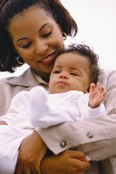

What Can Dentists Do to Help?
- Partner with the CT Department of Public Health’s “Home by One” Program and become a dental home.
- Participate in the “Home by One” dental home orientation
- Accept referrals from the WIC Program for age one dental visits
- Identify a liaison in your office as the contact person for WIC and physician referrals
- Learn more about a dental home from the American Academy of Pediatric Dentistry at: www.aapd.org

How Can I become a Dental Home for WIC?
- Contact Tracey Andrews RDH, BS, the “Home By One” Program Coordinator at the CT. Department of Public Health Office of Oral Health at (860) 509-8146 or at: tracey.andrews@ct.gov with questions concerning “Home By One” or to schedule an orientation for your dental team.
- You also may want to enroll as a provider for the Medicaid/HUSKY Dental Program to receive the new reimbursement rates for WIC children covered by HUSKY insurance. See the Connecticut State Dental Association’s website for more information about how to become a HUSKY provider www.csda.com

“HOME BY ONE” IS SUPPORTED BY A GRANT FROM HRSA #H47MCO8648
www.ct.gov/dph

