SNAP-Ed Nutrition Education Program
The CT Department of Public Health (DPH) collaborates with the University of Saint Joseph (USJ) to provide Supplemental Nutrition Assistance Program Education (SNAP-Ed) services throughout the state of Connecticut. SNAP-Ed is a federally funded grant program that supports evidence-based nutrition education for persons eligible for the Supplemental Nutrition Assistance Program (SNAP). The SNAP-Ed goals are to encourage SNAP recipients to make healthy food choices within a limited budget and to be physically active.

The nutrition education activities listed below are from the Eating Smart • Being Active (ESBA) curriculum. ESBA is developed using the latest research from the current Dietary Guidelines for Americans. Each education topic features hands-on activities to reinforce learning and apply new skills, including food preparation, food tasting, and physical activity. All SNAP-Ed activities are provided by trained nutrition professionals including registered dietitians, nutrition educators, and students at no cost to you.
Due to COVID-19 all services are provided virtually until further notice

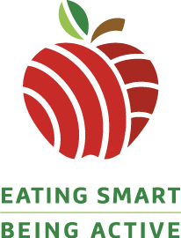
Education Topics:
- Get Moving! (physical activity as part of a healthy lifestyle)
- Plan, Shop, $ave (stretch food dollars and read nutrition fact labels)
- Fruits & Veggies (increase the amount and variety of fruits and vegetables)
- Make Half Your Grains Whole (identify whole grain foods and their benefits)
- Go Lean with Protein (choose lean proteins and keep food safe)
- Build Strong Bones (eat calcium rich foods and choose low-fat dairy)
- Make a Change (choose foods/drinks low in fat, salt, and sugar)
- Celebrate Healthy Meals (how to involve family in good food choices)

Nutrition Education Sessions (Online):
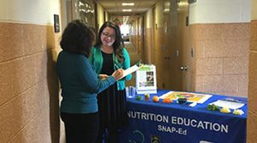
- Engage participants in a brief lesson(s) with a nutrition message to encourage lifestyle behavior changes.
- Includes interactive videos and modules via Microsoft Forms.
- Promoted via social media.
- Lessons also available on individual site flyers under live workshop information.
- Participants enter into raffle to receive an incentive upon completion.

Nutrition Education Workshops (Online):
- Engage participants in a facilitated group discussion using activities and materials related to a nutrition message to encourage lifestyle behavior changes.
- Includes a food demonstration, and physical activity.
- Are in a classroom setting via Zoom that last 45-60 minutes in duration.
- Topics are chosen by the site.
- Participants receive an incentive upon completion.

Telephonic Health Coaching Program:
- Motivates Connecticut residents to develop healthier choices and significant changes to their lifestyles.
- Sessions are directed by participants where they learn effective strategies to achieve their health and wellness goals.
- Participants receive 6 engaging sessions with a qualified health coach.
- Each session occurs on the phone and lasts about 30 minutes at a convenient time for the participant.

Training & Technical Assistance for Child Care Professionals:
The Nutrition & Physical Activity Self-Assessment for Child Care (NAPSACC) is a training and technical assistance program designed to assist child care programs in establishing nutrition and physical activity practices and policies that align with the latest obesity prevention research and guidelines.

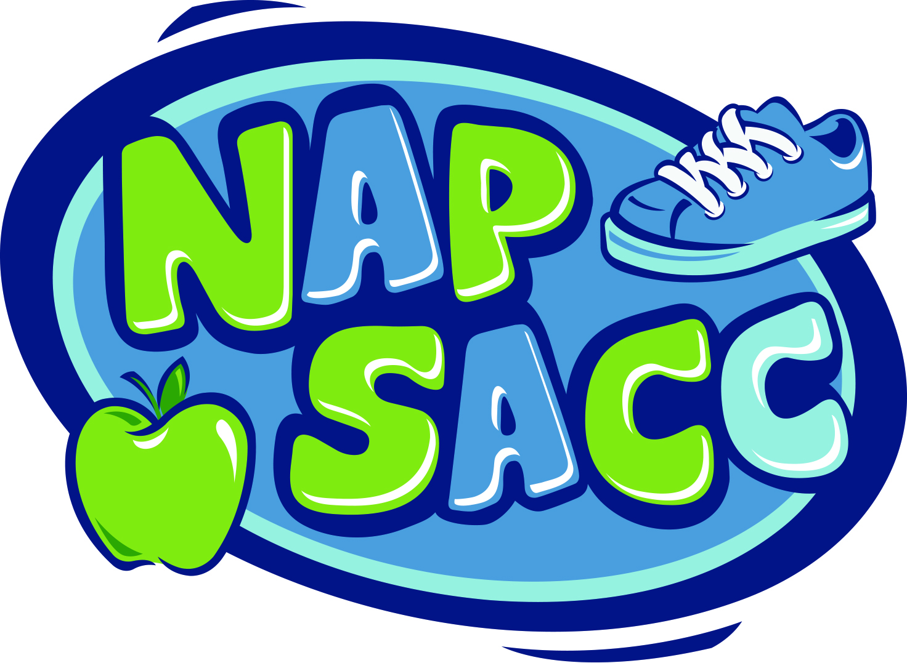
- Programs complete a simple checklist to determine where they meet current best practices.
- A technical assistance provider will support goal setting and implementation, and may provide up to 5 hours of staff training.
- Teachers receive books, CDs, and other materials to assist with incorporating nutrition and physical activity in the classroom.
- Programs receive a gift card for achieving their self-selected goal(s).

The Coordinated Approach to Child Health (CATCH) Early Childhood is designed to nurture a love of physical activity, provide an introduction to classroom-based gardening and nutrition, and encourage healthy eating in children ages 3-5.

Each program that participates in CATCH Early Childhood will receive:

          - Training and tools to implement a fun nutrition and physical activity program.
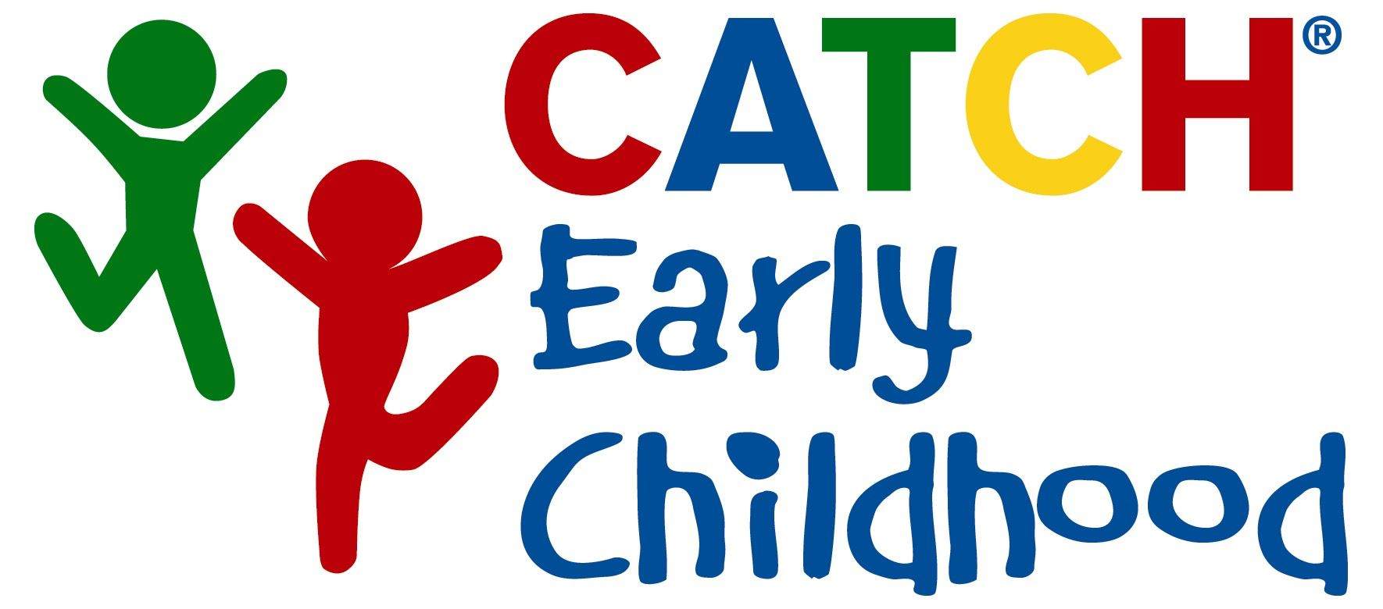
          - Convenient and flexible lesson plans and sample schedule.
          - Over 400 moderate-to-vigorous physical activity cards and relaxation exercises for transitions back to the classroom.
          - A music CD that keeps the class motivated, moving, and having fun.
          - Parent tip sheets to send home and encourage family involvement.
          - A technical assistance provider to help you implement CATCH.

To schedule SNAP-Ed online activities at your organization, please contact:
Mary Gollan, MS, RDN, CD-N, CLC
Program Coordinator
SNAP-Ed Nutrition Education Program
University of Saint Joseph
Phone: 860-231-5623
Email: mgollan@usj.edu

