Vendor Portal New Application User Guide

Welcome to the Connecticut WIC Vendor Portal New Application User Guide, a screen-by-screen review of the online application screens necessary to apply for Connecticut WIC vendor authorization.

This document is a reference guide for the Connecticut WIC Vendor Portal. It focuses on how to apply online for authorization in the WIC Program. It has procedures for registering for a user account and how to create and submit an application. This user guide does not provide information on the WIC Vendor Agreement that determines authorization into the WIC Program. Information regarding authorization can be found on the Department of Public Health WIC Retailers webpage at https://portal.ct.gov/DPH/WIC/Retailers.

PLEASE NOTE: The Connecticut WIC Program requires that all vendors be SNAP authorized and open continuously for one full calendar year prior to application to be eligible for authorization.

If at any time during this process you have questions please call the Connecticut WIC Program at 860.509.8084 and press #2 or send an email to DPH.ptwic@ct.gov and ask for assistance with the online portal application.

This application process will require you to enter demographic information in a variety of internet screens. To help you with this task, review and complete the Vendor Portal Worksheet available for download and printing on the WIC Retailers webpage.

You will also be required to upload documents to the application through the portal. These uploads can take the form of PDF, word documents, and images. For help with scanning, search your mobile device’s app store for “scanner apps.” You may also want to consult with your local office supply store about scanning.

Lastly, the CT WIC Vendor Portal can only be accessed by using Internet Explorer as your internet browser. Please turn off the pop-up blocker in that browser to ensure that all required screens and pop-ups are able to open.

Let’s begin. Proceed to the Login Page of the vendor portal https://ctwicportal.dph.ct.gov/Account/Login.

Login Page – First time users must click on the Register as a new user button.
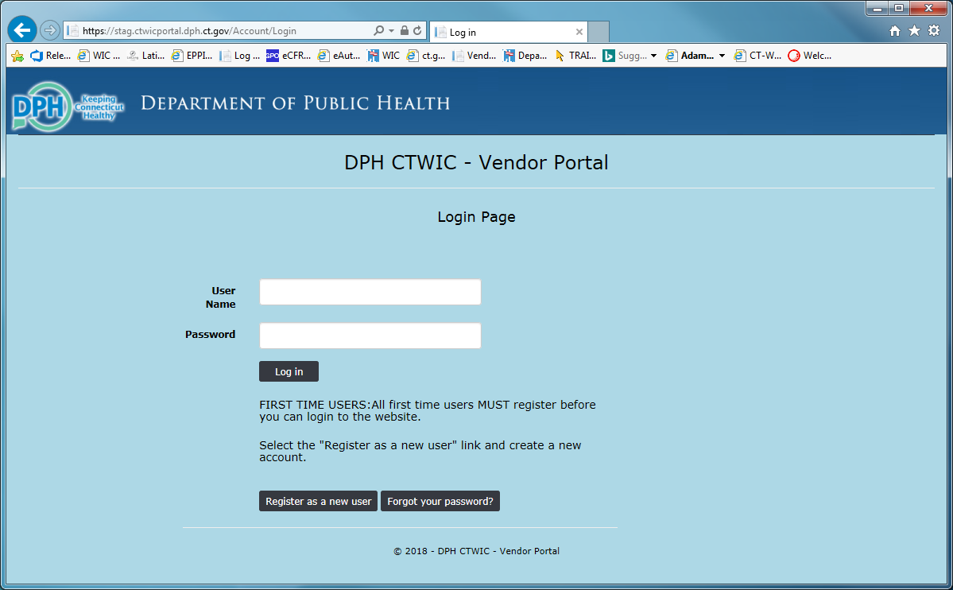
Registration Page – After clicking on the Register as a new user button, fill in all the fields with the required information.
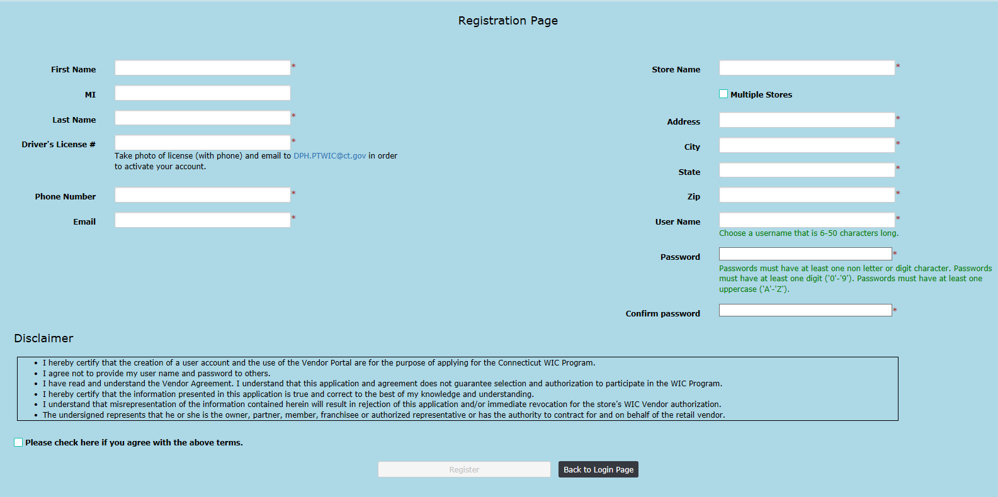

Only after entering data in all fields correctly, reading the Disclaimer, and clicking the Disclaimer agreement checkbox will you be able to click on the Register button. Please note the instructions under the Driver’s License # data field. To complete your registration and have your registration approved, the Connecticut WIC Program must receive an electronic photo of the registrant’s valid state or federal identification. 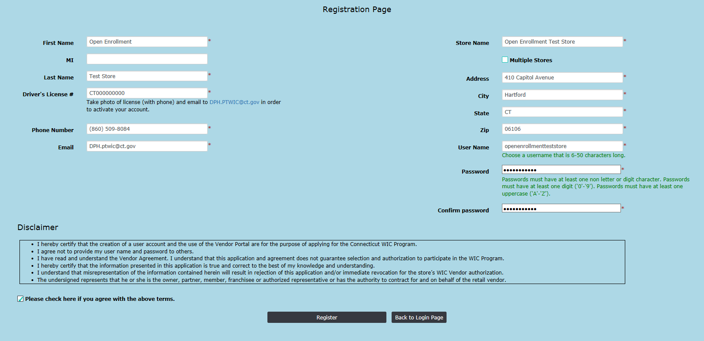

After clicking on the Register button you will receive the message seen below.
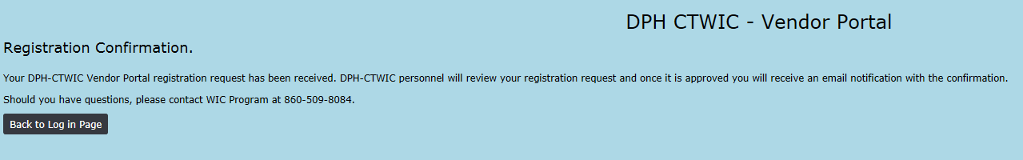
After WIC personnel have reviewed your registration, received your photo of your valid state or federal identification and activated your user account, you will receive an email similar to the one found below with your specific registration information and instructions to log into the portal to complete your online application. This email will be sent to the email address used for account registration.
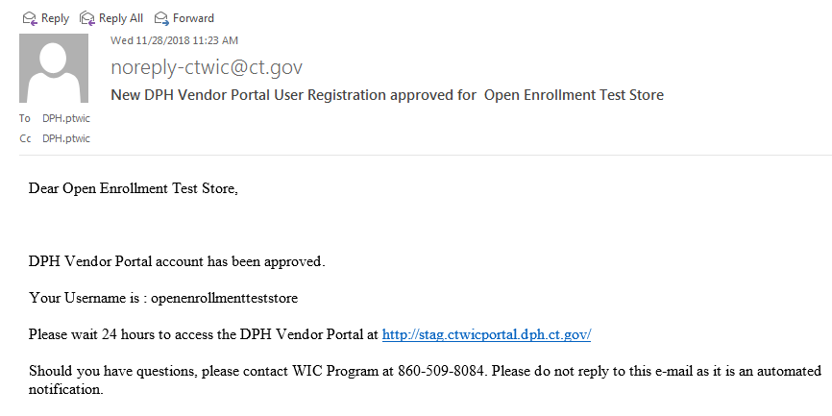

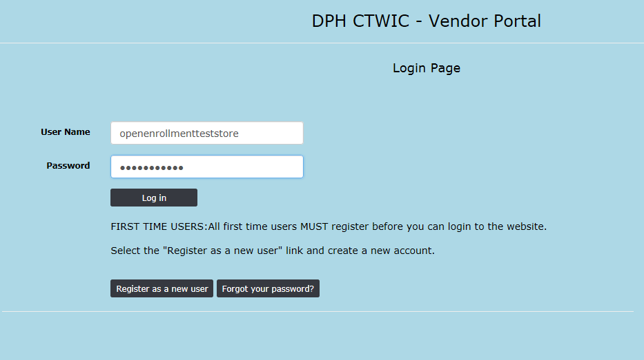

After clicking the Log In button you will be redirected to the State screen.

Click on the word Vendor in the upper left side.

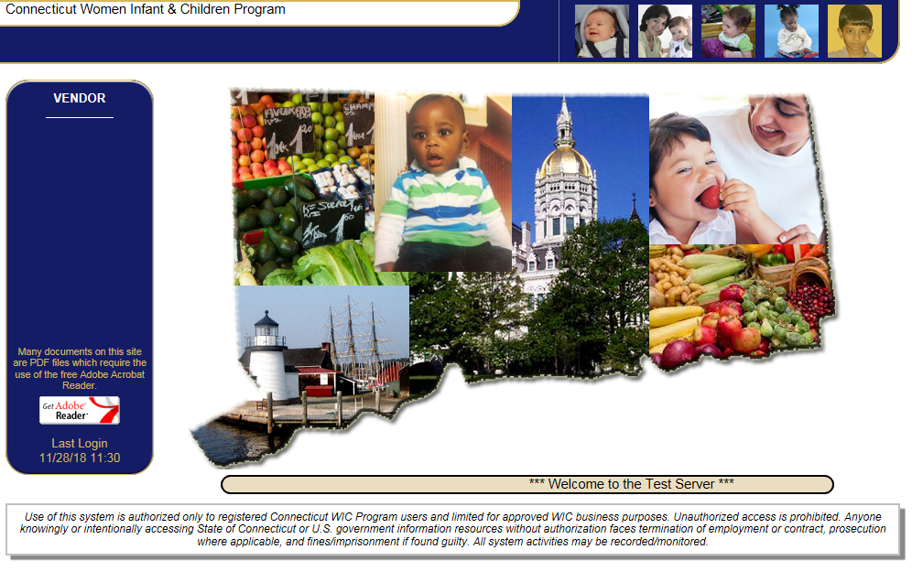

Click on. When the menu expands click on.

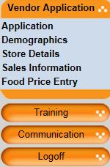
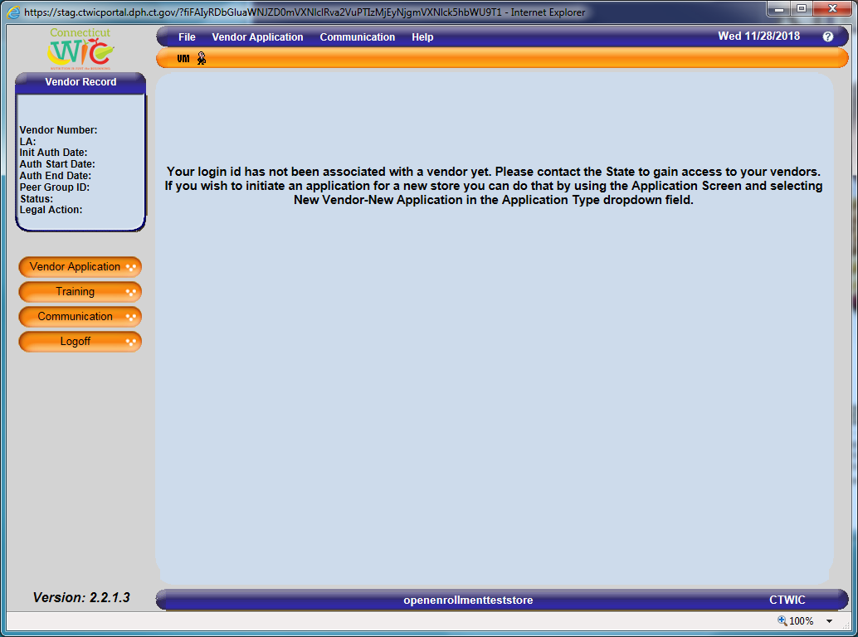

You are now on the Application screen. There are three application types. If your store has never been WIC authorized before, select New vendor-New application and click on Go. If your store has previously applied for authorization or was previously authorized by the Connecticut WIC Program, select Non-active vendor-New application and click on Go. Do NOT select Active vendor-Renewal application.
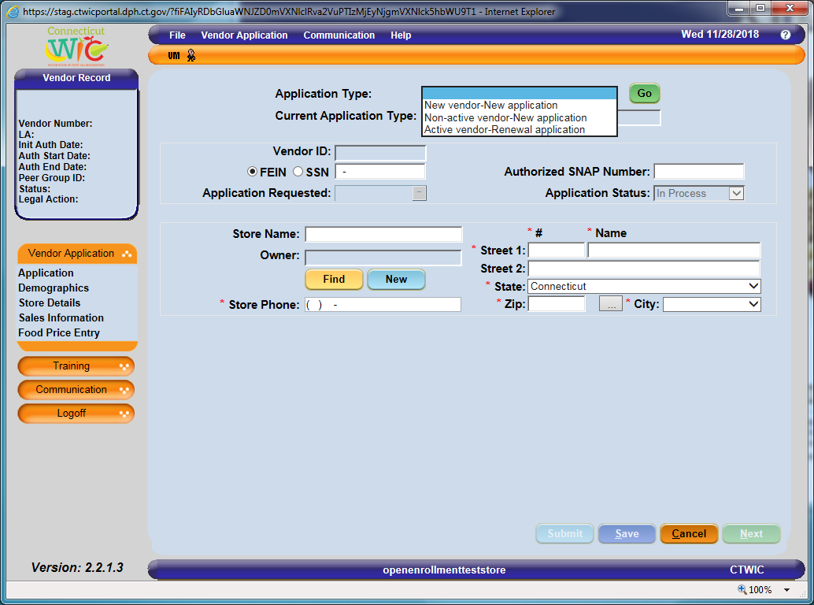
Enter all the required data in the white data fields. When entering the Owner information, if you are a new store to the WIC Program click on. If your store was previously authorized by CT WIC, the Owner information is already entered.

PLEASE NOTE: The Connecticut WIC Program requires that all vendors be SNAP authorized prior to application to be eligible for authorization.

When thebutton is clicked:
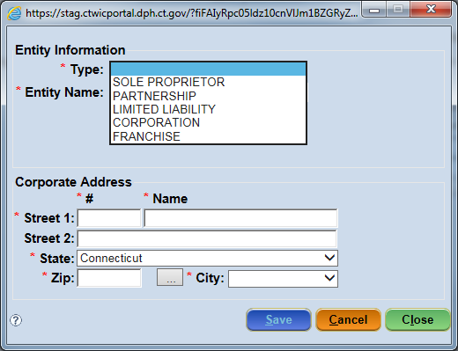

Select the Owner Entity Type, enter the Owner Entity Name and address. Then click on and then.
When all data has been entered on the Application screen click. The message “Data Saved Successfully” will appear in the blue bar at the bottom of the screen. You may now click.

NOTE: After saving the Application screen with the correct Application Type you may and return to your application anytime during the application period. For Open Enrollment this means that you have until January 31 to return to your application, complete it and submit the application. On all screens data that you enter is saved whenever you click. For Instructions on how to RE-ENTER THE VENDOR PORTAL please see Page 18.
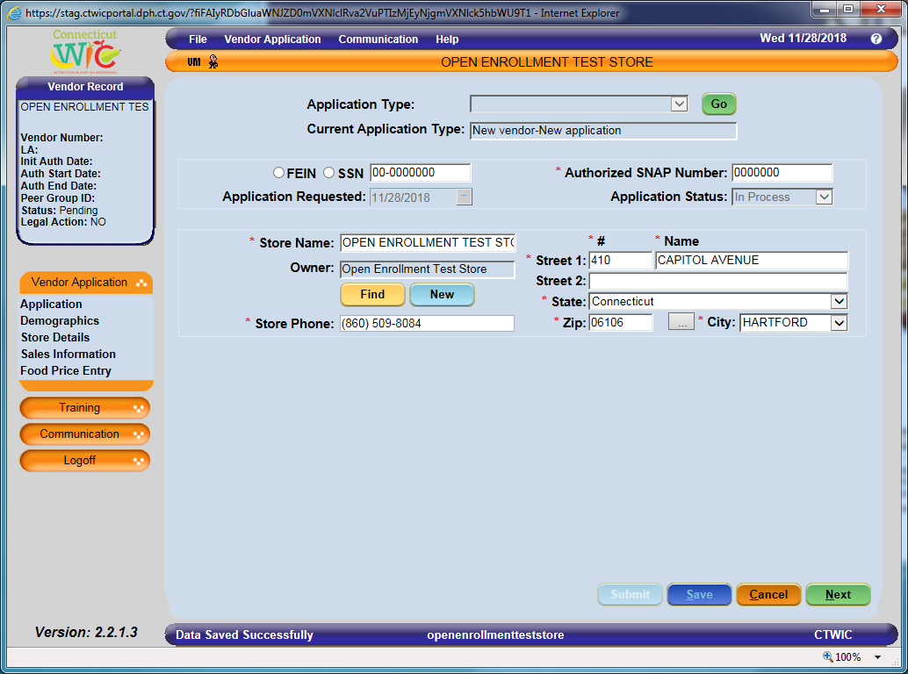
On the Demographics screen, enter all the required data in the white data fields that are blank. Add Store Contacts and their information by clicking on and entering the required data. The owner must be listed as a store contact. If you have a store manager or other store personnel who will attend training, communicate with the WIC Program, or be responsible for the training of store personnel that information must be entered here as well.
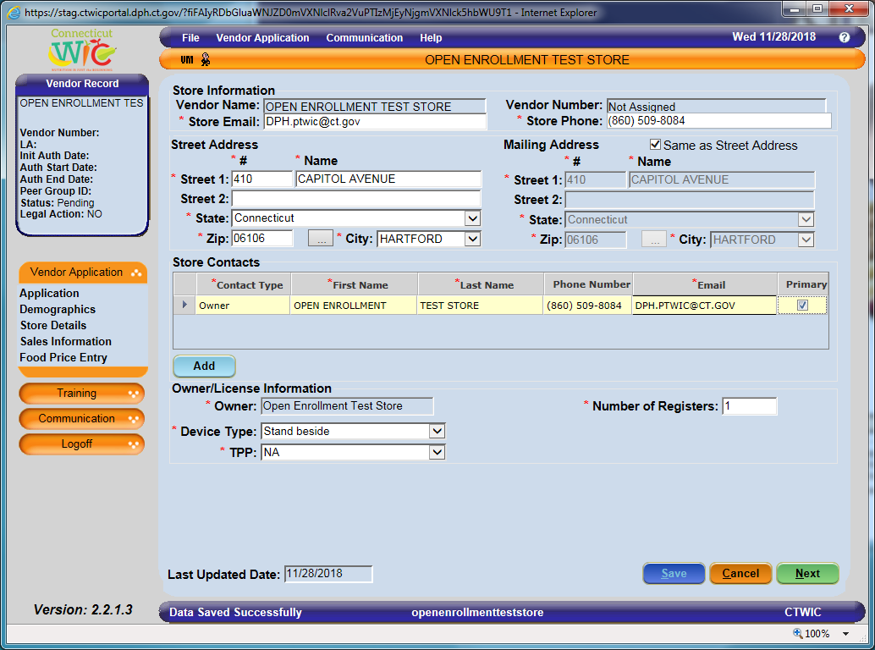

When all data has been entered on the Demographics screen click. The message “Data Saved Successfully” will appear in the blue bar at the bottom of the screen. You may now click.

On the Store Details screen, enter all the required data in the white data fields that are blank. Selecting the Preferred Store Language is a very important part of this screen. The language selected in that field will determine what training classes you are offered after your application has been approved. Please select the primary language that is spoken by the store personnel who will attend the mandatory training. Enter the Open and Close times for your store. Enter the correct Number of store workers and Number of store workers who will handle WIC transactions. Answer all the Questions.
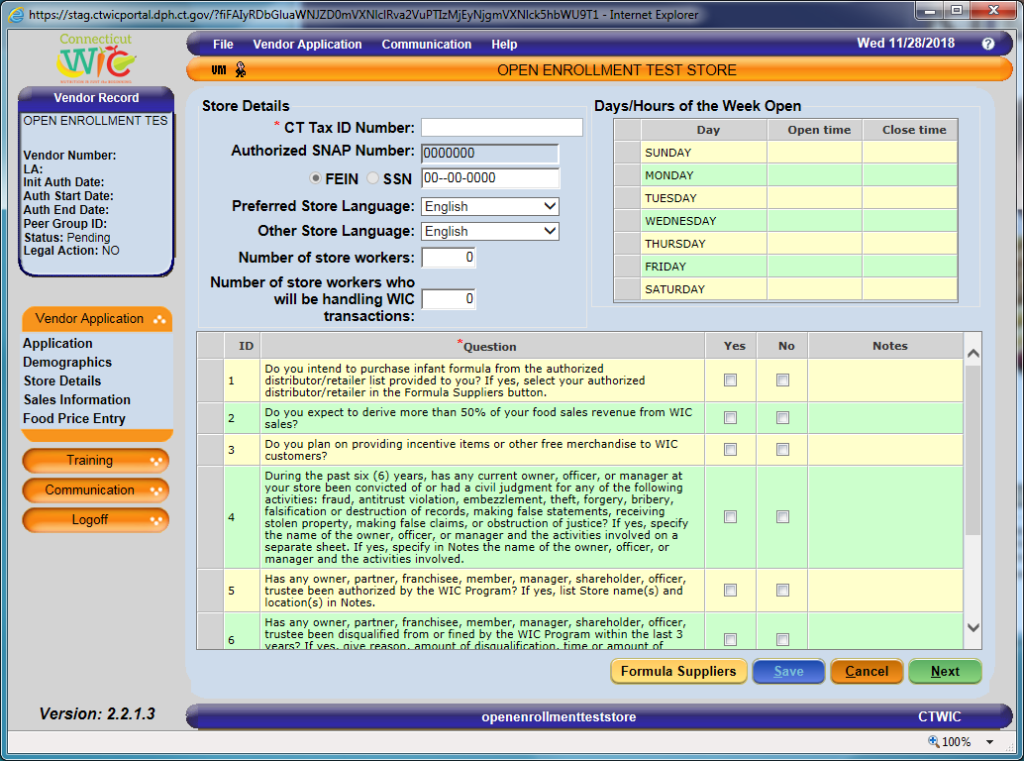
Before clicking and click on.

When the button is clicked:
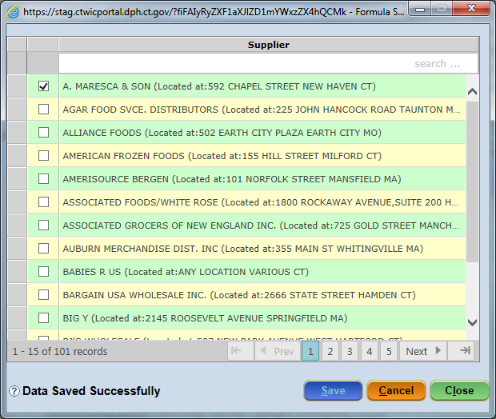

Select the Formula Supplier that you will use to supply your store with the required infant formula. Then click on and then.

When all data has been entered on the Store Details screen click. The message “Data Saved Successfully” will appear in the blue bar at the bottom of the screen. You may now click.

On the Sales Information screen, enter all the required data in the white data fields that are blank. Please enter the sales and tax information for the last four tax filing quarters going back from the date of your application. For example: If you are applying in January 2019 then report on the four tax filing quarters (twelve months) from January 2018 to December 2018.

PLEASE NOTE: The Connecticut WIC Program requires that all vendors be open continuously for one full calendar year prior to application to be eligible for authorization.

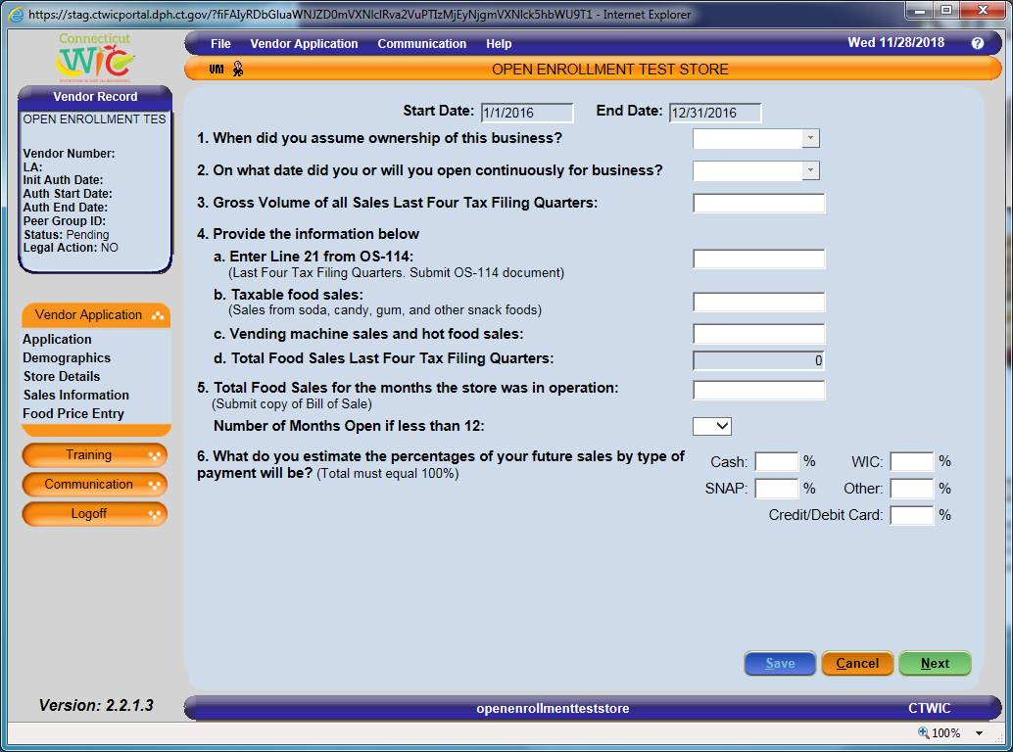
When all data has been entered on the Sales Information screen click. The message “Data Saved Successfully” will appear in the blue bar at the bottom of the screen. You may now click.

On the Food Price Entry screen, enter all the required data in the Lowest Price and Highest Price data fields.
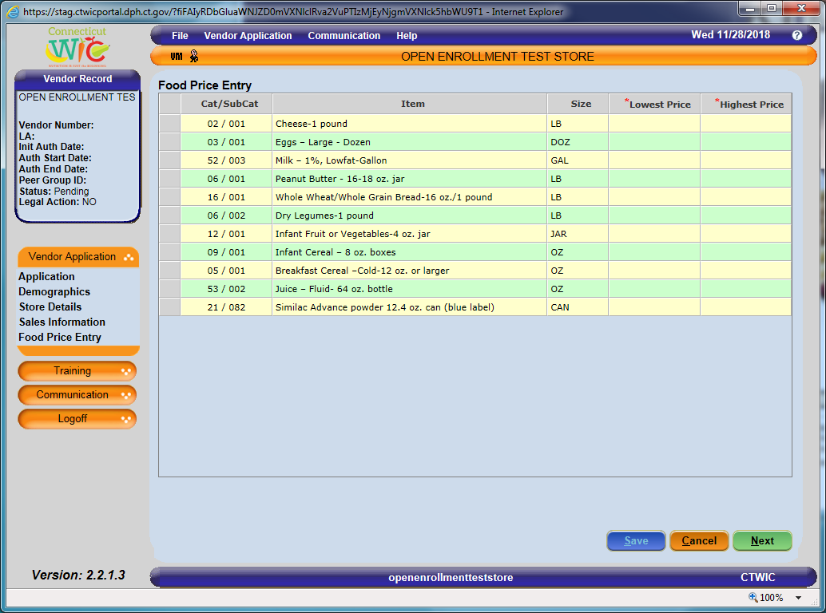

When all data has been entered on the Food Price Entry screen click. The message “Data Saved Successfully” will appear in the blue bar at the bottom of the screen. You may now click.

You have now been re-directed to the Uploaded Documents screen which can be found under the button. On the screen, you are required to Upload a minimum of three different documents. The required documents are the following: the Owner Information Form, the Owner’s valid and current state or federal picture identification, and the Connecticut Department of Revenue Services Sales and Tax Use Summary form OS-114. There are other documents that may be required for uploading depending on your store’s demographic profile. See below.

The Owner Information Form must be printed from the WIC Retailers webpage and filled out completely. You must then scan the two page form as one PDF (creating one document) for uploading to this screen.

The Connecticut WIC Program considers a state issued driver’s license or picture identification card as a valid form of identification if it is not expired. The Program also considers a U.S. government issued passport or visa as a valid form of identification if it is not expired. You must take a photo of the valid identification and upload it to this screen.

If you have a store manager you are required to upload their valid picture identification to this screen.

You are required to provide your Sales and Tax Use Summary form OS-114 for the last four tax filing quarters (the previous twelve months). For each filing, depending on whether you file quarterly or monthly, these documents are two pages each. These two page documents (eight pages total if you file quarterly or twenty-four pages total if you file monthly) should be scanned as one document and then uploaded to your application in the portal.

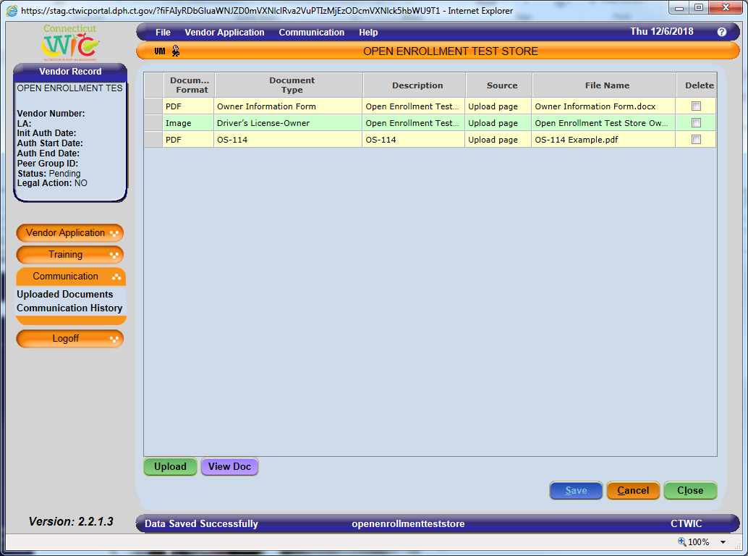

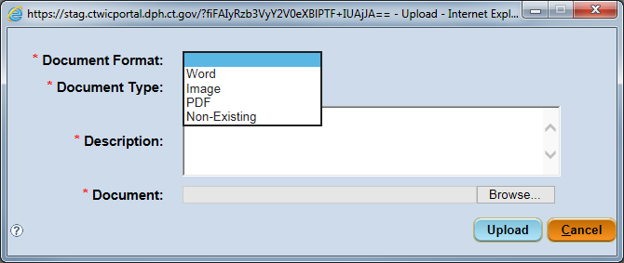

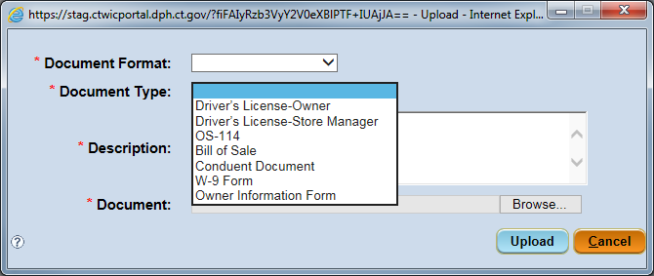

After uploading all of the required documents in the proper format and with the proper document type you must proceed back to the Application screen toyour application. Do this by clicking on. When the menu expands click on.
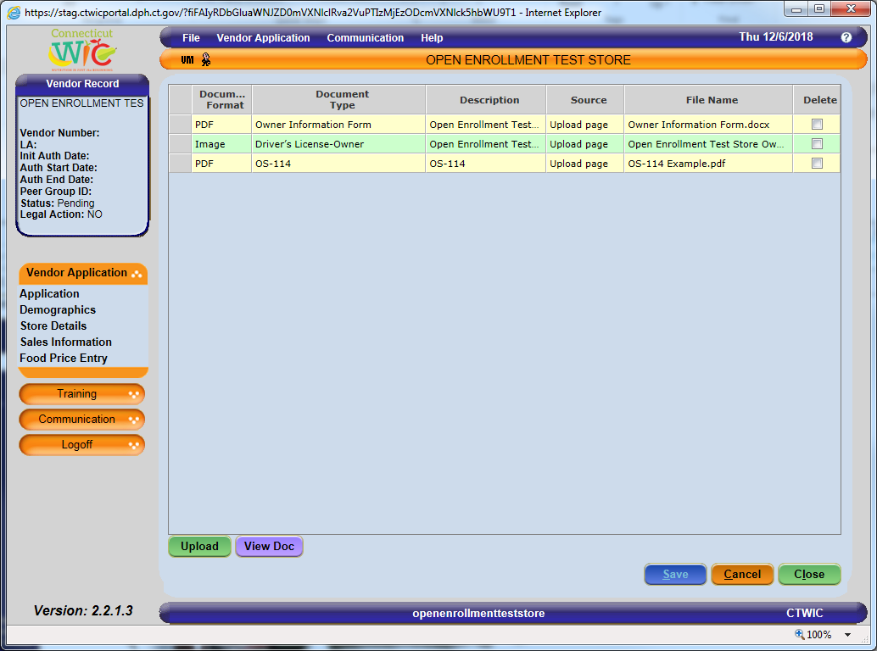

Once back on the Application screen click. If all the requirements of the Vendor Application screens have been met then the message “Application Submitted Successfully” will appear in the blue bar at the bottom of the screen.
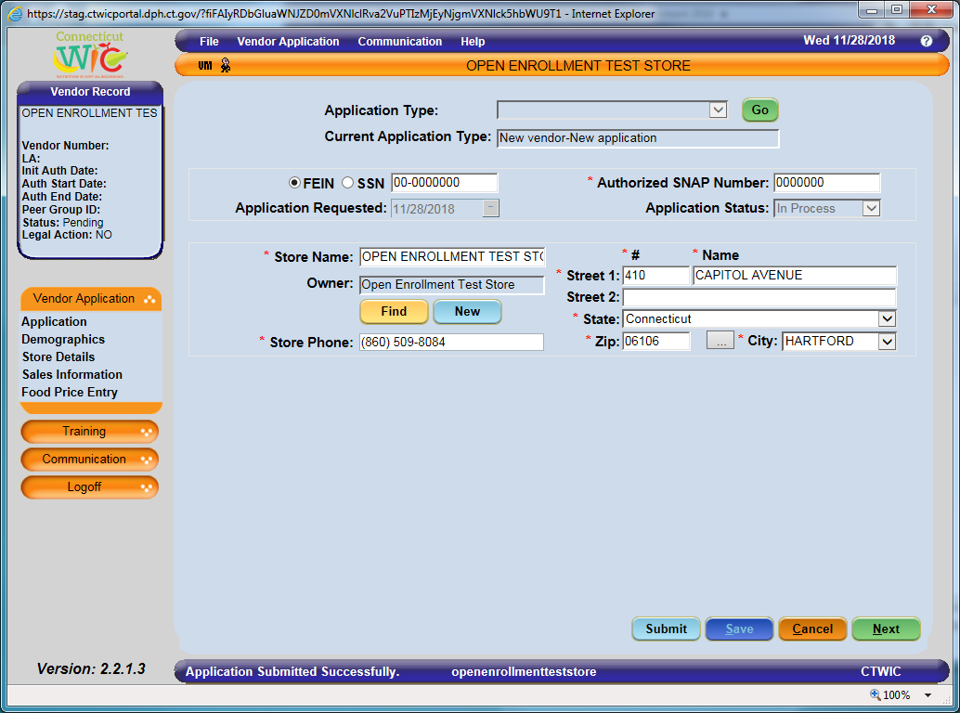

If you have not fulfilled all the system requirements from the Vendor Application screens, clicking will produce an “Ineligibility” message that will provide information as to why you are not eligible to submit the application. There are many different versions of this “ineligibility” message. These messages may be generated due to missing information or failure to meet the Connecticut WIC Program’s Vendor Selection Criteria. You should, at all times, refer back to the Vendor Agreement and Appendix A Vendor Selection Criteria for review. The vendor agreement is always available on the WIC Retailers webpage. If you have questions regarding the submission of your application please call the Connecticut WIC Program at 860.509.8084 and press #2 or send an email to DPH.ptwic@ct.gov and ask for assistance with the online portal application.

If your application was successfully submitted you will receive an email similar to the one found below at the email addresses entered on the Demographics screen.
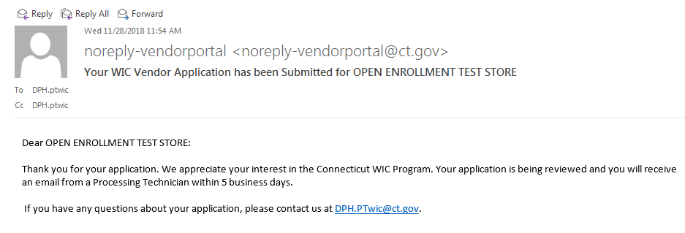
As stated in the “Application has been Submitted” email, your application will be reviewed by WIC personnel within five business days. If your application is approved you will receive an “Application has been Approved” email indicating approval. In addition, the email will instruct you to re-enter the vendor portal to select your training class.
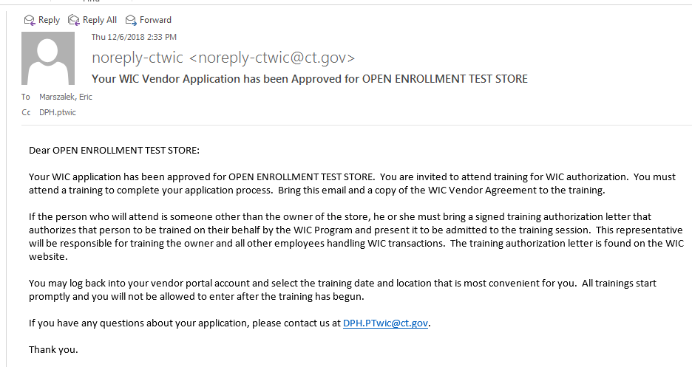

At any time, and for any reason (completing or editing the application, submitting the application, or choosing training), when RE-ENTERING THE PORTAL you will now be re-directed from the State screen to the Make Active screen seen below. EVERY TIME that you login to the vendor portal you will be re-directed to this screen and you must make the vendor record that you want to access “Active.” Do this by clicking on the row then clicking. The message “Vendor has been made active” will appear in the blue bar at the bottom of the screen.

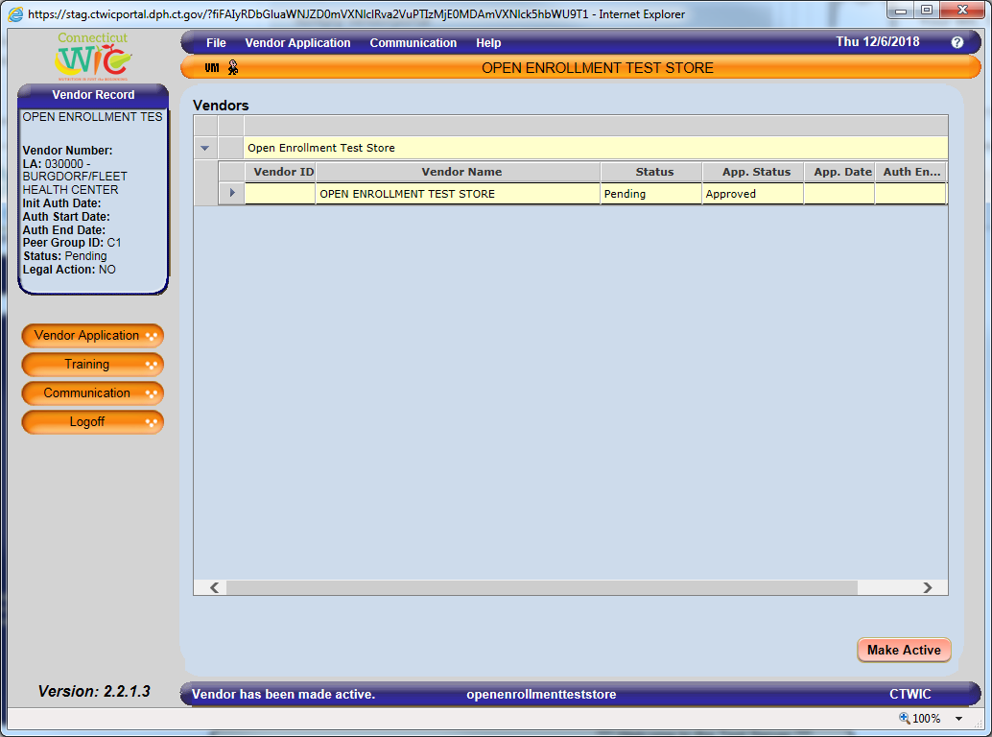
To select your Training class click on.
When you click onthe message found below will appear. Click.
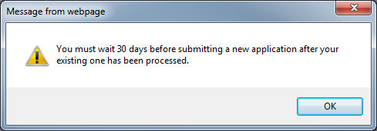

When the menu expands click.

On the Select Training screen you will have a selection of training classes available to you for attendance. This list is created based on your Store Type, Device Type, and Preferred Store Language. Select the training class that you will attend. When you clickan email will be sent to the email addresses listed on the Demographics screen. This email will contain the details of the training class you selected.
