November 23, 2015

VIA ELECTRONIC FILING AND US MAIL

Jeffrey R. Gaudiosi, Esq.
Executive Secretary
Public Utilities Regulatory Authority
Ten Franklin Square
New Britain, CT 06051

Re: Docket No. 14-12-21 – Joint Investigation by DPH and PURA of REJA’s (Rainbow Springs) Request to Cease Operations as a Water Company

Dear Mr. Gaudiosi:

Enclosed please find Aquarion’s responses to Late Files 14 and 15.

We certify that this filing is being made electronically and that the electronic filing is complete. Should you have any questions concerning the foregoing, please contact me at your convenience at (203) 362-3001.

Sincerely,

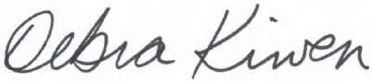

Debra Kirven
Controller

