How to Add Members to a Distribution List.
- Tools – Address Book
- Go to – “Show Names From the:”
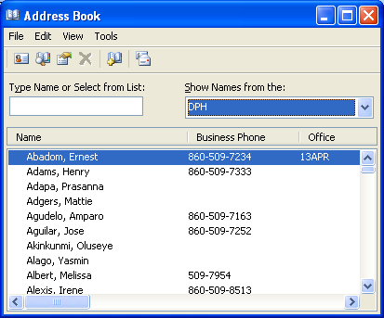
3. Use the drop down window and select “Distribution List
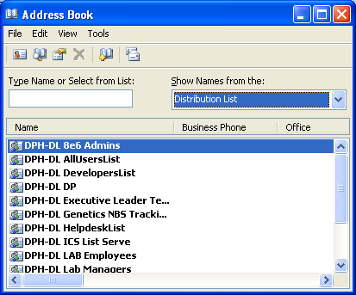

- Select your list and double click list to modify, for example

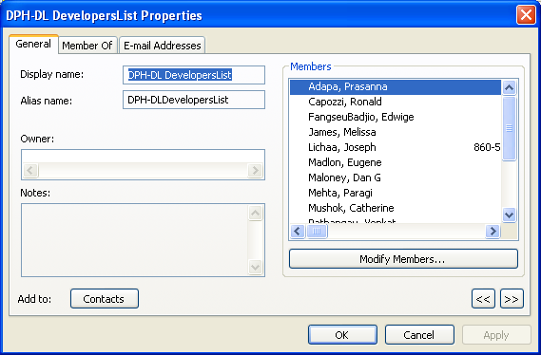

- Modify members to add or remove from your list.

