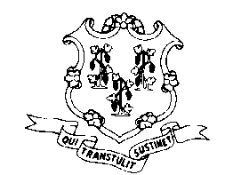

STATE OF CONNECTICUT
DEPARTMENT OF PUBLIC HEALTH
Office of Health Care Access

Certificate of Need Equipment Replacement Notification Form

Pursuant to 19a-638(b)(18), an existing imaging equipment may be replaced, if such equipment was acquired through certificate of need approval or a certificate of need determination, provided a health care facility, provider physician or a person notifies OHCA of the date on which the equipment is replaced and the disposition of the replaced equipment.

Please complete the following:
Provider Name & Address:
Name and description of the equipment to be replaced:
Docket or Report number of the CON authorization of the existing imaging equipment being replaced:
Address of the existing imaging equipment:
Name and description of the replacement equipment:
Location where replacement equipment will be operated:
The date the replaced equipment was replaced:
The disposition of the replaced equipment

Person Completing the form:_____________________, __________________
Name Title
____________________, __________________
Signature Date

