February 26, 2016

Department of Public Health
P.O. Box 340308, MS#13PHO
410 Capitol Ave.
Hartford, Connecticut 06134-0308

Jeffrey R. Gaudiosi, Esq.
Executive Secretary
Public Utilities Regulatory Authority
Ten Franklin Square
New Britain, CT 06051

Re: Docket No. DPH 15-06-01/ PURA 15-08-24 – Joint Investigation of DPH and PURA Regarding Cedarhurst Association, Inc.’s Request to Cease Operations as a Water Company

This letter is a request to change and/or add the contact person/persons for Aquarion Water Company of Connecticut in the above referenced dockets. Please remove Mr. John Walsh from the service list and add:

Debra E. Kirven
Controller
600 Lindley Street
Bridgeport, CT 06606
dkirven@aquarionwater.com

Troy Dixon
Director, Rates and Regulation
600 Lindley Street
Bridgeport, CT 06606
tdixon@aquarionwater.com

Frederic Lee Klein
Pullman & Comley, LLC
90 State House Square
Hartford, CT 06103
fklein@pullcom.com

Should you have any questions concerning the foregoing, please contact me at your convenience at (203) 337-5990.

Sincerely,
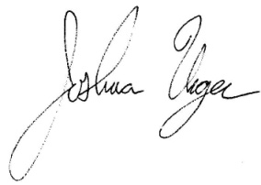
Joshua Unger
Senior Regulatory Compliance Specialist

