Title: Booking a Conference Room

Intended Audience: DPH Business Users

Entity: Request for Service

Description: Help desk to assist users with booking a conference room reservations and reoccurring meetings.

Step-by-step Procedure: Do not book a meeting directly into the conference room. To book a Conference Room follow these steps:

When you are ready to book a Conference Room - Find an available Conference Room and Time you want to book and……

  - “Select New Appointment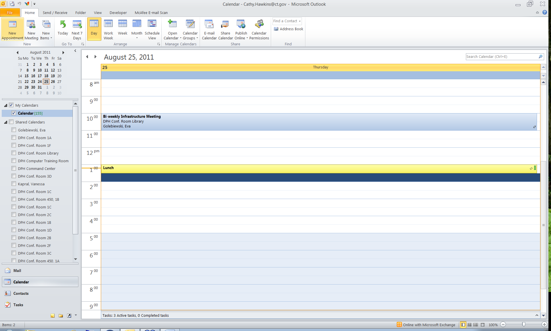
- Fill in the subject line, start date & time and end date & time

- Select Scheduling Assistance and click add Attendees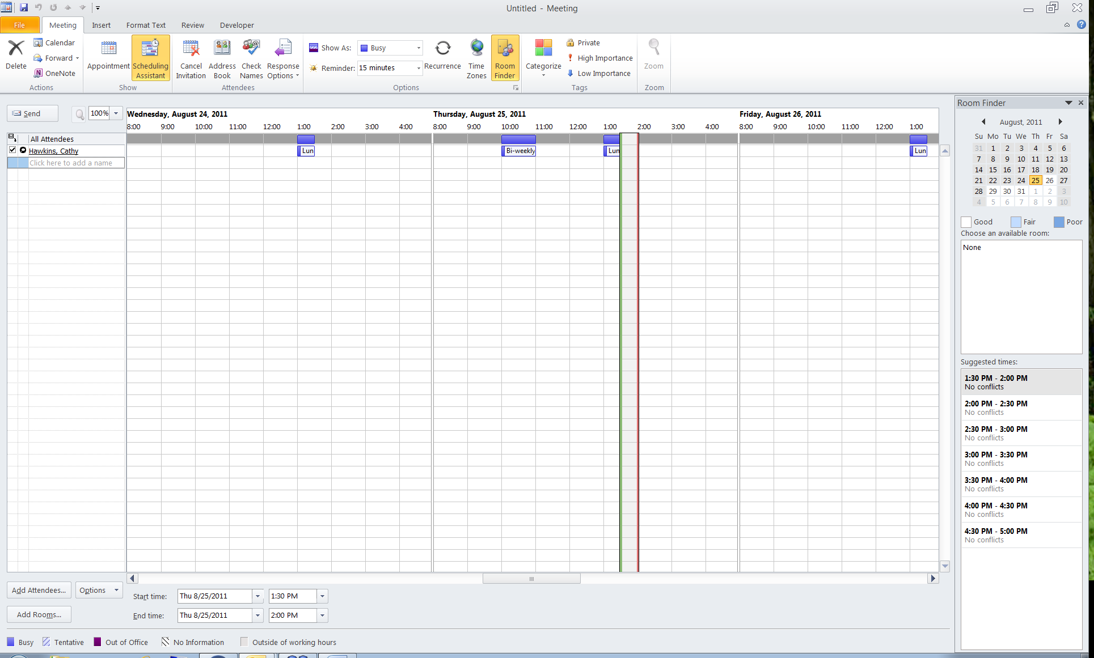

- Add Attendees that are required and or optional and hit OK. You do not have to add a “Resources” anymore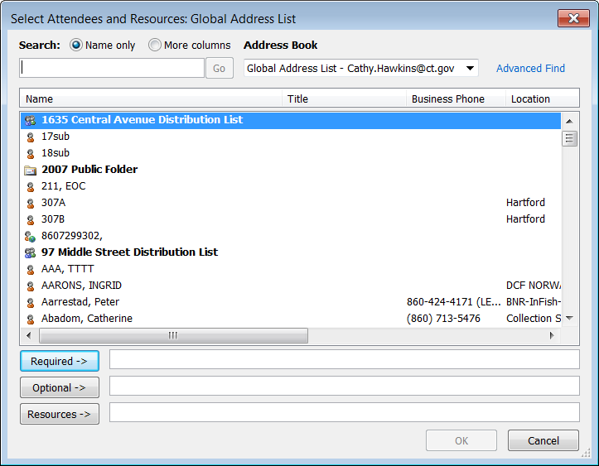
- Then Select Add Room and Select the Conference Room you want to book and Hit Send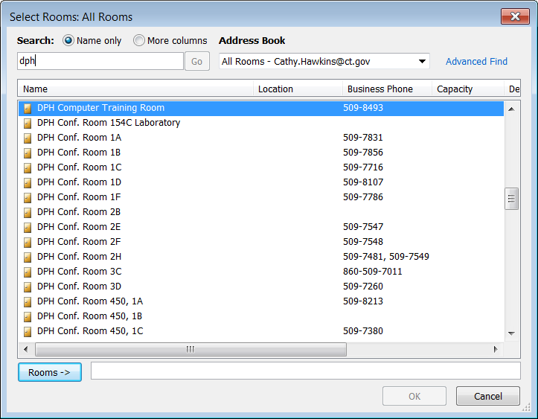

- When a meeting invitation is sent out, the organizer receives a confirmation Email from the Conference Room in which you booked with the subject of Accepted or Declined. You no longer have to remember to add the conference room as a resource as they are now automatically added as such.

  - Accepted Response: 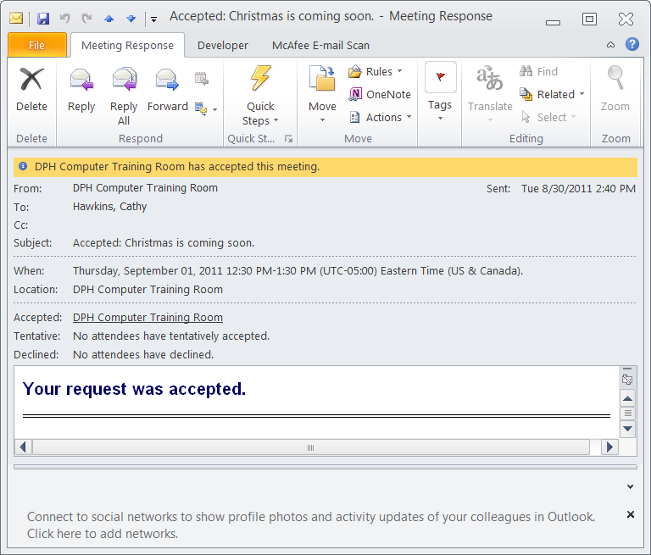

  - Meeting Conflict (Declined) Response: 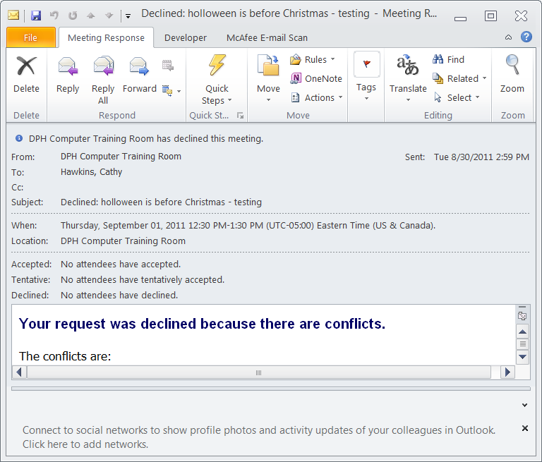

- When a message is Declined, the meeting created remains in the calendar. The Business user who created the meeting must move it to a different time slot, a different room or cancel/delete the entry. By doing it this way, will send notifications of the cancelled meeting to the invitees.

- When creating reoccurring meetings, choose an end date or the number of occurrences. The rooms/resources are allowed to be scheduled up to 6 months in advance. If you leave no end date, or the reoccurrence is set to end greater than the 6 months allotted, it will be declined. In the notification sent out, the maximum end date allowed is in the text of the email. User must set the end date or number of occurrences and resend out the notifications to the invitees. This feature eliminates open-ended and orphaned meetings.

Success Criteria: User can reserve a conference room or reoccurring meeting.
Escalation Point: If User cannot book a room, route IMPACT Work Order to Helpdesk.dph@ct.gov or Call the Helpdesk @X7777 Messaging Services

