WIC Programs Participating in the
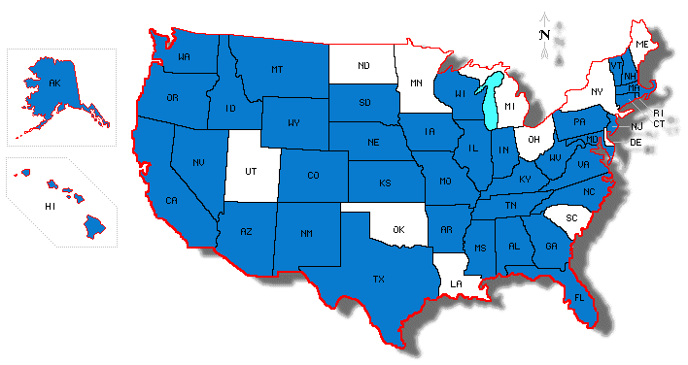National Food and Nutrition Questionnaire (NATFAN), 2009
*
*
*
*
*
*
*
* an asterisk indicates that one or more ITOs within this state participated in NATFAN
**The Mariana Islands also participated in NATFAN but are not shown on this map

Participating State and ITO WIC Programs:
- Alabama
- Alaska
- Arizona
- Arkansas
- California
- Chickisaw Nation
- Chocktaw Nation
- Citizen Potawatomi Nation
- Colorado
- Connecticut
- District of Columbia
- Eight Northern Indian Pueblos
- Florida
- Georgia
- Hawaii
- Idaho
- Illinois
- Indiana
- Iowa
- ITC of Arizona
- ITC of Nevada
- Kansas
- Kentucky
- Maine
- Mariana Islands
- Maryland

- Mississippi
- Missouri
- Montana
- Muscogee Creek
- Nebraska
- Nevada
- New Hampshire
- New Jersey
- New Mexico
- North Carolina
- Oregon
- Pennsylvania
- Pueblo of Isleta
- Rhode Island
- Rosebud Sioux
- Santee Sioux Nation
- Seneca Nation
- South Dakota
- Tennessee
- Texas
- Vermont
- Virginia
- Washington
- West Virginia
- Wisconsin
- Wyoming

