Accreditation Learning Community
August 22, 2018
Meeting Summary

Aligning SHIP Priorities with local CHIPs
As DPH looks to update its State Health Assessment and State Health Improvement Plan (SHIP) over the next couple of years, it is important to consider where priorities at the local level are aligning so that resources and strategies can also be aligned at the state level wherever possible. Based on the discussion during the call, the table found on DPH’s webpage will be revised to show Health Systems as a priority for Norwalk Health Department, Mental Health and Substance Abuse as a priority for East Shore Health District, and a footer will be added to indicate which health departments fall under the larger hospital plans, such as the departments included in the Greater New Haven plan.
Implementing a Strategic Plan (Measure 5.3.3)
The purpose of Measure 5.3.3 is to assess the health department’s implementation of its strategic plan. Your department should have documentation of a process in place that is used to monitor progress being made on strategic objectives at least annually. One example must be dated within 14 months, while the other example may be older, but dated within 5 years of submitting documentation.

After setting priorities and objectives in the Strategic Plan, prioritize 3-5 objectives as part of the health department’s implementation phase. What needs to be done first? Are there any easy wins that can be accomplished to create momentum? These priorities will be where the health department focuses its efforts for the timeframe of the workplan. DPH uses annual workplans and monitors progress on each workplan quarterly.

Workplans should include an appropriate level of detail for implementation, use a format that allows for periodic reporting on progress, and use a structure that lets the ready easily see how activities are linked to strategic plan objectives. Aligning these employee performance plans with specific strategic objectives is an effective way to support the plan’s roll-out. The two examples DPH provided PHAB have been shared as a model for meeting Measure 5.3.3A. The process at DPH consists of developing a workplan for each priority objective, assigning a program or staff member as lead, and each workplan lead reporting out on progress at least quarterly at monthly Public Health Strategic Team meetings or Quality Improvement Council meetings. The template worksheet that DPH uses to track progress and activities has also been shared.

Megan DiMeglio from the Norwalk Health Department shared slides on the implementation process followed in Norwalk. Targets for the plan are monitored by supervisors weekly and the Senior Management Team reviews and reports out on progress being made during weekly meetings with the Director of Health. The Director monitors timelines using a Gantt chart. Examples of Norwalk’s documentation can be found in the slideshow presentation.

Last minute tips on implementation of the strategic plan: Strategic plans are living documents and should be reviewed and revised when appropriate. A standard schedule of reviewing implementation progress allows the department to revise objectives based on what has been accomplished or where progress has stalled and why. DPH revises its strategic priorities and objectives annually.

Next Meeting: Thursday September 27, 1-2pm
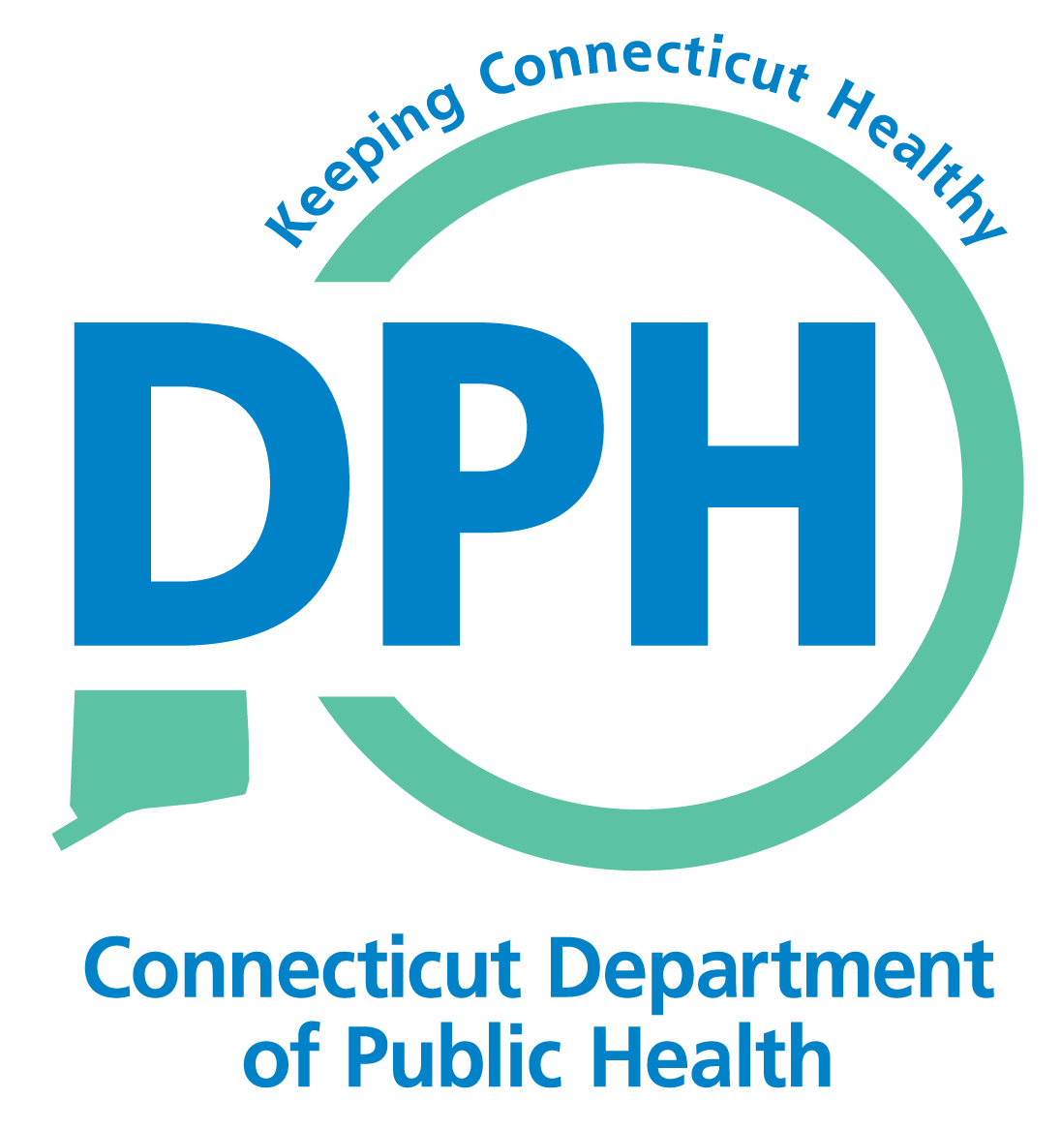
Topic: Domain 12 – Engaging the Governing Entity

