Accreditation Learning Community
July 25, 2018
Meeting Summary

PHHS Block Grant Announcement
The current Block Grant cycle is being extended for one more year to give the Commissioner time to revamp the menu of activities. It is possible the new menu of activities will mirror the CDC 6|18 initiative, excluding teen pregnancy and healthcare-associated infections, in addition to a few other program areas. The new menu and application is expected in early 2019.

Developing a Strategic Plan (Measure 5.3.1 and Measure 5.3.2)
According to the PHAB definition, a strategic plan results from a deliberate decision-making process to define where an organization is going. It is a tool that helps health departments, who are constantly being pulled in various directions, address its community’s chief public health needs while allowing the agency to adapt to a changing environment. If designed, implemented, and monitored correctly, a strategic plan provides a common foundation to set direction, inform decision making, and assess performance.

The goal of the PHAB requirements is to ensure health departments conduct a strategic planning process that would result in an actionable plan that addresses organizational needs. This webinar presentation covered how to develop a strategic plan that meets best practices and national standards.

In addition, the webinar discussed an article related to strategic planning from the Journal of Public Health Management and Practice – May/June 2018. The article described a case report in which Kent County Health Department revised its Strategic Plan to better align with quality improvement efforts.

Next Meeting: Wednesday August 22, 1-2pm
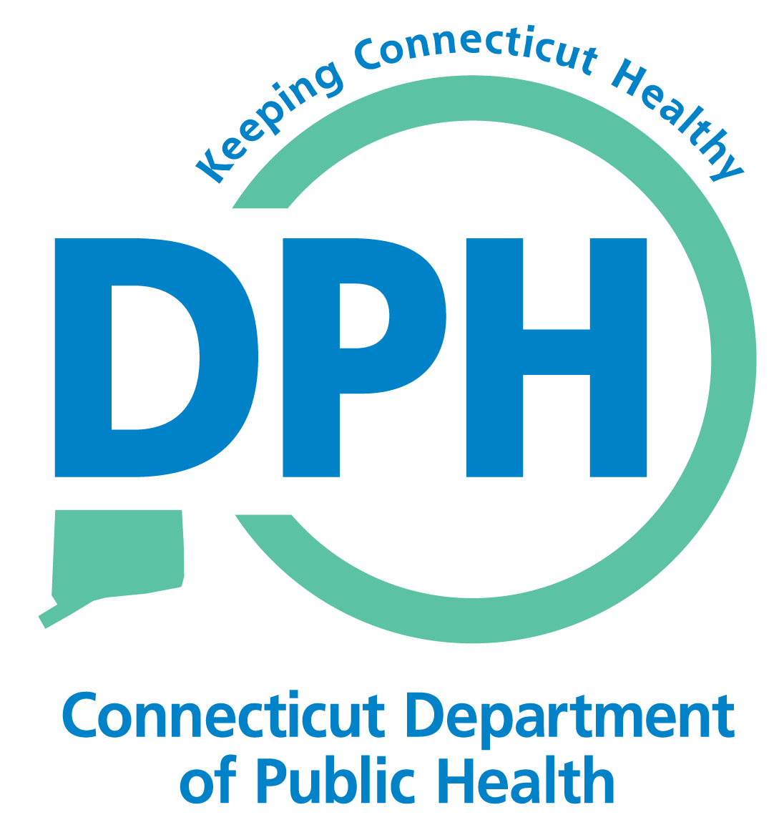
Topic: Strategic Planning (continued) and Implementation

