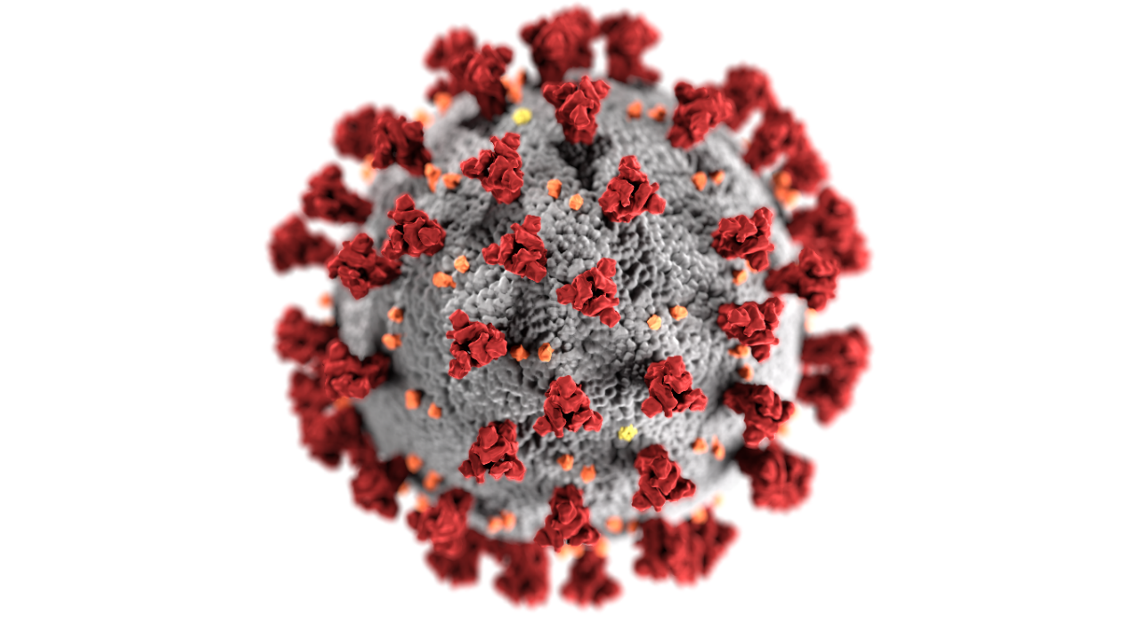
[AUTHOR/AGENCY]
[Date] | [Version number]
COVID-19 Vaccination Plan
[Jurisdiction name]

Table of Contents
Record of Changes 2
Instructions for Jurisdictions 3
Section 1: Preparedness Planning 4
Section 2: COVID-19 Organizational Structure and Partner Involvement 5
Section 3: Phased Approach to COVID-19 Vaccination 6
Section 4: Critical Populations 7
Section 5: COVID-19 Provider Recruitment and Enrollment 8
Section 6: COVID-19 Vaccine Administration Capacity 9
Section 7: COVID-19 Vaccine Allocation, Ordering, Distribution, and Inventory Management 10
Section 8: COVID-19 Vaccine Storage and Handling 11
Section 9: COVID-19 Vaccine Administration Documentation and Reporting 12
Section 10: COVID-19 Vaccination Second-Dose Reminders 13
Section 11: COVID-19 Requirements for IISs or Other External Systems 14
Section 12: COVID-19 Vaccination Program Communication
Section 13: Regulatory Considerations for COVID-19 Vaccination 16
Section 14: COVID-19 Vaccine Safety Monitoring 17
Section 15: COVID-19 Vaccination Program Monitoring 18
Appendix 19

Record of Changes
Date of original version:
Date Reviewed | Change Number | Date of Change | Description of Change | Name of Author

Instructions for Jurisdictions
The COVID-19 Vaccination Plan template is to assist with development of a jurisdiction’s COVID-19 vaccination plan. Jurisdictions should use this template when submitting their COVID-19 vaccination plans to CDC.
The template is divided into 15 main planning sections, with brief instructions to assist with content development. While these instructions may help guide plan development, they are not comprehensive, and jurisdictions are reminded to carefully review the CDC COVID-19 Vaccination Program Interim Playbook for Jurisdiction Operations as well as other CDC guidance and resources when developing their plans. Jurisdictions are encouraged to routinely monitor local and federal COVID-19 vaccination updates for any changes in guidance, including any updates to the CDC COVID-19 Vaccination Program Interim Playbook for Jurisdiction Operations.

Section 1: COVID-9 Vaccination Preparedness Planning
Instructions:
- Describe your early COVID-19 vaccination program planning activities, including lessons learned and improvements made from the 2009 H1N1 vaccination campaign, seasonal influenza campaigns, and other responses to identify gaps in preparedness.
- Include the number/dates of and qualitative information on planned workshops or tabletop, functional, or full-scale exercises that will be held prior to COVID-19 vaccine availability. Explain how continuous quality improvement occurs/will occur during the exercises and implementation of the COVID-19 Vaccination Program.

Section 2: COVID-19 Organizational Structure and Partner Involvement
Instructions:
- Describe your organizational structure.
- Describe how your jurisdiction will plan for, develop, and assemble an internal COVID-19 Vaccination Program planning and coordination team that includes persons with a wide array of expertise as well as backup representatives to ensure coverage.
- Describe how your jurisdiction will plan for, develop, and assemble a broader committee of key internal leaders and external partners to assist with implementing the program, reaching critical populations, and developing crisis and risk communication messaging.
- Identify and list members and relevant expertise of the internal team and the internal/external committee.
- Describe how your jurisdiction will coordinate efforts between state, local, and territorial authorities.
- Describe how your jurisdiction will engage and coordinate efforts with leadership from tribal communities, tribal health organizations, and urban Indian organizations.
- List key partners for critical populations that you plan to engage and briefly describe how you plan to engage them, including but not limited to:
- Pharmacies
- Correctional facilities/vendors
- Homeless shelters
- Community-based organizations

Section 3: Phased Approach to COVID-19 Vaccination
Instructions:
- Describe how your jurisdiction will structure the COVID-19 Vaccination Program around the three phases of vaccine administration:
Phase 1: Potentially Limited Doses Available
Phase 2: Large Number of Doses Available, Supply Likely to Meet Demand
Phase 3: Likely Sufficient Supply, Slowing Demand

Section 4: Critical Populations
Instructions:
- Describe how your jurisdiction plans to: 1) identify, 2) estimate numbers of, and 3) locate (e.g., via mapping) critical populations. Critical population groups may include:
  - Healthcare personnel
  - Other essential workers
  - Long-term care facility residents (e.g., nursing home and assisted living facility residents)
  - People with underlying medical conditions that are risk factors for severe COVID-19 illness
  - People 65 years of age and older
  - People from racial and ethnic minority groups
  - People from tribal communities
  - People who are incarcerated/detained in correctional facilities
  - People experiencing homelessness/living in shelters
  - People attending colleges/universities
  - People living and working in other congregate settings
  - People living in rural communities
  - People with disabilities
  - People who are under- or uninsured
- Describe how your jurisdiction will define and estimate numbers of persons in the critical infrastructure workforce, which will vary by jurisdiction.
- Describe how your jurisdiction will determine additional subset groups of critical populations if there is insufficient vaccine supply.
- Describe how your jurisdiction will establish points of contact (POCs) and communication methods for organizations, employers, or communities (as appropriate) within the critical population groups.

Section 5: COVID-19 Provider Recruitment and Enrollment
Instructions:
- Describe how your jurisdiction is currently recruiting or will recruit and enroll COVID-19 vaccination providers and the types of settings to be utilized in the COVID-19 Vaccination Program for each of the previously described phases of vaccine availability, including the process to verify that providers are credentialed with active, valid licenses to possess and administer vaccine.
- Describe how your jurisdiction will determine the provider types and settings that will administer the first available COVID-19 vaccine doses to the critical population groups listed in Section 4.
- Describe how provider enrollment data will be collected and compiled to be reported electronically to CDC twice weekly, using a CDC-provided Comma Separated Values (CSV) or JavaScript (JSON) template via a SAMS-authenticated mechanism.
- Describe the process your jurisdiction will use to verify that providers are credentialed with active, valid licenses to possess and administer vaccine.
- Describe how your jurisdiction will provide and track training for enrolled providers and list training topics.
- Describe how your jurisdiction will approve planned redistribution of COVID-19 vaccine (e.g., health systems or commercial partners with depots, smaller vaccination providers needing less than the minimum order requirement).
- Describe how your jurisdiction will ensure there is equitable access to COVID-19 vaccination services throughout all areas within your jurisdiction.
- Describe how your jurisdiction plans to recruit and enroll pharmacies not served directly by CDC and their role in your COVID-19 Vaccination Program plans.

Section 6: COVID-19 Vaccine Administration Capacity
Instructions:
- Describe how your jurisdiction has or will estimate vaccine administration capacity based on hypothetical planning scenarios provided previously.
- Describe how your jurisdiction will use this information to inform provider recruitment plans.

Section 7: COVID-19 Vaccine Allocation, Ordering, Distribution, and Inventory Management
Instructions:
- Describe your jurisdiction’s plans for allocating/assigning allotments of vaccine throughout the jurisdiction using information from Sections 4, 5, and 6. Include allocation methods for populations of focus in early and limited supply scenarios as well as the variables used to determine allocation.
- Describe your jurisdiction’s plan for assessing the cold chain capability of individual providers and how you will incorporate the results of these assessments into your plans for allocating/assigning allotments of COVID-19 vaccine and approving orders.
- Describe your jurisdiction’s procedures for ordering COVID-19 vaccine, including entering/updating provider information in VTrckS and any other jurisdictional systems (e.g., IIS) used for provider ordering. Describe how you will incorporate the allocation process described in step A in provider order approval.
- Describe how your jurisdiction will coordinate any unplanned repositioning (i.e., transfer) of vaccine.
- Describe jurisdictional plans for monitoring COVID-19 vaccine wastage and inventory levels.

Section 8: COVID-19 Vaccine Storage and Handling
Instructions:
- Describe how your jurisdiction plans to ensure adherence to COVID-19 vaccine storage and handling requirements, including cold and ultracold chain requirements, at all levels:
  - Individual provider locations
  - Satellite, temporary, or off-site settings
  - Planned redistribution from depots to individual locations and from larger to smaller locations
  - Unplanned repositioning among provider locations
- Describe how your jurisdiction will assess provider/redistribution depot COVID-19 vaccine storage and temperature monitoring capabilities.

Section 9: COVID-19 Vaccine Administration Documentation and Reporting
Instructions:
- Describe the system your jurisdiction will use to collect COVID-19 vaccine doses administered data from providers.
- Describe how your jurisdiction will submit COVID-19 vaccine administration data via the Immunization (IZ) Gateway.
- Describe how your jurisdiction will ensure each COVID-19 vaccination provider is ready and able (e.g., staff is trained, internet connection and equipment are adequate) to report the required COVID-19 vaccine administration data elements to the IIS or other external system every 24 hours.
- Describe the steps your jurisdiction will take to ensure real-time documentation and reporting of COVID-19 vaccine administration data from satellite, temporary, or off-site clinic settings.
- Describe how your jurisdiction will monitor provider-level data to ensure each dose of COVID-19 vaccine administered is fully documented and reported every 24 hours as well as steps to be taken when providers do not comply with documentation and reporting requirements.
- Describe how your jurisdiction will generate and use COVID-19 vaccination coverage reports.

Section 10: COVID-19 Vaccination Second-Dose Reminders
Instructions:
- Describe all methods your jurisdiction will use to remind COVID-19 vaccine recipients of the need for a second dose, including planned redundancy of reminder methods.

Section 11: COVID-19 Requirements for IISs or Other External Systems
Instructions:
- Describe your jurisdiction’s solution for documenting vaccine administration in temporary or high-volume vaccination settings (e.g., CDC mobile app, IIS or module that interfaces with the IIS, or other jurisdiction-based solution). Include planned contingencies for network outages or other access issues.
- List the variables your jurisdiction’s IIS or other system will be able to capture for persons who will receive COVID-19 vaccine, including but not limited to age, race/ethnicity, chronic medical conditions, occupation, membership in other critical population groups.
- Describe your jurisdiction’s current capacity for data exchange, storage, and reporting as well as any planned improvements (including timelines) to accommodate the COVID-19 Vaccination Program.
- Describe plans to rapidly enroll and onboard to the IIS those vaccination provider facilities and settings expected to serve healthcare personnel (e.g., paid and unpaid personnel working in healthcare settings, including vaccinators, pharmacy staff, and ancillary staff) and other essential workers.
- Describe your jurisdiction’s current status and plans to onboard to the IZ Gateway Connect and Share components.
- Describe the status of establishing:
  - Data use agreement with the Association of Public Health Laboratories to participate in the IZ Gateway
  - Data use agreement with CDC for national coverage analyses
  - Memorandum of Understanding to share data with other jurisdictions via the IZ Gateway Share component
- Describe planned backup solutions for offline use if internet connectivity is lost or not possible.
- Describe how your jurisdiction will monitor data quality and the steps to be taken to ensure data are available, complete, timely, valid, accurate, consistent, and unique.

Section 12: COVID-19 Vaccination Program Communication
Instructions:
- Describe your jurisdiction’s COVID-19 vaccination communication plan, including key audiences, communication channels, and partner activation for each of the three phases of the COVID-19 Vaccination Program.
- Describe your jurisdiction’s expedited procedures for risk/crisis/emergency communication, including timely message development as well as delivery methods as new information becomes available.

Section 13: Regulatory Considerations for COVID-19 Vaccination
Instructions:
- Describe how your jurisdiction will ensure enrolled COVID-19 vaccination providers are aware of, know where to locate, and understand the information in any Emergency Use Authorization (EUA) fact sheets for providers and vaccine recipients or vaccine information statements (VISs), as applicable.
- Describe how your jurisdiction will instruct enrolled COVID-19 vaccination providers to provide Emergency Use Authorization (EUA) fact sheets or vaccine information statements (VISs), as applicable, to each vaccine recipient prior to vaccine administration.

Section 14: COVID-19 Vaccine Safety Monitoring
Instructions:
- Describe how your jurisdiction will ensure enrolled COVID-19 vaccination providers understand the requirement and process for reporting adverse events following vaccination to the Vaccine Adverse Event Reporting System (VAERS).

Section 15: COVID-19 Vaccination Program Monitoring
Instructions:
- Describe your jurisdiction’s methods and procedures for monitoring progress in COVID-19 Vaccination Program implementation, including:
  - Provider enrollment
  - Access to COVID-19 vaccination services by population in all phases of implementation
  - IIS or other designated system performance
  - Data reporting to CDC
  - Provider-level data reporting
  - Vaccine ordering and distribution
  - 1- and 2-dose COVID-19 vaccination coverage
- Describe your jurisdiction’s methods and procedures for monitoring resources, including:
  - Budget
  - Staffing
  - Supplies
- Describe your jurisdiction’s methods and procedures for monitoring communication, including:
  - Message delivery
  - Reception of communication messages and materials among target audiences throughout jurisdiction
- Describe your jurisdiction’s methods and procedures for monitoring local-level situational awareness (i.e., strategies, activities, progress, etc.).
- Describe the COVID-19 Vaccination Program metrics (e.g., vaccination provider enrollment, doses distributed, doses administered, vaccination coverage), if any, that will be posted on your jurisdiction’s public-facing website, including the exact web location of placement.

Appendix
Instructions: Jurisdictions may choose to include additional information as appendices to their COVID-19 Vaccination Plan.

