Hospitals, federally qualified health centers, pharmacies, and local public health departments (or other high throughput mass vaccinators providing community-based services, yet to be established) should reach out to CT’s Healthcare Coalition to obtain access to the online registry of licensed professionals who have agreed to share their contact information and expressed an interest in becoming paid vaccinators. The following instructions are meant for hospitals, FQHCs, pharmacies, or local public health departments/districts willing to pay qualified healthcare professionals to serve as vaccinators at their clinics.
Instructions to access the registry
- Go to www.cthcc.org

- Click on “Request Access”. Please note you only have to do this your first time to the site. Subsequent times you can skip to Step #6.

- Complete the requested information. In the last box, enter “Vaccinator Registry List”
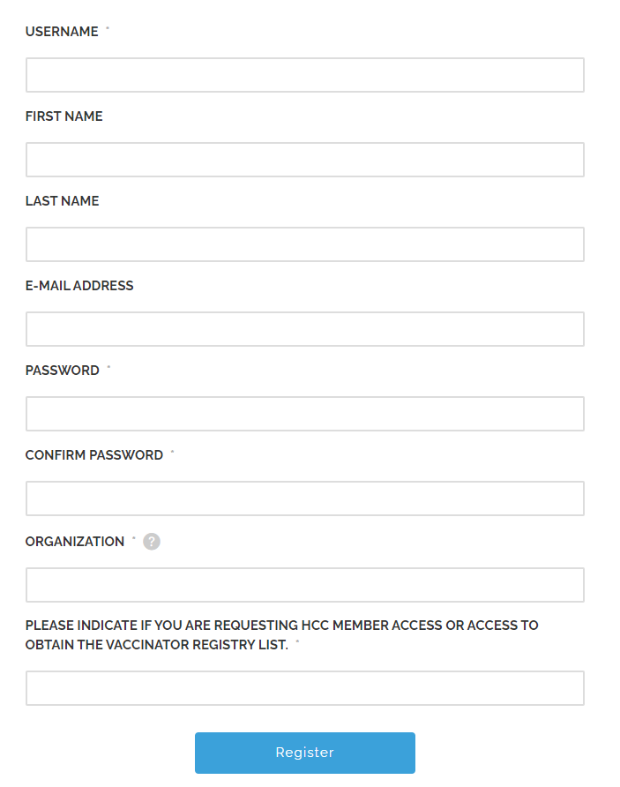

- Click Register. You will be approved within 24-48 hours of request.

- After getting access, return to www.cthcc.org

- Click “Login” at the top of the page

- Enter your credentials

- Navigate to “Vaccinator Registry” at the top of the page. Then click “Download File”
