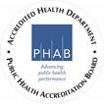
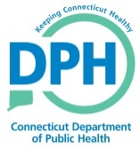
AGENDA
MOLST Advisory Committee Meeting
January 14, 2020, 9:00-10:00
Department of Public Health
(Conference Room 2F, 410 Capitol Ave)

- Welcome / New Members

- Molst Advisory Committee
  - Posting of meetings and minutes
  - Email soliciting agenda items one week prior

- Discussion regarding the definition of a legally authorized representative in the MOLST act “Legally authorized representative” means a minor patient’s parent, guardian appointed by the Probate Court or a health care representative appointed in accordance with sections 19a-576 and 19a-577” , what role is there for of next-of-kin, spouse, or conservator. Challenges/gaps:

- Update on physician MOLST Training a Twenty MD’s trained/certified per a CT Train query

- Re-appointment Letters

- Subcommittees
  - Website review and updates;
  - Provider training and outreach;
    - Carol Dietz
  - Consumer outreach;
  - MOLST Form management and distribution;
  - Quality Assurance and Performance Improvement; and
  - Provider Implementation

- Future opportunities for quality improvement

