ITEM #1220027A – construction Signs

[This is a sample special provision that should be revised to be specific to each project.]

Section 12.20 is supplemented and amended as follows:

Article 12.20.01 – Description:

Add the following:

The Contractor shall also furnish, install, maintain, and remove Bipartisan Infrastructure Law project signs. The Bipartisan Infrastructure Law project signs shall be of the details, colors and materials as shown on the attached detail sheet.

The sign legend for this Project shall include the U.S. Department of Transportation pictograph on the lower right side of the sign with the legend [insert Project funding source: Federal Highway Administration, FTA, FRA, or NHTSA.]

Article 12.20.03 — Construction Methods:

Add the following:

The Contractor shall install the Bipartisan Infrastructure Law (BIL) project signs prior to initiating construction.

[Include the following paragraph for projects with roadway impacts where the BIL project sign will be visible from a public roadway. Please revise the paragraph if needed.]
The Contractor shall install BIL project sign TP1550 on each major roadway approach to the construction Site in advance of the Project limit(s).
The sign detail is included and is also available at TP1550--BIL-ROADWAY.pdf.

[Include the following paragraph for projects where the BIL project sign will be located at or near a facility. Please revise the paragraph as applicable.] The Contractor shall install BIL project sign TP1551 in the parking lot, facility grounds, shared-use path, or other area in the vicinity of construction as indicated in the Contract documents or directed by the Engineer.
The sign detail is included and is also available at TP1551-BIL-NON-ROADWAY.pdf.

The Contractor shall maintain the BIL project signs for the entire duration of the Project. The Contractor shall relocate the BIL project signs during construction as needed and shall remove the signs after construction work is completed.

Article 12.20.05 – Basis of Payment:

Add the following:

The price shall also include furnishing, installing, maintaining, relocating, and removing the Bipartisan Infrastructure Law project signs and sign posts and all hardware, materials, and labor incidental thereto.
[Include this detail sheet for projects where the BIL project sign will be located at or near a facility (not within highway ROW).]
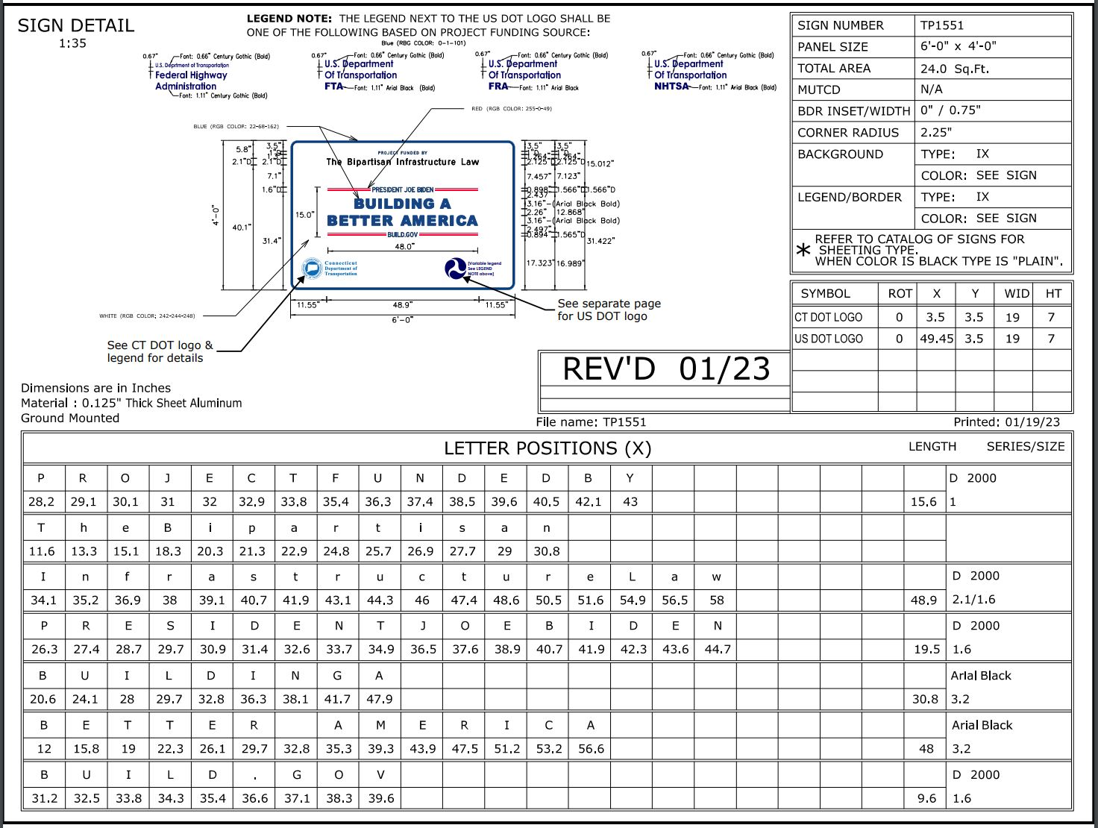
[Include this detail sheet for projects where the BIL project sign will be visible from a public roadway.] 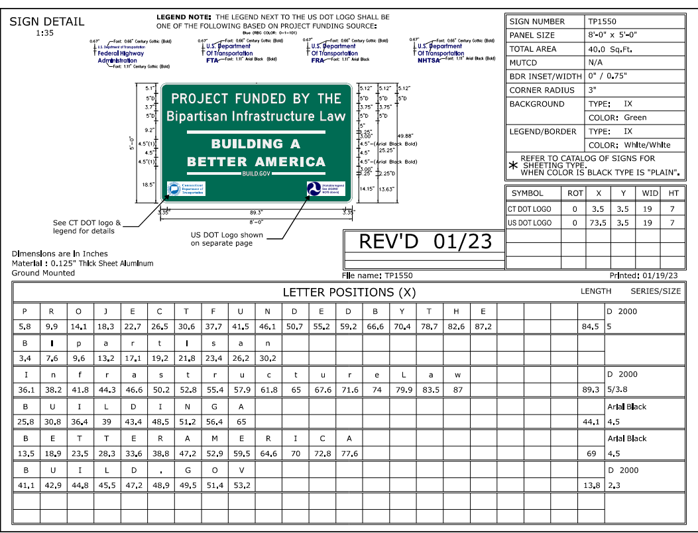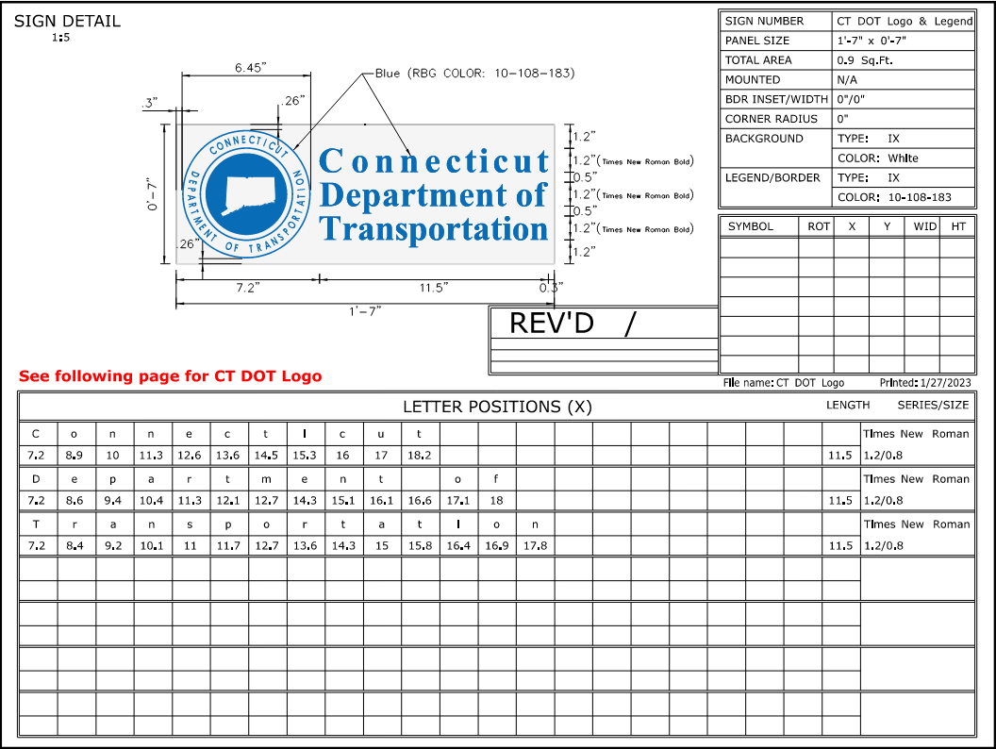
Link to .dgn file: CTDOT_logo.dgn
Link to .dgn file: USDOT_logo.dgn

