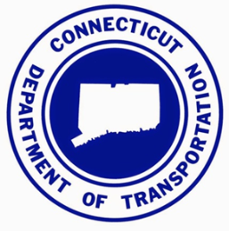
For Research Section Use Only
Problem Statement #:
Date Received:
Research Project Suggestion Form

1. Project Title (required).

2. Problem Statement (required). Concisely describe the problem that needs to be researched.

3. Background (required). To avoid duplication of other current and past research, minimum literature search should be conducted on TRID. Summarize the findings of the preliminary literature search. Attach pertinent background information, if needed.

4. Research Proposed (required). What research is proposed to address the above need? If possible, describe the major task(s) necessary to achieve the objectives.

5. Expected Benefits (required). Describe how this research will serve the public by providing transportation system elements and services that emphasize quality, safety, cost effectiveness, economic vitality, and/or sensitivity to the environment.

6. Implementation (required). Describe how the research results can be implemented. Identify the CTDOT office, or an entity outside of CTDOT, responsible for implementation.

7. Submitted by (required)
Name:
Title:
Affiliation:
Dept. /Bureau:
Phone No.:
E-mail:

8. Champion (optional): Must be internal to CTDOT, feel strongly that the research will benefit the Department, chair the technical panel, and ensure implementation.
Name:
Title:
Phone No.:
E-mail:

9. Sponsor(s) (optional): Must be internal to CTDOT (Bureau Director or higher) and support implementation, as appropriate.
Name:
Phone No.:
E-mail:

10. IT Component (required): Choose an item.
If the project includes an IT component, describe the IT component in as much detail as possible. (Purchase of IT hardware, development of databases, acquisition of existing applications, etc.)

Submit to:
Edgardo Block, P.E.
Office of Policy and Strategic Planning; Research Section
Bureau of Policy and Planning
Connecticut Department of Transportation
E-mail: Edgardo.Block@ct.gov
Phone: 860-594-2495

This form is available at: www.ct.gov/dot/research

