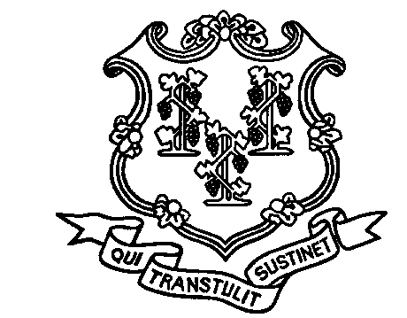

STATE OF CONNECTICUT

Department of Correction

24 Wolcott Hill Road

Wethersfield, CT 06109

FAMILY MEDICAL LEAVE ACT

Acknowledgement of Receipt

I acknowledge receipt of the Department of Correction’s Statement of Employee Rights and Responsibilities under the Family Medical Leave Act (FMLA).

___________________________________________________________________
Print Name

____________________________________________________________________
Employee Signature Date

Rev. 8/21/13

