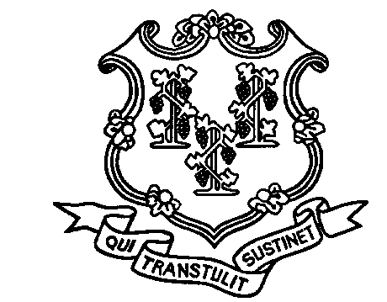
STATE OF CONNECTICUT

DEPARTMENT OF CORRECTION
24 Wolcott Hill Road
Wethersfield, Connecticut 06109

RELEASE

I do hereby give the Department of Correction the right to use my picture, portrait, or photograph in all forms and media and in all manners, including composite for advertising, trade, or any other lawful purposes, and I waive any right to inspect or approve the finished product, including written copy, that may be created in connection therewith.

I have read this release and am fully familiar with its contents.

_____________________________________________________
Print Name

_____________________________________________________
Sign Name

_____________________________________________________
Date

_____________________________________________________
Witness

_____________________________________________________
Date

