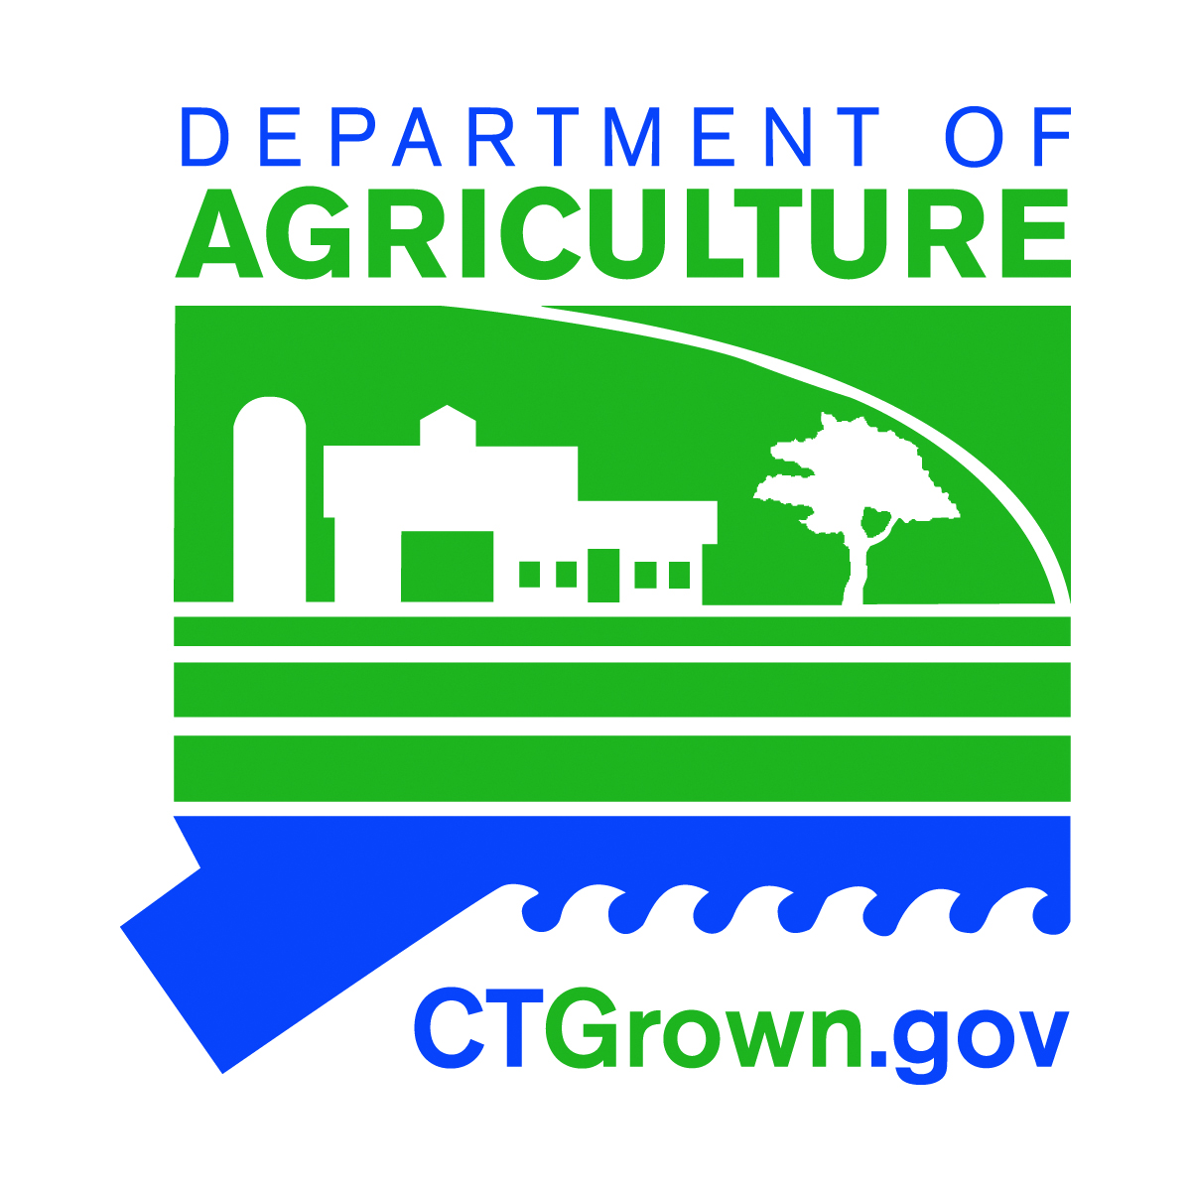
STATE OF CONNECTICUT

DEPARTMENT OF AGRICULTURE

Office of the Commissioner

Bryan P. Hurlburt  Commissioner | 860-713-2501  www.CTGrown.gov

Freedom of Information Act Request
Completed forms may be submitted in person, via e-mail to AGR.FOIA@ct.gov, or mailed to Department of Agriculture, FOIA Administrator, Suite 701,450 Columbus Blvd., Hartford, CT 06103. Please note that your request is also a public record, and thus, subject to disclosure. Paper copies are subject to a charge of $.25 per page. For large document requests, the department may require a deposit of the estimated amount of the copy charges. The documents will be provided in electronic form by the department, to the extent reasonably available.

Part I: Requester Information

Name: Mailing Address: City/Town: State: Zip Code: Affiliation (optional): Phone: *E-mail: _______________
*By providing this e-mail address you are agreeing to receive official correspondence from the department, at this electronic address, concerning the subject form. Please remember to check your security settings to be sure you can receive e-mails from “ct.gov” addresses. Also, please notify the department if your e-mail address changes.

Part II: Description of Records
NOTE: Each request may reference only one specific property location address. Please submit separate requests for each additional location.

Document review and/or copies sought (please be specific, i.e., include licensee name, property location address, all available case file numbers, programs within DOAG having involvement, date range and exact information being sought).

