**Learning Inventory of Skills Training (L.I.S.T.) Guide and Manual**

**Dana Begin, OTR/L**

**Office of the Commissioner, State of Connecticut Department of Mental Health and Addiction Services**

**Stephen Keller, OTR/L**

**Southeastern Mental Health Authority, State of Connecticut Department of Mental Health and Addiction Services**

**Susan Strumpf, MS OTR/L**

**Western Connecticut Mental Health Network, State of Connecticut Department of Mental Health and Addiction Services**

**Acknowledgements**

We would like to acknowledge and extend our appreciation and gratitude to the leadership staff of the Department of Mental Health and Addiction Services, Young Adult Services, Office of the Commissioner, especially Cheryl Jacques, DNP, APRN (Statewide Director of YAS), Amy Marracino, LCSW (Director of YAS Community Programs) and Nikki Richer (Director of YAS Operations) for their support, guidance and affording us the opportunity to utilize our creativity and expertise to develop an instrument that is now being implemented statewide and having a significant positive impact on the individuals we serve.

We would also like to recognize Dr. John Holland, LCSW, Ph.D. (YAS Behavioral Health Clinical Manager) who provided his expertise and knowledge regarding improving reliability and validity, data collection, and quality assurance measures.

And finally, to all of the DMHAS YAS Occupational Therapists, Certified Occupational Therapy Assistants, and former student interns who contributed their thoughts and ideas in the development of this manual.

**Table of Contents**

**Chapter 1 Introduction…………………………………………………………………………………………………………..1**

Nature and Purpose…………………………………………………………………………………………………………………..1

Factors……………………………………………………………………………………………………………………………………….1

Domains…………………………………………………………………………………………………………………………………….2

Clinical Applications………………………………………………………………………………………………………….……….5

User Qualifications………………………………………………………………………………………………………….….…….5

**Chapter 2 Overview of Tool and Scoring Procedures………….…………………………………………………..7**

Standard Procedures………………………………………………………………………………………………………………….7

Administration Time………………..………………………………………………………………………………………………..8

Physical Conditions…………………………………………………………………………………………………………………….8

Materials……………………………………………………………….………………………………………………………………….8

Establishing and Maintaining Rapport………………………………………………………………………………………11

Administration of the LIST………………………………………………………………………………………………………..12

Sequence of Domains………………………………………………………………………………………………………………12

Item Directions………………………………………………………………………………………………………………………..12

Key Points for Observing Skills………………………………………………………………………………………………….13

Repetition of Items and Probing of Responses…………………………………………………………………………13

The “Teaching Trap”…………………………………………………………….………………………………………………….14

Generalization of Knowledge………………………………………………………………………………………………….15

Personal Expectations…………………………………………………………………………………………………………….16

Transparency……………………………………………………………………………………………………………………………16

Capitalize on Staff Strengths and Interests………………………………………………………………………………17

Be Flexible and Know When to “Bail”…………………………………………………………………………………….. 17

Scoring and Completing the Record Form……………………………………………………………………………….17

**Chapter 3 Administration and Scoring Directions…………………………………………………………………19**

General Directions……………………………………………………………………………………………………………………19

Money Management……………………………………………………………………………………………………………….20

Food Management…………………………………………………………………………………………………………………..29

Personal Appearance and Hygiene…………………………………………………………………………………………..35

Home Management…………………………………………………………………………………………………………………40

Housing……………………………………………………………………………………………………………………………………46

Transportation…………………………………………………………………………………………………………………………51

Emergency and Fire Safety Skills……………………………………………………………………………………..………55

Health and Wellness……………………………………………………………………………………………………………..…61

Community Resources……………………………………………………………………………………………………………..70

Sexual Health…………..………………………………………………………………………………………………………………74

**Appendices………………………………………………………………………………………………………………………….78**

**CHAPTER 1**

**Introduction**

**Nature and Purpose**

The Learning Inventory of Skills Training (L.I.S.T.) is an individually administered observation of a person’s skills and abilities in activities of daily living (ADLs), instrumental activities of daily living (IADLs) and social/emotional skills. ADLs are basic self-care skills that one needs to care of their personal appearance and well-being such as feeding, grooming, toileting and dressing. IADLs are more complex tasks that are needed to be able to live independently and successfully such as cooking, cleaning, managing finances and shopping. Social/emotional skills are those which contribute to the ability to cope with, regulate and manage emotions, interact and relate to others, and to feel good about oneself.

The LIST was developed to be a comprehensive, albeit non-exhaustive, tool that can be used to assist in the decision making process regarding levels of care, living arrangements, need for specialized services/supports, modifications or adaptations to home and work environments, and instruction on areas for skill development.

The LIST can be used with individuals of all ages with a typical minimum age of at least 12 years old.

**Factors**

Two factors can be derived from each skill, and/or an overall picture of each domain: Knowledge and Application.

* **Knowledge:** The LIST is primarily intended to measure *knowledge* of skills – does the individual *know how* to do the skill – and less about whether or not they *actually* do it. That is why the items in each domain are worded to measure knowledge (“knows how to” vs. “is able to”).
* **Application:** The secondary factor is determining if the individual is able to *apply their knowledge* to carry out and perform the skill or task. In other words, do they actually *do* it?

**Domains**

The LIST consists of 20 domains for the Department of Mental Health and Addition Services (DMHAS) and 21 for the Department of Children and Families (DCF) which include:

* Money Management
* Food Management
* Personal Appearance and Hygiene
* Home Management
* Housing
* Transportation
* Emergency and Safety Skills
* Health and Wellness
* Educational Planning
* Job Seeking Skills
* Job Maintenance Skills
* Knowledge of Community Resources
* Interpersonal Skills
* Legal Skills
* Coping Skills
* Anger Management Skills
* Relationship Skills
* Pregnancy Prevention Skills
* Parenting and Childcare Skills
* Medication Management
* Permanency (DCF only)

Although the tool offers 21 life skill domains, the staff person should determine which domains are most relevant to the individual and observe only those areas (or those domains that have been identified as the “core” domains by the agency and therefore required as part of the tool).

All of the domains are set up in the same way. Skills are grouped into subscales by skill level into “Basic” skills, “Intermediate” skills, and “Advanced” skills. It should be noted that the skills in each skill level are not listed in any particular order. For example, in the money management domain, “Knows the value of coins and currency” is not considered any more basic than, “Knows at least one way to save money on purchases” just because it is listed first. They are both considered to be equally “Basic” skills.

It is extremely important to note the “minimum number of required skills” in each skill level of the domains. These are guides for when the staff person should stop the observation of that domain. Within each skill level, the minimum number of required skills indicates when the staff person should progress to the next skill level. **Note: The observer should pay close attention to the minimum number of required skills in each domain as they change based upon the domain, the skill level, and the number of skills in each domain. IMPORTANT: The observer must always start the observation with the Basic skills in the domain.** There are three reasons for which the observation must begin with the “Basic” skills

1. If the individual knows a lot of the “Basic” skills it will help to build their confidence and assist with making the interview (observation) less threatening or anxiety producing.
2. We don’t want to make any assumptions that they have all of the basic skills – some they may know, some they may not.
3. We might miss some important information about their skills if we start anywhere but the beginning.

For example, in the Money Management domain, the individual must know **three out of five of the Basic skills** in money management in order for the staff person to proceed on to observe the Intermediate skills. Therefore, if the individual only has **two of the five Basic skills**, the staff person’s **observation of the Money Management** **domain can end right there**. The rationale for this is that if the individual doesn’t have at least the minimum number of required skills in the Basic level, it is not likely that they will have many or any of the Intermediate or Advanced skills, and likely not have enough of those skills to be rated as such.

If you know the individual well, you may know that they have some or a few of the Intermediate and/or Advanced skills and the staff person can note that on the tool by checking them off. These are called “splinter skills”. “Splinter skills” are advanced or higher level skills that someone learns or has been taught, but doesn’t have the foundation knowledge. For example, a child can be taught through practice how to write their own name but they may not understand or know how to read or what the letters mean or how to put letters together to form words.

If the individual **does have at least three** (or four or five) of the Basic skills in Money Management, then the staff person should **proceed on** to begin to observe the Intermediate skills.

The minimum number of required skills in each domain is based upon a standard of knowing 75% or more of the skills (3 out of 4, 5 out of 6, etc.).

Another reason to end our observation if the individual doesn’t know at least the minimum number of required skills is that if the staff person continues to ask them questions that they don’t know the answers to, it can become very frustrating and upsetting for the individual and hurt their self-esteem and performance.

For each skill that you observe and determine that the individual knows how to do that skill, place a check mark (✔) in the box next to that skill. For each skill that you observe and determine that the individual *does not know* how to do that skill, place an (✘) in the box next to that skill. For any skill not observed, leave the box blank.

Each domain also includes a ‘comments’ section. This section is very important and should be utilized to capture and include important information about the individual such as:

* Ability to *apply* their skills: This was discussed earlier that an individual may know how to do a lot of things, but may not apply their skills. The comments section should be used to indicate this, and the possible reasons *why* they might not be applying their skills (if the observer has knowledge of this).
* Any mismatch between the individual’s developmental age and chronological age: If a particular domain is not observed due to a mismatch, this should be noted in the comments. Such as, “Although John is 20 years old, due to cognitive and developmental disabilities, this domain is not able to be observed at this time.” Also, a mismatch in skills and chronological age should be noted. For example, an individual may be 20 years old, and only have 2 of the basic skills in Money Management. One would expect that a 20 year old would have more skills in money management based upon their age. When this mismatch occurs, the staff person should provide information as to why in the comments.
* Any other information that is relevant to the individual and important for providers to know about their skills in that particular domain.

**Clinical Applications**

The LIST can yield valuable information and serves several purposes as outlined below.

* **Determine competencies:** The LIST will provide information regarding skills and strengths an individual already has and identify focus areas for further instruction and development.
* **Monitor and measure progress:** Annual or periodic evaluations can provide information regarding someone’s progress (or lack thereof).
* **Provide information which can be used to assist in determining level of care:** For example, if an individual scores particularly low in “Emergency and Safety Skills”, it might be determined that they would need supervised and/or supported housing arrangements.
* **Identify areas needed for skill building:** The provider and the individual should discuss which domains they will prioritize to focus on for skill instruction.
* **Assist with developing a plan of care:** Once a thorough observation has been done, those skills that have been prioritized can then be incorporated into the individuals plan of care.

**User Qualifications**

While there are no restrictions as to who can administer the LIST, there are several recommendations that should be considered prior to administration.

* **Training:** It is preferable that individuals who wish to administer the LIST attend trainings offered *prior* to using the tool. However, if this is not possible, then particular attention should be paid to using this manual and the recommendations set forth.
* **Manual:** The use of this manual and adherence to the recommendations is imperative to maintain fidelity, reliability and validity of the tool.
* **Population:** Individuals who administer this tool should be knowledgeable about, and experienced in working with, the population they are testing.

**Chapter 2**

**Overview of Tool and Scoring**

**Standard Procedures**

The directions for administration and scoring of the LIST (see Chapter 3) provide very specific information to ensure that the tool is delivered in a uniform and standardized manner.

Skills are listed in subscales in each domain under “Basic”, “Intermediate”, or “Advanced”. The staff person should always begin by observing the “Basic” skills and pay special attention to the minimum number of required skills (which are discontinue rules) in each subscale to know when and if to stop the observation of that particular domain.

There are three methods by which the staff person can obtain information directly from the examinee to be used in the tool: demonstration, the use of a “toolkit” or interview. Since this instrument was primarily designed to measure *knowledge* of skills rather than application, this manual provides instruction on how to conduct an interview to determine knowledge of skills. There are some items which require demonstration through simulation, pantomime, and pen and paper in order to get a better sense of the individual’s knowledge that a simple interview question would not provide. If the staff person does not feel that the interview alone is sufficient or adequate to determine skill level, he/she may actually have the individual demonstrate the skill. For example, if the individual has difficulty using words to explain how they use the washing machine, the staff person could ask the individual to demonstrate how he/she uses it.

The staff person can also obtain and use information about the individual’s skills from those people that know the individual best and/or see the individual in their natural environment (parents, foster parents, program staff, caregivers, school teachers, etc.). Try to ask detailed questions about what they have observed the individual do (or not do). For example: A program staff member tells you that Johnny is independent with banking. However, when you take Johnny to the bank, you actually discover that he just walks up to the teller and the teller does everything for him (fills out deposit or withdrawal slip, writes it in the bank book, etc.).

**Administration time**

Administration time varies greatly and is highly dependent on the individual, how many domains are observed at a time, whether it is done through demonstration or by interview, and the skill level of the participant. Administration will take far less time with individuals that are less skilled, due to the discontinue rules. The tool does not need to be completed all in one session and in fact can take place over the course of several sessions, based upon the needs and attention span of the individual. Breaks can be taken if necessary and are encouraged.

**Physical Conditions**

The tool should be completed in a quiet space, with good lighting and limited noise and distractions. Some test items require the use of items to demonstrate a skill (by using pen and paper, calculator, cooking utensils, pictures, etc.) therefore it may be beneficial to be seated at a desk or table.

**Materials**

Several of the materials needed for this tool are included in the appendices and referenced in the directions pertaining to that skill. The staff person must provide the following items for their “toolkits”:

* **Money Management Toolkit:**
  + Pen and pencil
  + Calculator
  + Money either fake or real
    - Coins: penny, nickel, dime, quarter
    - Bills: $1, $5, $10, $20
  + 2 items for role play to purchase with price tags
* **Food Management Toolkit**
  + Paper, pen, pencil for grocery list
  + Frying pan
  + Calculator
  + Rice, seeds, beans for using measuring cups
  + Can of food (to use opener)
  + Food items that contain expiration dates
  + Frozen food bag (empty)
  + Can with cooking instructions (empty)
  + Utensils:
    - Fork
    - Knife
    - Spoon
    - Spatula
    - Measuring cups/spoons
    - Flipper (metal and Teflon)
    - Colander
    - Can opener
    - Pizza cutter
    - Wisk
    - Optional to have in toolkit are: cheese grater, peeler, rolling pin, hand mixer (can use pictures instead)
* **Personal Appearance and Hygiene**
  + Iron (Optional)

**Items provided in Appendices:**

* **Money Management** 
  + Luxury/necessity work sheet
  + Blank withdrawal and deposit slips
  + Blank checks worksheet with check register/ledger
  + Sample utility bills (2)
  + Budgeting scenarios
  + Sample paycheck
  + Monthly budget worksheet
  + Sample monthly bank statement
* **Food Management**
  + Healthy Food Choice Hand-out
  + Cafeteria Menu
  + “Burger Land” Menu
  + Utensils Identification Exercise
  + Olive Garden Menu
  + Expiration Date Exercise
  + Canned Food Preparation Exercise
  + Frozen Food Preparation Exercise
  + Meal planning sheet
  + Adjusting Amounts of a Recipe Exercise
* **Personal Appearance and Hygiene**
  + Sorting Laundry Exercise
  + Reading Clothing Labels Exercise
  + Washing Clothes Information
  + Drying Clothes Information
* **Housing**
  + Apartment Advertisement Exercise
* **Pregnancy Prevention**
  + Condom Use Information

**Establishing and Maintaining Rapport**

It is very important to establish and maintain a good working relationship and rapport with the individual. The more relaxed and comfortable the individual feels, the more forthcoming they will be with information. Therefore, the staff person should try to avoid telling the individual that they are being “tested” or “evaluated” and that this is an “assessment” of their skills. This can often lead to an increase in anxiety, which can then lead to either poor performance or inflated performance (where the individual reports that they can do more than they really can). A general introduction or “script” can be found in Chapter 3.

The staff person should start by reassuring the individual that they are simply looking to get to know them better by finding out what they are good at and what skills they might need to learn in order to be as independent as possible. It can be introduced as a series of questions and tasks that are common in daily living.

The nature of the questions in some of the domains can, at times, become very personal in nature (particularly Personal Appearance and Hygiene, and Pregnancy Prevention). It is recommended that whenever possible, the tool be administered by a person whom the individual trusts, has a rapport with, and/or has an established professional relationship.

The interview (observation or discussion) should be as natural as possible and flow like a normal conversation. This will also reassure the individual that the staff person is interested in getting to know them, rather than whether or not they know the “right” answers to questions. As a result of this, conversation may get off topic or tangential. Some off-topic discussion is OK and can at times lead to relevant and useful information about their skills and abilities in other domains. Be prepared to allow this to happen as it can be a way to engage the individual and develop trust and rapport. Other times the conversation may truly stray too far from the topic and the individual may need to be redirected back to the topic. The staff person might say, “Ok, that information is helpful. Let’s move on to the next item.” or “I’d really like to hear more about that when we meet again. But for now, let’s keep going.”

**Administration of the LIST**

**Sequence of Domains**

The domains of the LIST can be observed in any order and do not follow any particular sequence. The staff person and participant can choose which one(s) they would like to start with based upon individual preferences, time considerations and needs.

The staff person *must*, however, begin by observing the “Basic” skills in each domain and pay close attention to the discontinue rules or “minimum number of required skills” in each skill level.

**Item Directions**

Each item in Chapter 3 provides the staff person with questions and/or prompts for the individual and the materials needed (whether from the “toolkit” or appendix). It also identifies “scoring” criteria and a list of potential/possible correct responses, however it should be noted that this list is not exhaustive and an individual may offer a correct response that isn’t listed. In most cases, the scoring is objective, however in some cases the staff person may have to use their best judgment as to whether the individual provided an adequate response.

**Key Points for Observing Skills**

There are a few key points that should be emphasized because they important to keep in mind when conducting the observation.

*Repetition of Items and Probing of Responses*

Repetition and/or re-wording of a question or prompt is OK if the individual is unable to understand the original query. Modification in language or vocabulary may need to be made to accommodate each individual’s cognitive abilities.

The staff person may also need to probe responses to gain more clarity, or to obtain more detail if an answer is too vague.

In addition, responses that are correct because of local/regional circumstances or new technology should be scored as correct.

* What is the “essence” of the question (or skill)?: The staff person must understand what each skill is really trying to determine. For example, in food management “Knows that it is important to wash hands before eating and preparing a meal”. An individual washes their hands *every time* before they eat or prepare food. When they are asked why they do it, they reply, “Because they [staff] tell me to.” Even though the individual washes their hands every time prior to eating or preparing food, they don’t know (or are not able to state) *why it’s important* to do so (because of germs, its good hygiene, bacteria, etc.) and therefore would not be marked as having this skill.
* “Leading” questions: It is OK and sometimes necessary to ask leading questions to try to get the individual to provide an answer that the staff person is looking for. For example, in personal appearance and hygiene, the staff person would like to find out if the individual showers or bathes regularly. Asking the question directly will not elicit a reliable answer. (Staff: “Do you shower or bathe regularly?” Individual: “Yes.” – Not reliable). Instead, the staff person might need to ask leading questions such as, “Tell me about your morning routine. What do you do when you get up in the morning?” If the individual answers with tasks other than bathing/showering, the staff person may need to ask a more direct and leading question like, “Is there anything you do to take care of your personal appearance or your hygiene?”
* “Follow-up” questions:These types of questions are needed when the staff person needs more information about something in order to make sure the individual really does know or have the skill. For example, in money management you ask the youth, “Give me some examples of something that is a ‘luxury’ and something that is a ‘necessity’.” The individual responds, “A nice car is a luxury and clothing is a necessity.” Although this is true, we may need a follow-up question here such as, “Where do you shop for clothes?” If the youth responds, “Saks Fifth Avenue, Nordstrom, I like Coach bags,…” The staff person would want to explore further if the individual is able to recognize that clothing and items from these types of stores aren’t “necessities”.

*The “Teaching Trap”*

The “teaching trap” is very easy to fall into while observing. It happens when the staff person stops observing skills, and begins teaching something in the middle of the observation. For example, in the money management domain, the staff person asked, “If you had two quarters, a dime and a nickel, how much money would you have?” and the individual responded with “Two dollars.” The “teaching trap” would be to say to them, “Well, let’s talk about that... a quarter is worth 25 cents so two would be 50 cents… a dime is worth 10 cents and a nickel is worth 5 cents so if you add 50 cents plus 10 cents plus 5 cents, how much do you have?” And the individual replies, “65 cents” what should the staff person do? Should they check them off that now they have the skill? No. The staff person should try to avoid teaching so they don’t run into this dilemma. Also, teaching takes a lot of time and will increase the time it takes to complete the tool. An individual may try to ask the staff person to teach them the right answer in the moment, but a good response would be, “I’m really glad you want to learn how to do that, and I’d be happy to teach it to you, we can definitely work on it together. Let’s try to finish our discussion of (fill in the blank) first.”

**However, there is a time when teaching SHOULD happen during the observation.**  This is when there is a **significant safety concern** and the staff person wants to be sure they know the correct way to respond. For example, in home management, the staff person asks the individual about what cleaning products he/she uses when they clean their apartment and they say, “Oh I just mix a little ammonia with a little bleach, it gets things really clean!” **STOP AND TEACH them that it is very dangerous to mix cleaning products and why.** Another example would be if the staff person asked the individual if they would know what to do if there was a gas leak in their apartment and they say, “I don’t know, I’d probably light a cigarette and call someone.” **STOP AND TEACH!**

*Generalization of Knowledge*

Generalization of knowledge is the ability to apply your knowledge if a variety of different environments, conditions, locations, and situations. This is very important to identify and determine, because even though an individual may know how to do something in one area, does not mean they are able to generalize it to other areas. Some examples include: the individual’s current apartment has a dishwasher… do they still need to learn how to wash dishes? YES, because they may move to an apartment that doesn’t have a dishwasher. Gas stoves vs. electric stoves: cooking on them is slightly different. It may take some time to “re-learn” how to cook if going from one to the other. Transportation: knowing how to take the bus in Hartford is different than taking the bus in New Haven, or Torrington, or Norwich.

*Personal Expectations*

Using the example of “knows how to make a bed” in home management, the staff person may have their own personal expectation of how they like (or think) their bed should be made. Some people like hospital corners with the sheet smoothed out and the comforter pulled up with 8 pillows fluffed and sitting perfectly at the head of the bed. Others may just throw the comforter over the crinkled up sheet and haphazardly toss the pillows somewhere on the bed and consider it made. The staff person must be cautious not to hold the individual to their own personal expectation of how *they* think something should be done, but rather what is generally considered to constitute “knowledge” or “successful mastery”. The scoring instructions in Chapter 3 will provide some consistency and guidance around this.

*Transparency*

Transparency means being able to have an open and honest discussion with the individual about his or her skills and any mismatch the staff person might notice between *what they think they know* (or are telling the staff person) and what the staff person is observing. This especially comes into play in the personal appearance and hygiene domain. The individual may tell you that they bathe/shower every day, but the staff person notices that their clothing appears stained and dirty, their hair is matted down and greasy, and they have an odor. Therefore, the staff person wouldn’t “check off” that they shower or bathe regularly. The individual then asks, “What are you writing about me? Can I see what you’re writing? Why didn’t you check that off? I told you that I do that.” The discussion about the mismatch is most successful when there is a good rapport between the staff and the youth. **This may mean that consideration should be made to choose staff to observe different domains depending on their relationship with the individual.** Personal appearance and hygiene can be a challenging domain to observe if the relationship (rapport, trust) between the staff and the individual is not present. Also, gender considerations should be made and matched accordingly. The staff person should also be respectful in what they write in the comments about the individual because they have the right to see what the staff person is writing. It should NEVER be anything offensive, demeaning, or disrespectful.

*Capitalize on Staff Strengths and Interests*

Similar to staff’s relationships with clients, staff also have their own “expertise” and experience that should be recognized and utilized. For example, a nurse may be best equipped to observe the medication management domain. Certain staff may shy away from wanting to observe or teach money management skills because they know that they aren’t good with money themselves. It is helpful to match staff strengths and interests to domains to be observed and taught to maximize the benefits for the individual.

*Be flexible and know when to “bail”*

The staff person should be prepared to know when to say “when”. He or she may be trying to observe an individual and keep coming up against resistance. It may just not be the right day/time to do the tool. Perhaps the individual is upset because they just got bad news, or didn’t get the check they were expecting, or had a bad day at work/school. It is OK to “bail” and end the session and try again another day.

**Scoring and Completing the Record Form**

The first page of the LIST is the score sheet or Record Form which is where the staff person will complete the demographic information and record the individual’s scores.

The results of the tool yield 5 skill levels. They are:

* **Pre-Basic:** Means the youth has **less than** the minimum number of required skills in the Basic category
* **Basic:** Means that the youth has **at least** the minimum number of required skills in the Basic category
* **Intermediate:** Means that the youth has **at least** the minimum number of required skills in the Intermediate category
* **Advanced:** Means that the youth has **at least** the minimum number of required skills in the Advanced Category
* **Independent:** Means that the youth has **more than** the minimum number of required skills in **all** categories (Basic, Intermediate and Advanced).

These scores then get transcribed onto the first page record form of the LIST by checking off the appropriate box under the corresponding skill level.

The record form also requires the staff person to identify, based upon a Likert scale, how well (overall) the individual *applies* their skills in that domain.

The Record Form also requires the individual, along with the staff person, to choose and prioritize the top two to three domains that will be the focus for skill building.

**CHAPTER 3**

**Administration and Scoring Directions**

**General Directions**

The scoring criteria outlined in this chapter provide guidelines for determining how to quantify an individual’s response. Some items have only one response that is correct, but other items elicit responses that can include several correct answers. Examples of responses are given to aid in scoring, but it is important to note that the examples are not exhaustive. In some cases, responses require a specific number in order to be “counted”. For example, “Must be able to state at least three ways”. In these cases, the staff person can prompt or ask a follow up question to see if the individual can expand on their response, just as long as the staff person does not provide them with the answer in their query. If they still do not meet the minimum criteria, the response should not be “counted”.

Introduce the LIST to the individual by stating, “I’d like to talk to you about what you know and what you might want to learn more about in order to help you reach your goals. Some of the questions I am going to ask you will be really easy; just bear with me and we will get through them. Also, some of the questions might be really hard – you might not know the answer or you might not want to answer and that is OK. No one answers all of them correctly. You can just tell me that you don’t know, prefer not to answer, or that you ‘pass’ on answering.”

The Scoring Directions begin on the following page. Included in the manual are the scoring directions for the domains that are the most objective domains, whose skills can be most easily “measured”. These domains include: Money Management, Food Management, Personal Appearance and Hygiene, Home Management, Housing, Transportation, Emergency and Safety Skills, Health and Wellness, Community Resources and Pregnancy Prevention.

**A. MONEY MANAGEMENT**

**BASIC: Must know 4 out of 6**

Prompt Answer Indicating Knowledge

|  |  |
| --- | --- |
| **1. Knows values of coins/currency** | **Must know at least one** |
| “If you have 2 quarters, one dime, one nickel and 4 pennies, how much money do you have?”  **OR**  Present fake money found in tool kit or use real money (optional).  Coins: Penny, nickel, dime, quarter  Bills: $1, $5, $10, $20 | $0.69  **OR**  Able to correctly state the value of all:  Penny  Nickel  Dime  Quarter  $1 Bill  $5 Bill  $10 Bill  $20 Bill |
| **2. Knows how to make a transaction at a store and count change correctly** | **Must know at least one** |
| “You go to the store to buy milk, cereal, bread and soda. Your total is $12.65 (including tax). You pay with a $20 bill. How much change should you get?”  **OR**  Role-play making two different purchases at a store switching roles as the cashier and consumer.  Purchase is $2.65 and individual pays with a $5 dollar bill (consumer)  **OR**  Purchase is $3.84 and individual pays with a $10 dollar bill (cashier)  Use items to purchase in tool kit e.g., Axe deodorant, bar of moisturizing soap with price tags | $7.35  **OR**  Able to count change given by cashier (staff person) to verify that it is correct or incorrect  **OR**  Able to provide “consumer” with correct amount of change |
| **3. Understands the difference between luxuries and necessities and can give examples of both** | **Must be able to provide at least one example of a luxury AND necessity** |
| “Please explain the difference between a luxury and necessity and give some examples of each.”  You can use the worksheet **(Appendix 1 pg. 78)** if needed to assist the individual to provide examples. | If any answers do not seem clear, ask why the example is necessary or why it is not  Facilitator uses best clinical judgment as individual needs may vary.  (Ex: One with a diagnosis of PTSD may use gaming to self sooth when triggered) |
| **4. Understands the difference between sale price and regular price** | **Must indicate at least two ways of knowing the difference** |
| “What does it mean when something is ‘on sale’ vs. ‘regular’ price”? OR “How would you know if an item’s price is a sale price or the regular price?” | It is labeled as “sale” price  In sale section at store  In the store’s sale flyer  Notified by a mailing of a sale  **Note:** “It’s cheaper” is not sufficient knowledge to be able to tell if something is on sale. They need at least two of the above indicators to determine that it is “on sale” and that the price wasn’t just marked down to a new “regular” price. |
| **5. Knows at least one way to save money on purchases** | **Must indicate at least two ways** |
| “What are ways to save money when you buy things?” | Various answers will indicate knowledge of ways to save money  Buy items on sale  Use coupons  Buy in bulk  Purchase generic products or store brand products  Shop at discount/thrift stores  Find mark downs  Buy used  Comparison Shopping (*Prompt: What does “comparison shopping” mean?) |
| **6. Knows how to use a calculator to perform simple math equations** | **Must be able to do all** |
| Ask individual to use a calculator to perform the following:  **17 + 34 =**  **42 – 19 =**  **12 x 64 =**  **108 ÷ 16 =** | Provide with calculations of addition, subtraction multiplication, division:  51  23  768  6.75 |

**INTERMEDIATE: Must know 6 out of 8**

Prompt Answer Indicating Knowledge

|  |  |
| --- | --- |
| **1. Knows how to open a checking or savings account** | **Must provide adequate responses (examples of prompts/questions provided below)** |
| “How would you go about opening a checking or savings account?”  “What items would you need to bring with you?”  **Optional:**  “Can you explain the difference between a checking and savings account?” | Go to a bank to complete an application or use the internet to open one on-line  **Must identify at least 3 items below:**  Need driver’s license or another form of identification  Need to know SS#  Good credit (bank may ask for credit card and obtain a credit bureau report)  Need to make a deposit with at least the minimum amount of money needed to open the account  Not required but it helps to find a bank without fees for checks, without a required minimum balance, and in a good location in case you need to walk there  A savings account is used to keep your money safe, to save for large purchases, prevent theft, obtain an ATM card. A checking account is used to write checks to pay for things and obtain a debit card. |
| **2. Knows how to read bills** | **Must know all** |
| “Do you receive any bills?” (cell phone, heat, electric, water, credit cards)  Provide individual with sample utility bills **(Appendices 2 and 3 pg. 79-80)** or use a real bill they may have and ask the following questions:  1) “What are the current charges?”    2) “Is there a past due that will be carried over to this month? How do you know?”  3) “When is the payment due?”  4) When did you use more gas/electricity;  September or January? | (Informational)  Is able to correctly answer questions about the bill.  **Answers: Appendix 3/Appendix 3**  $149.10/$80.19  No; “Payment Received”/No; “Balance Forward” says $0.00  February 15, 2013/February 5, 2005  Gas Bill: January (Appendix 9)  Electric Bill: September (Appendix 10) |
| **3. Knows how and when to pay bills using checks, money orders, and/or online** | **Must know all** |
| “How do you or would you pay a bill?”  “Does it have to be paid by a specific date?”  “If so, how would you know that date?”  Give 2 blank checks or money orders **(Appendix 4 pg. 81)** and information needed or have 2 examples of bills to be paid | Can state at least one way:  Go to the company in person and pay by check or money order  Send a check or money order by mail  Pay the bill online  Yes  The due date is indicated on the bill  Blank checks (or money orders) are filled in with all correct information needed (including utility bill account number(s) if paying bills) |
| **4. Knows the difference between an ATM/Debit Card, credit card and EBT card** | **See Criteria Below** |
| “Please explain the difference between an ATM/Debit card, credit card and EBT card?”  **\*Note:** Some individuals may confuse these with an EBT Card. If they have an EBT card, they should also know what it is used for | **ATM/Debit Card: (must state at least two)**  Linked to your bank account  Uses a PIN number  Used to withdraw money  Sometimes fees are charged to take out money  Can also be used to make purchases at stores  VISA or Mastercard logo on it  Can be used for other banking transactions at an ATM such as deposits, balance inquiries, or transfer of money  **Credit Card: (must state at least two)**  Used to make purchases  Money that is loaned to you until you pay it back to the bank or credit card company  Buying on credit requires paying back interest  Must make minimum monthly payments to avoid penalties, fees and damaging your credit score  **EBT Card: (must state at least two)**  EBT stands for Electronic Benefits Transfer  Issued when someone approved for benefits  Cash Assistance goes on this card  Food Stamps (SNAP) goes on this card  Can be used to make “approved” purchases |
| **5. Knows how to use an ATM machine and/or bank teller to make withdrawals and deposits.** | **Must indicate appropriate processes for both withdrawal and deposit** |
| “Please describe how to use an ATM to make withdrawals and deposits.”  “How would you make a deposit or withdrawal using the bank teller?”  Provide individual with blank banking forms **(Appendix 5 pg. 82)** and suggest amounts to pay bills or make withdrawals/deposits  Make a pencil and a pen available and permit individual to choose (pen should be chosen because it is permanent and cannot be erased.) | **General Steps: (when at the ATM)**  Insert card into the ATM as shown on the diagram  Select language  Enter PIN  **Withdrawals: (includes general steps from above)**  Enter or select amount to withdraw  Take note of any fees that will be charged  Remove cash from dispenser  Be sure to retain your card  **Deposits: (includes general steps from above)**  Cash or checks can be deposited  Select “Deposit”  Fill out information on deposit envelope  Place cash or check in envelope and seal it  Insert deposit envelope into ATM when prompted by machine  Be sure to retain your card  Form (deposit or withdrawal) is completed correctly without any missing information (individual chooses pen to write with) |
| **6. Knows how to keep track of the money that is deposited and withdrawn from a bank account** | **Names at least one way** |
| “How do you keep track of the money you put in and take out of your account?” | Check my bank statement (either paper or online)  Banking app  Call the automated system via phone  Write it down (check or banking register) |
| **7. Understands the difference between gross wage and take home pay including various payroll deductions** | **Must know 3 out of 4** |
| Provide individual with example pay check stub **(Appendix 6 pg. 83)** | Is able to correctly explain that gross pay is what was earned for hours worked before deductions.  Take home pay is the balance after all deductions on pay check  Able to correctly state these amounts (gross and net) indicated on example pay check  Able to describe the various possible deductions   * Medical Insurance * FICA = Social security (Federal Insurance Contributions Act; doesn’t need to know what FICA stand for) * Union Dues |
| **8. Knows how to budget for a week including some understanding of savings** | **Must know all items** |
| **(Appendix 7 pg. 84)**  Carlos has **$50.00** in spending money **for the week**.  He likes to get coffee **every day, which is $2.50 each time**.  He also smokes cigarettes, and buys a pack **3 times a week, each pack is $8.00**.  He also needs a 5 ride **bus pass which is $14.00**.  QUESTIONS:   * Does he have enough money for all of these things? How do you know? * If not, what could he do? | No. Because all of these items totals $55.50 and he only has $50  **Must name at least 2 ways to decrease spending:**  Cut out the coffee  Buy less expensive coffee  Make coffee at home  Quit smoking  Increase his income by working  Buy a monthly bus pass (more cost effective) |

**ADVANCED: Must know 5 out of 7**

Prompt Answer Indicating Knowledge

|  |  |
| --- | --- |
| **1. Knows how to make out a monthly budget covering regular expenses for independent living** | **Must know all** |
| Ask:  “Do you know how much money you have coming in each month?”  “What is the difference between fixed and flexible expenses and what are your regular fixed expenses and your flexible expenses?”  **AND**  **(Appendix 7 pg. 84)**  Jessica’s total monthly income is **$1,000 per month.** She is looking to get a job.  Her rent is **$650 per month**.  Her utilities are **$100 per month**.  Her cell phone bill is **$50 per month**.  She spends **$50 per week on food**.  She buys a **monthly bus pass for $30**.  QUESTIONS:   * Does she have enough money for all of these things? How do you know? * Is there anything else she might need to buy during the month? * Are there any ways she could increase her income and/or decrease her expenses?   **OR**  Provide with Monthly Budget worksheet **(Appendix 8 pg. 85)** | Is aware of and able to state all sources of income  Fixed would be things like rent, car payments, cell phone bill (unless person goes over limits in contract)  Flexible are expenses with variable amts. Such as clothing, food/leisure/entertainment, toiletries, possibly food even if person has food stamps but at times buys less or more  No. Because all of these things add up to $1,030 and she only has $1,000  Clothing  Toiletries/Hygiene products  Leisure activities  Try to get a job  Spend less on food  Cut down or get rid of cell phone bill  Get a roommate to share costs  Able to identify sources of income and then distribute money into the relevant monthly expenses. |
| **2. Knows how to modify a budget for “unexpected” emergencies\*** | **Must state at least one way to modify budget** |
| **(Appendix 7 pg. 84)**  Devon has a part-time job and is very good at saving money.  His income is **$2,000 per month**.  His rent is **$750 per month**.  His utilities are **$150 per month**.  His cell phone bill is **$65 per month**.  He spends **$50 per week on food**.  He has his own car. His insurance is **$100 per month** and **gas is about $120 per month**.  He always puts some money into his savings account each month, and has a **current balance of $3,000**.  Unfortunately, Devon’s car needs some repairs which will **cost $2,500**.  QUESTIONS:   * Does Devon have enough money to pay for the repairs? How do you know? * What if he didn’t have enough to pay for them? What could he do?   Individual may need examples of “unexpected emergencies” which can be provided to them and might include: lost bus pass, unexpected repairs needed to home or personal property, replacing items after a theft, loss of job/income, etc.) | Yes. Because the cost for repairs is only $2,500 and he has $3,000 in his savings.  Use other public transportation until he saved enough to fix his car  Get rid of his car  Increase his work hours to make/save more money  Ask if he could pay off the repairs monthly (in installments) |
| **3. Knows how to read monthly bank statements, compare balances, make adjustments as necessary** | **Must know all** |
| “Have you ever received a monthly bank statement or accessed it online?”  Provide individual with sample bank statement **(Appendix 9 pg. 86)**  1) “What is the account number on this statement?”  2) “Were there any services charges or fees? If so, what was the total amount? What was the charge(s) for?”  3) “What is the new balance of the account?”  4) “What was the amount of check number 184?”  5) “Are there any outstanding checks? How do you know?” | Yes/No  Is able to answer questions about the sample bank statement correctly:    0471-678  $3.50 - Monthly maintenance fee  $883.97  $1,232.27  Asterisk next to number after the missing one |
| **4. Knows how to shop using unit pricing** | **Must know all** |
| “Explain how to shop using unit pricing?” | Rather than looking at just the total price for the item, there is a tag on the shelf telling you how much a certain amount (or “unit) of the product costs. You should buy the item that charges less per unit. Even if the total price is lower or higher, you will be getting more for your money. |
| **5. Know the importance of getting and keeping receipts for cash transactions (rent, bills, etc.)** | **Must indicate at least one valid reason** |
| “Why is it important to get and keep receipts for anything that you pay for with cash (like your rent, utilities, bills, etc.)? | So you have proof that you paid it and paid the full amount due  There is no record of anything that you buy with cash in your bank account |
| **6. Understand buying on credit, interest, and late payment penalties (credit cards, etc)** | **Must know all** |
| “What is a credit card used for?”  “What are the pros and cons of having a credit card?”  “How does it affect making credit card payments?”  “Is there any way to avoid paying interest on a credit card?”  “What is a late payment penalty?” | Making purchases that you don’t have enough cash for  Pros:  Can buy things you don’t have the money for  Can help to build “credit” if you make payments on time  Cons:  End up paying more money than the item is worth (due to interest)  Not being able to afford the monthly payment can negatively affect your credit scores  In the long run, more money is actually spent on the purchase due to paying interest; making the monthly payments will be higher  Do not carry a balance over to the next month or pay the borrowed or spent amount in full.    A fee added on to the next month’s payment which is basically a fine for making a late payment |
| **7. Knows how to create a savings plan** | **Must know both** |
| “If you wanted to save money to purchase something, or simply to have a savings, how would you plan this?” | Determine how to set aside money each month after basic needs are budgeted for  Answer should include knowledge of using a savings account or other investment vehicle in order to earn interest |

**B. FOOD MANAGEMENT**

**BASIC: Must know 3 out of 5**

Prompt Answer Indicating Knowledge

|  |  |
| --- | --- |
| **1. Knows it is important to wash hands before eating and preparing food** | **Must state reason WHY it is important to wash hands** |
| “What is a good habit to practice before eating or preparing food?” **OR**  “What is the first thing you should do before eating or preparing food?”  May mention gathering supplies, turn on light etc. To narrow the question if person does not mention hand washing, add to the inquiry; “for cleanliness?”  Inquire, “Why is it important?” | *Only score they have the knowledge if person stated washing hands AND a reason it is important*  Wash hands  Washing hands  If you had to suggest “washing hands”, **do not score this as having the knowledge** and add to comment section that person will need reminders to do this since the answer was not given without prompting  **Must indicate at least one of the following:**  Germs  Bacteria  You can get sick  You can spread illness, etc. |
| **2. Can describe the five food groups and foods that contribute to a healthy lifestyle** | **Must know all three aspects of the question (described below)** |
| “Please name the food groups”  Provide individual with healthy food comparison worksheet **(Appendix 10 pg. 87)**  “Can you say which of these foods is healthier?” | **Needs to include all 5 food groups** protein (meat, chicken, fish), vegetables, fruits, dairy, grains    Correctly answers with apple, cottage cheese and fruit, baked potato, oatmeal, plain yogurt and fresh salad. |
| **3. Knows name and appropriate use of cooking utensils** | **Must be able to identify at least 10 & their function** |
| Use the sheet with pictures **(Appendix 11 pg. 88)** or bring items with you (tool kit) | Measuring Spoons (A)  Measuring Cups (A)  Hand Mixer or Blender (B)  Whisk (C)  Pizza Cutter (D)  Fork (E)  Knife (E)  Spoon (E)  Flipper or Spatula (F)  Colander or Sieve (G)  Cheese Grater (H)  Rubber Spatula or Scraper (I)  Vegetable Peeler (J)  Rolling Pin (K)  Can Opener (L)  Butcher Knife (M)  Non-stick pan (N) |
| **4. Knows appropriate storage place for different items** | **Must know all** |
| ”Where do you store…”:   * …Bananas? * …Raw meat? Which shelf? * …Eggs? * ,,,Box of pasta, and/or can of soup * TV dinner | In the kitchen; counter or basket  Refrigerator - must be bottom shelf  Refrigerator  In a cabinet – boxes in high cabinet (ants, mice) storage near floor is safer for cans  Freezer |
| **5. Knows how to tell when food is spoiled/old and how to use dates on food packages** | **Must know both** |
| “How can you tell food is outdated or too old to eat?” ask about vegetables, cheese, milk  Using actual (empty) food containers in toolkit **(or Appendix 12 pg. 89)** ask them to tell you “What is the expiration date for this item?” Do not cue or give a hint-see if they look for a date | Indicates signs such as wilted leaves, mushy, mold, and sour smell  Finds expiration date on item(s) and reads it correctly (best used by or sell by) |

**INTERMEDIATE: Must know 4 out of 6**

Prompt Answer Indicating Knowledge

|  |  |
| --- | --- |
| **1. Knows how to order a meal from a menu** | **Must know both** |
| Provide individual with “Burger Land” **(Appendix 13 pg. 90)** and Cafeteria **(Appendix 14 pg. 91)** menus  “You have $5.00 to spend at Burger Land; $10 at the Cafeteria. What would you order?”  “You have $20.00 to spend at Olive Garden.” Hand person a menu **(Appendix 15 pg. 92)** “What would you order? Who would you tell this to?” | Using the menus provided, individual must stay within budgeted amount  Able to place an order and stays under 20.00 Also indicates giving the order to a waitperson. |
| **2. Knows how to calculate the cost of a meal in a restaurant (including tax and tip)** | **Must calculate correct responses and cost** |
| “When you pay for a meal in a restaurant, do you have to calculate the tax yourself or is it already included?”  “How do you calculate the tip?”  Optional:  “Do you know how much the tax is?” | It’s already included  By adding 10-20% of the total depending on the service.  6.35% |
| **3. Knows how to fix breakfast, lunch, dinner for one** | **Must indicate how to prepare at least one item for each meal (breakfast, lunch, dinner) using proper method, quality and quantity** |
| “When is the last time you made breakfast, lunch, or dinner for yourself?” “What did you make?” Did anyone help you?”  “How did you prepare the meal?” (Ask for details)  **Breakfast?**  Ex. Eggs (hard boiled, scrambled, fried, omelet, etc.), oatmeal, biscuits and gravy, grits, waffles, pancakes, etc.  **Lunch?**  Ex. Cold sandwich (cold cuts, PB&J, tuna), hot sandwich (Panini, melt, BLT, etc.) salad, soup, macaroni and cheese, etc.  **Dinner?**  Ex. Burger, hot dog, pizza, macaroni and cheese, chicken (any type), steak, tacos, rice and beans, pasta, fish, etc.  “Would you like to learn how to cook more things?” | If individual has not prepared a meal for themselves, they may be able to describe how (knowledge). How to “fix” a meal is more than just a piece of fruit or snack bar. |
| **4. Knows how to tell when food is properly and thoroughly cooked** | **Must indicate at least one way** |
| “What are ways to determine when your food is thoroughly cooked?” | Follow recommended cooking time for size/amt. (may use cooking thermometer for beef, chicken or turkey)  **OR**  Visually inspect e.g., no red/blood in chicken or pork; fish is opaque; beef-depends on desired doneness |
| **5. Knows how to plan and shop for a week’s menu and stays within food budget** | **Must indicate process below or an acceptable variation** |
| “How do you plan and shop for groceries and be sure to stay within your weekly food budget? If you’d like, you can use this weekly meal planner to help you.”  **(Appendix 16 pg. 93)**  “What do you need to consider when making your weekly grocery list?”  “How would you plan your trip to the store?”  **\*Note: Individual should be able to describe at least 5 steps including what they need to do BEFORE they shop, and AFTER they come home.**  **Additional prompting questions might include, “What should you do before you go grocery shopping?” and “What should you do once you get home from grocery shopping?”** | Look to see what items I already have and which ones I need and make sure I have enough money for them  Make a grocery list for the items I need  I need to stay within my budget and buy what I need to make the things I want during the next week (planning)  I have to go through my current supplies so I don’t over buy or miss something I need  Arrange for transportation (bus, ride, etc.)  Using my list, find the items I need in the store and put them in my cart  Once I have everything, pay for my groceries and bag them up  After I bring them home, put them away in the proper locations |
| **6. Knows how to use appliances safely** | **See indicators below** |
| **Microwave**:  “What should someone use when heating or cooking food in the microwave?”  “What are things that cannot go in the microwave?” If person does not mention it, ask, “Is it alright to use Styrofoam in the microwave? A can of soup or canned vegetable?”  **Stove**:  “Can you tell me safe practices to follow when using the stove/oven for food preparation?”  **Toaster:**  “If something is stuck in the toaster (does not pop up) how should you remove it?”  **Coffee Maker/Pot**:  “Is there anything you need to do with the coffee maker prior to leaving the house?”  “What is a precaution to avoid an electrical problem or potential fire with your coffee pot cord?”  **Any other appliance** including vacuum cleaner, hair dryer, iron, blender, electric mixer, curling iron  If individual will be living somewhere with a **gas stove,** have them demonstrate how to turn the stovetop on and off. “Please demonstrate how to turn a gas burner on.” (If they do not have a gas stove, do not score and do not penalize) | Knowledge **(must know both):**  Microwave safe dishes  Metal, aluminum foil, or Styrofoam  Needs to describe **at least three safe cooking practices** related to the stove:  Never leave the food unattended  Use the correct temperature  Don’t wear loose upper body clothing around the stove  Use a pot holder if handle may be hot  Do not leave paper on the stove top  Always turn the stove off after use  Do not leave an empty pan on a hot burner  Turn pot handle inwards  Be sure oven is free from food or grease before using  If there is a fire in the oven - close the oven door  **Must know both:**  Unplug it first and use a metal fork or tongs (plastic may melt).  Let it cool completely if using fingers  **Must know both:**  Unplug it and/or turn it off  Make sure the cord is not wet or lying in water, is securely in-tact on the pot end and the plug end and that the cord is not frayed  **Must know at least two:**  Make sure the cord is not wet or lying in water, is securely in-tact at both ends, the cord is not frayed, appliance is unplugged when not in use  **Must know both:**  Knows how to adjust the flame  Knows how to properly turn the gas/flame on and off |

**ADVANCED: Must know 1 out of 2**

Prompt Answer Indicating Knowledge

|  |  |
| --- | --- |
| **1. Knows how to follow instructions on preparing canned or frozen food** | **Must be able to identify proper cooking instructions as indicated on package** |
| Give individual an empty container (or provide a picture) of a canned **(Appendix 17 pg. 94)** and/or frozen **(Appendix 18 pg. 95)** food item. As applicable to the food item, ask:  “How would you prepare this using the…”  “…Oven?”  “…Microwave?”  “…Stove?” | Is able to find where the cooking instructions are located on the package and read directions on can or frozen food bag and verbalize correct steps.  (To see if the individual can differentiate between cooking methods) |
| **2. Knows how to prepare meal using a recipe and can adjust for more/less people** | **Must be able to provide an accurate and adequate description of how to prepare the meal AND be able to provide proper measurement for adjusting the recipe** |
| Provide individual with a recipe. **(Appendix 19 pg. 96)** Ask them to talk through how they would make it. Ask them to adjust the recipe by half and to double it (must provide accurate measurements). | Able to read recipe and talk through how they would make it  Able to adjust measurements for:  Half the number of people it is created to feed  Double the number of people it is intended to feed |

**C. PERSONAL APPEARANCE & HYGIENE**

**BASIC: Must know 3 out of 4**

Prompt Answer Indicating Knowledge

|  |  |
| --- | --- |
| **1. Understands importance of showering/bathing regularly** | **Must indicate knowledge of frequency and the reason (importance)** |
| “How often do you think someone should shower or bathe?”  (*Note: hair care may be more or less frequent depending on culture and ethnicity)  “Why?” | Answers will vary according to individual and cultural and/or ethnic considerations.  Individual responds by indicating frequency of *at least* every 2 – 3 days (or more frequent depending on culture and ethnicity)  Mentions cleanliness (germs, dirt, avoid spreading illness)  Social reasons |
| **2. Knows how to use common hygiene products (shampoo, soap, deodorant, shaving cream, etc.)** | **Must have reasonable responses for all three questions/prompts** |
| “What are specific products you use for personal hygiene?” (May need prompts such as for your body? Skin? Mouth? Hair?)  “Please describe how you use shampoo and soap in the shower.” | Identifies products for:  Body  Skin  Mouth  Hair  Describes cleaning entire body including genitalia |
| **3. Knows the cost of regularly used hygiene products (shampoo, soap, deodorant, shaving cream, etc.)** | **Must indicate reasonable costs for products** |
| “How much does it cost for you to purchase shampoo?” | Cost varies from $1.00 at dollar store (or less) to 4-5 dollars each item. If more than that, gather more information with follow up questions and include in comment section. |
| **4. Knows importance of brushing teeth regularly** | **Must appropriately answer all three questions/prompts** |
| “How do you clean your mouth?”  “How often **should** someone brush their teeth?”  “Why?” | I brush my teeth (if flossing is included, that’s great! but not required for this item)  At least 2 x/day (comment section if they do not actually do this)  Important to maintain health of teeth and gums and socially for breath |

**INTERMEDIATE: Must know 3 out of 5**

Prompt Answer Indicating Knowledge

|  |  |
| --- | --- |
| **1. Knows how to keep hair neat, clean, and how to use basic grooming tools** | **Must be able to indicate proper usage of at least their own personal grooming tools** |
| “What do you use to care for your hair? To clean it?”  “To style it?”  “Can you show me how to use tools for grooming?” | Shampoo. Conditioner is optional. “Soap” may need follow up questions to see if it is by choice, or lack of money or concern for condition of hair.  Individual preference but at least needs to use a brush or comb or pic (exception is dreadlocks)  Using individual’s personal hygiene items or props in tool kit, have individual pantomime use of tool(s) they stated that they use (comb, brush, pic, curling iron, shaver) |
| **2. Knows how to dress in clean clothing appropriate to the season** | **Must indicate at least two appropriate items related to each question/prompt** |
| “Tell me what to wear when you go out in the winter?”  “Summer?”  “Rain and/or Snow?”  “When is it important to change into clean clothes?” | Heavy coat, scarf, hat, boots, gloves, etc.)  Shorts, T-shirt, bathing suit, sandals, sun hat, etc.  Rain coat, umbrella, hoodie, hat, gloves/mittens  Every day or more often if they get dirty or smell (after exercising, after showering, etc.) |
| **3. Knows appropriate clothing to wear for all occasions/events** | **Must indicate appropriate response to all questions/prompts** |
| “What would be the best choice of clothing if you were”:   * Attending a wedding at a church? * Going on a hike in the woods * Going on a job interview * Going on a picnic in the Fall * Sled riding after a snow fall * To watch a sports event on a hot day | **Individual describes:**  A special occasion outfit  Comfortable attire; proper foot ware for hiking, cover up clothing (or bug spray)  Casual business attire or professional attire depending on the job  Comfortable clothing – lightweight jacket or sweatshirt/hoodie  Warm and/or waterproof clothing including jacket, boots, hat, gloves  Shorts; sleeveless top (unless individual wears long sleeves to prevent sun burn); sneakers or sandals; sunglasses, hat, baseball cap, or visor |
| **4. Knows how to wash clothes using appropriate temperatures, amounts of soap, etc.** | **Must be able to give an example of when to wash an item in all temperatures and appropriate amount of soap** |
| “When would you want to wash clothes using cool/cold water?”  “When would you want to wash clothes using warm water? “  “When would you want to wash clothes using hot water?”  “How much detergent should you use?”  **(Appendix 20 pg. 97)** | First step is to sort clothes  Cool:  New clothes get washed in cold and with like colors due to tendency to bleed  Warm:  Dark colors  Hot:  Dish rags, bath towels, sheets, other bedding  Very dirty items such as sweaty work-out clothes, dirty jeans, heavy fabric and cleaning rags  A cap full  Depends on the size of the load, may need more for a larger load or less for a smaller load  Sometimes the washing machine has a “cup” that you fill with detergent |
| **5. Knows how to dry clothes in dryer using appropriate settings** | **Must know at least two out of four listed below** |
| “When would you use the “regular/heavy” setting?”  “When would you use the “low/medium/high heat settings?”  “When would you use the “air dry/air fluff” setting?”  “When would you use the “timed dry” setting?”  **(Appendix 21 pg. 98)** | Fastest, hottest setting; best for white/light colored fabrics  As indicated or directed by the label on the clothing.  No heat; for fluffing clothes only, can’t be used for drying  Runs for a selected amount of time |

**ADVANCED: Must know 3 out of 4**

Prompt Answer Indicating Knowledge

|  |  |
| --- | --- |
| **1. Knows how to use appropriate stain removal techniques for different types of stains** | **Must indicate at least one different types of stain and appropriate method for removal** |
| “What should you do as soon as you get a stain on your clothing?” | Prevent it from “setting” &  Treat immediately with water or with proper solvent if available (avoid hot water or it may set)  Avoid direct heat – heat will make most stains bond (set)  Avoid pressure – apply solvents gently by dabbing and letting it **soak** rather than scrubbing forcefully  Depending on type of stain and fabric, use various solvents:  water, salt, vinegar, lemon juice,  glycerin, bleach, hydrogen  peroxide, ammonia, detergent  A spray or stick pre-treatment may be used as soon as possible  Pay for professional cleaning if clothing is important to you and feel unsure of the correct cleaner to use or you can’t take a chance on home cleaning.  Avoid bar soap- it can set stains permanently. |
| **2. Knows how to sort laundry based on color & fabric** | **Must indicate at least two out of 5 items below** |
| “Can you explain how and why you would sort laundry based on color and fabric?”  Optional:  Using sheet in tool kit, **(Appendix 22 pg. 99)** ask individual to group clothes together for laundering  (Temperature should also be considered but is not part of this question) | Whites go together **(A, F, G, L, O, P)**  Separate: new clothes get washed with like colors in case they bleed **(E)**  Bright and light colors: red, orange, yellow, light pastels **(C, I, R, S, T)**  Dark colors: blue, black, brown **(B, D, H, J, K, M)**  Delicates: linen, silk, lingerie, lacey **(N, Q)**  Heavy: towels & heavy fabric (jeans): **(J, L, G)** |
| **3. Knows how to read clothing labels to determine method of cleaning: hand wash, dry-clean, machine wash, hang dry** | **Must be able to identify at least temperature and cycle recommended** |
| Using clothing that the person owns, have them determine the best method by reading the label  Option is to use the printed label examples found in tool kit **(Appendix 23 pg. 100)**  **Examples of prompts:**  Are there 2 here that are safe to iron?  Are there any that you cannot dry clean?  Can dry clean?  What temperature should you wash this one in? | Reads and able to state best method  Reads and able to state best method |
| **4. Knows how to iron clothes** | **Must demonstrate proper technique** |
| This may be done through demonstration.  If an ironing board is available this is the best method.  This may be done through pantomime using cool iron in toolkit. If ironing board is unavailable, use a counter or table top and a clothing item (may use a towel under the clothing) | Individual uses proper technique ironing entire clothing item including sleeves and collar and is able to re-position the item as needed to cover all surface area  Individual uses proper technique ironing entire clothing item including sleeves and collar and is able to re-position the item as needed to cover all surface area |

**D. HOME MANAGEMENT**

**BASIC: Must know 3 out of 5**

Prompt Answer Indicating Knowledge

|  |  |
| --- | --- |
| **1. Knows how to wash dishes adequately using soap and hot water** | **Must indicate processes listed below (or some type of acceptable variation)** |
| “What is the correct way to wash dishes?”  “How about removing grease from a skillet?”  “Getting food that is stuck on a very dirty pan?” | Use hot water and dish soap  Remove stains/stuck on food  Use a sponge, brush, or dish rag with soapy water  Rinse thoroughly  Air dry on a towel or dish drainer or use a drying towel  If already semi-hardened, wipe out with a paper towel and throw grease away  Run under very hot water before washing as described above  SOAK in warm soapy water  Use a Brillo (SOS) or other scouring pad if steel (not with non-stick coated pan)  Complete washing as described for dishes |
| **2. Knows how to change a light bulb** | **Must indicate process listed below (or some type of acceptable variation)** |
| “How do you change a light bulb?” | Make sure power source is off/unplugged  Check the size/type of bulb and the recommended wattage-do not go over what is indicated on the light fixture or appliance  If switching from another appliance, let bulb cool before handling  Remove the old bulb in a counter clockwise direction  Insert the new bulb and twist in a clockwise direction until tightened  Turn the power source back on |
| **3. Knows why it is important to change bed linens and how often to do so** | **Must indicate at least two reasons why it is important** |
| “Why is it important to change the sheets on your bed?”  “How often should someone change their sheets?” | Because they get dirty from:  Sweat  Drool  Dead skill cells  Dust mites  Oils from skin  Food/liquids (from eating in bed)  Pet dander/fur  Germs/illness  Allergens in the air  At least every two weeks |
| **4. Knows how to dispose of garbage** | **Must indicate process listed below (or some type of acceptable variation)** |
| “How do you empty the garbage?  “How often should you empty the garbage?”  **Optional follow up question:**  “What about glass bottles, cardboard boxes, and cans?” | Remove the full bag from the garbage can (making sure to include any trash in the bottom of the trash can) and tie it off at the top  Clean inside of container if needed – may spray with Lysol  Put a new bag into the garbage can  Dispose the bag of garbage in the proper receptacle (dumpster, trash can)  Put trash out in designated area for pick up on scheduled day (if applicable)  If using gloves, clean or dispose of them; if using bare hands, wash hands thoroughly when finished  At least twice a week or whenever it gets full  Wipe off or rinse out and put in recycle container |
| **5. Knows how to use a plunger to unstop a toilet or sink** | **Must indicate process listed below (or some type of acceptable variation)** |
| “Please explain how to use a plunger to unclog a toilet or sink?” | Protect the floor surrounding the toilet/sink with newspapers or towels.  Place the plunger into the toilet/sink so it completely covers the drain opening. The bowl/sink needs enough water to reach at least halfway up the head of the plunger. You may need to add water with a bucket.  Grip the handle of the plunger with both hands. Push it down slowly, but bring it up quickly without lifting the head of the plunger from the drain. The plunger should be perpendicular to the drain so it can be pumped straight up and down, rather than at an angle.  Pump the handle up and down rapidly several times to create suction and dislodge the clog.  Release the head of the plunger after pulling up sharply several times. Flush the toilet/run the faucet to see if the water flows freely.  Repeat the pumping and releasing action several times. If the clog remains, contact a plumber. |

**INTERMEDIATE: Must know 4 out of 6**

Prompt Answer Indicating Knowledge

|  |  |
| --- | --- |
| **1. Knows how to use vacuum cleaner properly and change bags/empty canister** | **Must respond with answers listed below (or some type of acceptable variation)** |
| “Have you ever used a vacuum cleaner?” OR “Do you currently have/use a vacuum cleaner?”  “How do you know if the vacuum cleaner needs to be emptied?”  “How do you empty/change the vacuum bag/canister?”  “What would you do if something gets stuck in the vacuum cleaner?” | Yes or no  If the bag or canister is full or the vacuum is not working like it usually does (not picking up things/no suction)  Some vacuums have a removable canister which can be emptied and reused.  With the bag type, the outer bag gets unzipped and the inner bag needs to be disconnected and carefully removed while closing up the opening so the contents do not spill. After disposing of the old bag, a new one needs to be attached. Be sure it snaps into place to prevent spillage into the larger bag. Zip up the outer bag.  Turn it off and unplug it. Remove the object from the vacuum cleaner; remove anything that may have wrapped around the wheels. Turn it back on to see that it is in working condition before you resume vacuuming. Ask for help if unsure or take it to be repaired. |
| **2. Knows how to prevent sinks and toilets from clogging** | **Must indicate at least two ways** |
| “How does someone prevent sink and toilet clogs?” | Do not place items into the sink or toilet that do not belong in the sink or toilet (paper, garbage, food, feminine hygiene products, etc.)  Remove items that may cause a clog in the future (hair, food, etc.)  Always be sure drain cover is over the opening  During a large BM, perform a “courtesy” flush to avoid a clog |
| **3. Knows how to clean floors (sweep/mop) using appropriate cleaning products** | **Must indicate process listed below (or some type of acceptable variation)** |
| “How do you clean your floors?” | Use a broom and dustpan or a vacuum first to remove dirt/dust/debris on floor  Then use a mop/sponge and cleaner (or a “Swiffer”) specifically made for cleaning floors. |
| **4. Knows how to clean surfaces (tables, furniture, counters) using appropriate cleaning products** | **Must indicate process listed below (or some type of acceptable variation)** |
| “How do you clean surfaces such as tables, furniture and counters?” | For tables and counters, using paper towels, sponge or a rag with an all-purpose cleaner OR disinfecting wipes.  If furniture is wood, using a damp cloth and/or dust cloth (microfiber) |
| **5. Knows how to clean the bathroom (toilet, tub, sink) using appropriate cleaning products** | **Must indicate process listed below (or some type of acceptable variation)** |
| “How do you clean the toilet?  “How do you clean the tub?”  “What do you use to clean the sink?” | A toilet brush or wear gloves if using a sponge and an all-purpose cleaner or toilet cleaner for the inside of the bowl.  Wear gloves and use a sponge and cleaner for the top and underneath of the seat and the outside of the toilet including the handle.  Flush when finished and inspect to check for any missed areas  Using paper towels, a sponge or rag with an all-purpose or bathroom cleaner OR disinfecting wipes.  Using paper towels, a sponge or rag with an all-purpose or bathroom cleaner OR disinfecting wipes. |
| **6. Knows how to clean a stove/oven** | **Must indicate process listed below (or some type of acceptable variation)** |
| “How does someone clean their stove?”  “How does someone clean their oven?” | Clean the stove top surface of dirt and stuck on food/spills with paper towels/rag/sponge and an all-purpose cleaner that will not harm the surface depending on the stove top material (glass)  Flat top stoves require specific cleaner such as Ceramic Stove Top cleaner. Regular cleaning products will not work on this surface.    Some ovens have a self-cleaning button. Still need to remove food and debris from the oven prior to using this feature  Open a window while using cleaning products for proper ventilation |

**ADVANCED: Must know 3 out of 5**

Prompt Answer Indicating Knowledge

|  |  |
| --- | --- |
| **1. Knows how to stop toilet from running** | **Must indicate process listed below (or some type of acceptable variation)** |
| “What would you do if the toilet kept running?” | First try jiggling the handle to see if it stops  Take lid off of toilet  Inspect flushing mechanism: Is it stuck? Is the ball higher than the water level? Is the water level too low? Is the chain still intact?  This mechanism may need to be cleaned , adjusted, or replaced  (If unable, ask the landlord, a plumber, or other person who has this skill & knowledge) |
| **2. Can identify chores that should be done on a regular basis but don’t need to be done every day** | **Must indicate at least three chores** |
| “What are some chores that should be done on a regular basis, but don’t need to be done every day?” | Can be any acceptable answer, does not need to be from this list:  Take out the garbage  Dust  Vacuum  Mop  Sweep  Clean the bathroom  Change bed linens  Clean out the fridge  Wash clothes  Wipe down appliances |
| **3. Knows how and when to reset a circuit breaker** | **Must provide an adequate description of a circuit breaker and how to reset it.** |
| “What is a ‘circuit breaker’ is and where is it located in your home?”  “How do you ‘reset’ a circuit breaker?” | If individual does not know where it is, score as not having the knowledge.  A circuit breaker is the “control panel” for the electricity.  Find the breaker that is in the “off” position and flip it back to the “on” position |
| **4. Knows how to conserve energy and water** | **Must indicate at least three ways** |
| “What are three ways to conserve energy and/or water?” | Turn off the water when brushing your teeth  Fill the sink up with water when washing dishes (instead of using running water)  Have leaky faucets repaired  Don’t take extra long showers  Turn off lights when you don’t need them  Turn the heat or AC down or off when you’re not home or at night when you are sleeping  Don’t leave the windows open with the heat/AC is on  Keep the thermostat (temperature) of the heat/AC at a reasonable level  Use energy efficient light bulbs |
| **5. Knows how to get rid of and avoid roaches, ants, mice, etc.** | **Must indicate at least three ways to prevent and get rid of pests** |
| “Please tell me three ways you can prevent and/or get rid of pests like cockroaches, ants, mice, etc.?” | Clean living space thoroughly and keep it clean  Keep food containers sealed  Don’t leave food out for extended periods of time  Mop the floor routinely to get rid of crumbs and sticky spots  Take the trash out regularly  Use store bought traps/poison (landlord ***may*** supply this)  Keep food properly stored (either in fridge or high in cabinets)  Clean up dirty dishes as soon as possible |

**E. HOUSING**

**BASIC: Must know 2 out of 3**

Prompt Answer Indicating Knowledge

|  |  |
| --- | --- |
| **1. Understands concept of renting** | **Must indicate at least two concepts** |
| “What does it mean to ‘rent’ an apartment?” | A person does not own the property  Rent (money) is paid every month for living there  The renter pays rent to a landlord and often signs a lease; most common is monthly or yearly |
| **2. Knows how to complete a rental application** | **Must be able to give at least three examples of questions asked on a rental application** |
| “What are three commonly asked questions on a rental application?” | Name  Current Address  Social Security Number  Previous Addresses and length of time you live there  References  Ever convicted of a felony?  Ever been evicted?  Ever filed bankruptcy?  Income  Employer Information  Marital Status  Driver’s License Number  Name(s) of anyone else who will be living there |
| **3. Knows how to access emergency housing if necessary (shelter, family, friend, etc.)** | **Must identify two viable options/methods for securing emergency housing/shelter** |
| “How and where can someone turn if they needed to find emergency housing?” | Call 211 – Info-line  Local shelter ________________  Identifies a (viable) friend, relative, or support they could reside with temporarily  Hotel (only a viable option if they have the money to pay for one) |

**INTERMEDIATE: Must know 3 out of 5**

Prompt Answer Indicating Knowledge

|  |  |
| --- | --- |
| **1. Knows how to look for housing using newspaper, internet, etc.** | **Must provide at least one way** |
| “How would you go about finding housing?” | Must identify at least one way:  The newspaper  Google  Zillow  Online real estate site (Craigslist, etc.)  Real estate fliers/magazines |
| **2. Understand basic terms (lease, utilities, studio/ efficiency, security deposit, reference, etc.)** | **Must be able to define at least 3 of the listed terms** |
| “Please explain:”  “What is a lease?”  “Utilities?”  “Studio/Efficiency?”  “Security Deposit?”  “Reference?” | A contract/legal agreement that allows you to rent an apartment/house for a certain amount of money for a specific time period  Public services, such as gas, electricity, cable, phone  A small apartment consisting of one main living space, a small kitchen (kitchenette) and bathroom  A specific amount of money that the landlord requires you to pay before you move in just in case you cause some damage to the apartment while you’re living there. The landlord keeps your money until you move out. He/she will then inspect the apartment and return your deposit to you if there is no damage. If there is damage, the landlord may use all or part of your deposit to repair the damage  An individual (preferably a former landlord) that serves as a contact for someone seeking to verify or ask questions about a potential renter’s ability to carry out his or her rental obligations (payment of rent, adherence to tenancy agreement, upkeep of property), relationship with other tenants (if applicable)  May include a credit check - this will allow them to see if you have a good history of paying your bills |
| **3. Knows how to determine their housing budget** | **Must indicate all considerations** |
| “What are some of the costs to consider when looking for an apartment for rent?”  “Which of these are within your budget?” (Show individual handout of samples apartment ads **Appendix 24 pg. 101**)  “If you do not know what you can afford, how can you find out?” | Monthly income  Monthly utilities cost (Electricity, cable, phone, gas)  Amount of rent  Individualized answer    Speak with a realtor, social services, HUD office, Case manager or housing coordinator at their agency |
| **4. Knows how to identify their current housing needs** | **Must identify** **at least three** **applicable considerations:** |
| “What are things that you would want to have/look for in your housing?” | Number of bedrooms (living alone or with roommate?): studio/efficiency? 2 or 3 bedroom?  Any barrier to climbing stairs (1 vs. 2 story, elevator needed?)  Location – (walking distance to work, on a bus line, near stores/laundry, etc.)  Does place allow pets (if applicable: fenced in yard? place to walk? area for BMs)  Type and size of storage space (closets, basement, etc.)  Garage or other parking availability (on or off street?)  Physical needs may preclude a shower over a tub. (Are there grab bars? Proper lighting? Railings at staircases?)  Are laundry facilities in the apartment, building or nearby? |
| **5. Knows the pros/cons of having/choosing a roommate** | **Must indicate at least two “pros” and two “cons”** |
| “What are some advantages of having a roommate?”  “Disadvantages?” | Shared rent (can afford bigger/nicer place)  Shared expenses (utilities, food, etc.)  Shared responsibilities (cleaning, cooking)  Not being “alone” (company, friendship)  Not being “alone”/shared spaces (less privacy)  Different personalities  Different lifestyles (visitors, cleaning habits, schedules,)  Possible theft of personal items/food  Possible financial conflicts  Possible interpersonal conflicts  Noise, parties, different waking hours  Drug/alcohol use |

**ADVANCED: Must know 3 out of 5**

Prompt Answer Indicating Knowledge

|  |  |
| --- | --- |
| **1. Knows what costs to consider (utility deposits, connection fees, security deposit, 1st month’s rent, purchase of furniture, etc.) when moving in to a new apartment** | **Must indicate at least three costs** |
| “What are the (initial) costs to consider when moving into a new apartment?” | Apartment security deposit  First month’s rent  Electricity start-up fees (if applicable)  Cable start-up fees (if applicable)  Phone start-up fees (if applicable)  Furnishing needed for apartment (furniture, household items, cleaning supplies, etc.) |
| **2. Knows to inspect the apartment to make sure appliances work and that the landlord has supplied accurate information about the apartment and neighborhood** | **Must know at least three things to inspect** |
| “Is there anything you should do before signing a lease and moving into an apartment?”  “What should you check prior to moving in?” | Inspect the apartment  Take pictures of existing damages  View the apartment and check that all appliances work appropriately  Make sure there is adequate space for needs (bedroom size, bathroom size)  Go at various times during the day (and evening) to see the activity – if any  Safety Inventory (doors and windows lock, 2 exits for fire safety, peep hole, stairs and railings are safe and in good repair, well lit parking area and hallways/stairs)  No evidence of animal or bug infestation  Grounds appear well maintained  Find out about the neighbors & neighborhood  Ask a neighbor about the area/building/community  Water pressure |
| **3. Knows and understands the concept of a lease** | **Must indicate all items listed below** |
| “What is the purpose of having a rental lease?” | Legal contract whose conditions are agreed upon when both the landlord and renter sign their names.  Offers protection to both the landlord and renter  Defines the responsibilities and expectations for both the landlord and the renter |
| **4. Knows and understands landlord and tenant rights and responsibilities** | **Must indicate at least two rights and two responsibilities for each** |
| “What are rights/responsibilities of the landlord?”    “What are the rights/responsibilities of the tenant?” | **Landlord:**  To repair items not in proper working order (appliances, leaking pipe, railings, elevator, etc.)  Clear driveway/walkway of snow  Keep building and property safe and in good repair  Set and enforce rules set in the lease  Keeps plumbing, heating and electricity in good working order  Keep grounds/property in good condition  **Tenant:**  Maintain the condition of the apartment  Repair any damages caused by self or visitors  Pay rent on time  Pay utilities on time if this is not included in the rent  Avoid having “couch surfers”, “squatters” or other people living in the apartment who aren’t on the lease  Report any concerns to the landlord |
| **5. Knows what it means to be a “good neighbor”** | **Must identify at least two examples of each** |
| “What are some examples of residents’ rights with regard to property and noise?” OR “How can you be a ‘good neighbor’?”  “What might some consequences be if the other residents’ rights are not respected?” | Be thoughtful of neighbors  Keep apartment and property clean and safe  Do not disturb neighbors with loud music or guests  Do not disturb neighbors with pets  Do not allow guests or pets to destroy property  Report problems to the landlord    Given a warning to comply with responsibilities of the renter set in lease agreement  Fines  Eviction from the property |

**F. TRANSPORTATION**

**BASIC: Must know 3 out of 4**

Prompt Answer Indicating Knowledge

|  |  |
| --- | --- |
| **1. Knows the different types of public transportation available** | **Must indicate at least 4 types** |
| “What are some different types of public transportation?” | Airplane  Taxi  Trolley  Subway  Bus  Train  Boat/Ferry  Limousine  Uber/Lyft  Carpool/Vanpool Services |
| **2. Knows the nearest public bus stop to your home** | **Must be able to identify at least one bus stop near their home** |
| “Where is the bus stop that is closest to your home?” | Answers vary according to location |
| **3. Knows amount of money required for bus fare** | **Must be able to indicate the correct cost for at least one type of bus pass** |
| Ask how much it costs to ride the bus to a familiar location (from their home):  “How much does it cost to ride the bus?”  **OR**  “How much does it cost for a bus pass?”  **\***Should know that they are eligible for reduced fare passes (disabled) but not required for this item* | Able to indicate that this can be obtained from the bus driver, internet, or bus company/station  If they have used the bus, may state how much it cost for a particular route or Is able to guestimate the cost within .50 of the cost from the nearest stop to a familiar location  Able to accurately indicate the current price for a bus pass. |
| **4. Knows the importance of being on time for rides to appointments, etc.** | **See indicators below** |
| “Why is it important to make sure you are on time for rides to appointments?”  “How can someone make sure they are on time?” | **Must state at least two reasons:**  So you don’t miss your ride (bus, Uber, etc.)  So you aren’t late and don’t miss your appointment  Doctors can charge you for missed appointments (no call no show)  If you miss or are late for too many appointments they might not continue to see you  **Must state at least two ways:**  Have a watch and/or clocks so they know what time it is  Set an alarm to make sure you get up on time  Go to bed at a reasonable time so you aren’t too tired in the morning  Shower and/or pick out clothes the night before  Set an alarm to go off shortly before your ride/appointment time |

**INTERMEDIATE: Must know 2 out of 3**

Prompt Answer Indicating Knowledge

|  |  |
| --- | --- |
| **1. Knows how to call a ride service (taxi, Uber, etc.), provide information needed, and approximate cost of the service** | **Must know all indicators below** |
| Ask what information needs to be relayed to a ride service or role play the telephone call:  “How would you call for or get a ride service to take you somewhere?”  “If you called for a ride service, what would you say/ask?”  “About how much are the average rates for ride services?”  “How much would it cost to use a ride service to get to (choose a location in the area such as a local community college)?” | Knows how to obtain the phone number of a ride service  Starting and ending location  Inquire about the cost ahead of time  Type of payment (credit card, cash, other)    Answer will depend on the type of ride service mentioned.  Is able to state approx. cost of using a ride service to a specified location  **OR**  Able to describe how they would find out the cost |
| **2. Knows how to plan a trip using public transportation (bus, train, Uber, etc.)** | **Must provide both responses** |
| “If you wanted to travel across town or go to another town, what are the steps to plan this trip?” | Need to use the internet or reliable source/person to **obtain the correct address** of destination  Need to acquire information via the internet or, if using a bus, a bus schedule (paper or internet) to learn the times of departure, locations of bus stops, transfers required, and cost of bus fare |
| **3. Knows how to ask for directions when lost.** | **See indicators below** |
| “If you were on your way somewhere and became lost (how would you ask for directions) or what would you do?”  If person does not mention using discretion, ask the following:  “Is there anything you should consider when choosing who to ask?” | **Must indicate at least 2:**  Able to verbalize their needs and know where they are trying to go  Ask someone, “Can you give me directions to [desired destination]?  Use their phone/GPS/maps app  Call someone  **Mentions at least one “safe” choice:**  Police officer.  Store clerk  Phone call to a trustworthy person.  Avoid approaching a large group of people |

**ADVANCED: Must know 2 out of 3**

Prompt Answer Indicating Knowledge

|  |  |
| --- | --- |
| **1. Knows how to access a map online and follow directions to a designated location** | **Must indicate at least one way** |
| “How would you use your phone and/or the internet to get directions from one place to another?” | Ask “Siri”  Use the map app on my phone  Use the internet  Use Google Maps  **\*Note: Should also indicate selecting “drive”, “walk”, or “transit” when accessing the directions based upon their travel need.** |
| **2. Knows how to access specialized transportation for medical appointments (medical cab, etc.)** | **Must indicate correct response for all questions** |
| “What is a ‘medical cab’ or ‘non-emergency medical transportation (NEMT)?”  “How would you go about getting one? What do you need to qualify?”  “What would you need to give to them/tell them?” | It’s special transportation that will take me to and from my medical and mental health appointments if I have no other way to get there.  Medicaid Husky A, C, or D  Veyo is the current provider of these services.  Call them to schedule a ride  My insurance information  Date, time and location of pick up an drop off |
| **3. Knows the steps involved to get a driver’s license** | **Must know three** |
| “What information/items do you need to obtain a CT driver’s license?”   * Includes the process required | Proper identification (birth certificate, proof of address, photo I.D.)  Need to pass a vision test  Acquire a CT Learner’s Permit for at least 90 days  Complete a safe driving practice course  Pass the written and road tests  Must pay a fee for the test and a fee for the license |

**G. Emergency & Fire Safety**

**BASIC: Must know 5 out of 7**

Prompt Answer Indicating Knowledge

|  |  |
| --- | --- |
| **1. Knows function of police, ambulance, fire dept., and can reach by calling appropriate number** | **Must indicate at least two functions of each** |
| “What is the function of…”  “How can they be reached by phone?” | ***Police:***  To assist and protect regarding:  Robbery or other criminal activity  Safety at social functions  Patrol areas/neighborhoods  Enforce traffic laws  Direct traffic around construction or a  public event  “Search and rescue”  A natural or man-made disaster  ***Ambulance:***  To provide immediate medical care while transporting a sick or injured person to a hospital or other care center  To transport a sick or injured person to a hospital or other care center  ***Fire Department:***  Put out fires  Respond to medical and trauma alarms  Assist with evacuation and rescue  Available at most car accidents  Respond to gas leaks  Available when special resources are needed (overweight person, ladder is needed to rescue a person or sometimes animal from a well, a tree, entangled in wire fencing, etc.    Find local number in phone book or internet for a routine call.  If needing these services for an emergency, call 911 stating you name, location, and nature of emergency |
| **2. Knows how to evacuate residence in case of fire** | **Must indicate proper evacuation route and an alternate route** |
| “Tell me how to evacuate from your home if there was a fire?”  “What if that door is blocked by fire?” | Answer is according to the protocol for the individuals residence    If living in a house: any residence has to have two exit/entrances so person will describe the alternate route*  If living in an apartment building: although the building has 2 exits, if living in an apartment with only one door, they may need to use a window  *Supervised housing will have a designated meeting place.  *Those in unsupervised house should remain in the area to indicate to the fire dept. they are no longer in the building. |
| **3. Understands basic fire prevention (properly dispose of smoking material, using gas stove to heat house, etc.)** | **Must indicate at least three fire prevention strategies** |
| “Can you tell me some ways to prevent fires…?”   * …in the kitchen?” * …if you smoke or use candles?” * …with electricity and appliances?” | Don’t use your oven to heat your house  Don’t light a cigarette using the gas from the stove  Don’t over heat oil in a pan or it will catch fire  Don’t leave anything (flammable) on the stove  Clean off any spilled food on stove or in oven so it doesn’t burn and catch on fire  **Cigarettes:**  Don’t light a cigarette using the gas from the stove  Make sure it is out and use an outdoor can for disposal (ash tray if indoor smoking is permitted-be sure it is out)  Don’t smoke in bed (or be careful not to fall asleep while smoking)  **Candles:**  Don’t put/leave a candle near anything flammable (papers, towels, curtains, etc.)  Make sure the candle is completely put out  Don’t leave candles burning if you leave the house  Don’t leave candles burning while you are sleeping  **Electricity/Appliances:**  Use a surge protector (or multi-outlet device), don’t overload the outlet  Check cords on lights, appliances, etc. to be sure they aren’t damaged  Make sure lights don’t flicker  Make sure appliances are turned off or unplugged when not in use |
| **4. Knows the different methods for putting out different types of fires** | **Must indicate an example for each type of fire** |
| “What are the different types of fires and how would you put each of them out?” | **Paper or wood fire –** If very small and contained, water may be used. Follow PASS with an ABC fire extinguisher  **Grease fire** -do not use water. Turn the heat off, cover the pot with a metal lid, pour baking soda or sand on the flames. If this does not work, spray the pot with a class B dry chemical fire extinguisher or an ABC fire extinguisher.  **Electrical fire –** avoid water, unplug everything, use dry chemical**-**preferably a C fire extinguisher but you can use anABC fire extinguisher. While fire is still small you may turn off the main breaker to disrupt the flow of electricity. If is spreads or is not small, vacate the home or building  **ABC fire extinguisher may be used for all types** |
| **5. Knows how to check smoke alarm and how to replace the battery** | **Must indicate how to check alarm and replace battery** |
| Ask individual to show you (or tell you if alarm is hard wired) how and when to test the alarm | Most smoke alarms can be tested by pushing the button. Some however are hard wired to the electrical system and this cannot be demonstrated without alerting the local fire dept.  If the alarm is too high, you can use a ladder, sturdy chair (NOT a folding one) or step stool. If you still can’t reach it, call the landlord or the non-emergency number for the fire department to come check it.  Change the battery when you change the clocks  If it is intermittently beeping, it means the battery needs to be replaced  Showing you how to replace the battery can occur if the smoke alarm can be easily unscrewed and then replaced afterward. A sample smoke alarm may be used if interviewer has access to one. |
| **6. Knows how to lock/unlock doors/windows** | **Must indicate how to properly lock and unlock doors/windows** |
| Ask individual to demonstrate this (or try to provide a verbal description) | Individual is able to demonstrate (or provide a verbal description) successfully locking and unlocking at least one door and one window |
| **7. Knows the importance of carrying an ID** | **Must indicate at least one reason** |
| “Why is it important to carry an ID?” | In case of an emergency (medical, mental health)  To have “proof” of who I say I am  To be able to make certain purchases that require a certain age  To have my information if/when applying for a job |

**INTERMEDIATE: Must know 3 out of 4**

Prompt Answer Indicating Knowledge

|  |  |
| --- | --- |
| **1. Knows how and where to keep important documents (birth certificate, social security card, etc)** | **Must identify at least one safe place** |
| “Do you have your own birth certificate and social security card? If so, where do you keep them?”  *Note: If they keep their social security card in their purse/wallet score as not having the knowledge*  “If not, do you know where they are kept?” | In a safe place at home (ask what the “safe place” is)  In a lock box/safe  With a trusted family member/friend  With my conservator  With my case manager/staff person |
| **2. Knows how to tell if appliances are damaged, dangerous to use, and related safety concerns (fire, electrocution, etc.)** | **Must indicate at least three potential fire risks** |
| “How would you know if it was unsafe to use an appliance?”  “What could happen?” | Does not stay consistently on-e.g., light blinks on and off  Cord is frayed or has a ding in it  Multiple things plugged in one outlet  Appliance sparks or smokes or overheats  Cord is wet  Outlet and/or cord/plug is warm to the touch-(may mean overloaded circuit)  Makes a smell (like burning) when in use  Could cause a fire  Could get electrocuted |
| **3. Knows how to recognize the smell of a gas leak and knows what to do/whom to call if they smell a gas leak** | **Must provide at least three responses** |
| “How would you know if there was a gas leak in your home? What would you do?” | Gas is odorless but companies have added the smell of rotten egg so the leak can be detected  Exit the home or building immediately  Call 911 once outside  Call landlord once outside |
| **4. Knows at least three precautions for protecting oneself at home and in the community** | **Must indicate at least three precautions to protect oneself (can be in addition to ones listed below)** |
| “What are three ways you can protect yourself and stay safe when you are home alone or in the community?” | Stay away from unlit areas  Do not go out alone if possible  Do not expose yourself to unfamiliar situations or strangers  Keep charged cell phone with you  Notify someone if you are going out alone and what time you will be expected to arrive at your destination  Do not give personal information to an unknown person over the phone  Do not inform others except a trusted person in your life if you will be going away overnight  Have a flashlight with you if going out at night and available to you where you sleep in the home  Keep doors and windows locked  Wear light colored clothing if walking at night  **\*Some responses may include carrying a weapon. Discretion and careful consideration should be made as to whether this is a safe, legal and clinically sound option for the individual\*** |

**ADVANCED: Must know 1 out of 2**

Prompt Answer Indicating Knowledge

|  |  |
| --- | --- |
| **1. Knows how to use an ABC fire extinguisher** | **Must know all items** |
| “Have you ever used a fire extinguisher before? Do you know how to use one?”  If yes, continue below:  “What is an ABC fire extinguisher?”  “What is the acronym for using a fire extinguisher? What does it mean?”  “Where should you aim the spray?”  (ex. top of the fire, middle, or base of the fire?) | Yes/No  It’s the fire extinguisher you can use for all types of fires  P.A.S.S.  Pull pin, Aim, Squeeze, Sweep  Base of the fire |
| **2. Knows how to properly store cleaning materials** | **Must identify at least two appropriate safe storage practices** |
| “How and where should you store cleaning products?” | Always place out of reach of children (& pets)  Store all in original containers  Make sure storage area is well ventilated  Keep food and cleaning products stored in separate cupboards  Do not re-use containers or mix products  Read labels-flammable ones need to be in a cool location, marked, and in a locked storage cabinet |

**H. HEALTH & WELLNESS**

**BASIC: Must know 4 out of 6**

Prompt Answer Indicating Knowledge

|  |  |
| --- | --- |
| **1. Understands risks of drug (including nicotine) and alcohol abuse** | **Must indicate at least one physical danger/risk and one psychological danger/risk** |
| “What are the dangers of smoking cigarettes, drinking alcohol, and using drugs?” | Recognizes health issues and possible danger to self or others. Use comment section for anything worthy of note.  Individual mentions at least one **psychologica**l and one **physical** danger such as financial, interpersonal, employment, damage to family relations, depression, liver damage, breast, throat, lung cancer, cancer of various organs |
| **2. Can recognize and describe symptoms of cold, flu, other common health problems** | **Must indicate at least two symptoms of each** |
| Ask how to know if someone is sick with:   * Cold.................. * Flu …………. * Indigestion…………………… * Stomach virus………………… | Headache, runny nose, cough, congestion  Same but also may have aches & pains, fever  Pain, burning stomach, burping, gas  Irregular elimination diarrhea, cramps, vomiting |
| **3. Knows how and where to get emergency health care** | **Must know to call 911** |
| “What would you do if you needed emergency health care? Where would you get this care?” | Call 911 to be taken to local hospital (may include notifying case manager and/or MD) |
| **4. Knows how to use basic items in a first aid kit** | **Must indicate at least 4 items found in a first aid kit and their uses** |
| “What items would you find in a first aid kit and what are they used for?” | **Gloves –** Worn for protection from bodily fluids, germs, infection, etc.  **Adhesive Tape -** Used to hold gauze in place on cuts, scrapes, etc.  **Scissors –** Used to cut adhesive tape, may be needed to cut clothing off or open  **Gauze/Band Aids -**  Used for wounds that are oozing or bleeding  **Elastic (Ace) Bandage –** Used for a sprain/strain to wrap and keep it supported  **Antiseptic cream and Band-Aids** for cuts, scrapes and burns  **Eye wash and eye cup** for substance in the eye  **Tweezers** for tick bite, bee sting, splinter-and possibly antibiotic ointment and band aid for splinter  **Thermometer** for fever, can treat for comfort by giving something to reduce the fever if over 102 degrees.  No aspirin if under 18  If fever persists for more than 2 days, notify MD. (1 day with an infant)  **Ice Pack –** apply to bruise or abrasion |
| **5. Knows how to select a doctor, dentist or clinic for regular healthcare** | **Must indicate how they would select a doctor, dentist, or clinic** |
| “If you didn’t have a doctor or dentist that you saw regularly, how would you find one?”  “Who would you see if you had a health issue?”  “Who would you see for a toothache?”  “Where could you go if you needed something routine like a splinter removed or a prescription for antibiotics because of an infected finger or had a serious cold that wasn’t clearing up?” | Internet  211  TV or radio ad  Ask a friend or family member  Word of mouth  Regular doctor  Dentist  Local clinic or walk-in |
| **6. Knows how to obtain their medical insurance information (provider, number, etc.)** |  |
| “How would you find out who your medical provider is, your coverage, costs, insurance number, etc.? | Ask my doctor/case manager/conservator or someone I trust who might know  Look it up online  Access CT website |

**INTERMEDIATE: Must know 7 out of 9**

Prompt Answer Indicating Knowledge

|  |  |
| --- | --- |
| **1. Knows how to obtain personal immunization (shot) records and medical history** | **Must indicate at least two resources to obtain records** |
| “What are two possible resources if you want a copy of your immunization records and medical history?” | Current doctor  Childhood physician  School (keeps for a limited time)  Some state’s Health Dept.; DPH Dept. of Public Health (but not CT) have a registry of health information but may not include immunizations  Parents  Previous Residential setting |
| **2. Understands diagnoses, allergies, and any special medical/mental health care needs with associated prognosis & treatment** | **If applicable, use guide below. If not, score as “N/A” and do not penalize** |
| “Can you explain your medical and/or mental health diagnoses, any allergies, and treatment for these?” (consult medical record prior to asking this question) | Individual is able to report diagnoses and allergies and describe special care needs.  This is highly individualized. Individual’s medical record must be consulted in order to verify accurate reporting.  Person should be able to correctly state diagnoses, current treatment such as programming, therapy, medication along with side effects.  With regard to allergies, items to be avoided should be explained in addition to symptoms and treatment when/if exposed. |
| **3. Knows how to care for cold, flu, and minor illness** | **See indicators below** |
| “How would you care for a cold?”  “How would you care for the Flu?”  “How would you care for a stomach bug?” | **Mentions at least 2:**  Have access to Kleenex  Sinus pain/congestion medication  Sore throat lozenges or Dayquil-Nyquil or similar Over the counter (OTC) medicine  **Mentions at least 2:**  Drink plenty of fluids (not coffee, soda, alcohol)  Rest  Call doctor if not feeling better in a few days or temperature exceeds 102F longer than a day  **Stomach Bug: Mentions at least 2:**  Drink clear fluids  Stay hydrated  Try to eat bland foods (crackers, toast, etc.)  Drink Ginger Ale |
| **4. Know how to care for own minor injuries** | **See indicators below** |
| “How would you treat a burn?”  “How would you treat a minor cut?”  “What would you do for a splinter?”  “What would you do for a nosebleed?” | **Burns: Mentions at least 2**  Remove body from source of the burn  Remove clothing unless stuck to the skin and jewelry  Run cool (not cold or ice) water over the burn for at least 3-5 minutes  Apply aloe gel or cream and keep it clean and covered (sterile gauze or bandage)if size of quarter or smaller for 24 hours  Acetaminophen for pain  Call for emergency medical care  Keep person lying down with burned area elevated  Same as 1st degree while waiting and cover with clean dry cloth  **Cuts: Mentions at least 2**  Rinse wound thoroughly with water to clean out dirt and debris  Wash with mild soap  Cover with sterile gauze or adhesive tape  Change if bandage becomes wet and remove after scab forms  Call doctor if wound is red, swollen, warm, or draining pus  **Splinters: Mentions at least 2**  Wash hands  Clean tweezers and a needle (isopropyl alcohol)  Attempt to pull the splinter out the same direction and angle that it entered the skin with the tweezers  If the tip is not accessible, use the needle to make a small hole above the splinter and use the needle to lift the splinter out  Once splinter is removed, wash the area and cover with a clean dry dressing/bandage  **Nose bleed: Mentions at least 2**  Do not lean back-this may cause coughing, vomiting, or choking  Sit upright and tilt head slightly forward  Gently pinch the soft part of the nose just below bony ridge with a Kleenex or clean cloth  Keep pressure on the nose for approx.10 minutes   * Seek medical help if after two attempts the bleeding will not stop * Bleeding is heavy * Person is experiencing dizziness or weakness |
| **5. Knows how to make and keep appointments with healthcare professionals (doctor, dentist, clinician, etc.)** | **Must describe a reasonable process for making and keeping an appointment, as well as the necessary**  **documentation to bring with them** |
| “Do you have a list of phone numbers of your clinician and all medical providers you use or may need?”  “Please describe the steps of how you make an appointment and actually get to the appointment you have made?” | “Yes”  Knows where to go   1. Emergency Dept. if life threatening situation 2. Primary care physician for non-emergency 3. Other-Dental, Dermatologist, Psychiatrist, Gynecologist,   Ear Throat Nose – ENT, etc.  Indicates reason for visit  Obtains needed phone number  Has an insurance card and be sure this doctor is participating and the visit will be covered  Chooses a reasonable appointment day and time according to your schedule and transportation available to you  Knows to keep track of the appointment in cell phone, I-pad, wall or desk calendar  Thinks to set alarm and knows to be punctual  Knows to bring all relevant information with them:   * + list of medications   + insurance information   + money for co-pay   + any test/lab results   + contact information of   specialists you have seen  relating to this appointment   * + list of questions, pen & paper   Knows to call and cancel if they will not keep  the appointment |
| **6. Understands confidentiality issues, HIPAA, written consent** | **Must adequately describe confidentiality and the importance/reason** |
| “Please explain confidentiality?”  “Have you heard of HIPAA?”  “What does HIPAA entail?”  “Please explain what written (or informed) consent is” | This is a set of rules or a promise that limits access or places restrictions on certain types of information such as between the therapist and consumer, doctor and patient, lawyer and client  If yes- continue if no-stop.  How identifiable health information is protected as well as how it can be used and disclosed  Additional information:  PHI protected health information includes individual’s demographic data that relates to past. Present. Future physical and mental health, provision of care, and payment for the care. Any part of a patient’s medical record or payment history.  **Written consent:**  It is an agreement that means I am allowing my private, personal information to be shared with individuals or agencies that I specify. |
| **7. Understands importance of sleep in relation to daily functioning** | **Must indicate at least 3 reasons why sleep is important** |
| “Please name at least three reasons sleep is important in relation to daily functions?” | Getting up and being on time for school, work, appointments and responsibilities  Being alert while driving  Performing well at work  Maximize and maintain physical performance  Paying attention and retaining information  Healthy brain function  Maintaining appropriate social interactions  Emotional well-being  Improves learning  Helps immune system function properly |
| **8. Understands what medical insurance is and why it is so important** | **Must include all information below** |
| “What is medical insurance?”  “Why is medical insurance important?” | Medical insurance is insurance that covers the cost if a person becomes ill or injured  Without health insurance you may not be able to afford bills for health care needed.  Insurance protects you and you have better access to care.  If you are a U.S. citizen, you are required to have health insurance. |
| **9. Know how to determine when to go to an emergency room, family doctor, or walk-in clinic** | **Must include all information below** |
| “Please explain the difference between needing to go to the emergency room and family doctor, and walk-in clinic? You may give examples of each.” | **Handle the problem at home** – many minor cuts rashes, colds, scrapes, bruises can be handled with a first aid kit and over-the-counter OTC treatments  **Call your doctor** – If you are unsure of the level of care needed, a nurse may answer the phone and direct you. This may include ear pain, a rash, pain in the abdomen, headache that persists, mild wheezing, high fever  **Walk-in** – may be a good option late at night or on a weekend for minor injuries, x-rays, stitches, sore throat, suspected sprain or broken bone, an infected bug bite or cut, and things that are not life threatening but require medical attention on the same day  **Emergency Room** – Difficulty breathing bleeding that won’t stop, rapid heartbeat that won’t slow down, Stiff neck along with a fever, more than minor head trauma, anything that is potentially life threatening |

**ADVANCED: Must know 4 out of 6**

Prompt Answer Indicating Knowledge

|  |  |
| --- | --- |
| **1. Understands patient rights and knows how to advocate for self on health care issues with medical and behavioral health providers** | **Must provide at least two ways to advocate for self** |
| “What would you do if you have questions or disagreements about your care regarding your behavioral or medical health?” | Contact an advocate  Discussion with provider- go with a list of questions and write down answers – bring a friend or family member you trust  Clarify any issues you feel do not understand |
| **2. Knows who should be contacted in the event of an emergency (emergency contact info)** | **Must indicate at least one adult who they trust** |
| “Who is someone that you would like to be called if you had a health emergency? | Individualized; may be biological family member, foster care, health care worker, conservator, other |
| **3. Understands how diet and exercise impacts health** | **Must indicate at least three ways that diet or exercise impacts health** |
| “How does diet and exercise affect health? | There are many answers that would indicate knowledge.   * ***Exercise***: At least **one** type of physical exercise is mentioned such as walking, YMCA, daily sit-ups, Yoga, home exercise using a DVD or television instructor led session, bike riding, basketball or Frisbee with friends. **Frequency** should be at least 3 times per week. * ***Diet:*** Explains at least **one** healthy eating strategy to follow daily such as following the plate ½ veggies and fruits, making an effort to cut out sweets, drinking water instead of soda, planning meals, buying more fresh foods/less frozen & processed. |
| **4. Knows healthy methods for reducing stress and anxiety** | **Must indicate at least two methods for reducing stress and anxiety** |
| “What are some ways to reduce stress and anxiety?” | Yoga  Meditation  Medication  Exercise  Taking walks  Deep breathing exercises  Positive affirmations  Talking to someone  Journaling,  Participating in a preferred hobby/activity. |
| **5. Understands the benefits of engaging in healthy leisure activities** | **Must indicate at least three benefits of engaging in healthy leisure activities** |
| “What are the benefits of healthy leisure activities?” | There are many answers that would indicate knowledge such as:  Opportunity for socialization  Strategy for making exercise fun  Stress reduction  Improving self esteem  Sense of accomplishment  Productive use of free time  Things to do to feel good without abusing substances |
| **6. Has and knows how to obtain and/or maintain healthcare insurance (how to sign up, benefits, provider network)** | **Must provide answers indicated below (or something similar)** |
| “How does someone acquire health insurance? What is the enrollment process?”  “What are the benefits?”  “Please explain what is meant by provider network?” | Access CT Website  For instructions/assistance, contact insurance company directly or inquire at the local social security office, medical practitioner, or your treatment team  A percentage of doctor office visits, emergency room, walk-in clinic, and other health care services are paid. Individual is required to pay a fee (monthly, biweekly, bi-annually, yearly) to maintain health coverage. Health insurance is beneficial especially if an expensive procedure is required. Individual receives assistance is paying the cost of a service they may not be able to afford.  This is the network of all heath care providers who are participating in a particular insurance. Using an out of network provider may result in out of pocket expenses.  Some insurance plans permit the individual to see “out of network” providers but will reimburse a smaller percentage of the cost than is paid for using a network provider |

**I. Knowledge of Community Resources**

**BASIC: Must know 3 out of 5**

Prompt Answer Indicating Knowledge

|  |  |
| --- | --- |
| **1. Knows what 211 is and the services provided** | **Mentions at least two services of 211** |
| “What is 211 and what is it for?” | **Answers may include but are not limited to:**  It is a number to call if you need something  Helps you find food pantries, soup kitchens  Helps you find housing (shelters, etc.)  Helps you obtain energy assistance  Helps you find childcare  Helps you find medical/mental health care  Helps you find/access transportation  Helps you find legal assistance |
| **2. Knows where the nearest supermarket or shopping district is located** | **See criteria below** |
| “Please describe where the closest grocery store or shopping plaza is?” | Able to provide an accurate and relatively detailed description of the location  “Down the street or take a left and a right” is not sufficient. Needs to describe road names or a land mark (e.g., next to McDonalds) |
| **3. Knows how to get food in the event of an emergency** | **Must indicate one way for accessing food** |
| “If you ran out of food, what would you do?” | Indicates calling 211  Able to state a local food bank, soup kitchen, and describe how to access it (call, apply, visit in person).  Can state the name to call, location, hours of operation |
| **4. Knows how to access a crisis line** | **Must indicate at least one way to access a crisis line** |
| “How would you access a crisis line?” | Call the local DMHAS mobile crisis program or call crisis directly (appropriate number(s) at agency)  Or call 211  Or call 911 |
| **5. Knows location of nearest hospital** | **Must be able to provide both answers** |
| “Where is the nearest hospital?” | Able to name local hospital  Should be able to direct someone how to get there using street names and/or landmarks. |

**INTERMEDIATE: Must know 6 out of 8**

Prompt Answer Indicating Knowledge

|  |  |
| --- | --- |
| **1. Knows where the nearest Laundromat is located** | **Must indicate proper location of at least one of the nearest Laundromats** |
| “Where is the nearest Laundromat to where you live?”  (Even if person does laundry in their own home, they may need the Laundromat for a special load.) | Person is able to give the name and/or describe the location by giving at least  one cross street, landmark or indicating how they would walk or take the bus to get there. |
| **2. Knows how to find leisure activities in the community** | **Must indicate at least three ways** |
| “Please name at least 3 ways to find things to do for leisure in the community?” | Newspaper  Internet  Bulletin boards around town  Chamber of Commerce  Town Hall  Churches  Word of mouth  Radio  TV  Social Media (Facebook, Twitter, etc.) |
| **3. Knows how/where to find a self- help group or religious organization for support** | **Must indicate at least two resources/supports** |
| “How can you find support though a religious organization or self-help group?” | 211  Local churches  College guidance office  Chamber of Commerce  Town Hall  Internet sites  Radio  TV  Social Media (Facebook, Twitter, etc.) |
| **4. Knows where their personal bank (or nearest local bank) is located** | **Must indicate location of personal (or nearest) bank** |
| “Where is your bank located?”  If individual does not use a bank:  “Where is the nearest bank?” | Person is able to describe where the nearest bank is or describe the location of their personal bank using street names and/or landmarks. |
| **5. Knows how to obtain information by using 211, the internet, etc.** | **Must indicate how to use at least one method (211, Internet, etc.) to obtain information** |
| “Have you ever used 211 or the internet to obtain information?”  “If yes, what did you use and what were the steps?”  “If not, how would you find the nearest bank (or other community resource) using each one?” | Yes/No  Info-line is asking for information by calling 211  Internet is searching using the resource name and location  Call 211 and ask for a local bank name & address  Able to describe using a search engine and what to search  States how to search for “bank” in the yellow pages |
| **6. Knows the location of their primary care doctor and/or nearest walk-in clinic** | **Must indicate proper location for their primary care provider and/or walk-in clinic** |
| “Where is your doctor’s office or the nearest walk-in clinic?”  “If you don’t know, how could you find out?” | Able to describe location  Internet  211  Ask someone |
| **7. Knows location of nearest post office and how to use it** | **Must indicate location and at least two functions of the post office** |
| “Where is the nearest post office?”  “What are the functions/how can you use it?” | Able to describe location  Can give general information about the functions of the post office e.g.,  Can use it to mail letters by dropping letter off in outdoor mailbox or going in the lobby and using the drop slot or going to a teller at the desk  Using teller, it can be used to mail packages  A post office box can be purchased for a semi-annual or annual fee.  Buy stamps  Pick up a package  Pick up certified mail |
| **8. Knows the location of the nearest library and how to use the resources there (library card, computer use, taking out books or movies, reading periodicals-newspaper, magazines** | **Must be able to indicate where the library is, that a library card is needed to use resources, and identify at least two resources available** |
| “Where is the nearest library?”  “What resources are available there?”  “What do you need to check out a book or movie?” | Able to describe location  Computer  Periodicals –newspapers, magazines  Books  Movies  Classes  Library card |

**ADVANCED: Must know 3 out of 4**

Prompt Answer Indicating Knowledge

|  |  |
| --- | --- |
| **1. Knows whom to contact if utilities are disconnected or not working properly** | **Must indicate proper provider to call for specific service** |
| “Who would you call if one of your utilities got shut off or wasn’t working properly?” | Landlord, apt. building manager or call directly:  Phone – phone co  Heat – whichever type of company their heat is provided by  Cable Co. used or available for the area  Electricity - supplier |
| **2. Knows where the nearest employment office and/or service is located** | **Must indicate at least one employment office/service** |
| “Where is the nearest employment office or service?”  *Credit can be given for any type of employment service agency* | Able to describe the location of nearest employment office or service  Ex. American Job Centers (formerly CT Works), BRS, temp agency, etc.) |
| **3. Knows how to obtain a copy of his/her birth certificate** | **Must know all** |
| “How would you go about obtaining a copy of your birth certificate? What documents would you need?” | Need Identification  Contact town hall in the town I was born in-need proof of identity |
| **4. Knows how to obtain a duplicate social security card** | **Must know all** |
| “How would you go about getting a duplicate social security card if you lost yours?” | Need Identification  Go to the social security office – may need proof of birth |

**J. Sexual Health**

**BASIC: Must know 4 out of 6**

Prompt Answer Indicating Knowledge

|  |  |
| --- | --- |
| **1. Knows how pregnancy occurs** | **Must provide at least one accurate response** |
| “How does someone get pregnant?” | Unprotected sex  When sperm from the male fertilizes the egg in the female |
| **2. Knows methods of birth control/sexual barriers (depending on sexual orientation)** | **Must name at least 3 methods:** |
| “Can you tell me at least threebirth control methods and/or sexual barriers?” | **Birth Control:**  Abstinence  Birth control pill  Condoms (male and female)  Depo-Provera shot  Diaphragm and spermicidal jelly  IUD Intrauterine devices (Mirena)  Sponge  Cervical Cap  BC Implant  Nuvoring  Birth control patch  Emergency contraception pills (morning after pill)  Sterilization  **Sexual Barriers:**  Condoms (male and female)  Dental dams  Gloves  Finger cots |
| **3. Knows how to get birth control/sexual barriers (depending on sexual orientation)** | **Must name at least one legitimate resource** |
| “Where can you get birth control/sexual barriers?” | Physician  Local family planning office (Planned Parenthood, etc.)  Pharmacy (for condoms, only for birth control if prescribed by doctor) |
| **4. Knows what an STD/STI is and can name a few** | **Must know what it is and name at least 2** |
| “What is an STD/STI?”  “Can you name a few?” | Stands for Sexually Transmitted Disease/Infection  You get it from having unprotected sex with someone who has it  Gonorrhea  Syphilis  Chlamydia  Hepatitis, viral  Pelvic Inflammatory Disease (PID)  Herpes  Human Papilloma Virus (HPV)  HIV/AIDS  Pubic Lice (crabs) |
| **5. Knows where to go to get information on sex or pregnancy** | **Must name at least one source other than the internet** |
| “If you want any information about sex or pregnancy, where can you obtain it?” | Physician  Planned Parenthood  Info-line (211)  Internet (reliable sites such as, Webmd.com, Planned Parenthood)  Sexual Education/Health Class  School |
| **6. Know what “sexual consent” is and why it is important** | **Must indicate at least one appropriate response for each question** |
| “What is sexual consent?”  “Why is it important?” | It means that my partner and I are agreeing to engage in a particular sexual act or activity  Because if one person doesn’t want to then they have the right to say no and the other person should respect that. |

**INTERMEDIATE: Must know 2 out of 3**

Prompt Answer Indicating Knowledge

|  |  |
| --- | --- |
| **1. Knows how to properly use birth control/sexual barriers** | **Must indicate proper use for at least birth control pill and condoms** |
| “Can you give a few examples of BC and the proper way to use them?”  “Please describe the proper use, including precautions, of BC pills?”  “Please describe the proper use, including precautions, of condoms?” (**Appendix 25 pg. 102)** | See responses to question #2 in Basic…  Proper use is according to physician, label, instructions  Follow prescribed instructions (vary according to pill)  No missed pills  Be aware of medication interactions (antibiotics decrease effectiveness)  **See Appendix 29 pg. 105** |
| **2. Knows location of family planning office** | **Must be able to indicate at least one family planning location nearby** |
| “Where is the closest family planning office located?” | Provides at least one accurate location nearby |
| **3. Understand the risks of unprotected sex** | **See indicators below** |
| “What could happen to someone if they have unprotected sex?”  “Are there other ways to get an STD other than from having sex? If so, how?” | Pregnancy  STDs **(ask for specific names of some)**  **Must name at least two**  Oral sex  Mutual masturbation  Anal sex  Any exchange of bodily fluids (razor, toothbrush, needle, compromised skin integrity) |

**ADVANCED: Must know 3 out of 4**

Prompt Answer Indicating Knowledge

|  |  |
| --- | --- |
| **1. Able to identify the signs and symptoms of an STD/STI** | **See indicators below** |
| “What are some symptoms of an STD/STI?”  “Is it possible to have and STD/STI and not have symptoms?” | **Must indicate at least 2 symptoms:**  Painful urination  Lower abdominal pain  Vaginal discharge in women  Discharge from the penis in men  Pain during sexual intercourse in women  Bleeding between periods in women  Testicular pain in men  Thick, cloudy or bloody discharge from the penis or vagina  Pain or burning sensation when urinating  Heavy menstrual bleeding or bleeding between periods  Painful, swollen testicles  Painful bowel movements  Anal itching  Strong vaginal odor in women  Yes |
| **2. Knows how to prevent the spread of STDs/STIs** | **Must be able to indicate at least two ways to prevent the spread of STDs/STIs** |
| “How can someone decrease the chance of getting/spreading an STD/STI?” | Abstinence  Single vs. multiple partners  Proper birth control/barrier methods (condoms)  Alternate sexual gratification methods (masturbation)  Dental dam |
| **3. Knows where to go for treatment for STDs/infections** | **Must indicate at least two appropriate places to go for treatment** |
| “Where would someone go if they think they may have an STD/STI?” | Physician  Planned Parenthood  Hospital/Emergency room  Walk-in Centers |
| **4. Knows options for pregnancy (carry to term, adoption, termination)** | **Must be able to indicate all three options and brief description** |
| “Please explain possible options for unwanted or unplanned pregnancy?” | Carry to term  Adoption  Termination |

**APPENDIX 1**

**Luxuries and Necessities**

**Worksheet**

|  |  |  |
| --- | --- | --- |
|  | **LUXURIES** | **NECESSITIES** |
| **FOOD** |  |  |
| **TRANSPORTATION** |  |  |
| **CLOTHING** |  |  |
| **HOUSING** |  |  |

**APPENDIX 2**

**Sample Utility Bill**

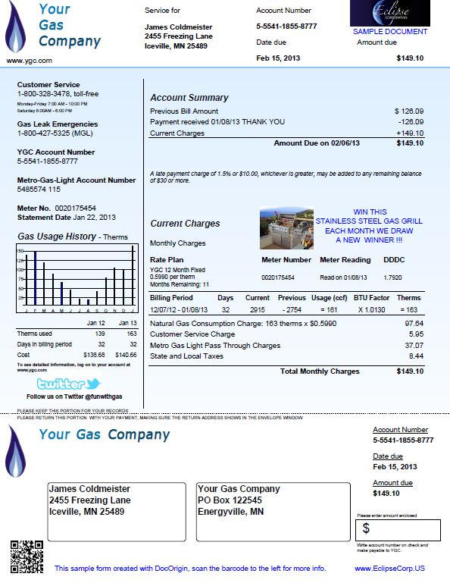

**APPENDIX 3**

**Sample Utility Bill**

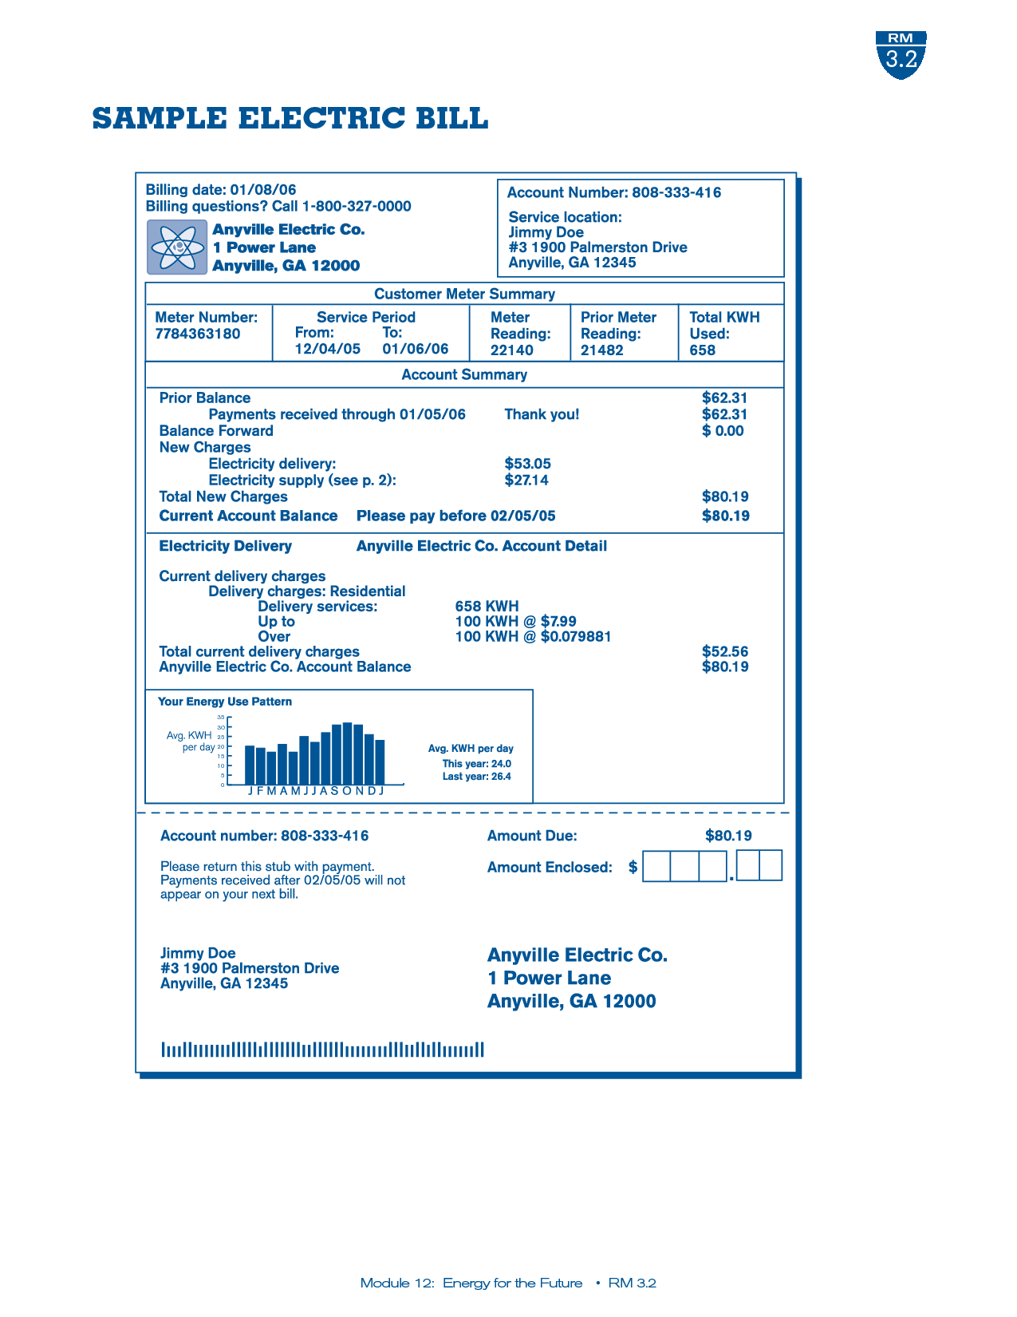

**APPENDIX 4**

**Blank Check and Money Order**

**Blank Check**

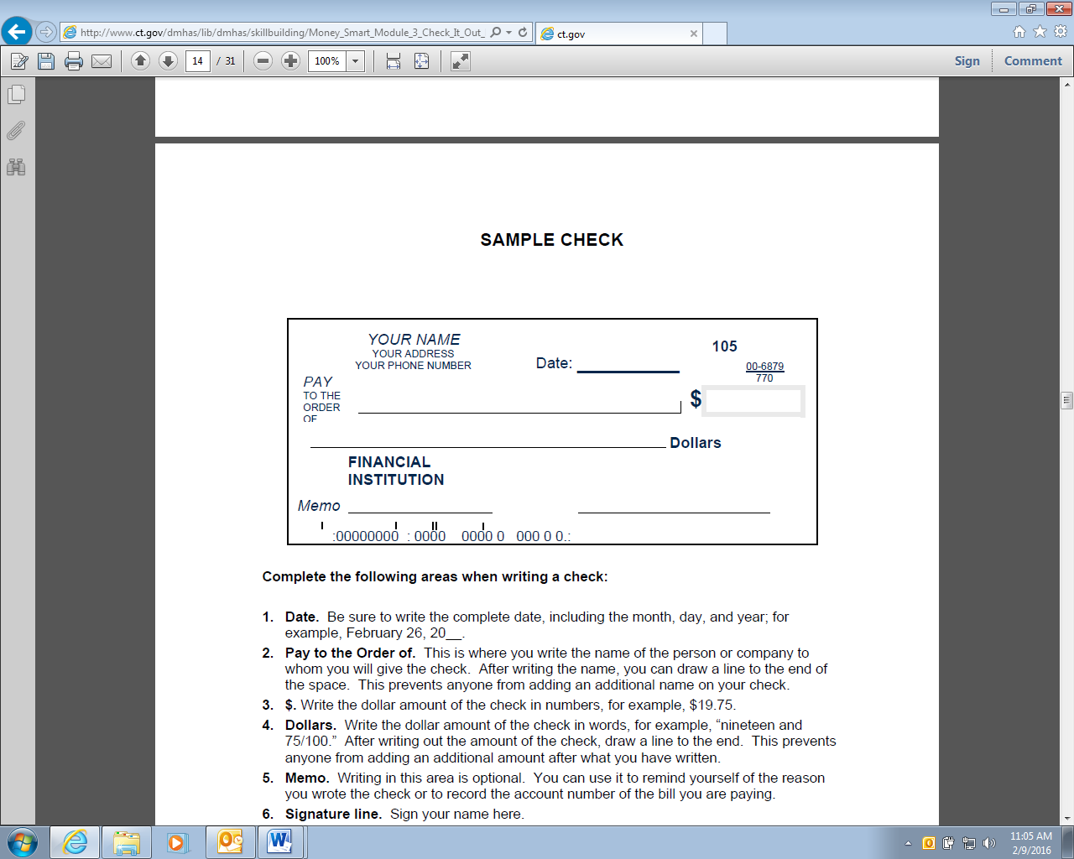

**Blank Money Order**

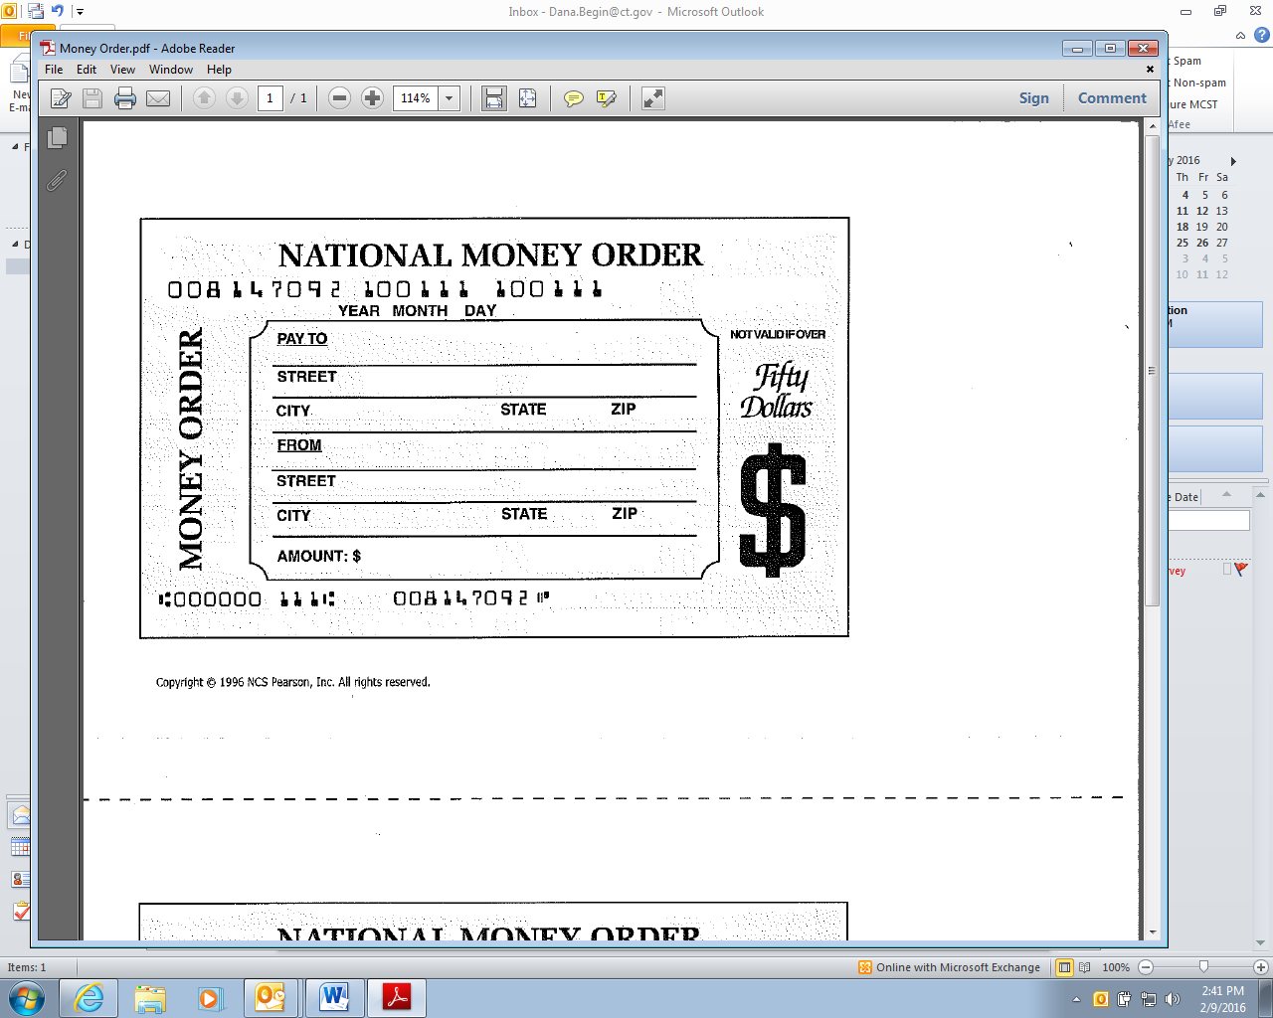

**APPENDIX 5**

**Blank Banking Forms**

**Deposit Slip**

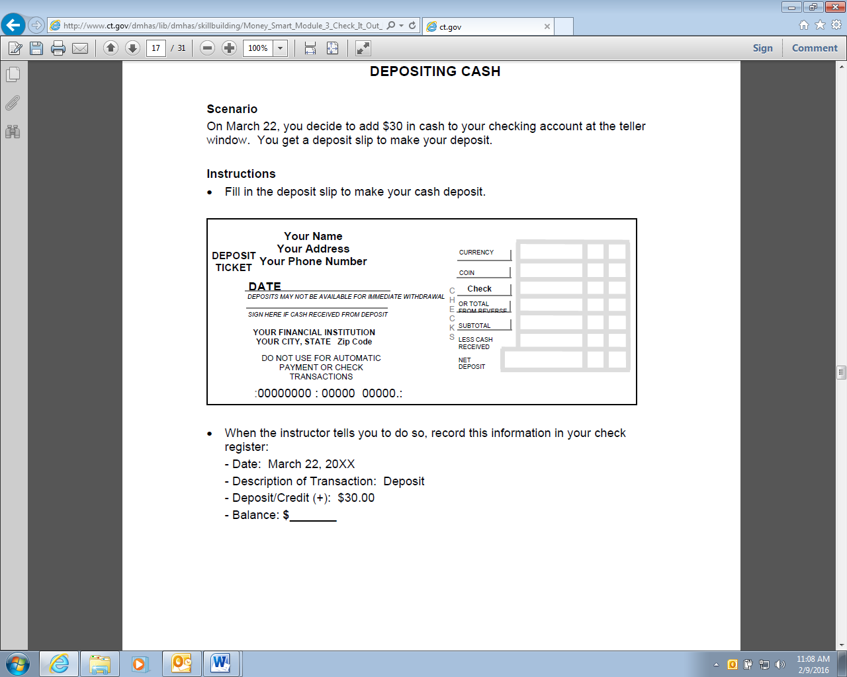

**Withdrawal Slip**

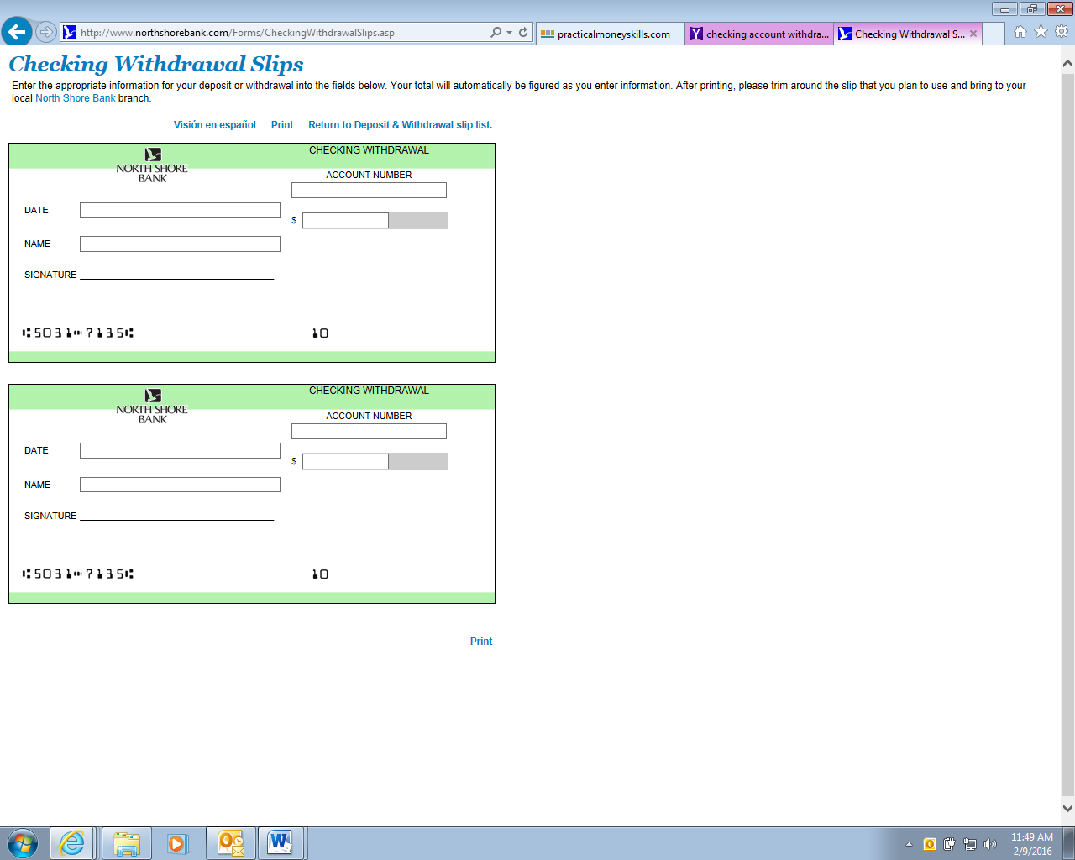

**APPENDIX 6**

**Sample Pay Check Stub**

**EARNING STATEMENT**

|  |  |  |  |  |
| --- | --- | --- | --- | --- |
| Employee Name/Address | Social Security # | Pay Period | Pay Date | Employee # |
| John Doe  123 Maple St, Anytown, USA | 123-45-6789 | 02/01/2016 – 02/12/16 | 02/12/16 | 346751 |
| Income Rate Hours Current Pay | | Deductions Total YTD Total | | |
| **GROSS EARNING** $10.00/hr 40.00 $400.00 | | Statutory Deductions  FICA – Medicare  FICA – Social Security  Federal Tax  State Tax | $5.80  $24.80  $32.97  $20.00 | $5.80  $24.80  $32.97  $20.00 |
| YTD Gross YTD Deductions  **$400.00 $83.57** | YTD Net Pay  **$316.43** | Total  **$400.00** | Deductions  **$83.57** | Net Pay  **$316.43** |

**APPENDIX 7**

**Please read each scenario and answer the questions:**

**Weekly Budget Scenario**

Carlos has $50.00 in spending money for the week.

He likes to get coffee **every day, which is $2.50 each time**.

He also smokes cigarettes, and buys a pack **3 times a week, each pack is $8.00**.

He also needs a 5 ride **bus pass which is $14.00**.

QUESTIONS:

* Does he have enough money for all of these things? How do you know?
* If not, what could he do?

**Monthly Budget Scenario**

Jessica’s total monthly income is **$1,000 per month.** She is looking to get a job.

Her rent is **$650 per month**.

Her utilities are **$100 per month**.

Her cell phone bill is **$50 per month**.

She spends **$50 per week on food**.

She buys a **monthly bus pass for $30**.

QUESTIONS:

* Does she have enough money for all of these things? How do you know?
* Is there anything else she might need to buy during the month?
* Are there any ways she could increase her income and/or decrease her expenses?

**Modifying a Budget for Unexpected Emergencies**

Devon has a part-time job and is very good at saving money.

His income is **$2,000 per month**.

His rent is **$750 per month**.

His utilities are **$150 per month**.

His cell phone bill is **$65 per month**.

He spends **$50 per week on food**.

He has his own car. His insurance is **$100 per month** and **gas is about $120 per month**.

He always puts some money into his savings account each month, and has a **current balance of $3,000**.

Unfortunately, Devon’s car needs some repairs which will **cost $2,500**.

QUESTIONS:

* Does Devon have enough money to pay for the repairs? How do you know?
* What if he didn’t have enough to pay for them? What could he do?

**APPENDIX 8**

**Monthly Budget Worksheet**

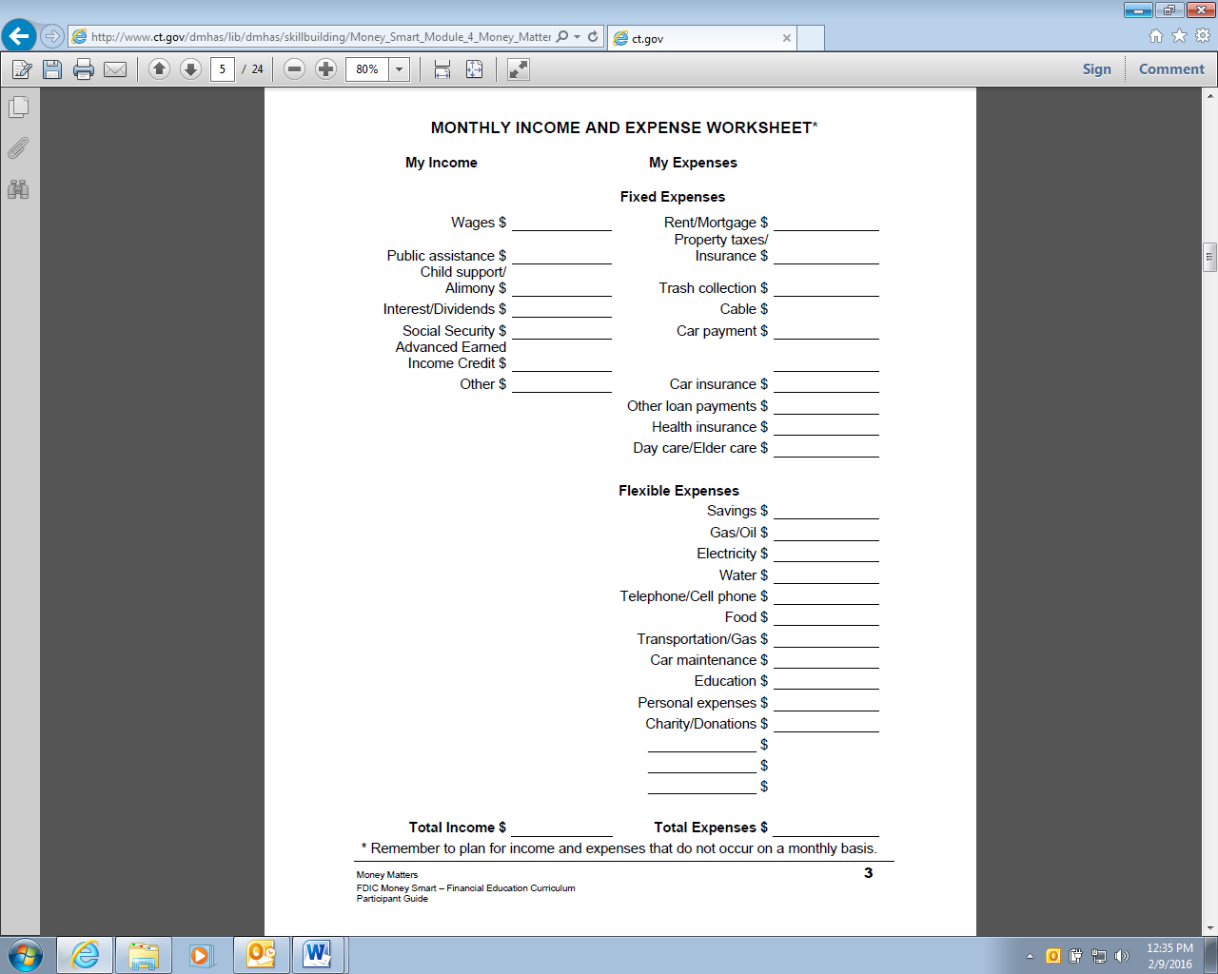

**APPENDIX 9**

**Sample Bank Statement**

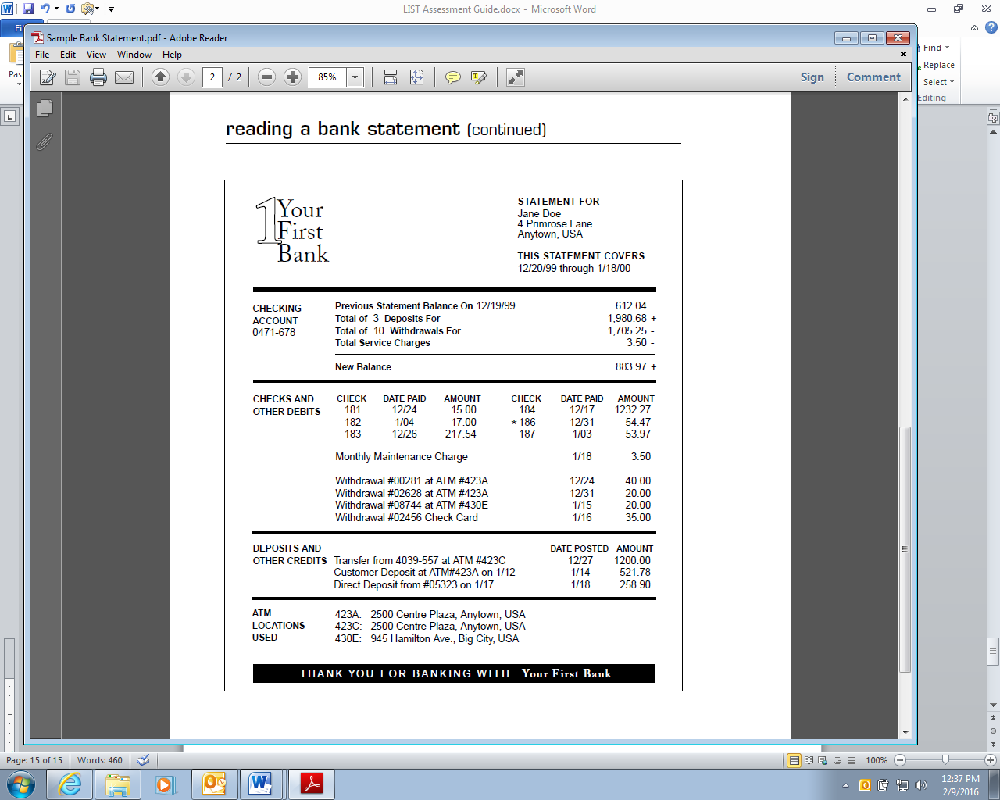

**Note: * indicates check not cleared**

**APPENDIX 10**

**Healthy vs. Unhealthy**

**Choose the more healthy food in each row**

|  |  |
| --- | --- |
| **APPLE** | **BAG OF DORITOS** |
| **HOT CHOCOLATE** | **COTTAGE CHEESE & FRUIT** |
| **FRENCH FRIES** | **BAKED POTATO** |
| **OATMEAL** | **CAPT’N CRUNCH** |
| **FRUIT YOGURT** | **PLAIN YOGURT** |
| **FRESH SALAD** | **FROZEN BROCCOLI** |

Ask “Why?” for each choice.

**APPENDIX 11**

**Cooking Utensils**

|  |  |  |
| --- | --- | --- |
| **A.** | **B.** | **C.** |
| **D.** | **E.** | **F.** |
| **G.** | **H.** | **I.** |
| **J.** | **K.** | **L.** |

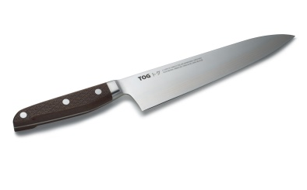 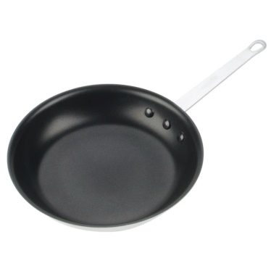

**N.**

**M**.

**APPENDIX 12**

**Expiration and Sell by Dates (can use actual products too)**

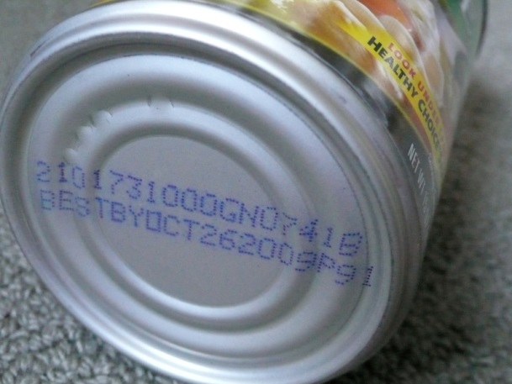 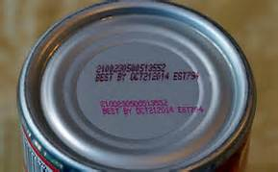

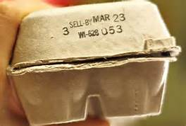 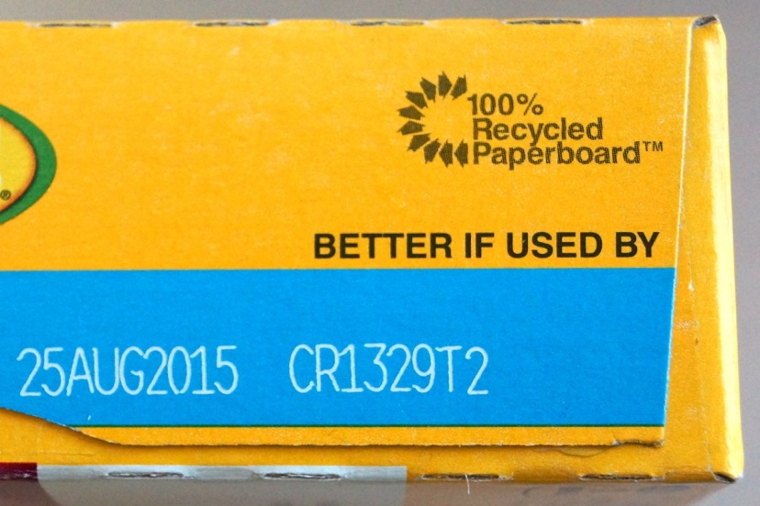

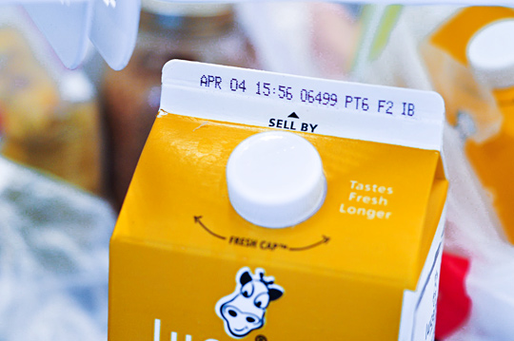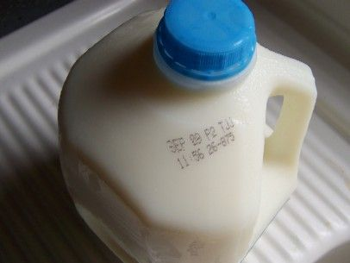

**APPENDIX 13**





**“Burger Land” Menu**

**VALUE MENU**

Hamburger $1.79 Ice Cream Cone $1.25

Bacon Cheeseburger $1.99 Milkshake _ $1.89

Jumbo Burger Special $ 3.22 Soda _ $ 1.00

Fish Fillet $ 2.19 Orange Juice $0.89

Chicken Nuggets (5 pc.) $ 2.29 Coffee $0.99

French fries $ 0.99 Apple Pie $1.88

Tossed salad $1.25 Blueberry Crumble $1.75

**MEAL COMBOS**

Combo meals come with small fries and small drink.



Upgrade to Medium for $0.69 or Large for $1.20



Jumbo Burger Meal $6.49

Bacon Cheeseburger Meal _____$ 5.19

Chicken Sandwich Meal $ 6.49

Fish Fillet Meal $ 3.99

Chicken Nuggets Meal (10 pc.) $ 5.99

Garden Grilled Chicken Salad _$ 5.59

Veggie Burger Meal $5.49

**Appendix 14**

**Cafeteria Menu**

|  |  |  |  |  |  |  |  |
| --- | --- | --- | --- | --- | --- | --- | --- |
| |  |  |  | | --- | --- | --- | | **TODAY'S MENU** | [Click for Nutritive Analysis](http://nutritionanalysis.dds.uconn.edu/longmenu.asp?sName=UCONN+Dining+Services&locationNum=26&locationName=UC+Cafes+-+Bookworms&naFlag=1&WeeksMenus=This+Week's+Menus&dtdate=04/16/2018&mealName=TODAY'S+MENU) |  | | | | | |
| |  |  |  |  | | --- | --- | --- | --- | | *-- SOUPS -- Subject to change.* | | | | | |  |  | | --- | --- | | **Large Chunky Beef Chili** | http://nutritionanalysis.dds.uconn.edu/LegendImages/glutenfree.gif | |  | $4.95 |  | | *This is a classic chili full of chunks of beef, kidney and black beans and red, yellow and green bell peppers. Simmered in a flavorful blend of tomatoes and spices.* | | | | | |  |  | | --- | --- | | **Large Spinach Feta Chowder** | http://nutritionanalysis.dds.uconn.edu/LegendImages/vegetarian.gif | |  | $4.95 |  | | *Spinach & feta cheese blended with cream, potatoes and mushrooms.* | | | | | |  |  | | --- | --- | | **Large Yellow Mac & Cheese** | http://nutritionanalysis.dds.uconn.edu/LegendImages/vegetarian.gif | |  | $5.75 |  | | *Our ultimate comfort food, elbow macaroni and a creamy  sauce made with a three cheese blend and a touch of spice.* | | | | | |  |  | | --- | --- | | **Small Chunky Beef Chili** | http://nutritionanalysis.dds.uconn.edu/LegendImages/glutenfree.gif | |  | $3.00 |  | | *This is a classic chili full of chunks of beef, kidney and black beans and red, yellow and green bell peppers. Simmered in a flavorful blend of tomatoes and spices.* | | | | | |  |  | | --- | --- | | **Small Spinach Feta Chowder** | http://nutritionanalysis.dds.uconn.edu/LegendImages/vegetarian.gif | |  | $3.00 |  | | *Spinach & feta cheese blended with cream, potatoes and mushrooms.* | | | | | |  |  | | --- | --- | | **Small Yellow Mac & Cheese** | http://nutritionanalysis.dds.uconn.edu/LegendImages/vegetarian.gif | |  | $3.00 |  | | *Our ultimate comfort food, elbow macaroni and a creamy  sauce made with a three cheese blend and a touch of spice.* | | | | | |  |  |  | | --- | --- | --- | | **Whole Wheat Rolls** | http://nutritionanalysis.dds.uconn.edu/LegendImages/sodium.gif | http://nutritionanalysis.dds.uconn.edu/LegendImages/vegetarian.gif | |  | $0.00 |  | | *-- SALADS --* | | | | | |  |  | | --- | --- | | **Cobb Salad Bowl** | http://nutritionanalysis.dds.uconn.edu/LegendImages/glutenfree.gif | |  | $5.95 |  | | |  |  |  |  |  | | --- | --- | --- | --- | --- | | **Side Salad** | http://nutritionanalysis.dds.uconn.edu/LegendImages/glutenfree.gif | http://nutritionanalysis.dds.uconn.edu/LegendImages/sodium.gif | http://nutritionanalysis.dds.uconn.edu/LegendImages/vegetarian.gif | http://nutritionanalysis.dds.uconn.edu/LegendImages/vegan.gif | |  | $1.95 |  | | |  |  |  | | --- | --- | --- | | **Side Salad with Grilled Chicken Strips** | http://nutritionanalysis.dds.uconn.edu/LegendImages/glutenfree.gif | http://nutritionanalysis.dds.uconn.edu/LegendImages/sodium.gif | |  | $3.95 |  | | *-- SANDWICHES --* | | | | | |  | | --- | | **Chicken Cordon Bleu Sandwich** | |  | $4.95 |  | | |  |  |  | | --- | --- | --- | | **Dairy Free Chickpea Salad Sandwich** | http://nutritionanalysis.dds.uconn.edu/LegendImages/vegetarian.gif | http://nutritionanalysis.dds.uconn.edu/LegendImages/vegan.gif | |  | $2.95 |  | | |  |  | | --- | --- | | **Egg Salad on Hard Roll** | http://nutritionanalysis.dds.uconn.edu/LegendImages/vegetarian.gif | |  | $2.95 |  | | |  |  | | --- | --- | | **Gluten Free Chicken Cordon Bleu** | http://nutritionanalysis.dds.uconn.edu/LegendImages/glutenfree.gif | |  | $4.95 |  | | |  | | --- | | **Ham & Cheese Sandwich on Piadina** | |  | $3.95 |  | | |  |  |  | | --- | --- | --- | | **Husky Peanut Butter & Jelly** | http://nutritionanalysis.dds.uconn.edu/LegendImages/nuts.gif | http://nutritionanalysis.dds.uconn.edu/LegendImages/vegetarian.gif | |  | $2.00 |  | | |  |  |  | | --- | --- | --- | | **Organic Vegetarian Hummus Sandwich** | http://nutritionanalysis.dds.uconn.edu/LegendImages/vegetarian.gif | http://nutritionanalysis.dds.uconn.edu/LegendImages/vegan.gif | |  | $6.25 |  | | |  | | --- | | **Roast Beef Ciabatta w/ Horseradish** | |  | $5.95 |  | | *Our roast beef sandwich topped with a horseradish cole slaw and finished with swiss cheese on a whole grain ciabatta.* | | | | | |  | | --- | | **Tuna on Wheat Roll** | |  | $3.95 |  | | |  | | --- | | **Turkey and Cheese Sandwich** | |  | $2.95 |  | | | | | |
| *-- SNACK --* | | | |
| |  |  |  |  | | --- | --- | --- | --- | | **Black Forest Parfait** | http://nutritionanalysis.dds.uconn.edu/LegendImages/nuts.gif | http://nutritionanalysis.dds.uconn.edu/LegendImages/sodium.gif | http://nutritionanalysis.dds.uconn.edu/LegendImages/vegetarian.gif | |  | $2.70 |  |
| |  |  |  |  |  | | --- | --- | --- | --- | --- | | **Cranberry Quinoa Salad Container** | http://nutritionanalysis.dds.uconn.edu/LegendImages/glutenfree.gif | http://nutritionanalysis.dds.uconn.edu/LegendImages/sodium.gif | http://nutritionanalysis.dds.uconn.edu/LegendImages/vegetarian.gif | http://nutritionanalysis.dds.uconn.edu/LegendImages/vegan.gif | |  | $2.50 |  |
| |  |  |  |  | | --- | --- | --- | --- | | **Greek Blueberry Granola Parfait** | http://nutritionanalysis.dds.uconn.edu/LegendImages/nuts.gif | http://nutritionanalysis.dds.uconn.edu/LegendImages/sodium.gif | http://nutritionanalysis.dds.uconn.edu/LegendImages/vegetarian.gif | |  | $4.95 |  |
| |  |  |  |  | | --- | --- | --- | --- | | **Hummus and Vegetable Dipper** | http://nutritionanalysis.dds.uconn.edu/LegendImages/glutenfree.gif | http://nutritionanalysis.dds.uconn.edu/LegendImages/vegetarian.gif | http://nutritionanalysis.dds.uconn.edu/LegendImages/vegan.gif | |  | $1.95 |  |
| |  |  |  |  | | --- | --- | --- | --- | | **Pineapple With Vanilla Yogurt** | http://nutritionanalysis.dds.uconn.edu/LegendImages/glutenfree.gif | http://nutritionanalysis.dds.uconn.edu/LegendImages/sodium.gif | http://nutritionanalysis.dds.uconn.edu/LegendImages/vegetarian.gif | |  | $3.95 |  |
| |  |  |  |  | | --- | --- | --- | --- | | **Strawberry Granola Parfait** | http://nutritionanalysis.dds.uconn.edu/LegendImages/nuts.gif | http://nutritionanalysis.dds.uconn.edu/LegendImages/sodium.gif | http://nutritionanalysis.dds.uconn.edu/LegendImages/vegetarian.gif | |  | $3.95 |  |

**APPENDIX 15**

**Restaurant Menu**

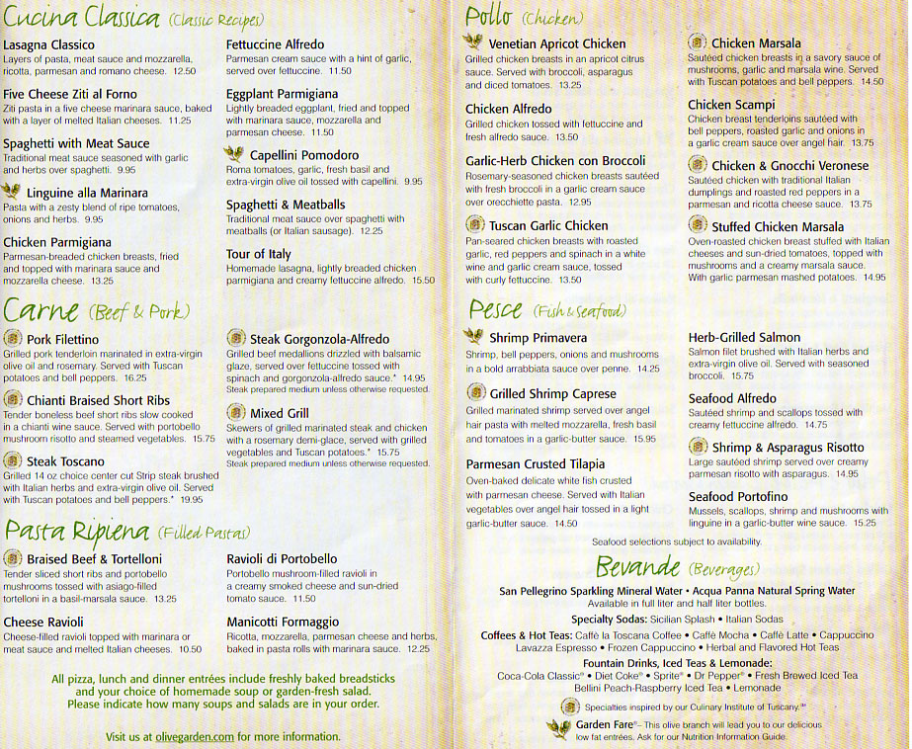

**APPENDIX 16**

**Meal Planning Worksheet**

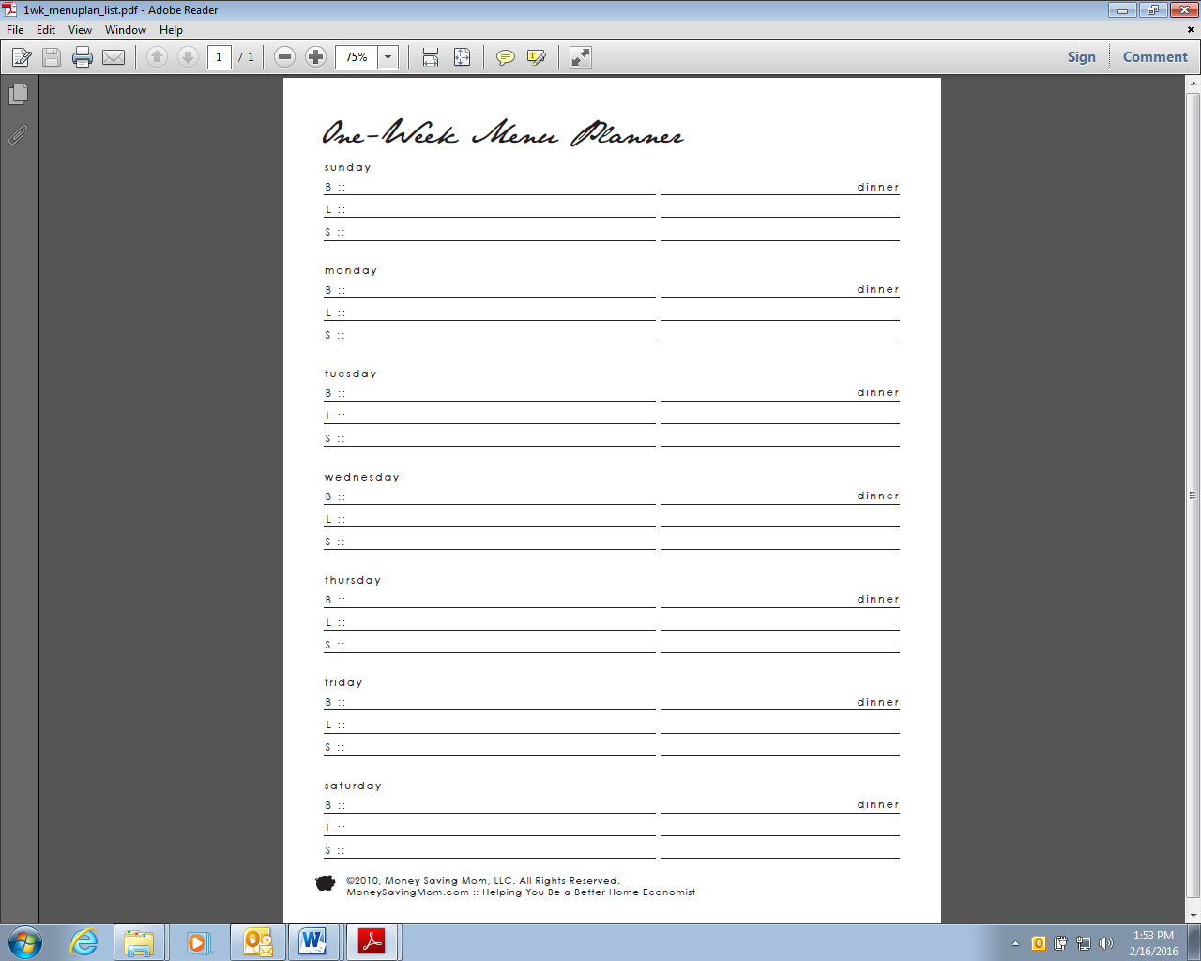

**APPENDIX 17**

**Canned Food Preparation**

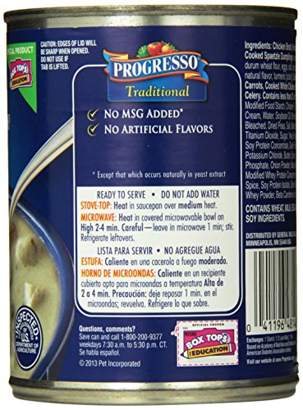

**APPENDIX 18**

**Frozen Food Preparation**

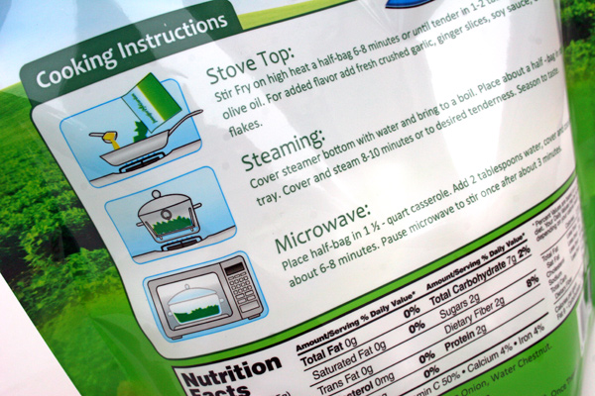

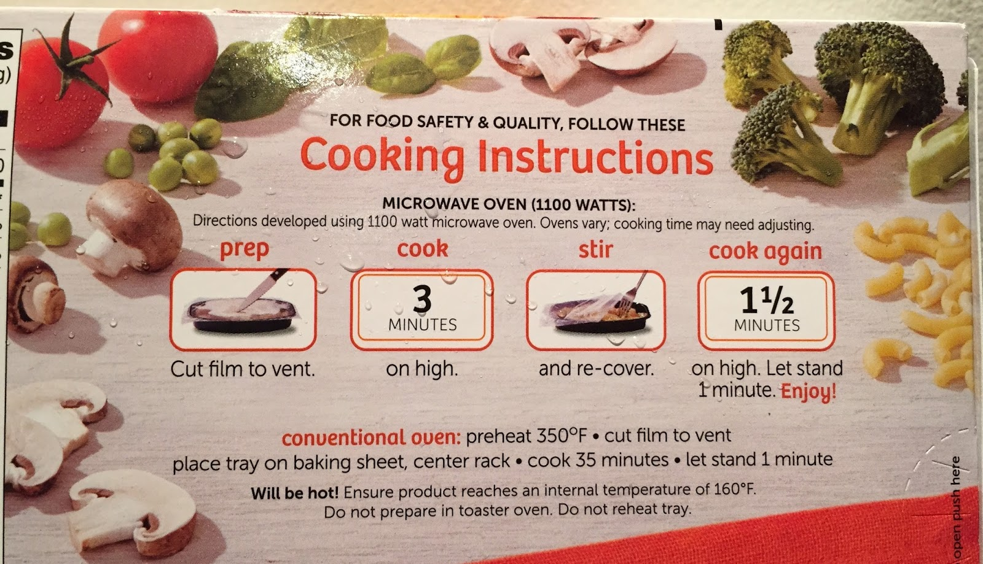

**APPENDIX 19**

**Following a Recipe and Adjusting Amounts**

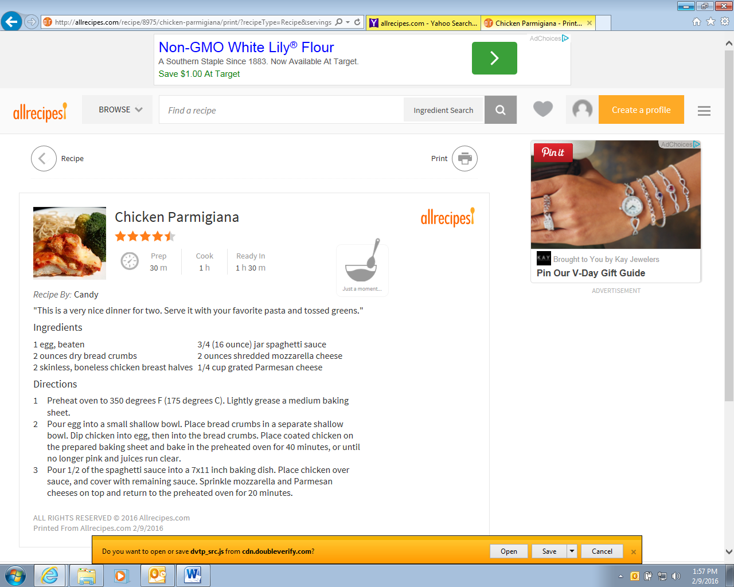

**APPENDIX 20**

**Washing Clothes**

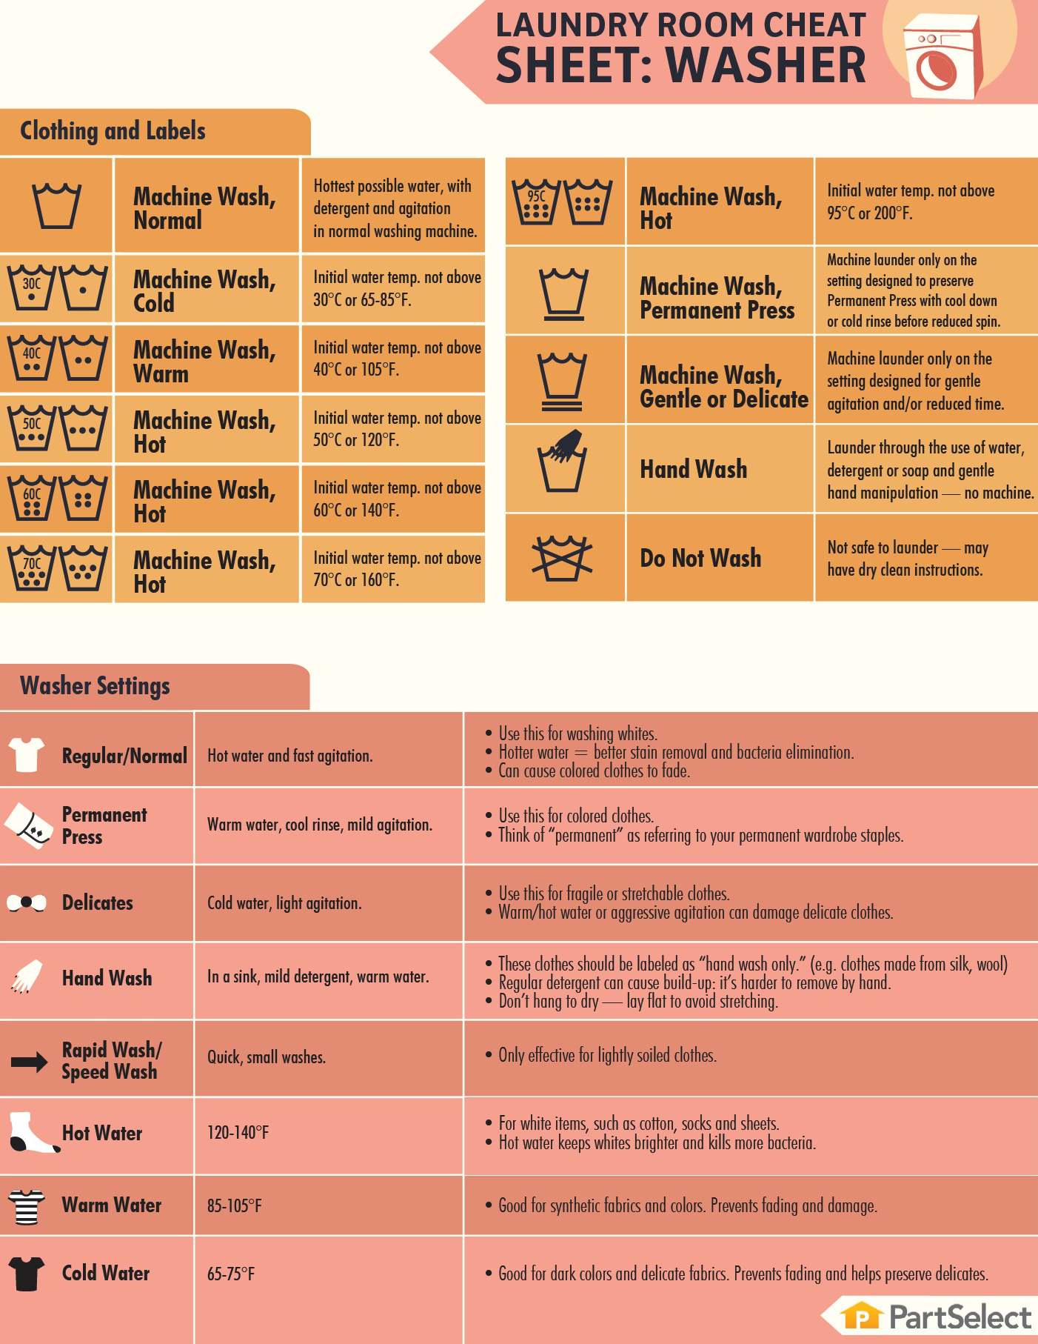

**APPENDIX 21**

**Drying Clothes**

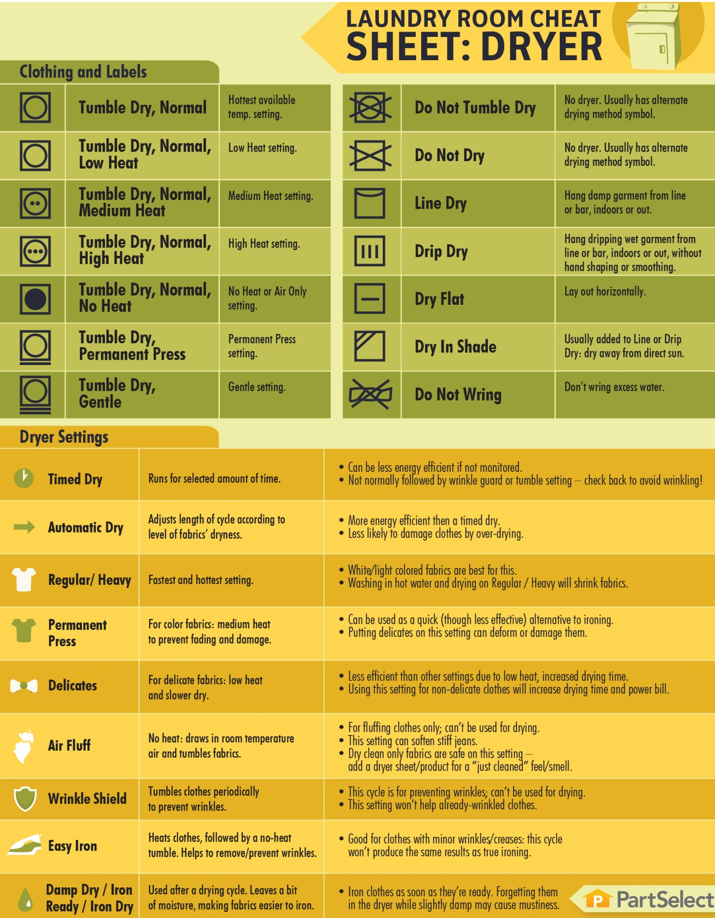

**APPENDIX 22**

**Sorting Laundry**

|  |  |  |  |
| --- | --- | --- | --- |
| A.. | B. | C. | D.. |
| E.. | F.. | G.. | H.. |
| I.. | J.. | K.. | L.. |
| M.. | N.. | O.. | P.. |
| Q.. | R.. | S.. | T.. |

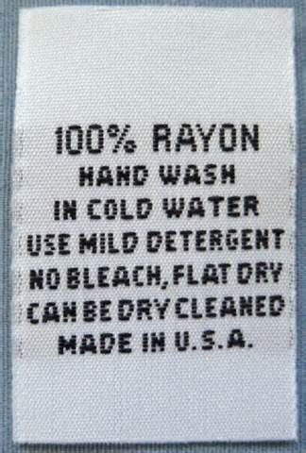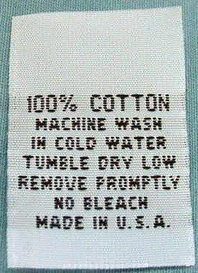**APPENDIX 23**

**Reading Clothing Labels**

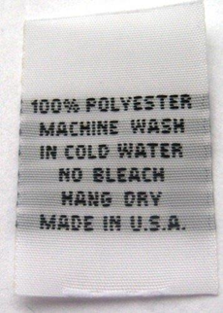

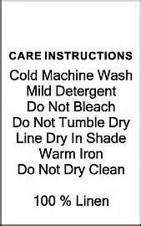

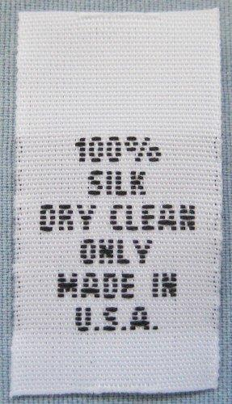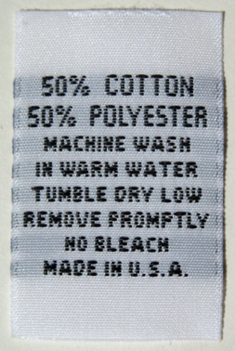

**APPENDIX 24**

**Apartment Options**

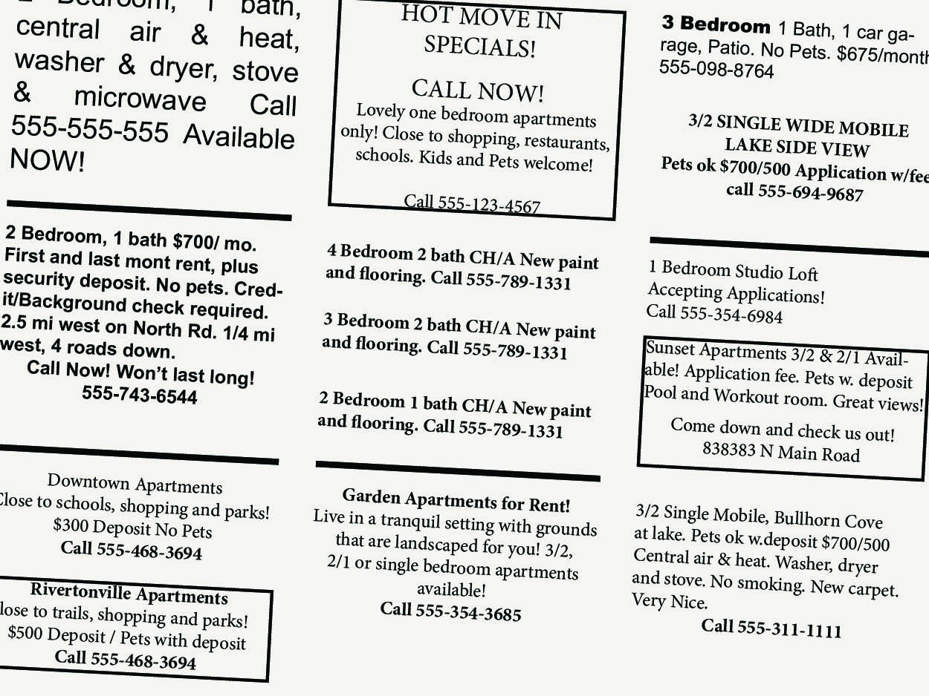

**APPENDIX 25**

**Consistent and Correct Condom Use**

* To achieve maximum protection by using condoms, they must be used consistently and correctly.
* The failure of condoms to protect against STD/HIV transmission usually results from inconsistent or incorrect use, rather than product failure.
* Inconsistent or nonuse can lead to STD acquisition because transmission can occur with a single sex act with an infected partner.
* Incorrect use diminishes the protective effect of condoms by leading to condom breakage, slippage, or leakage. Incorrect use more commonly entails a failure to use condoms throughout the entire sex act, from start (of sexual contact) to finish (after ejaculation).

**How to Use a Condom Consistently and Correctly:**

Use a new condom for every act of vaginal, anal and oral sex throughout the entire sex act (from start to finish). Before any genital contact, put the condom on the tip of the erect penis with the rolled side out.

If the condom does not have a reservoir tip, pinch the tip enough to leave a half-inch space for semen to collect. Holding the tip, unroll the condom all the way to the base of the erect penis.

After ejaculation and before the penis gets soft, grip the rim of the condom and carefully withdraw. Then gently pull the condom off the penis, making sure that semen doesn't spill out.

Wrap the condom in a tissue and throw it in the trash where others won't handle it.

If you feel the condom break at any point during sexual activity, stop immediately, withdraw, remove the broken condom, and put on a new condom.

Ensure that adequate lubrication is used during vaginal and anal sex, which might require water-based lubricants. Oil-based lubricants (e.g., petroleum jelly, shortening, mineral oil, massage oils, body lotions, and cooking oil) should not be used because they can weaken latex, causing breakage.

**Precautions:**

1. To achieve maximum protection by using condoms, they must be used consistently and correctly.

2. Before you put a condom on:

* Store condoms in a cool, dry place away from direct sunlight.
* Check the expiration date on the condom.
* Do a pillow test — does the air stay in the package?
* Tear the condom package carefully — without using your teeth — to open.
* If the condom looks damaged, discolored, or brittle, do not use.