REWARD
Murder of Anthony Hamlin
$25,000
For information leading to the arrest and conviction of the person or persons responsible for the murder of Anthony Hamlin.
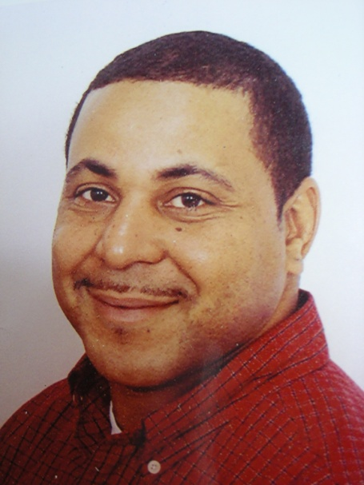
Anthony Hamlin was found murdered in a vacant field on Shewville Rd in Ledyard, CT on January 28, 2006. The Governor of the State of Connecticut has authorized this reward to assist in the investigation.

Anyone with information about this crime can contact:
Connecticut State Police Eastern District Major Crime Squad
(860)886-6603
New London County State’s Attorney
(860)443-2835

