0 Disaster News
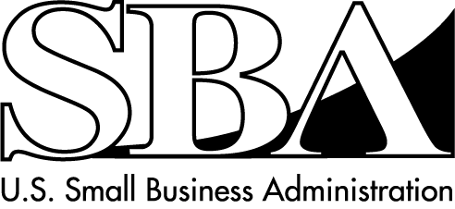
Physical and Economic Injury Loans for Businesses

SBA Disaster Assistance – Field Operations Center- East – 101 Marietta Street, NW, Suite 700, Atlanta, GA 30303
_________________________________________________________________________________________________________________________________
Release Date: April 16, 2015 Contact: Michael Lampton
Release Number: 15-180 CT 14268/14269 Email: Michael.Lampton@sba.gov
Phone: (404) 331-0333
SBA disaster assistance available to
Private NonProfit organizations in Connecticut

ATLANTA – The U.S. Small Business Administration announced today certain Private
NonProfit organizations (PNPs) that do not provide critical services of a governmental nature may be eligible to apply for low interest rate disaster loans. These loans are available following the Presidential disaster declaration for Public Assistance resulting from damages caused by a severe winter storm and snowstorm on Jan. 26 – 28, 2015.

PNPs located in the following Connecticut counties are eligible to apply to SBA: New London, Tolland and Windham. Examples of eligible non-critical PNP organizations include, but are not limited to, food kitchens, homeless shelters, museums, libraries, community centers, schools and colleges.

“PNP organizations are urged to contact their local Emergency Management Agency to obtain information about local briefings. At the meeting, PNP representatives will need to provide information about their organization,” said Frank Skaggs, director of SBA Field Operations Center East in Atlanta. The information will be submitted to FEMA to determine eligibility for a Public Assistance grant or whether the PNP should be referred to SBA for disaster loan assistance.

PNP organizations may borrow up to $2 million to repair or replace damaged or destroyed real estate, machinery and equipment, inventory and other business assets. The interest rate is 2.625 percent with terms up to 30 years. Applicants may be eligible for a loan amount increase up to 20 percent of their physical damages, as verified by the SBA, to make improvements that help prevent the risk of future property damage caused by a similar disaster.

The SBA also offers Economic Injury Disaster Loans to help PNP organizations meet working capital needs, such as ongoing operating expenses. Economic Injury Disaster Loan assistance is available regardless of whether the organization suffered any physical property damage.

Applicants may apply online using the Electronic Loan Application via SBA’s secure website at https://disasterloan.sba.gov/ela.

Disaster loan information and application forms may also be obtained by calling the SBA’s Customer Service Center at 800-659-2955 (800-877-8339 for the deaf and hard-of-hearing) or by sending an e-mail to disastercustomerservice@sba.gov. Loan applications can be downloaded from the SBA’s website at www.sba.gov/disaster. Completed applications should be mailed to: U.S. Small Business Administration, Processing and Disbursement Center, 14925 Kingsport Road, Fort Worth, TX 76155.

The filing deadline to return applications for physical property damage is June 8, 2015. The deadline to return economic injury applications is Jan. 8, 2016

# # #

For more information about the SBA’s Disaster Loan Program, visit our website at www.sba.gov/disaster.

