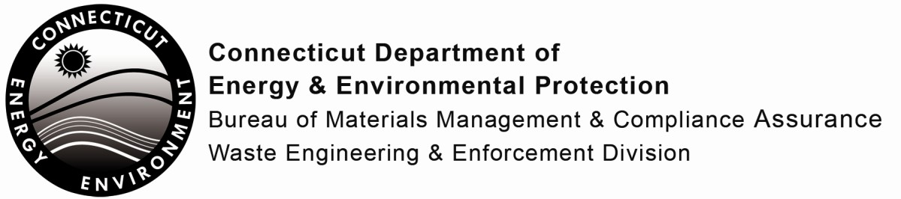

Certification Application for Operators of Resources Recovery Facilities
Print or type unless otherwise noted. You should retain a copy for your files.
In accordance with the Regulations of Connecticut State Agencies, Sections 22a-231-1, this application must be completed to apply for or renew certification.

Part I: Applicant Information
2. Certification Type: (Check One)
Initial
Renewal
3. Resources Recovery Facility Classification: (Check One) Class 1 - Processing capacity over 600 TPD
Class 2 - Processing capacity equal to/less than 600 TPD
4. Operator Certification Status: (Check One)
Chief Operator
Shift Operator
5. Other Related Certifications/Licenses Currently Held:

1. Name of Applicant:
Mailing Address:
City/Town: | State: | Zip Code:
Phone: | Email:

Part II: Education
1. Elementary and Secondary School (Check Highest Grade Completed):
1 2 3 4 5 6 7 8 9
10
11
12
If No, have you obtained a High School Equivalency Certificate?
Identify Source:
Yes
No

2. Did you graduate from high school? | Yes | No
If Yes, please provide the following:
Year of Graduation:
Name of School:
Mailing Address:  City/Town: |  | State: Zip Code:

Part II: Education (continued)
3. List Any Other Related Educational Courses:
Date Taken Name of Class
Sponsoring Organization
Check if additional sheets are attached to this page.

2. College:  Mailing Address: City/Town: Dates Attended: Major/Minor:  Degree Obtained? | Yes | No | Type: | State: | Zip Code:
College:  Mailing Address: City/Town: Dates Attended: Major/Minor:  Degree Obtained? | Yes | No | Type: | State: | Zip Code:

Part III: Experience (List Related Employment Only)
1. Present Employer: Mailing Address: City/Town:
Dates Employed: From: Job Title:
Description of Facility and Your Duties:
State:
To:
Zip Code:

Part III: Experience (continued)

2. Former Employer: Mailing Address:
City/Town: State: Zip Code:
Dates Employed: From: To:
Job Title:
Description of Facility and Your Duties:
3. Former Employer: Mailing Address:
City/Town: State: Zip Code:
Dates Employed: From: To:
Job Title:
Description of Facility and Your Duties:

Part IV: Certification

“I certify that all information provided by me in this application and any attachments is true and complete to the best of my knowledge and belief, and I understand that any false statement I have made in this application or any attachment is punishable as a criminal offense, in accordance with Connecticut General Statutes, Section 22a-209-6 and 22a-231-1, under Connecticut General Statutes, Section 53a-157b.”
Signature of Operator |  | Date
Name of Operator (print or type) |  | Title (if applicable)
Please return this application to:

WASTE ENGINEERING AND ENFORCEMENT DIVISION
BUREAU OF MATERIALS MANAGEMENT AND COMPLIANCE ASSURANCE CONNECTICUT DEPARTMENT OF ENERGY AND ENVIRONMENTAL PROTECTION 79 ELM STREET
HARTFORD, CT 06106-5127

Any questions, please contact the DEEP Recycling Program at 860-424-3366 or deep.recyclingprogram@ct.gov

