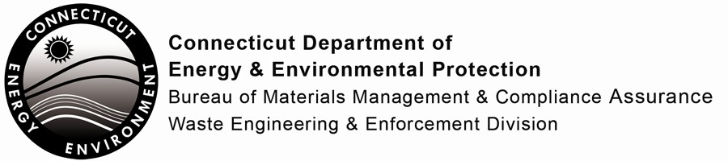

Certification Application for Operators of Landfills, Transfer Stations, Recycling and Volume
Reduction Facilities

Print or type unless otherwise noted. You should retain a copy for your files.

In accordance with the Regulations of Connecticut State Agencies, Sections 22a-209-6, this application must be completed to apply for or renew certification.

Part I: Applicant Information
2. Do You Currently Hold a Valid Connecticut Certificate?
Yes
No
If Yes, Please Attach a Photocopy of The Certificate (if available) to This Application and Complete the Following:
- Type of Connecticut Certification: (Check One)
Landfill / Transfer Station / Volume Reduction Facility Operator Transfer Station / Volume Reduction Facility Operator only Recycling Facility Operator
Other:

- Certificate Number:

- Date Certificate Expires:
3. Do You Have Other Related Certifications?
Yes
No
If Yes, Please Attach A Photocopy To This Application. Sponsoring Organization:
Type of Certification: Certificate Number:
Date Certificate Expires:

1. Name of Applicant:
Mailing Address:
City/Town: | State: | Zip Code:
Phone: | Email:

Part II: Education/Training

1. Elementary and Secondary School (Check Highest Grade Completed):
1 2 3 4 5 6 7 8 9 10 11 12

2. Did you graduate from high school? | Yes | No
If Yes, please provide the following:
Year of Graduation:
Name of School:
Mailing Address:  City/Town: |  | State: Zip Code:
If No, have you obtained a High School Equivalency Certificate? Yes No Identify Source:

3. College:  Mailing Address: City/Town: Dates Attended: Major/Minor:  Degree Obtained? | Yes | No | Type: | State: | Zip Code:
College:  Mailing Address: City/Town: Dates Attended: Major/Minor:  Degree Obtained? | Yes | No | Type: | State: | Zip Code:

3. List Any Other Related Educational Courses or Training Taken Within The Last 5 Years:
Date Taken Name of Class Duration Sponsoring Organization

Check if additional sheets are attached to this page.

Part III: Experience (List Related Employment Only)

1. Present Employer: Mailing Address:
City/Town: State: Zip Code:
Dates Employed: From: To:
Job Title:
Description of Facility and Your Duties:
2. If you have been employed less than 5 years with the present employer, please complete the following: Former Employer:
Mailing Address:
City/Town: State: Zip Code:
Dates Employed: From: To:
Job Title:
Description of Facility and Your Duties:

Part IV: Certification

“I certify that all information provided by me in this application and any attachments is true and complete to the best of my knowledge and belief, and I understand that any false statement I have made in this application or any attachment is punishable as a criminal offense, in accordance with Connecticut General Statutes, Section 22a-209-6, under Connecticut General Statutes, Section 53a-157b.”
Signature of Operator |  | Date
Name of Operator (print or type) |  | Title (if applicable)
Please return this application to:

WASTE ENGINEERING AND ENFORCEMENT DIVISION
BUREAU OF MATERIALS MANAGEMENT AND COMPLIANCE ASSURANCE CONNECTICUT DEPARTMENT OF ENERGY AND ENVIRONMENTAL PROTECTION 79 ELM STREET
HARTFORD, CT 06106-5127

Any questions, please contact the DEEP Recycling Program at 860-424-3366 or deep.recyclingprogram@ct.gov

