Restricted and Permit Use Pesticide Dealer
Exam Study Manual

Revision 4/2023
Information for Pesticide Dealers

Enclosed is a study manual for the restricted-use and permit-use dealer examination. The examination is based upon this manual and the Cornell Core Certification Training Manual for Pesticide Applicators and Technicians which is available from The Cornell Store, phone: (607) 255-4111 or https://textbooks.store.cornell.edu. OR

The National Pesticide Applicator Certification Core Manual: http://www.ag.utah.gov/documents/CoreManual.pdf can be used in place of the Cornell Core Manual.

When you are ready to take this test, see the instructions on the website for creating an elicense account and applying for the dealer exam. There is a $200.00 fee for the test, and a license fee of $120.00 per year. Pesticide Dealer Webpage.

If you have any questions, please contact the Pesticide Management Program by email at DEEP.PesticideProgram@ct.gov

Applicable Statutes and Regulations for Registered Restricted-use Pesticide Dealers

Connecticut General Statutes
Sec. 22a-56. Registration of pesticide distributors. Regulations. Fee. (a) No person shall distribute, sell, offer for sale, hold for sale, ship, deliver for shipment or receive and, having so received, deliver or offer to deliver any restricted or permit use pesticide unless that pesticide is registered in accordance with the provisions of this part.
(b) The commissioner may prescribe standards for the registration of sellers and distributors of restricted and permit use pesticides. Such standards shall provide that to be registered, a person must be competent with respect to the handling of pesticides and must demonstrate knowledge concerning the proper application of pesticides, their hazards and impact on the environment.
(c) Any person who distributes, sells, offers for sale, holds for sale or offers to deliver any restricted or permit use pesticide to any person in the state shall register his name and address with the commissioner annually. The commissioner may by regulations adopted in accordance with the provisions of chapter 54 require the payment of a fee sufficient to cover the cost of administering examinations for registration and assisting in carrying out the purposes of section 22a-451. The fee for each annual registration shall be one hundred twenty dollars. The fees collected in accordance with this section shall be deposited in the General Fund.
Sec. 22a-56a. Grounds for refusal to grant registration. The Commissioner of Energy and Environmental Protection may refuse to grant distributor registration or renewal of registration and may revoke or suspend registration following a hearing in accordance with the provisions of chapter 54. Any violation of the provisions of this part or of section 22a-66z or a regulation adopted thereunder, applicable to registered distributors, shall be grounds for revocation, refusal to renew or suspension of registration including, but not be limited to, the following: (1) Falsification of records required to be maintained pursuant to subsections (a) and (b) of section 22a-58 or refusal to keep and maintain such records; (2) neglecting or refusing to comply with or violating any of the provisions of this part, the regulations adopted thereunder, or any lawful order of the commissioner; (3) the distribution, sale or offering for sale of any restricted use pesticide to any person unless that person is a commercial supervisor or a private applicator certified under section 22a-54 or under subsection (a) of section 23-61a or section 23-61b, or a seller registered under section 22a-56; (4) distribution, sale or offering for sale any permit use pesticide to any person unless that person has a permit issued in accordance with the provisions of this part, subsection (a) of section 23-61a or section 23-61b, or to a seller registered under section 22a-56; (5) the distribution, sale, offering for sale, holding for sale or offering to deliver any restricted or permit use pesticide without distributor registration under section 22a-56.
Sec. 22a-56b. New registration after suspension or revocation. Any registered distributor of restricted pesticides whose registration is suspended or revoked under any provision of this part may apply for a new registration when the time established by the commissioner in the order suspending or revoking the registration has elapsed.
Sec. 22a-57. Restrictions on sale of pesticides. (a) No person shall distribute, sell or offer for sale any restricted use pesticide to any person unless that person is a commercial supervisor or a private applicator certified under section 22a-54 or a seller registered under section 22a-56.
(b) No person shall distribute, sell or offer for sale any permit use pesticide to any person unless that person has a permit issued in accordance with the provisions of this part, subsection (a) of section 23-61a or section 23-61b, or to a seller registered under section 22a-56.
(c) The provisions of this section shall apply to all persons who distribute, sell or offer for sale restricted and permit use pesticides for use in the state of Connecticut.
Sec. 22a-58. Records to be kept by distributors and applicators. (a) The commissioner may prescribe regulations requiring each distributor, common or contract carrier, dealer, or any other person who distributes, sells or offers for sale, delivers or offers for delivery any restricted or permit use pesticide or device subject to this part to maintain such records with respect to their operations and the pesticides and devices produced as specified in subsection (b) of this section.
(b) For the purposes of enforcing the provisions of this part, subsection (a) of section 23-61a and sections 23-61b and 23-61f, any distributor, carrier, dealer, or any other person who sells or offers for sale, delivers or offers for delivery any pesticide or device subject to this part and said sections, shall, upon request of any officer or employee of the Department of Energy and Environmental Protection duly designated by the commissioner, furnish or permit such person at all reasonable times to have access to, and to copy:
(1) All records showing the delivery, movement, or holding of such pesticide or device, including the quantity, the date of shipment and receipt, and the name of the consignor and consignee; or
(2) In the event of the inability of any person to produce records containing such information, all other records and information relating to such delivery, movement, or holding of the pesticide or device. Any inspection with respect to any records and information referred to in this subsection shall not extend to financial data, sales data other than shipment data, pricing data, personnel data, and research data.
(c) Private applicators shall maintain a record with respect to each use of restricted use pesticides, which shall include, but not be limited to, the following information: (1) The name of the applicator, (2) the kind and amount of pesticide used, (3) the date and place of application, and (4) the crop or site treated and the amount of acreage treated. A copy of the record shall be submitted to the commissioner on or before January thirty-first for the preceding calendar year in which the application was made.
(d) Commercial applicators shall maintain records with respect to their use of and supervision of the use of pesticides. Such records shall be maintained for not less than five years after the date of application and shall include, but not be limited to, the (1) name and certification number of the commercial supervisor and the commercial operator, (2) kind and amount of pesticide used, (3) date and place of application, (4) pest treated for, and (5) crop or site treated. A summary of the items maintained under subdivisions (1) and (2) shall be submitted to the commissioner on or before January thirty-first for the preceding calendar year in which the application was made on such form as the commissioner may prescribe.
(e) For purposes of enforcing the provisions of this part, any commercial applicator or private applicator using restricted pesticides shall, upon request of any officer or employee duly designated by the commissioner, furnish such person or permit such person to have access to and to copy, at reasonable times, the records required by subsection (c) or (d) of this section.
Sec. 22a-59. Enforcement authority: Inspections, samples, warrants. (a) For purposes of enforcing the provisions of this chapter, sections 10-231b, 10-231c and 10-231d, subsection (a) of section 23-61a and sections 23-61b and 23-61f, the commissioner may designate, within available appropriations, officers or employees who may enter at reasonable times, any establishment or other place where pesticides or devices are being or have been used, or where pesticides or devices are held for use, distribution or sale in order to: (1) Observe the application of pesticides; (2) determine if the applicator is or should be certified; (3) determine if the applicator has obtained a proper permit to apply restricted use pesticides; (4) inspect equipment or devices used to apply pesticides; (5) inspect or investigate the validity of damage claims; (6) inspect or obtain samples in any place where pesticides or devices have been used or are held for use, storage, distribution or sale; (7) obtain samples of any pesticides or devices packaged, labeled and released for shipment and samples of any containers or labeling for such pesticides or devices; and (8) obtain samples of any pesticides or devices that have been used; and obtain samples of any containers or labeling for such pesticides or devices. Before undertaking such inspection, the officers or employees shall present to the owner, operator or agent in charge of the establishment or other place where pesticides or devices are held for distribution or sale, appropriate credentials and a written statement as to the reason for the inspection, including a statement as to whether a violation of the law is suspected. If no violation is suspected, an alternate and sufficient reason shall be given in writing. Each such inspection shall be commenced and completed with reasonable promptness. If the officer or employee obtains any samples, prior to leaving the premises, he shall give to the owner, operator or agent in charge a receipt describing the samples obtained and, if requested, a portion of each such sample equal in volume or weight to the portion retained. If an analysis is made of such samples, the laboratories of the Connecticut Agricultural Experiment Station may be used and a copy of the results of such analysis shall be furnished promptly to the owner, operator or agent in charge and the commissioner.
(b) For purposes of enforcing the provisions of this part, subsection (a) of section 23-61a and sections 23-61b and 23-61f, and upon a showing to an officer or court of competent jurisdiction that there is reason to believe that the provisions of this chapter and said sections have been violated, officers or employees duly designated by the commissioner are empowered to obtain and to execute warrants authorizing: (1) Entry for the purpose of this section; (2) inspection and reproduction of all records showing the quantity, date of shipment, and the name of consignor and consignee of any pesticide or device found in the establishment which is adulterated, misbranded, not registered, in the case of a pesticide, or otherwise in violation of this part and said sections and in the event of the inability of any person to produce records containing such information, all other records and information relating to such delivery, movement, or holding of the pesticide or device; and (3) the seizure of any pesticide or device which is in violation of this part and said sections.

Regulations of Connecticut State Agencies
22a-66-4 Registration of Pesticide Distributors
(f) Registered distributors shall maintain their restricted-use and permit-use pesticides in secure structures, physically separated from food, feed, grain, electrical service entrances, and any other condition which could create a potentially hazardous situation. The entrance shall be marked with appropriate warning signs and kept closed and locked when unattended. The structure should be well ventilated, clean and contain essential fire prevention and clean-up equipment, including but not limited to absorbent material to contain spills, fire extinguisher and respirator.
(g) Each registered distributor shall be responsible for the acts of co-workers in relation to all provisions of these regulations.
(h) Any distributor displaying restricted-use pesticides for sale, shall display such pesticides in an area separate from general-use pesticides and shall post a prominent sign bearing the statement "for sale to certified applicators only" at the display. The statement shall be imprinted in letters at least one inch high.
Sec. 22a-66a-1. Public notification of outdoor pesticide applications
(c) Requirements for pesticide wholesalers, distributors and retailers.
(1) In accordance with subsection (f) of section 22a-66a of the Connecticut General Statutes, any wholesaler or distributor selling pesticides to a retail establishment shall make available to the owner of such retail establishment signs which meet the requirements of subsection (b) of this section. The owner of each retail establishment shall, at the time of sale, provide signs which meet the requirements of subsection (b) of this section to each purchaser of a pesticide registered with the state or federal government for outdoor use and shall provide such signs in a sufficient number to allow the purchaser to meet the requirements of section 22a-66a(c) of the Connecticut General Statutes.
(2) The owner of each retail establishment selling pesticides which are registered with the state or federal government for outdoor use shall display a sign notifying customers of the posting requirements of section 22a-66a(c) of the Connecticut General Statutes. The sign shall be conspicuously displayed at each point of sale in the retail establishment in such a manner that it is easily read by a purchaser at the time of sale. The sign shall be in the following format and contain the following statements which shall be professionally printed: "NOTICE TO PESTICIDE BUYERS" in bold letters at least one-half inch high, and the following statements in letters at least three-eighths of an inch high:
(A) Under Connecticut law, any person making an outdoor application of a pesticide within 100 yards of any property line must, at the time the pesticide is applied, post a sign notifying the public of the pesticide application at each conspicuous point of entry to the property.
(B) Pesticide sellers must provide the required signs to each buyer of a pesticide which is registered with the state or federal government for outdoor use.

Pesticide Applicator Certificates

In the State of Connecticut, the pesticide "license" is called a certificate. People use the terms interchangeably, but by Statute it is a certificate. Arborist is the only category that is deemed a license, but Arborist is a category of supervisor certification.

The State of Connecticut, through the Pesticide Management Program of the Department of Energy and Environmental Protection, administers the certification of persons who apply pesticides in Connecticut. If a person applies pesticides on property other than that owned by him/her or his/her employer, the person must have Commercial Applicator certification. If the person grows an agricultural commodity and applies restricted-use pesticides as part of their farming operation, the person is eligible for the Private Applicator's certificate. There are six certification types in Connecticut:

- Private Applicator - Farmers and other growers of agricultural commodities who use restricted-use pesticides on property they own or rent. They can purchase restricted-use pesticides but cannot apply pesticides for hire.

- Governmental Private Applicator - Farmers and other growers of agricultural commodities who use restricted-use pesticides. Must be a Federal, State or Municipal employee applying restricted-use pesticides on the grounds of the governmental facility where they work. They can purchase restricted-use pesticides but cannot apply pesticides for hire.

- Commercial Supervisor - Applies pesticides on property other than their own or their employer. They are responsible to decide which pesticides to use and how they will be used. They supervise pesticide applications made by Commercial Junior Operators and can buy restricted-use pesticides.

- Commercial Junior Operator- Performs pesticide applications for hire under the instruction of a Commercial Supervisor. CANNOT BUY RESTRICTED-USE PESTICIDES.

- Governmental Commercial Supervisor - Supervises government pest control operations on municipal or governmental properties. Must be a Federal, State or Municipal employee. They can buy restricted-use pesticides but cannot apply pesticides for hire.

- Governmental Commercial Junior Operator - Performs pesticide applications under the instruction of a Governmental Commercial Supervisor. Must be a Federal, State, or Municipal employee and cannot apply pesticides for hire. CANNOT BUY RESTRICTED-USE PESTICIDES.

Private Applicator Certificate
A private applicator, by law, is a farmer/grower who produces agricultural commodities. Private Applicator and Governmental Private Applicator certification is equivalent to a Commercial Applicator Supervisor, in a private capacity. A person holding a Private Applicator or Governmental Private Applicator certificate can purchase restricted-use pesticides.

A private applicator cannot apply pesticides for hire; however, they can barter with another farmer in exchange for applying pesticide. Private applicators apply pesticides on land they own or rent or on land that is owned or rented by their employer.

Private applicators do not have certification categories; however, they cannot purchase fumigants unless they have either a soil fumigant or non-soil fumigant endorsement on their certificate.

If the farmer gets paid for applying pesticides to another farmer’s crop, they must have a Commercial Applicator Supervisor certification in the commercial agricultural plant (1A) category. Only one certified private applicator is required per farm in Connecticut.

Below are samples of Private Applicator's certificates. The color of this certificate is BLUE. Please note the sections labeled - Issued, Expires and Certificate No. The Certificate No. is preceded by "PA-." The Government Private Applicator certificate is the same as the Private Applicator except that the Cert No. is preceded by "GPA-."

The first example below is still in circulation but will be completely phased out by the end of 2026. The new certificates, shown in the second and third examples below, will have a different appearance and will include the prefix PMPA. For governmental certification, the certificate will read “Government Only: YES” or “Government Only: NO.”

Old: This version is being phased out
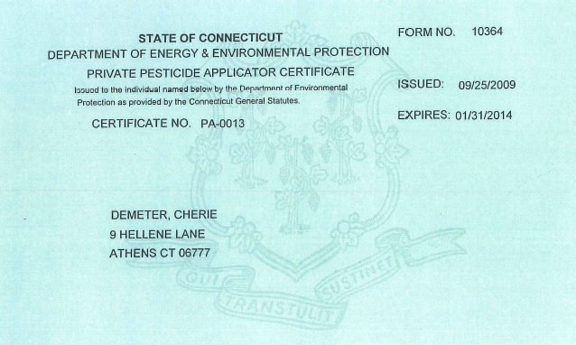
Name
Address

New:
NOTE: Government Only:NO and lack of soil or non-soil fumigation endorsement
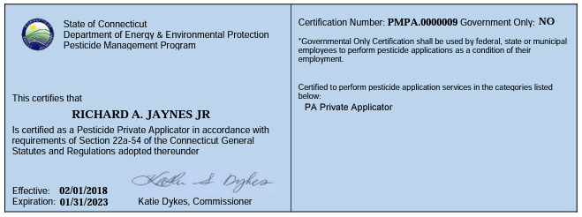
Name

2023 Revision:
NOTE: New Agency Logo, Government Only:No and Soil Fumigant endorsement
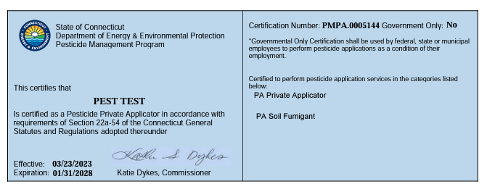

Commercial Pesticide Applicators
Anyone who applies pesticides for hire in Connecticut is a commercial applicator. Commercial applicators must obtain certification before applying pesticides on a job. They need a certificate to apply any pesticide whether it is a general-use, restricted-use, or permit-use pesticide.

There are two levels of commercial certification – supervisor and junior operator.
Only the supervisory level can buy restricted-use pesticides.

Commercial Supervisor
A Commercial Supervisor is the decision maker for pesticide applications done for hire, but they are limited to performing work only in the category or categories of certification they hold. Below is a sample Commercial Supervisor certification showing the certification category with the corresponding category code. The color of Commercial Supervisor certification is WHITE. Please note the sections of the certificate showing the issue date, expiration date, certification number, certification category and certification category code. The certification number is preceded by "S-" or, for governmental employees, “GS-“

Arborist certification is a category of commercial supervisor certification that is issued to individuals who perform professional tree work including pesticide treatments. The appearance of the certificate is the same as described above. An arborist certification may be a four-digit number preceded by an "S-" or a five-digit number beginning with the numeral 6. Governmental certification is not available for the Arborist category so the certificate should always read “Government Only:No.” Individuals with Arborist certification can have additional certification categories on their Commercial Applicator Supervisor certificate; however, a separate certificate is issued for governmental certification categories.

The first example below is still in circulation but will be completely phased out by the end of 2026. The new certificates will have a different appearance and will include the prefix PMCS. For governmental certification, the certificate will read “Government Only: YES” or “Government Only: NO” as shown in the second and third examples below.

Old: This version is being phased out
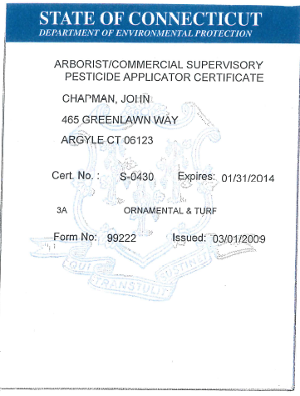
Name
Address

New:
NOTE: PMCS Prefix, Government Only:Yes and certification categories
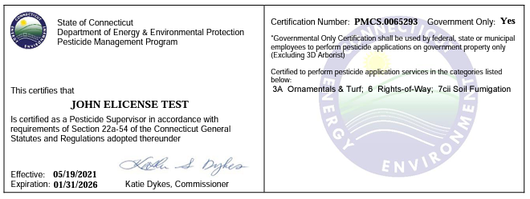

2023 Revision:
NOTE: New Agency logo, PMCS Prefix, Government Only:Yes and certification categories
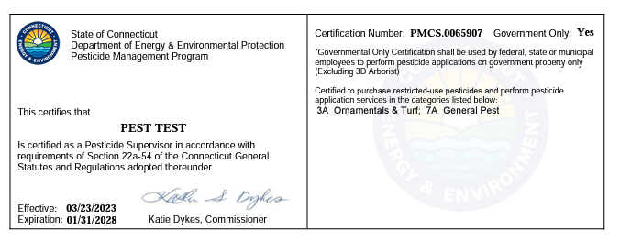

Old Arborist: This version is being phased out
Note: Certification number beginning with the number 6 with no prefix

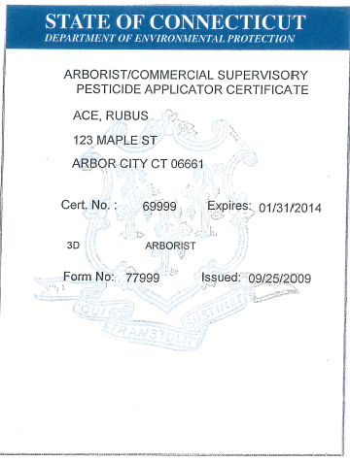
Name
Address

New Arborist:
Note: PMCS Prefix and Government Only:NO
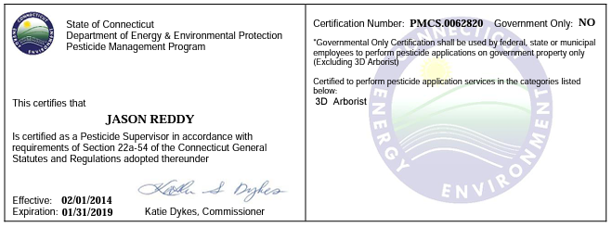
Name

2023 Revision:
Note: New agency logo, PMCS prefix and Government Only:NO
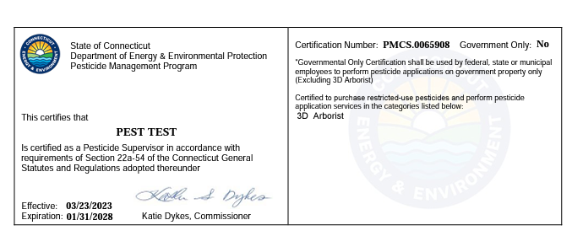

Supervisor Certification Categories
1A: Agricultural Pest Control
1B: Harvested Crops
2: Forest Pest Control
3A: Ornamental and Turf
3B: Golf Course Superintendent
3C: Interior Plantscape
3D: Arborist (Note: there is no governmental certification for this category)
5: Aquatic Pest Control
6: Right of Way
7A: General Pest Control
7B: Termite and Wood Destroying Organisms
7Ci: Structural Fumigation
7Cii: Soil Fumigation
7Ciii: Pipe Fumigation
7D: Rodent Control
7E: Bird Control
7F: Mosquitoes and Biting Flies
7G: Wood Preservation
7I: Cooling Tower
8: Public Health (governmental only)
9: Regulatory (governmental only)
10: Demonstration and Research

Category Descriptions

Commercial Junior Operator Certificate
An individual holding a commercial junior operator certificate can only apply pesticides for hire under the supervision of someone with Commercial Supervisor certification. THEY CANNOT BUY RESTRICTED-USE PESTICIDES. Below is a sample Junior Operator certification. The color is YELLOW with black lettering. Please note the issue date, expiration date and certificate number. The certificate number is preceded by an "O -" Junior Operator certifcations do not have certification categories and wil not display a category code.

The first example below is still in circulation but will be completely phased out by the end of 2026. The new certificates will have a different appearance and will include the prefix PMCO. For governmental certification, the certificate will read “Government Only: YES” or “Government Only: NO” as shown in the second and third examples below.

Old: This version to be phased out
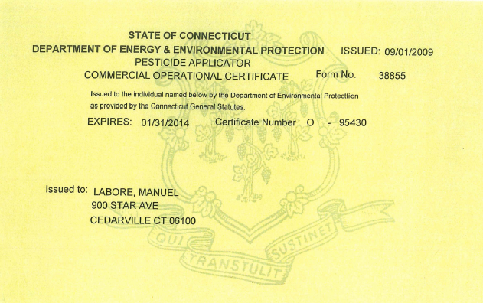
Name
Address

New:
Note: PMCO Prefix, Government Only:Yes and “Restricted-Use Pesticides” statement
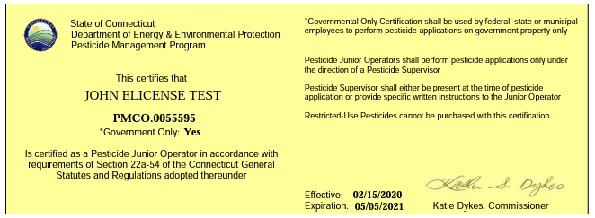

2023 Revision:
Note: New agency logo, PMCO Prefix, Government Only:Yes and “Restricted-Use Pesticides” statement
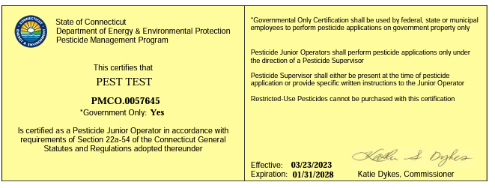

Permit-Use Pesticides (Aquatic)

Some pesticides are only available by permit. The permit application must be completed by the applicant and approved by the Pesticide Management Program.

According to state statute, a permit must first be obtained to use any chemical in any body of water in the state for control of aquatic weeds, fish, or any aquatic organism.

An aquatic permit is required whether someone is treating a water body that they own or hiring someone apply chemial(s) for them. Anyone performing aquatic application for hire must also have Commercial Supervisor certification in the Aquatic (5) category.

The quantity of chemicals allowed is on the front page of the permit. Please note that this is the proper amount needed to treat the lake or pond and does not take container size into account. You may sell the permit holder a larger amount of chemical if the package size dictates. For example, if the permit calls for 7 pounds of a chemical which only comes in 5 pound packages, it is acceptable to sell the permit holder 10 pounds (2 bags). Make sure you sign the form to prevent re-use, and return it to the holder so that he may refer to it.

A sample permit is shown below. The permittee must present a valid permit to the Restricted-Use Pesticide Dealer when purchasing pesticides for aquatic use. The dealer must sign the last page of the permit at the time of sale so that the permit cannot be used again. The permit form is retained by the permittee/purchaser. The dealer must report the sale on their annual restricted-use sales report.

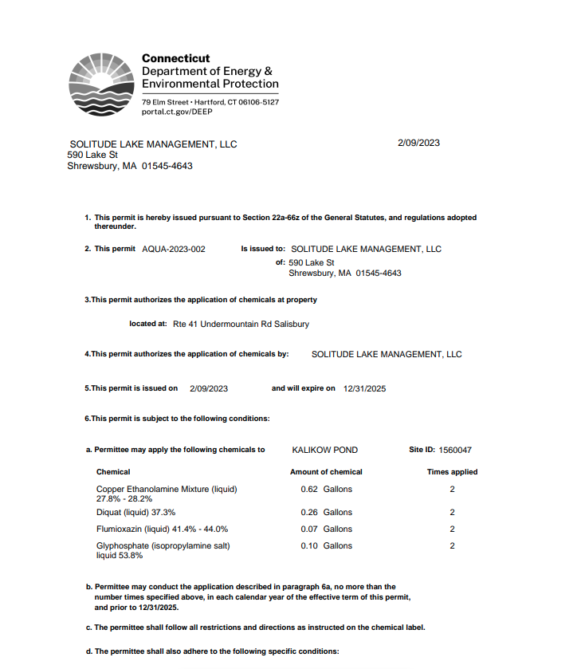

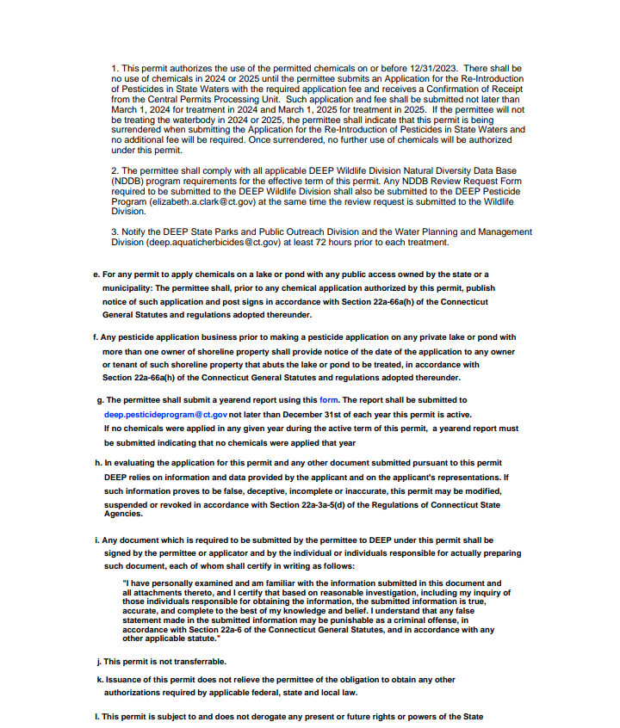
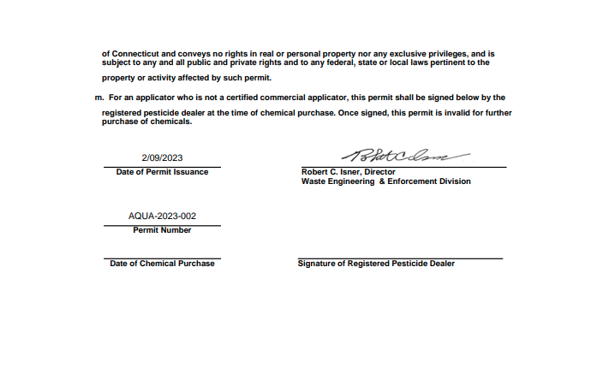
Permit Use Pesticides (Aerial)

The aerial application of pesticides may only be allowed with an approved aerial permit issued by the Pesticide Management Program. The pilot/applicator must also have a commerical supervisor certification in the Aerial (11) category, this certification would allow for the purchase restricted-use pesticides, though no restricted-use pesticides would currently be permited for aerial use.

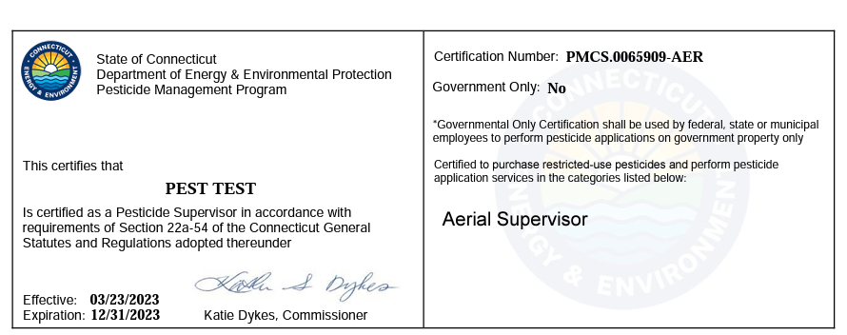

Sale of Restricted-Use Pesticides

Report of Sales of Restricted-Use or Permit-Use Pesticides

Sales Report Forms
Registered restricted-use pesticide dealers are required to maintain records of sales and transfers between dealers of restricted-use and permit-use pesticides. The report must be submitted annually by October 31st on the prescribed form.

Dealer renewal certificates will not be issued without submission of the required annual sales report. If your company has made no sales or transfers for the time period of October 1st through September 30th, the report still must be submitted with the words "no sales." Your company may wish to make copies for office use, however, an original report must be submitted.

A link to the required reporting form is provided below.

Completing the Forms
The Pesticide Management Program does not require that any one specific person, such as the dealer, fill out the sales report forms. As long as the dealer makes certain that the forms are kept properly, the dealer is complying with the law.

Certified Applicator/Permit Holder
The name of the person who is buying the pesticide must be recorded. The name should be recorded as it appears on the person's certificate or permit. If you are in doubt as to the verity of the bearer's qualifications, you should ask for additional identification. It is the responsibility of the registered pesticide dealer to be sure of the individual's qualifications.

Certificate Number or Permit Number
The certificate number or aquatic permit number must be recorded on the sales report form. The certificate number is is printed on their certification or can be verified online at www.elicense.ct.gov . Each aquatic use permit is numbered and dated when approved. On aquatic use permits, the permit number is found on the bottom of the last page. Aquatic permits cannot be verified online.

Amount Purchased
There are three columns to be completed and are entitled, "no. of Units," - which refers to the number of containers bought; "Wt.Nol Each Unit," - refers to the amount in weight (ounces or pounds) or volume (gallons, quarts, etc.) of the pesticide sold; and "Total Wt.No Sold" refers to the total amount recorded by weight or volume. Do not record amounts as "3 cases" or "4 bottles" on the use report.

EPA No. and Pesticide Purchased (Trade Name and Manufacturer)
The EPA number, the trade name and manufacturer of the pesticide are the last columns on the sales report form. The entire name of the manufacturer is not required - a single key word is sufficient such as "Dow" for The Dow Chemical Company. Often, the company logo as it appears on the label is sufficient.

*New Reporting Requirements Starting in 2022*
- Business/ Farm Name
- Address, city, state, zipcode of purchaser
- Expiration date of certification
- Categories held
  - You can only sell products for the certification categories the purchaser holds. So if the purchaser holds an arborist license you should not be selling them a product to control ticks.
- Certifying state
- Uncertified person approved for pick up, name, address, zipcode
- Copy of certified applicator provided Y/N
- Copy of signed authorization letter Y/N
- Copy of license/ governmental ID of the person provided the pesticide Y/N

Instructions on how to use the elicense reporting function to generate lists of minimum risk, restricted-use, and general use pesticides registered in the state can be found here.

The emphasis on completing the sales report form is for clarity. If the sales report forms are filled out by hand, please print legibly.

The sales report forms can be found here, you must used this form, we will no longer be accepting other forms.

