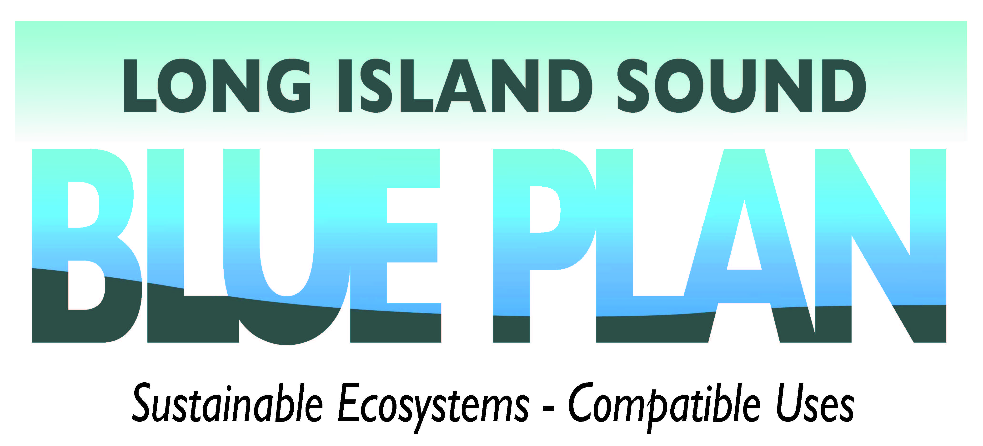


Long Island Sound Blue Plan Comment Form
Engaging stakeholders, which includes the general public, is critical to the success of the Long Island Sound Blue Plan. You are the foundation of the planning process and your input will result in a better plan for the Sound.

We want to make the planning process as inclusive as possible to make sure all views are represented, so we’re seeking widespread participation and input from stakeholders as the Blue Plan is developed.

If you would like to share your comments and concerns about the Long Island Sound Blue Plan, please fill out the form below.

To help get you thinking, please refer to the
- Blue Plan Basics Introduction,
- Public and Stakeholder Engagement Factsheet,
- Focusing on the Issues Factsheet, and
- Draft Vision and Goals document.

Or you can just give us a general comment about the Plan. You can also email us at DEEP.BluePlanLIS@ct.gov, or mail your comments to LIS Blue Plan, DEEP WPLR, Land and Water Resources Division – Planning, 79 Elm Street, Hartford, CT 06106.

Thank you for your interest in the Long Island Sound Blue Plan!

Blue Plan Comments: (All fields are required.)
Select a Topic
Name
E-mail
Your Comments
Would you like to receive occasional emails regarding the Blue Plan? | Yes No

Submit this completed form by email to DEEP.BluePlanLIS@ct.gov or postal mail to LIS Blue Plan, DEEP WPLR, Land and Water Resources Division – Planning, 79 Elm Street, Hartford, CT 06106.

