DEP USE ONLY
TOWN: PREM:
CLIENT:
AFS ID:
REPORT ID:

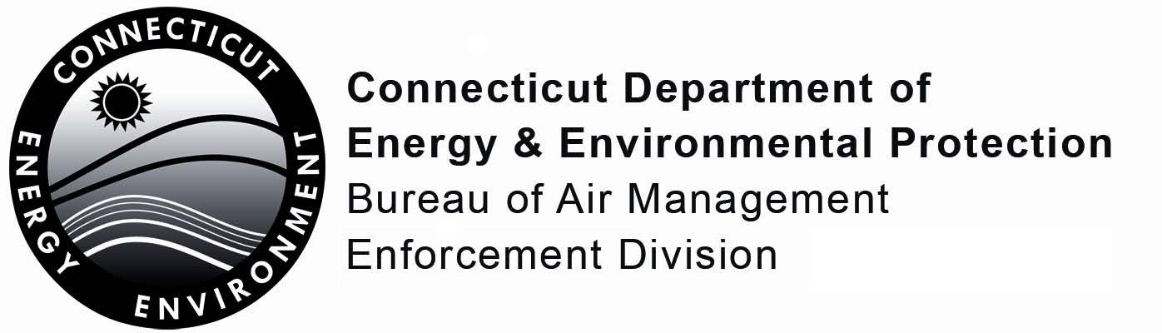
RCSA §22a-174-33b Annual Emissions Summary Form
- Premises Name:
Mailing Address:
City/Town: State: Zip Code: -
Business Phone: - - Ext. Fax: - -
Contact Person: Title:
E-Mail:
- Premises Address:
City/Town: State: Zip Code: -
- Reporting Period (mm/dd/yyyy): From: / / To: / /
Part I: Facility Information

Part II: Certification
The authorized representative for the owner or operator and the individual(s) responsible for actually preparing this form must sign this part. The form will be considered incomplete unless all required signatures are provided.
“I have personally examined and am familiar with the information submitted in this document and all attachments thereto, and I certify that based on reasonable investigation, including my inquiry of the individuals responsible for obtaining the information, the submitted information is true, accurate and complete to the best of my knowledge and belief.

I understand that any false statement made in the submitted information may be punishable as a criminal offense, under section 22a-175 or 53a-157b of the Connecticut General Statutes.”

Signature of Authorized Representative |  | Date
Printed Name of Authorized Representative |  | Title (if applicable)
Signature of Preparer (if different than above) |  | Date
Printed Name of Preparer |  | Title (if applicable)
Check here if additional signatures are required. If so, please reproduce this sheet and attach signed copies to this sheet.

Part III: Premises Actual Emissions Summary

- Were the actual emissions of any pollutant equal or exceed 50% of a Title V source threshold during any consecutive 12-month period of the previous calendar year, as logged pursuant to RCSA §22a-174-33b(f)(2): Yes No
- If yes, indicate the pollutants for which the premises actual emissions were equal to or exceed 50% of the Title V source threshold:
PM-2.5, PM-10, SOx, NOx, VOC, CO, HAP (aggregate), HAP (individual)
Complete no. 3 and 4 below for each pollutant indicated
- Consecutive 12-month Aggregate Periods |  | - Actual Criteria Pollutant and HAP Emissions (tons/consecutive 12-month aggregate)
From (YY) | To (YY)
February 1, 20 | January 31, 20
March 1, 20 | February 28, 20
April 1, 20 | March 31, 20
May 1, 20 | April 30, 20
June 1, 20 | May 31, 20
July 1, 20 | June 30, 20
August 1, 20 | July 31, 20
September 1, 20 | August 31, 20
October 1, 20 | September 30, 20
November 1, 20 | October 31, 20
December 1, 20 | November 30, 20
January 1, 20 | December 31, 20

The Annual Compliance Certification Form (ACC) must be submitted on or before March 1st in each year after the submittal of a Notification of Operation Under RCSA §22a-174-33b. All owners and operators who have submitted a Notification of Operation pursuant to this section must submit the ACC until such time the owner or operator submits a Notification to Cease Operation pursuant to this section.
Completed forms may be submitted either electronically via e-mail to DEEP.CACU@ct.gov (preferred method) or via mail to:
Supervisor
Compliance Analysis & Coordination Unit
Bureau of Air Management
Department of Energy and Environmental Protection
79 Elm Street. 5th Floor
Hartford, CT 06106-5127

Note: Forms submitted electronically via e-mail must be submitted as PDFs. Electronic signatures on completed forms will be accepted either as a digital signature on a PDF or a printed, signed, and scanned copy of the ACC submitted via e-mail.

If you have any questions, you may contact the Bureau of Air Management - Compliance Analysis and Coordination Unit (CACU) at (860) 424-4152 or DEEP.CACU@ct.gov.

