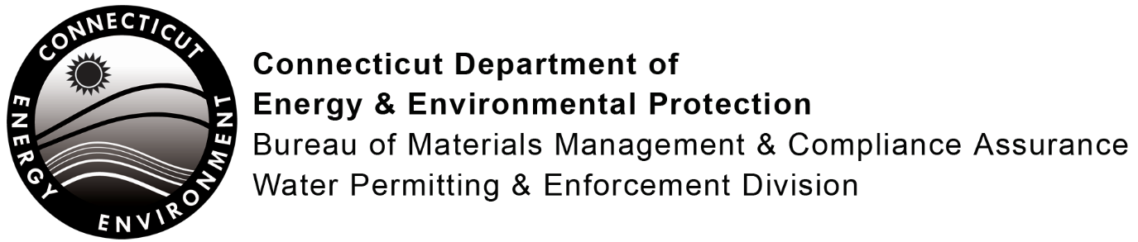

Monitoring Report Form

General Permit for the Discharge of Groundwater Remediation Wastewater
Site Name:
Address:
Registration Number: CTR
Monitoring results shall be recorded on this form as required pursuant to Section 5 of this general permit.
The parameters in the table below are a general permit minimum. Additional parameters may be required, dependent on the requirements of Section 5 of the general permit. Parameters not required shall be marked “NA”. The table is formatted to provide an unlimited amount of rows. For additional rows, press the tab key at the end of the last row. The header row will appear in each additional page.
Date Sampled: DSN:
Parameter | Result | Additional Parameters | Result
Daily Flow; if applicable
Total Volatile Organic Compounds (VOCs)
Oil & Grease – Hydrocarbon Fraction or Total Petroleum Hydrocarbons
MTBE
Cadmium, Total
Cobalt, Total
Copper, Total
Iron, Total
Lead, Total
Mercury, Total
Nitrogen, Total
Phosphorous, Total
pH
Temperature
Total Settleable Solids
Total Suspended Solids
Zinc, Total

Results to be maintained on site and submitted as required pursuant to Section 5(a) of this general permit with one exception:
The results of the initial screening analysis required pursuant to Section 5(a) of this general permit must be submitted on this form and attached to the registration form (DEEP-WPED-REG-027) as part of the general permit registration process.
Submit to: DMR SECTION (Except for monitoring submitted as part of the General Permit registration process.)
BUREAU OF MATERIALS MANAGEMENT AND COMPLIANCE ASSURANCE
DEPARTMENT OF ENERGY AND ENVIRONMENTAL PROTECTION
79 ELM STREET, HARTFORD, CT 06106-5127
“I certify that I have personally examined and am familiar with the information submitted in this document and all attachments thereto, and I certify that, based on reasonable investigation, including my inquiry of those individuals responsible for obtaining the information, the submitted information is true, accurate and complete to the best of my knowledge and belief. I understand that a false statement made in the submitted information may be punishable as a criminal offense, in accordance with Section 22a-6 of the General Statutes, pursuant to Section 53a-157b of the General Statutes, and in accordance with any other applicable statute. I also certify that this form is complete and accurate as prescribed by the commissioner without alteration of the text.”
Signature of Person Completing Form |  | Date
Name of Person Completing Form (print or type) |  | Title (if applicable)

