Notice to Residents 

FREE Electronics Recycling

According to state law, Connecticut residents can recycle the following electronic items FREE of CHARGE at their local collection center:

  - Computers
  - Monitors
  - Printers
  - Television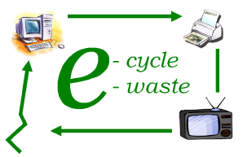

Collection Site/Hours:_______________________________________________________

Town contact/website:______________________________________________________________________

For more information on recycling other electronics, contact your town or www.ct.gov/dep/e-waste

