Historic Homes Rehabilitation Tax Credit Online Application Instructions
January 1, 2024
Any new projects must submit a part 1 and part 2 application prior to beginning construction.
Any existing applicants with a part 1 and part 2 application approved prior to January 1, 2024 must submit a part 3 and part 4 application after the work is complete.
To begin:
Go to: https://ctofficeofthearts.smapply.org/
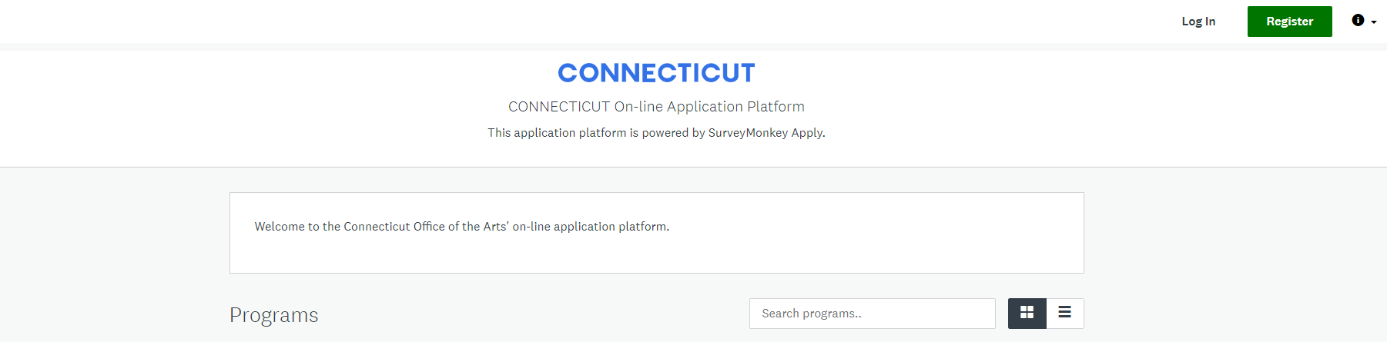
You will see the following programs:
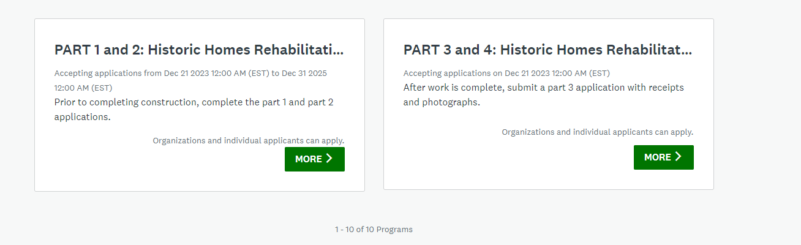
Choose the program that applies to you by clicking the green “more >” button:
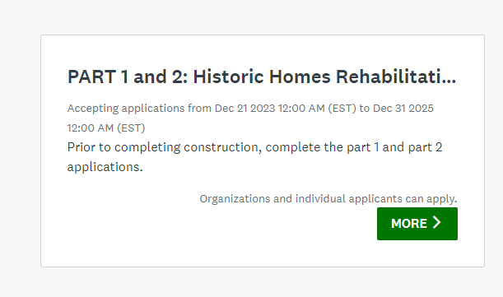
On the next page, click the green “apply” button.
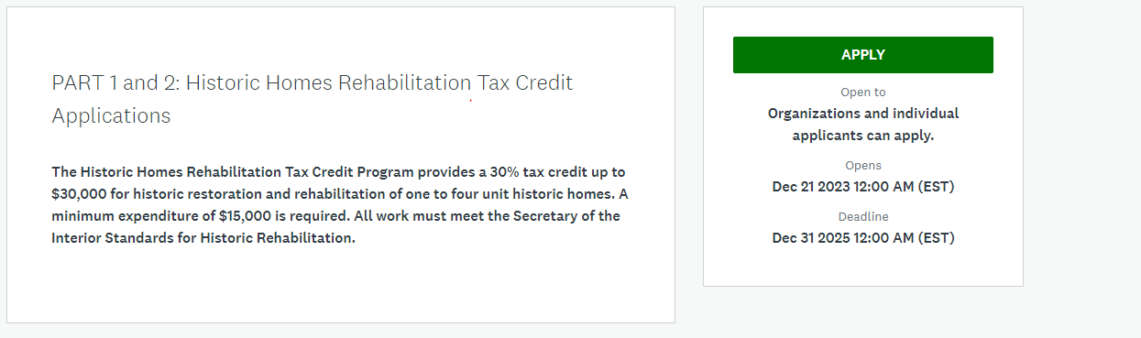
Next, name your application using the following format: Last name, City/Town, Address (Street Number, Street Name). For example: Fink, Hartford, 450 Columbus Boulevard
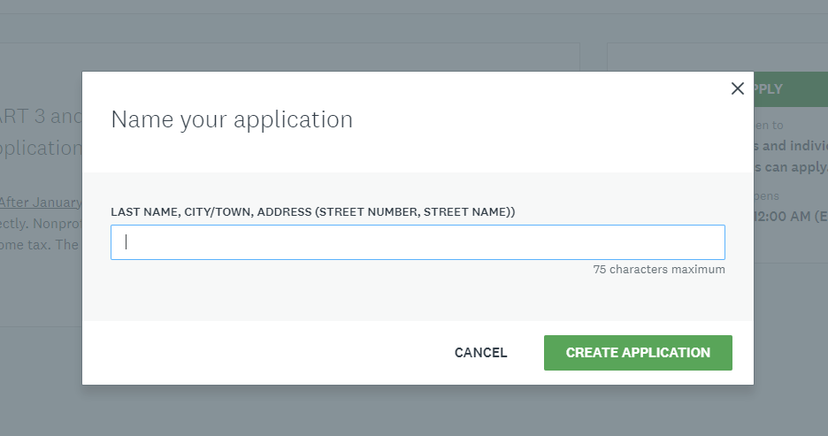
Next, register to create a Survey Monkey Apply account by clicking the black “Register” button on the top right of the screen.

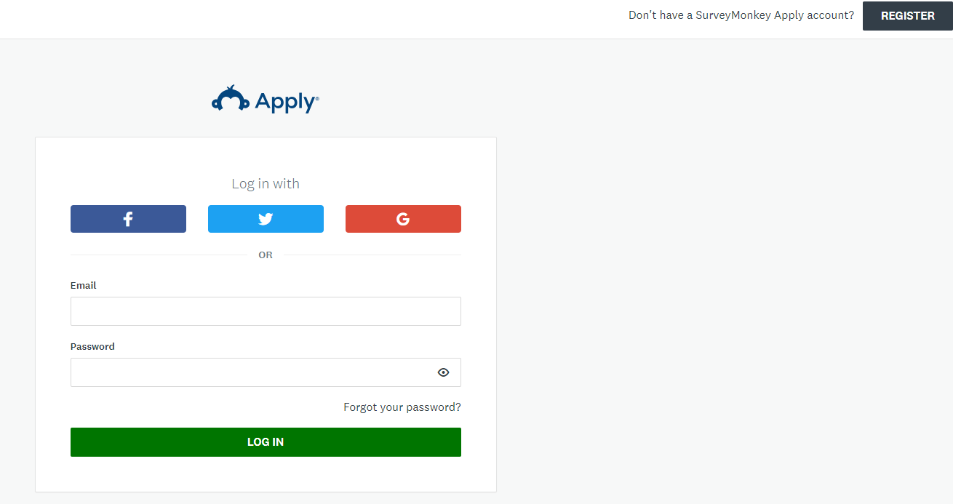
Then, register as an individual. If you would like to collaborate on the application with another person, that person will need to register as an individual as well, but should not complete a duplicate application. There will be a place for the application owner to add a collaborator later in the process.
Registration link for collaborator: https://ctofficeofthearts.smapply.org/acc/r/?g=77198
Then click the green button for “Create account”
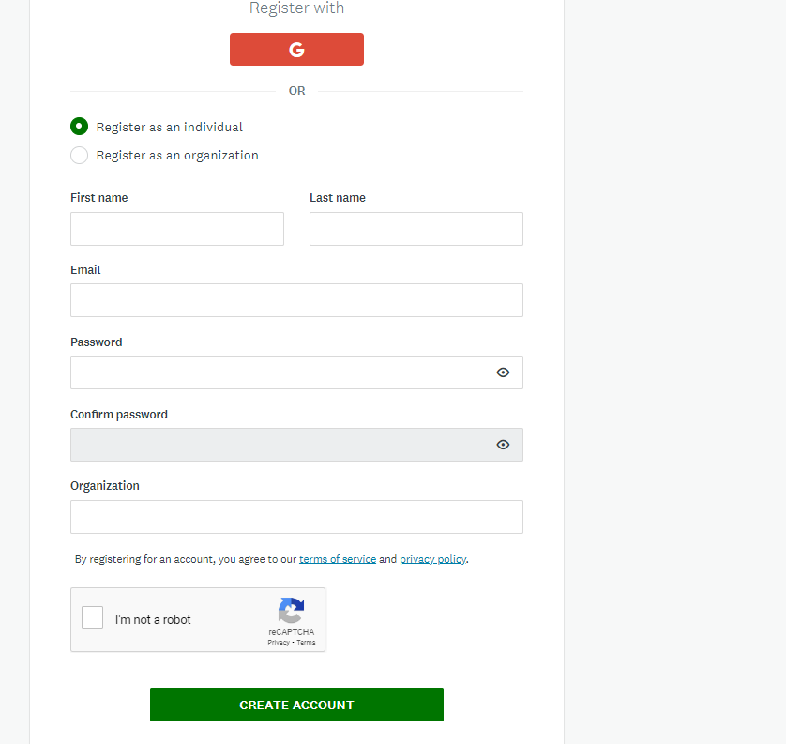
Next, verify your email address by clicking the green “Send verification link” button. You will not be able to submit applications or complete certain tasks until you have verified your email address.
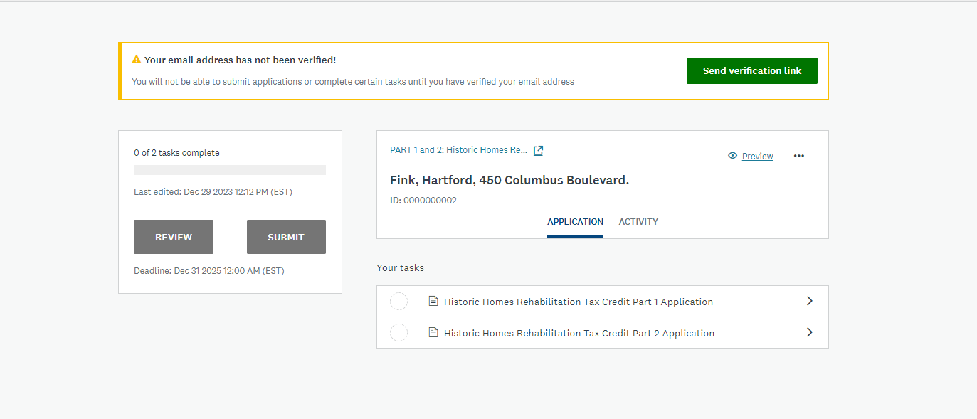
Go to your personal email account to register your Survey Monkey Apply account. The verification email will come from “noreply@mail.smapply.net”
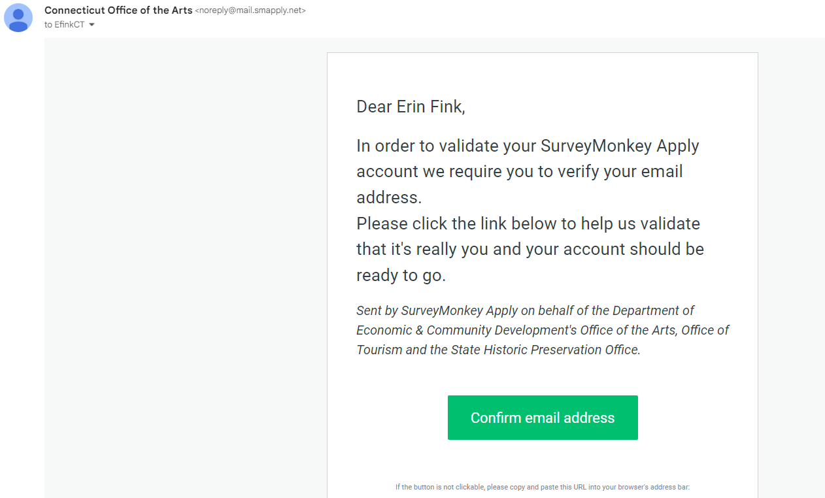
If your email is properly verified, you will see the following screen:

After your email address is verified, you can return to the application and click the green “start” button.
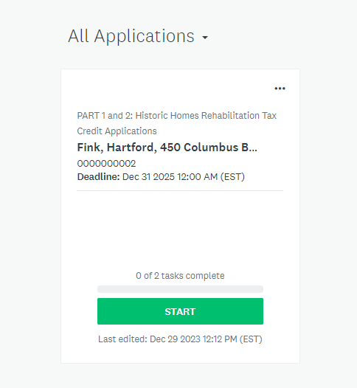
At this point, you can add a collaborator to the application if desired by clicking the black “add collaborator” button.
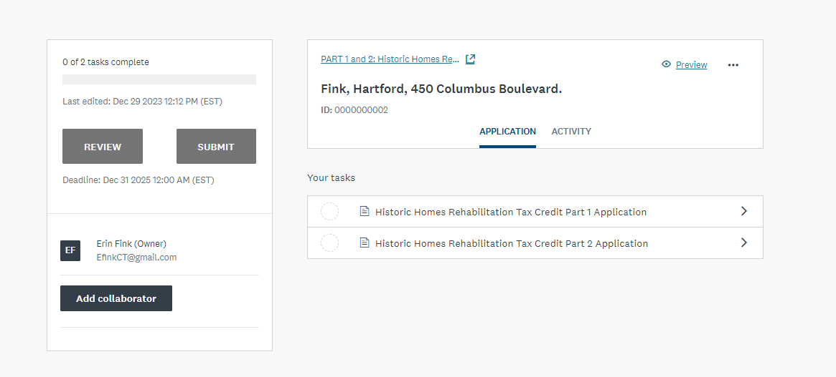
Make sure to select “view & edit” for the type of access for the collaborator.
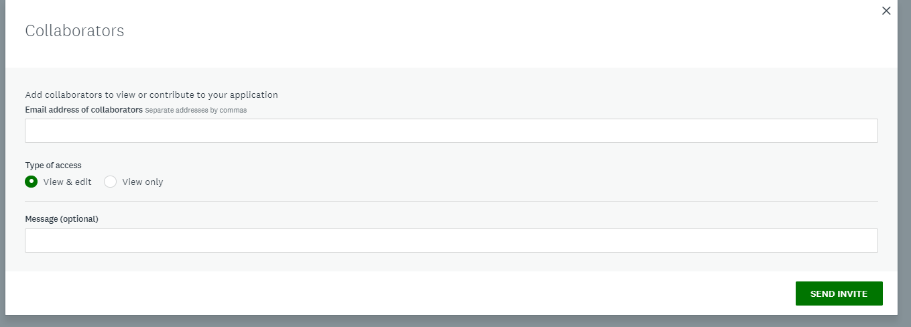
The Survey Monkey Apply system will automatically save any work done within an application. To confirm that it is saving, a green circle will be present until the application is submitted.

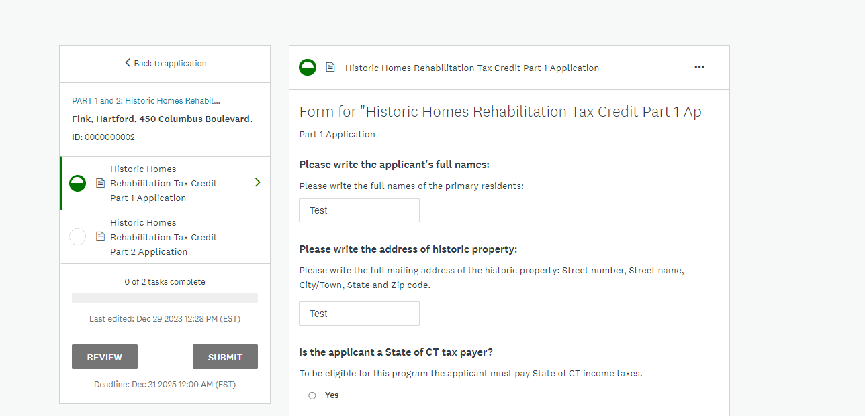
When the application is completed, select the green “mark as complete” button at the bottom of the page.
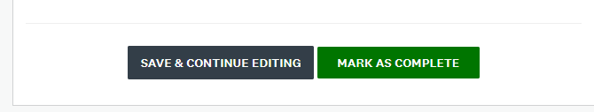
Please allow the State Historic Preservation Office 30 days to review your application. You may check in on the status by logging in at any point. Go to: https://ctofficeofthearts.smapply.org/

When a decision has been made, you will receive the following email at the email address you registered with:
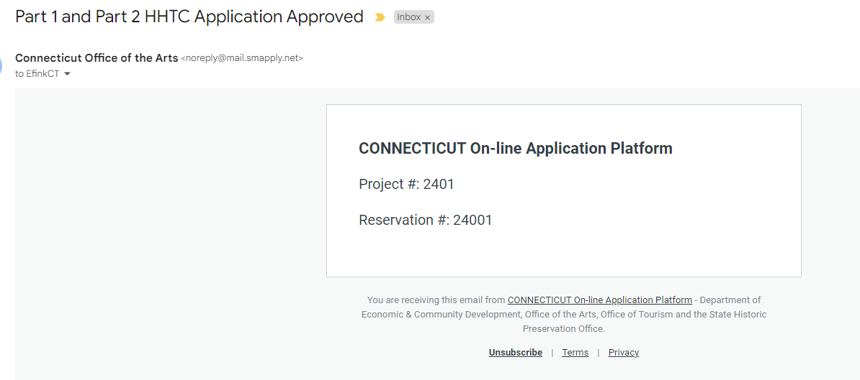
You can also check the decision status by logging in, where you will see the following messages:

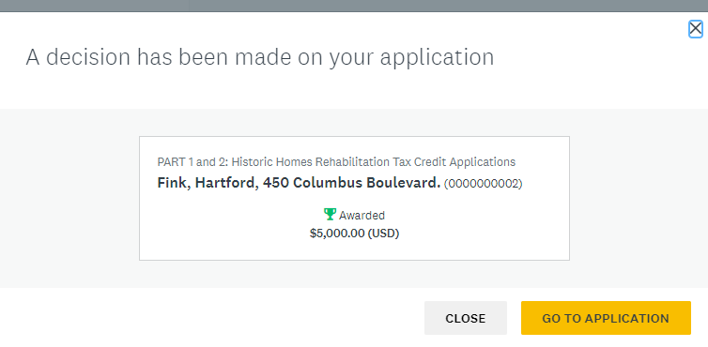
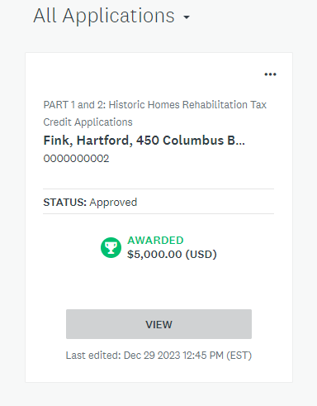
For a Part 1 and Part 2 application, a reservation amount will be specified.
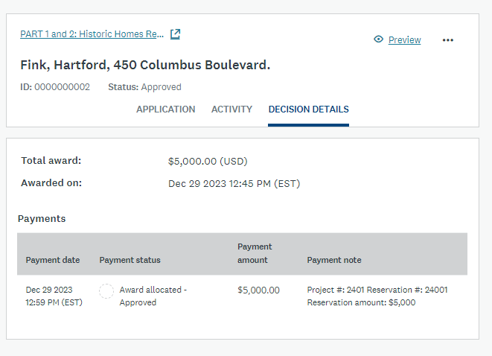
For a Part 3 Application, a voucher amount will be specified and you will receive the following email to the email address that you registered with:
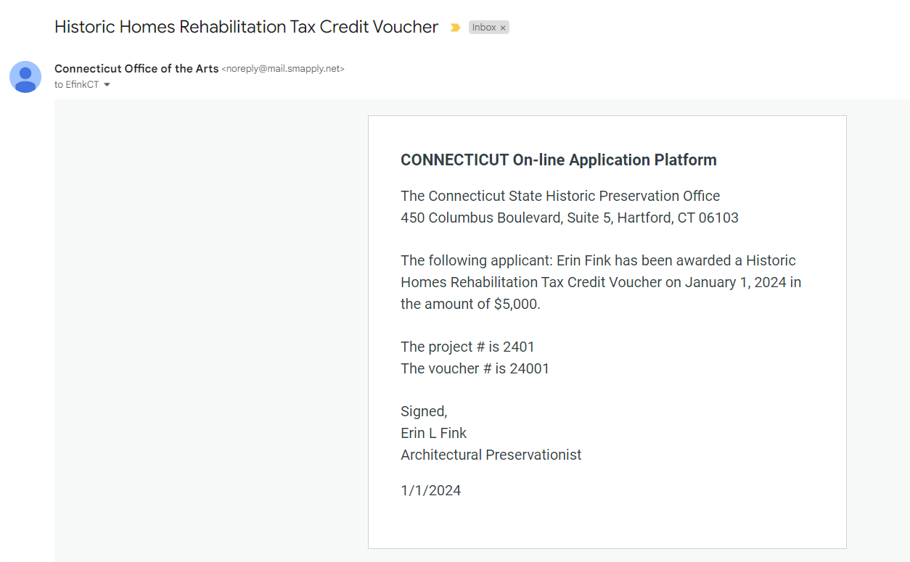
When you login to the system, you will see the following window:
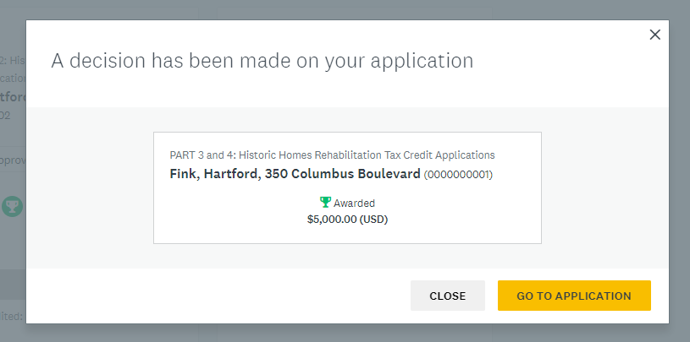
A formal voucher and tax filing information will be emailed by Erin.Fink@ct.gov or a member of the Department of Revenue Services. The tax credit shall be taken in the same tax year in which the tax credit voucher is issued. There are 3 ways to use the tax credit voucher:
- If the amount of the tax credit voucher exceeds the taxpayer’s liability for the tax imposed under chapter 229 (Income Tax) the Commissioner of Revenue Services shall treat such excess as an overpayment and, except as provided under section 12-739 or 12-742, shall refund the amount of such excess, without interest to the tax payer,
Or,
- Any unused portion of such credit may be carried forward to any or all of the four income years following the year in which the tax credit voucher is issued. Any excess at the end of the four year period may not be claimed as excess.
- For an owner that is a nonprofit corporation holding a tax credit voucher it may be used against the tax due under chapter 208a in the amount specified in the tax credit voucher

The online application and voucher process is new as of January 1, 2024. The application and process may be refined and updated as individuals work through the system if there are any issues identified.

For additional questions, please contact Erin.Fink@ct.gov

Thank you,
The Connecticut State Historic Preservation Office.

