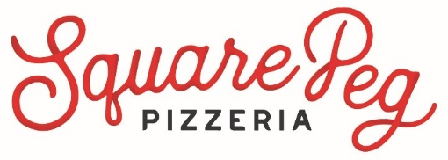
Re-Opening FAQ
Service 7 days a week, 12pm – 8pm (9pm on Fri/Sat).
We don’t require reservations. We do require your patience.
NOTHING is more important to us than the health and safety
of our Staff and Guests. Per Governor Lamont’s decision to permit limited outdoor dining to commence on May 20, Square Peg will begin patio and terrace seating on that date. Here is a summary of the safety precautions that we will be taking at Square Peg. These have been molded by State of CT and CDC Guidelines. They may evolve in time.
Your feedback is welcomed as well!
This is an on-going challenge, but we intend to meet it. We do not make the decision to open lightly. Please know that no employee has been compelled to return to work. We understand if now is not the right time to join us. If you have any concerns, hopefully these items give you confidence in your dining decision.

- Sanitizer available to Guests
- Tables of no more than 5 patrons
- Chair Backs of adjacent tables 6ft apart
- Frequent thorough handwashing by staff
- Disposable plate/glass/plasticware available
- Sanitizer at the entrances and near restrooms
- Tables & chairs wiped, sanitized between uses
- Self Certified using DECD and CDC Guidelines
- One-way traffic – egress separate from entrance
- Gloves & Masks mandatory for all staff and Guests
- Thermometer for all staff at the start of every shift
- Frequent facility cleaning & sanitizing contact surfaces

