

The State of Connecticut

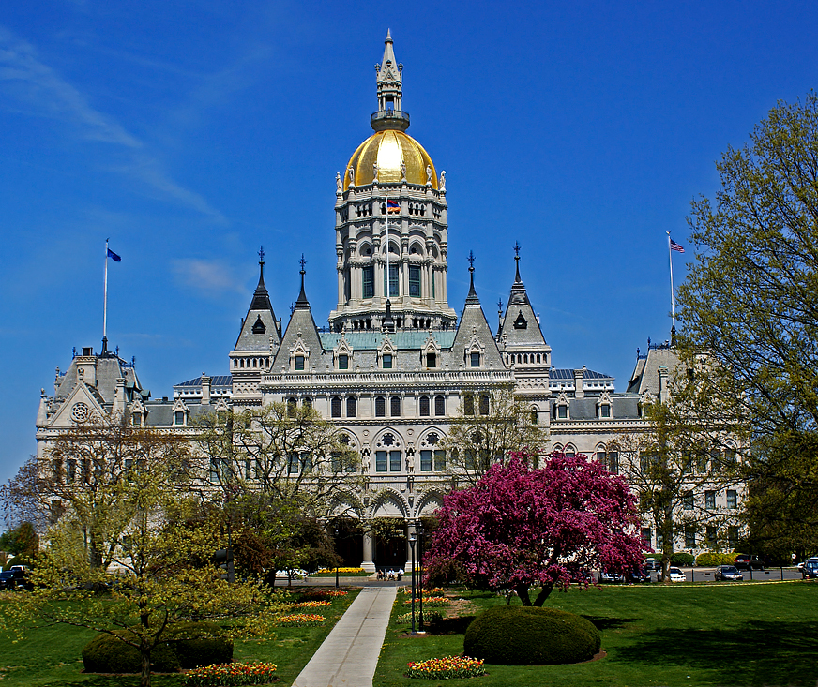

Department of Economic and Community Development

APPLICATION

Application Instructions

General Description
This request for Business Assistance is a brief outline to enable the DECD to determine, on a preliminary basis, the suitability and eligibility of the business to apply for financial assistance. A current business plan should be included with the request for this Business Assistance Application (consult with your Project Manager if assistance is needed). The business plan should include a complete description of the firm, its products and services, the project, and an explanation of the use of DECD funds. If the Application is approved, you will be asked for additional information to complete a final application. All information accompanying this Application is confidential and exempt from the Freedom of Information Act.

1. Business Name: List the full legal name of the applicant for financial assistance.

2. Address: Mailing address where correspondence should be sent. If different from the applicant location, so indicate.

3. Contact Person: If appropriate, include title.

4. Borrower: If other than the Business; list the individual(s), partnership or holding company.

5. Project Location: Give the location where financing will be used. The municipality is the jurisdiction to whom property taxes are paid.

6. Nature of Business: Give a complete, but concise, description of what the business does (e.g. manufacturing, technology, machining, etc.) Please include the Federal Employer ID # and NAICS Code.

7. Ownership: If not practical to list every business owner, include owners holding 10% or more of the business. If ownership of the borrower is different from the business, please list on a separate sheet the owners of the borrower. Minority or woman ownership must be 51% to be considered for this status. (“Minority” includes a variety of categories such as racial, ethnic, gender and disability status. Check with DECD staff to be sure.)

- Assistance Requested:
- Amount of Financing Requested: Specify amount and nature of assistance.
- Service(s) Requested: Identify type(s) of service requested.

9. Gross Sales/Receipts: Gross/Sales receipts of the business during the last calendar or fiscal year.

10. Employment: Current number of employees and the number of full-time employment to be created within 3-5 years after the start of the project.

11. Project Costs: Provide the project’s budgeted cost.

12. Source of Funds: The DECD will not be the primary source of funds. By statute, companies will be required to provide some level of funding toward the project. All sources of funding need to be identified on the application. Sources of funds should equal total project costs.

13. Project Description: Describe the project for which funding is being requested (i.e., type of equipment to be purchased, nature of inventory and uses for working capital). For a building, include address, acres of land, building's square footage, size of any structural building additions and appraised value of listed property. Provide lease information on current/prospective tenants. Note: DECD does not provide financing to surrender existing debt.

14. Required documents: (for application phase):

A. Letter of Good Standing from the Connecticut Department of Revenue Services (DRS).
B. Business Plan: Include a current copy of the firm's business plan.
C. Business Financial Statements: CPA prepared financial statements for the most recent three years and 5 year projections. (Federal tax returns may be admissible).
D. Cash Flow: Please include, as a part of the financial statements, year-to-date P&L and Balance Sheet.
E. Taxes Paid: Payroll, Sales, Corporate taxes paid to Connecticut (past 3 years and projected for 3 years).
F. Personal financial statements of owners of 10% or more of the company (due upon request).
G. Schedule of related affiliated companies.
H. If the project involves the purchase of a business, please provide the following:

I. Purchase Agreement or memorandum between the parties.
II. Current balance sheet of business being acquired.
III. Appraisal, or estimate of value, of seller's real estate and equipment.

15. Conventional Financing: Outline the amount and terms of any funds from conventional sources that are available to fund all, or a portion of the project. If applicable, indicate reasons for denial.

16. Public Disclosure: The DECD is required by law to include in its final approval consideration the extent to which the applicant has included community and employee participation, unless this question is answered "Yes", and an explanation is provided.

17. Repayment of State Funding: Must agree to register for electronic loan repayment via Automatic Clearing House (ACH) Debit Authorization. (Forms will be provided).

Application

(Please refer to the instructions on the previous page.)

1. | Business Legal Name:
2. | Address:
3. | Contact Person/Title:
 |  |  | Phone: |  |  | Email:
4. | Borrower(s) Name:
5. | Project Address:

6. | Type of Business
 |  | Manufacturer |  |  |  | Retailer |  |  |  | Wholesaler
 |  | Service Company |  |  |  | Construction |  |  |  | Finance, Insurance or Real Estate
 |  | Other (specify)
 | Type of Product or Service:
 | NAICS Code:
 | Federal Employer ID#: |  |  |  |  |  | State Tax Registration #:

7. | Business Ownership
 | Name |  | Title |  |  | % of Ownership | SS#
 |  | Minority owned |  |  | Woman owned (must be 51% minority or woman to qualify)

8. | State Assistance Requested:
 | A. | Amount of Financial Assistance Requested: |  | $
 | B. | Service(s) Requested:

9. | Gross Sales/Receipt
 | Total Sales/Receipts: | $ |  | Approximate % of Sales in CT:
 | Approximate % of sales outside CT: |  |  | Approximate % of sales outside US:

Page 1 of 4

10. | Connecticut Employment
 |  | Current Connecticut Employment |  |  |  | Project Related Connecticut Jobs
 |  | Number of Jobs |  | Minority |  | Retained |  | To be Created
 | Full-Time
 | Part-Time
 | TOTAL

11. | Project Costs
 | Machinery and Equipment | $ | Inventory | $
 | Working Capital | $ | Leasehold Improvements | $
 | Purchase of Land | $ | Purchase of Existing Building | $
 | Renovations/Construction | $ | Refinance of Existing Debt | $
 | Relocation | $ | Other (Please explain) | $
 | Total Project Cost | $

12. | Source of Funds
 | Amount of DECD Funding | $ | Equity from owners/partners | $
 | Amount of CI Funding | $ | Bank Loan | $
 | Funds from the Business | $ | Other (Please explain) | $
 | Total Source of Funds | $

13. | Project Description (attach additional sheet if necessary)

14. | Form of Organization
 |  | Private for Profit |  | Municipality
 |  | Non-Profit |  | Other (please explain)

15. | Form of Ownership
 |  | Corporation |  |  | Partnership
 |  | Proprietorship |  |  | Limited Liability Corporation
 |  | Sub-Chapter "S" corp. |  |  | Other (please explain)
Date Acquired/Established:

16. | Unpaid Taxes (List any below)
 |  | Type | Amount | Past due | Payment Terms
 | Federal
 | State
 | Local

17. | Are there outstanding, pending or anticipated claims or litigation against your company?
 |  | Yes (If "yes", please attach explanation) |  | No

18. | Have you ever personally declared bankruptcy or been an officer of a company or organization where bankruptcy was declared?
 |  | Yes (If "yes", please attach explanation) |  | No

19. | Required Documents (please refer to the instruction page)

A. Letter of Good Standing from the Connecticut Department of Revenue Services (DRS).
B. Business Plan: Include a current copy of the firm's business plan.
C. Business Financial Statements: CPA prepared financial statements for the most recent three years and 5
year projections. (Federal tax returns may be admissible).
D. Cash Flow: Please include, as a part of the financial statements, year-to-date P&L and Balance Sheet.
E. Taxes Paid: Payroll, Sales, Corporate taxes paid to Connecticut (past 3 years and projected for 3 years).
F. Personal financial statements of owners of 10% or more of the company (due upon request).
G. Schedule of related affiliated companies.
H. Information regarding a business acquisition.

20. |  | Have you received prior State financing?
 | Yes |  |  | DECD |  | CII |  | Amount | $ | Program |  | Date
 | No

21. | Conventional Financing
 | Please describe, on an additional sheet, what steps, if any, you have taken to obtain financing from conventional sources. Please outline the amount(s) and term(s) of the financing.

22. | Environmental Compliance
 | Do you have any outstanding orders or citations from either the Connecticut Department of Environmental Protection or federal Environmental Protection Agency? If yes, please describe on an additional sheet and give the name, address and telephone number of the individual handling your case at the respective agency.

23. | OSHA Compliance
 | Do you have any outstanding orders from the federal Occupational Safety and Health Administration? If yes, please describe on an additional sheet and give the name, address and telephone number of the individual handling your case.

24. | Public Disclosure
 | Will informing the municipality and employee representatives of the proposed request for financial assistance prior to DECD's final approval be considered a disclosure of confidential or proprietary information, or trade secret?
 |  | No |  | Yes (If "yes" please attach explanation)

Certification by Applicant

It is hereby represented by the undersigned as an inducement to the Department of Economic and Community Development to consider the financial assistance requested herein, that to the best of my knowledge and belief no information or data contained in the application or in the attachments are in any way false or incorrect and that no material information has been omitted, including the financial statements. The undersigned agrees that banks, credit agencies, the Connecticut Department of Labor, the Connecticut Department of Revenue Services, the Connecticut Department Environmental Protection, and other references are hereby authorized now, or anytime in the future, to give the Department of Economic and Community Development any and all information in connection with matters referred in this application, including information concerning the payment of taxes by the applicant. In addition, the undersigned agrees that any funds that may be provided pursuant to this application will be utilized exclusively for the purposes represented in this application, as may be amended.

Sign: Title: Date:

Print: ________________________________________

Please be sure to include the additional attachments required.

Return to:

C/O
DEPARTMENT OF ECONOMIC AND COMMUNITY DEVELOPMENT
Office of Business Development
450 Columbus Boulevard
Hartford, CT 06103
Phone (860) 500-2300
www.decd.org

Revised 4/17

