Manufacturing Innovation Fund Advisory Board
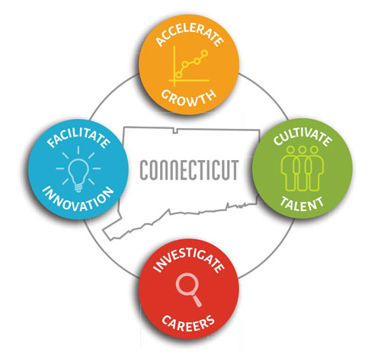

Meeting Agenda

TEAMS Meeting Call In Number: 1-860-840-2075
Participant Passcode: 953 522 119#

Thursday, October 1, 2020
9:00 a.m. - 10:30 a.m.

- Welcome & Introductions

- August Minutes (Vote)

- Portfolio

- Dream It Do It (Vote)

- DMCSP - Designation & CT Award

- Program Updates
  - MVP
  - Additive and Industry 4.0 Supply Chain Initiatives

- 2020 Annual Report – Status

- Other Business

