Manufacturing Innovation Advisory Board
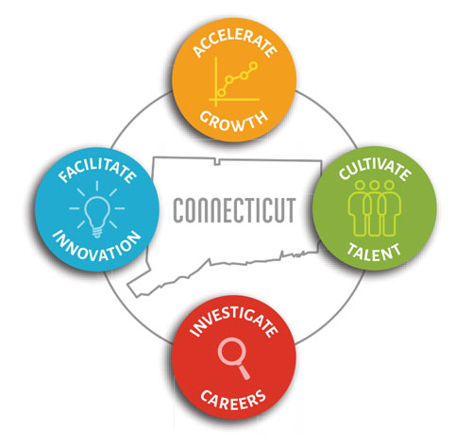

Meeting Agenda

TEAMS Meeting Call In Number: 1-860-840-2075
Participant Passcode: 699 503 261#

Thursday, April 21, 2022
1:00 p.m. - 2:30 p.m.

- Welcome

- February 2022 Meeting Minutes (Vote)

- Developing Manufacturing Strategic Plan for CT

- Update on Programs
  - Engineering Internship Program/Career Fair – CCAT
  - Manufacturing Voucher Program
  - Apprenticeship Program
  - Incumbent Worker Training Program
  - Hearts & Minds Advertising Campaign
- Digital Transformation/Cyber Security Roadmaps
- Manufacturing Website
- Regional Career Fairs
- CT Innovators/CT Manufacturers

- Portfolio
  - Review of Investments to Date
  - Planning for FY 22/23 Investments

- Other Business

