Manufacturing Innovation Fund Advisory Board
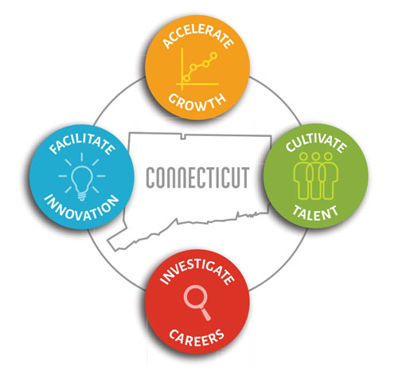

Meeting Agenda

TEAMS Meeting Call In Number: 1-860-840-2075
Participant Passcode: 533 178 982#

Tuesday, June 1, 2021
10:30 a.m. - 12:00 p.m.

- Welcome & Introductions

- April Minutes (Vote)

- Portfolio

• CT Labor Market Overview

- Governor’s Workforce Council Workforce Strategic Plan:
Update on Regional Sector Partnerships

- College Connections (Vote)

- Apprenticeship Program Update

- Other Business

