Manufacturing Innovation Fund Advisory Board
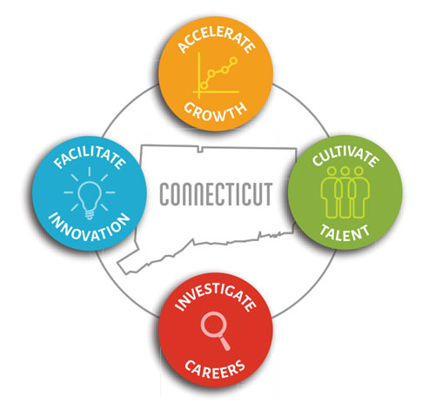

Meeting Agenda

TEAMS Meeting Call In Number: 1-860-840-2075
Participant Passcode: 5776 756 97#

Tuesday, February 2, 2021
10:30 a.m. - 12:00 p.m.

- Welcome & Introductions

- December Minutes (Vote)

- 2021 Schedule of Meetings (Vote)

- Michael Rocheleau – PTA Corporation

- Portfolio

- Governor’s Workforce Council Workforce Strategic Plan

- Program Updates

- MVP
- Industry 4.0 Voucher
- HRAM Program

- 2021 Look Ahead

- Other Business

