Manufacturing Innovation Advisory Board
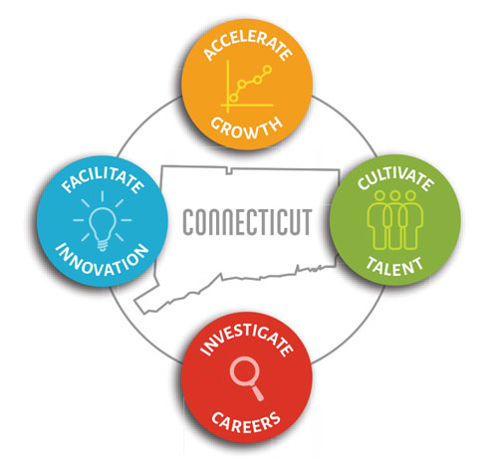

Meeting Agenda

TEAMS Meeting Call In Number: 1-860-840-2075
Participant Passcode: 410 909 774#

Thursday, February 17, 2022
1:00 p.m. - 2:30 p.m.

- Welcome & Introductions
  - Chief Manufacturing Officer

- December Minutes (Vote)

- 2022 Meeting Schedule (Vote)

- Portfolio

- Programs
  - Manufacturing Voucher Program (Vote)
  - Apprenticeship Program (Vote)
  - Incumbent Worker Training Program (Vote)
  - Engineering Internship Program (Vote)
  - Hearts & Minds Advertising Campaign (Vote)

- Update on New Initiatives
- CT Innovators/CT Manufacturers
- Digital Transformation/Cyber Security Roadmaps
- Manufacturing Website
- Regional Career Fairs
- CT Manufacturing, Engineering & Technical Career Fair
- Manufacturing Regional Sector Partnerships

- Other Business

